A. Christmas Tree Crossword A . Christmas Tree Crossword
The WORD BANK may help you to find the answers
- Father Christmas is another name for Santa CLAUS.
 |  |  |  | 1C | L | A | U | S
 | 2 |  |  | H |  | S
 |  | 3 |  | R
 | 4 |  |  | I
 | 5 |  |  | S
 |  |  | 6 | T
7 |  |  |  | M
 |  |  |  | 8A
9 |  |  |  | S
- We decorate the tree with twinkling ____s.
- We eat _______ for lunch on Christmas.
- The day after Christmas is called ____ Day.
- We give each other ____ on Christmas day.
- A ____ is a large sock which Santa Claus
fills with presents.
- Christmas is in _____. 
- The three kings followed an a__to find Jesus.
- Christmas is a festival to celebrate the birth
of Jesus ______.
- We put a ____ on top of the Christmas tree.
- We send ____ to our friends at Christmas.
 | 10 | T
11 |  | R
 |  | 12E
 | 13 | E
- The day before Christmas day is called
Christmas_______. 
- The church ____ ring on Christmas day. Grade:7/8/9?
¤WORD BANK: Jesus Christ耶穌基督/light燈/
turkey火雞/stocking聖誕襪/angel天使/ bell鈴聲

Boxing Day12月26日/card卡片/December12月 Class: Name:


B. The Chinese animal signs
Write the names of the animals in the grids. Then, write the letters in the shaped squares to find the answers to the three questions below. (The twelve animal signs are listed somewhere.)
1.On Chinese New Year people give children little red envelopes. What’s in the envelope? Answer: |  |  |  |  |  |  |  |  |  |  |  | 2. What does the message on the envelope say?  Answer: --
 |  |  |  |  |  |  |  |  |  |  |  | 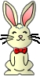
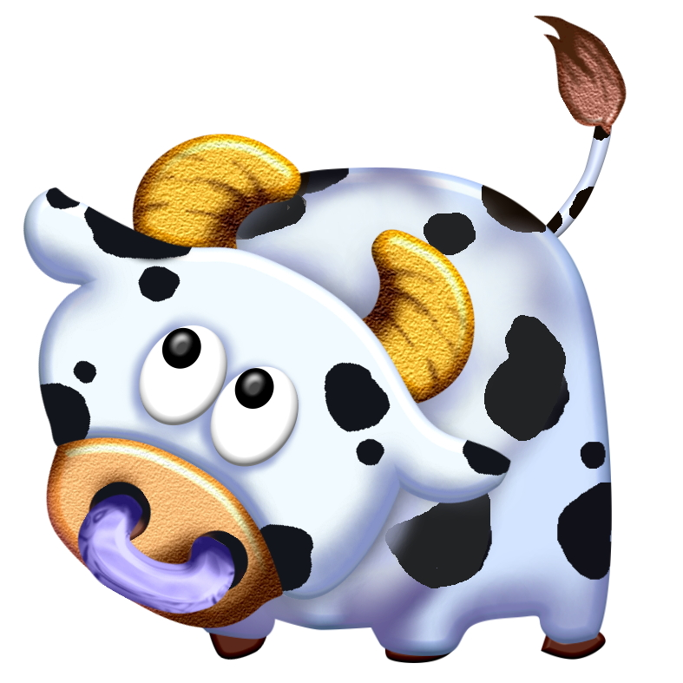 |  |  |  |  |  |  |  |  |  |  |  | 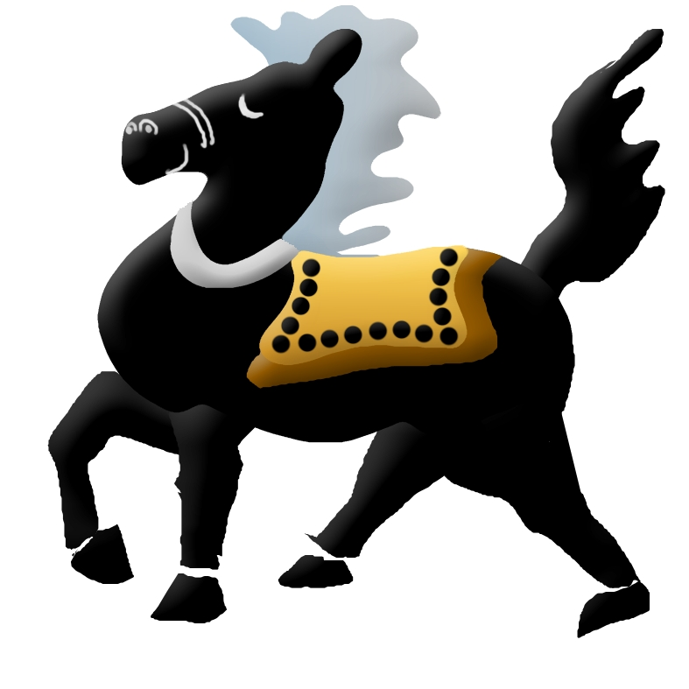
 |  |  |  |  |  |  |  |  |  |  |  | 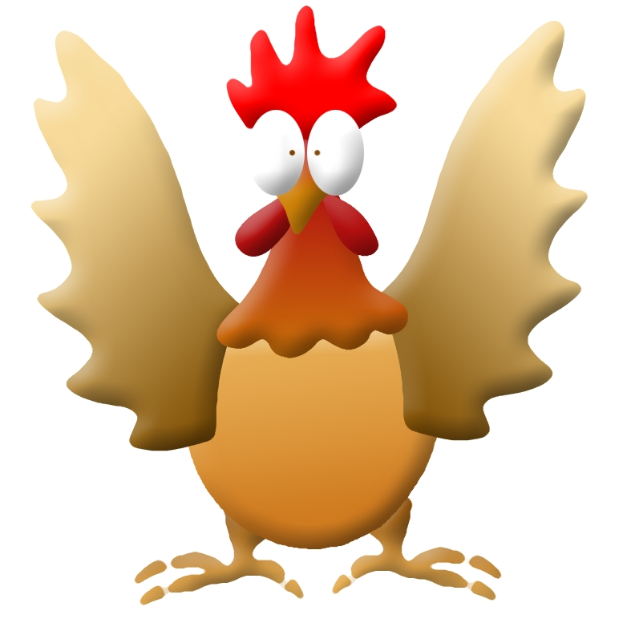
 |  |  |  |  |  |  |  |  |  |  |  | 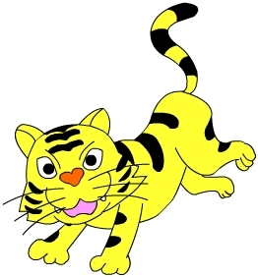
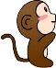 |  |  |  |  |  |  |  |  |  |  |  | 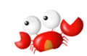
3. Which animal above is not one of the Chinese animal signs? Answer:
＊Your Grade: 7/8/9 ?  ＊Your Class ? ＊Your Name?
¤The Chinese animal signs: rat, ox, tiger, rabbit, dragon, snake, horse, sheep, monkey, rooster, dog, pig

