What Time Is it?

班級: 姓名:
*************************************************************************************
把以下的時間在時鐘上畫出來

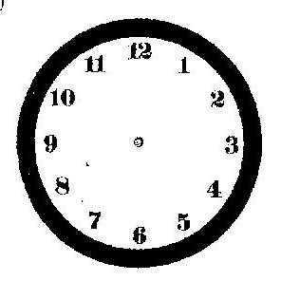
- four o’clock 2. nine twenty 3. six fifty

4. ten fifteen 5. one twenty-five 6. three forty-five

7. five minutes past twelve 8. five minutes to nine 9. a quarter to seven

