花蓮縣93年度國中八年級英語科基本能力檢核測驗
〔認識連續體〕
  - 請依字母順序，選出空格中正確的連續體大寫字母。
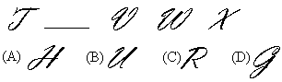
  - 請依字母順序，選出空格中正確的連續體小寫字母。
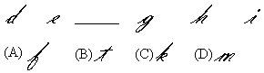
  - 請依所提示的句子，選出其正確的連續體寫法。
Tom is a junior high school student.
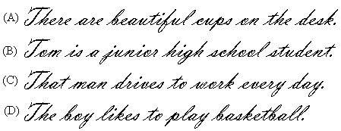
  - 請選出下列問句的適當對話。
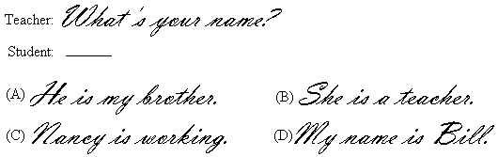

〔單詞測驗〕
  - At school, students study in the .
(A) bathroom (B) classroom (C) living room (D) dining room
  - The day before Saturday is .
(A) Friday (B) Thursday (C) Wednesday (D) Tuesday
  - The month between May and July is .
(A) February (B) September (C) March (D) June
  - My father’s brother is my .
(A) uncle (B) husband (C) cousin (D) aunt
  - I’m sick. I have to go to the to see a doctor.
(A) holiday (B) hospital (C) hotel (D) hobby
  - It’s convenient to e-mails to your friends on the Internet.
(A) get (B) hear (C) send (D) talk
  - On the Chinese New Year, all people in Taiwan the important day.
(A) practice (B) exercise (C) appear (D) celebrate
  - Today is Andy’s birthday. He gets a lot of . He is very happy.
(A) parents (B) presents (C) problems (D) persons
  - John: Do you know the word “psychology”?
Mary: I don’t know, either. Where’s the ? It can tell us the word’s meaning.
(A) dictionary (B) difficulty (C) difference (D) direction  meaning: 意義
  - That is Mr. Huang. He us math last year.
(A) taught (B) thought (C) caught (D) brought
  - A: I’m sorry. B: That’s all .
(A) night (B) light (C) right (D) fight

〔文法要點〕
- Peter Mr. White’s student.
(A) is (B) are (C) do (D) does
- Fred: Are the girls your new classmates?
Ted:
(A) Yes, she does. (B) No, they don’t. (C) Yes, she is. (D) No, they aren’t.
- Please the windows. It’s very hot today.
(A) open (B) opens (C) opening (D) to open
- It’s 12:10 in the afternoon. The students their lunch now.
(A) eat (B) eats (C) are eating (D) will eat
- Linda: is my English book?
Mom: It’s in the living room. You put it there this morning.
(A) What (B) Where (C) When (D) Who
- Nancy: my dog go to the park with us?
Mike: Of course, he can.
(A) Does (B) Will (C) Can (D) Is
- I don’t clean the kitchen. But my brother . He cleans it every evening.
(A) do (B) does (C) is (D) can
- Teacher: Bob, your English is very good. you speak it every day?
Bob: Not every day, but I read many English stories every week.
(A) Will (B) Does (C) Can (D) Do
- Annie: do you get up every morning?
Jane: I usually get up at six.
(A) What time (B) What day (C) How many (D) How often
- Yesterday morning, Jack at home with his sister.
(A) is (B) are (C) was (D) were
- The Wang family in Fuli last year.
(A) live (B) lives (C) living (D) lived
- Ted likes apples very much, his brother doesn’t.
(A) but (B) and (C) so (D) or
- Sue’s mother asked her some vegetables for her.
(A) buy (B) bought (C) buying (D) to buy
- Tom: John going to help you do your homework this afternoon? Joe: Of course!
(A) Will (B) Is (C) Can (D) Does
- Judy: Do you ever go to Liyu Lake in Hualien?
Helen: No, . But I hope I can go there some day.
(A) always (B) usually (C) never (D) often
- The students have to get up 5:30 tomorrow morning.
(A) in (B) on (C) at (D) by
- up early every morning is good for your health.
(A) Get (B) Gets (C) Got (D) Getting
- Jack is happy her mother with the housework every day.
(A) to help (B) helping (C) helps (D) helped
- When he has free time, he usually enjoys to music in his room.
(A) to listen (B) listening (C) listens (D) listened
- Next Wednesday is Little Tommy’s birthday. His father a birthday party for him.
(A) having (B) have (C) will have (D) to have

四、下列五個題組，共有15題（題號36~50），請依所附選文或圖表資料，選出一個正確或最佳的答案。

(36~40)
 spend: 花(時間) reservation: 預訂車票 problem: 問題
Next week, Mr. Black has a three-day holiday. Now he (36) about where to spend his holidays. Three months ago, he (37) to Kenting and had a nice time. This time, he decides (38) a trip to Taipei. His friend told him there is a new and nice hotel there. He (39) at the hotel for two nights. The only problem is how to get to Taipei. Oh, yes! The train! (40) a train always makes him happy. Right now he turns on his computer and starts to make the reservation for the train on line.

- (A) think (B) is thinking (C) thought (D) will think
- (A) goes (B) is going (C) went (D) will go
- (A) take (B) taking (C) will take (D) to take
- (A) stay (B) staying (C) will stay (D) to stay
- (A) Taking (B) Takes (C) Took (D) Take

(41~42)
底下是一部腳踏車圖，有A, B, C, D四個部位，請根據各題敘述，選出正確的部位答案：
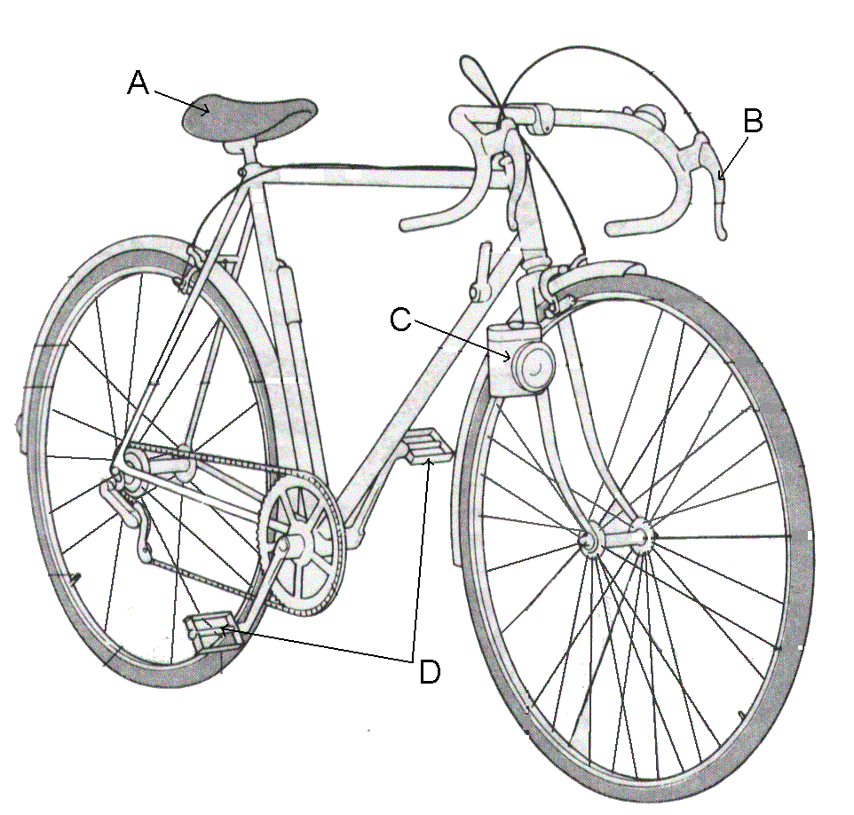

41. When you ride a bicycle, where do you put your feet?  feet: 腳
(A) A (B) B (C) C (D) D
42. When you want to stop your bicycle, what part do you want to use?
(A) A (B) B (C) C (D) D
(43~44)
林太太昨天在一家商店買東西，結帳後，她收到了一張統一發票：

中華民國94年5月1日
收銀機統一發票
(收執聯)
FB 79118642
倪財商號
NO: 71524683
TEL: 25624985
Good Taste Ice Cream
23 × 1 $ 23
Vegetable
12 × 3 $ 36
Milk
50 × 2 $ 100
Apple
10 × 6 $ 120
Rice
120 × 1 $ 120

Total: $ 399

Clerk No.: 35007579

- What number can Mrs. Lin use to call the store when she finds some problems with the milk?
(A) 79118642. (B) 71524683. (C) 25624985. (D) 35007579.  problem: 問題
- What kind of store did Miss Lin go?
(A) A supermarket. (B) A restaurant. (C) A book store. (D) A movie theater.
(45~47)
下週John班上即將畢業旅行，底下是他們班上的大致行程：
The first day:
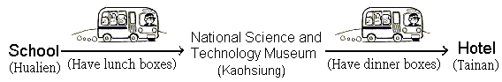

The second day:
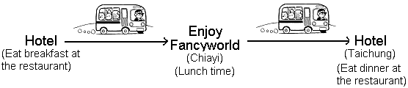

The third day:
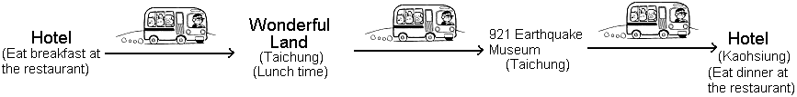

The fourth day:
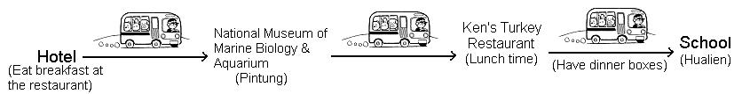

- How many museums will John’s class visit?
(A) Two. (B) Three. (C) Four. (D) Five.
- On which day will the students eat their lunch on the bus?
(A) The first. (B) The second. (C) The third. (D) The fourth.
- What is the right route John’s class will follow?  route: 路線
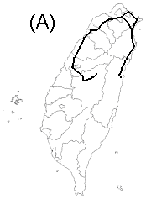 | 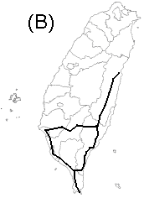 | 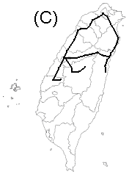 | 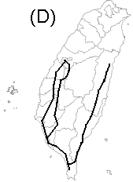

(48~50)
Some students are having their breakfast together in the classroom.
Huck: Our breakfast time again! Good food and good friends to talk to. This is why I like coming to school.
Amy: Don’t you talk with your family? We usually do our talking during the meals.  meal: 餐
Danny: He doesn’t have any brothers and sisters, and his parents don’t enjoy talking too much.
Amy: Hey, Helen, we both have hamburgers! Where did you get yours?
Helen: I got it at Mother Li’s Great Morning. The hamburgers there are really ambrosial.
Jeff: Helen is right. I have my breakfast there every weekend. Every time I go there, I always order a hamburger.
Danny: Last month, my uncle from Taipei came to my home, and I took him there to eat breakfast. He liked their hamburgers very much. He ate three in 5 minutes!
Amy: I’ll try it on Saturday. Where is it?
Helen: Go along Hualien Street to the Good Reader Bookstore, and you’ll find it on your right.

- What does the word ambrosial mean?
(A) Beautiful. (B) Delicious. (C) Expensive. (D) Convenient.
- Who never goes to Great Morning for breakfast?
(A) Helen. (B) Jeff. (C) Danny. (D) Amy.
- Which one is NOT true?
  - Danny’s uncle lives in Taipei.
  - Huck is the only child in his family.
  - Jeff likes Good Reader Bookstore’s hamburgers.
  - Amy will go to Mother Li’s store on Saturday morning.

