花蓮縣94年度國中七年級英語科基本能力檢核測驗
（ 總計50題，每題均為二分）
一、單選題
【字母】依大、小寫字母順序，選出在空格中應填入的字母？
1. H I ______ K L
(A) M (B) G (C) J (D) R
2. o p q s t u
(A) r (B) v (C) y (D) l
【文意字彙】
3. Coco: What are ______? Amy: They are my books.
(A) these (B) this (C) that (D) it
4. Sally is ______ a song now.  song: 歌曲
(A) swimming (B) singing (C) saying (D) studying
5. John is my uncle’s son. He is my ______.
(A) brother (B) sister (C) father (D) cousin
6. Sam: What do you like to ______? Peter: Milk tea, please.
(A) drink (B) drive (C) eat (D) do
7. Three and twelve are ______.
(A) thirteen (B) fourteen (C) fifteen (D) sixteen
8. He is ______ a bicycle.
(A) walking (B) doing (C) going (D) riding
9. The day after Wednesday is ______.
(A) Friday (B) Tuesday (C) Thursday (D) Saturday

【文法選擇】
10. I have a new friend, Sam. ______ is very tall.
(A) I (B) You (C) He (D) She
11. ______ John and Mark at school?
(A) Are (B) Is (C) Can (D) Do
12. Elva: Do you like milk tea? Cindy: Yes, I ______.
(A) am (B) like (C) do (D) can
13. Ken: ______ is the boy?
Jenny: He is my brother.
(A) How (B) What (C) Where (D) Who
14. There ______ flowers and trees in the park.
(A) have (B) has (C) is (D) are
15. Judy: Where is Joe?
Lisa: He is in the living room. He is ______ his homework.  homework: 家庭作業
(A) write (B) writes (C) writing
16. He has many brothers, but he ______ have any sisters.
(A) is not (B) can not (C) do not (D) does not
17. Mandy: Is your grandmother a teacher?
Jacky: Yes, ______ is.
(A) she (B) he (C) it (D) they
18. Judy and I play basketball ______ Sunday.
(A) in (B) on (C) at (D) under
19. John: What time is your English class today?
Sam: It’s _____ nine thirty-five.
(A) in (B) on (C) for (D) at
20. Tom: These two dictionaries are big _______ heavy.
Amy: Do you need help?  dictionary: 字典
Tom: Yes, please.
(A) so (B) and (C) but (D) or
21. John: This Saturday is David’s birthday. I buy a book for him.
Mary: ______ is it?
John: It’s eighty-nine dollars.
(A) How many (B) How tall (C) How much (D) How old
【對話】
22. Ted: ______! We are late for the math class.
Jane: OK.
(A) Thank you (B) Don’t worry (C) Excuse me (D) Hurry up
23. Jacky: What are you doing?
Lin: ______
(A) I have to go now. (B) I am reading a book.
(C) Park. How about you? (D) Oh, no. I am late.
24. John: Hello, Jason?
Sam: Hello?
John: Is this 856-4349?
Sam: Sorry. ______
(A) That’s a good telephone. (B) This is the living room.
(C) You’ve the wrong number. (D) We’re eating breakfast.
25. Tom & Amanda: Happy birthday! It’s for you!
Sam: Oh! A book! Thanks.
Tom & Amanda: ______
(A) You’re welcome. (B) Come on in. (C) It’s too bad. (D) Thank you very much.
二、整段式選擇：
(26-30)
- get: 得到 give: 給

Today is my birthday and I get many (26) . I get a dog from my parents. (27) name is Bo Bo. It’s very cute. My brother gives me a basketball and I like it very much. A letter is (28) my cousin, May. She is (29) the USA now. (30) the evening, my family and I eat a big cake. I have a very happy birthday.
26. (A) books (B) dogs (C) presents (D) cards
27. (A) My (B) Their (C) Your (D) Its
28. (A) to (B) for (C) from (D) at
29. (A) at (B) in (C) on (D) under
30. (A) At (B) In (C) On (D) Under

(31-35）
- hobby: 興趣 online: 線上 sometime: 改天

（在對話中使用適當的疑問詞)
阿雄是一個七年級的學生。某天放學後，他在MSN上跟一個剛認識的外國網友Andy聊天。
阿雄：Hello.
Andy：Hi. (31) are you?
阿雄：Fine, thank you.
Andy：Well, I am from the U.S.A. (32) are you from?
阿雄：I am from Taiwan.
Andy：Oh, I see. (33) are you?
阿雄：I am thirteen. And you?
Andy：I am fifteen. (34) is your hobby?
阿雄：I like playing computer games.
Andy：Me, too. We can play online games sometime.
阿雄：Good idea! (35) tomorrow?
Andy：OK. Goodbye.
阿雄：Bye.

31. (A) How (B) What (C) Where (D) Who
32. (A) Where (B) What (C) How (D) Who
33. (A) What time (B) How old (C) Where (D) How
34. (A) What (B) Where (C) How (D) Who
35. (A) What time (B) How old (C) What day (D) How about

三、閱讀測驗：
（36-37）
This is a desk.
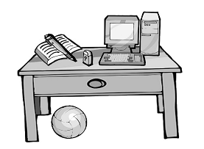
36. Where is the computer?
- It’s under the desk. (B) It’s on the desk. (C) It’s in the desk.
37. 根據上圖，哪一個敘述是對的？
(A) The book is on the pen. (B) The pen is in the desk.
- eraser: 橡皮擦
(C) The ball is under the desk. (D) The eraser is in the book.

（38-40）
哈囉，我是Sam，這是我的家族表，請根據圖表來回答下列問題！
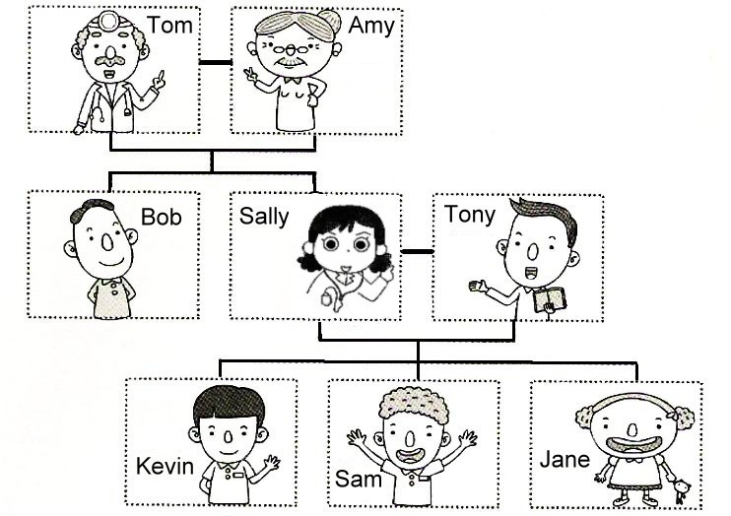
38. Sally is my ______. (A) mother (B) grandmother (C) sister (D) cousin
39. I am Jane’s ______. (A) father (B) brother (C) grandfather (D) sister
40. 根據上圖，哪一個敘述是錯的？
(A) Tom is Sally’s father. (B) Kevin and Jane are brother and sister.
(C) Tony is Kevin’s father. (D) Tony and Bob are brothers.

(41-43) 下列三個圖片分別是Tom, John和Sam每天的生活作息：
41. | 根據圖片（一）選出正確描述選項：  (A) He studies English 7:20.  (B) He watches TV at 7:20.  (C) He eats a cake at 7:20.  (D) He opens the door at 7:20. | 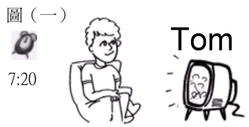
42. | 根據圖片（二）選出正確描述選項：  (A) John plays basketball at twelve.  (B) John has an English class at twelve.  (C) John eats lunch at twelve.  (D) John rides the bicycle at twelve. | 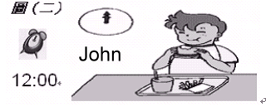
43. | 根據圖片（三）選出正確的描述選項：  (A) Sam opens the door at 6:30.  (B) Sam wakes up at 6:30.  (C) Sam goes to the movie at 6:30.  (D) Sam plays baseball at 6:30. | 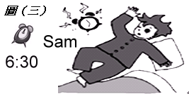

(44-46)
 | A | B | C | D
 | 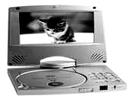 | 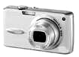 | 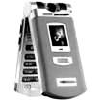 | 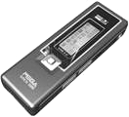
商品名稱 | DVD PLAYER | CAMERA | CELL PHONE | MP3 PLAYER
售價 | NT$ 15,000 | NT$ 9,000 | NT$ 11,000 | NT$ 3,000
照像功能 | ☹ | ☺ | ☺ | ☹
音樂功能 | ☺ | ☹ | ☺ | ☺
影片功能 | ☺ | ☹ | ☹ | ☹
3C 春季特價大拍賣 ☺: 有此功能 ☹: 無此功能
44. You want to see a movie on a DVD. What do you have to buy?
(A) A cell phone. (B) A DVD player. (C) An MP3 player. (D) A camera.
45. This weekend is John’s birthday. His friends, Tom and Susan, want to buy a present for him.
Now, they only have NT$ 3,200. What can they buy for John?  want to: 想要
(A) A cell phone. (B) A DVD player. (C) An MP3 player. (D) A camera
46. There is a beautiful girl in Class 712. You want to take pictures of her. What can you buy?
 take pictures: 照像
A
D
B
D
(A) and ( (B) and
D
B
C
C
(C) and (D) and

(47-50)
- often: 常常 test: 考試 on foot 走路

Hi, my name is Tony. There are four people in my family. My father, Sam, is forty years old. He is a doctor. My mother, Susan, is a teacher. She is thirty-five years old. My brother, Tom, is a student. I am a student, too. The school is near our home and we go to school on foot every day. On weekends, we often play basketball with our friends.
It’s six o’clock now. My dad is watching TV in the living room. My mom is cooking dinner in the kitchen. My brother is reading a book in his room. I am studying English in my bedroom. Our dog, A-fu, is sleeping under my desk. What a cute dog! I like it very much.

47. What is Tom doing?
(A) He is studying English. (B) He is reading a book.
(C) He is watching TV. (D) He is cooking dinner.
48. How do Tom and Tony go to school every day?
(A) They walk to school. (B) They go to school by bus.
(C) They ride a bike to school. (D) They go to school by MRT.
49. Where is A-fu?
(A) In the kitchen. (B) In the living room. (C) In the bathroom. (D) In Tony’s bedroom.
50. 根據上文，下列哪一個敘述是對的?

(A) Tom and Tony walk to school every day. (B) Tom and Tony play basketball every day.
(C) Sam is a teacher and he is 40. (D) Susan is a doctor and she is 35.

