高雄市立林園高級中學 國中部 100學年度 第 ㄧ 學期 一 年級 英語 科 第 一 次段考考卷
班級： 姓名： 座號：
- 聽力測驗 (30%)
- 選出聽到的句子或意思相近者。(10%)
- ( ) (A) Hello. (B) Good.
- ( ) (A) Good evening. (B) Bye.
- ( ) (A) He is William. (B) She is Wendy.
- ( ) (A) The number is 119. (B) The number is 911.
- ( ) (A) You’re not Jack. (B)Your name is Jack.
- 勾選聽到的圖片。(10%)
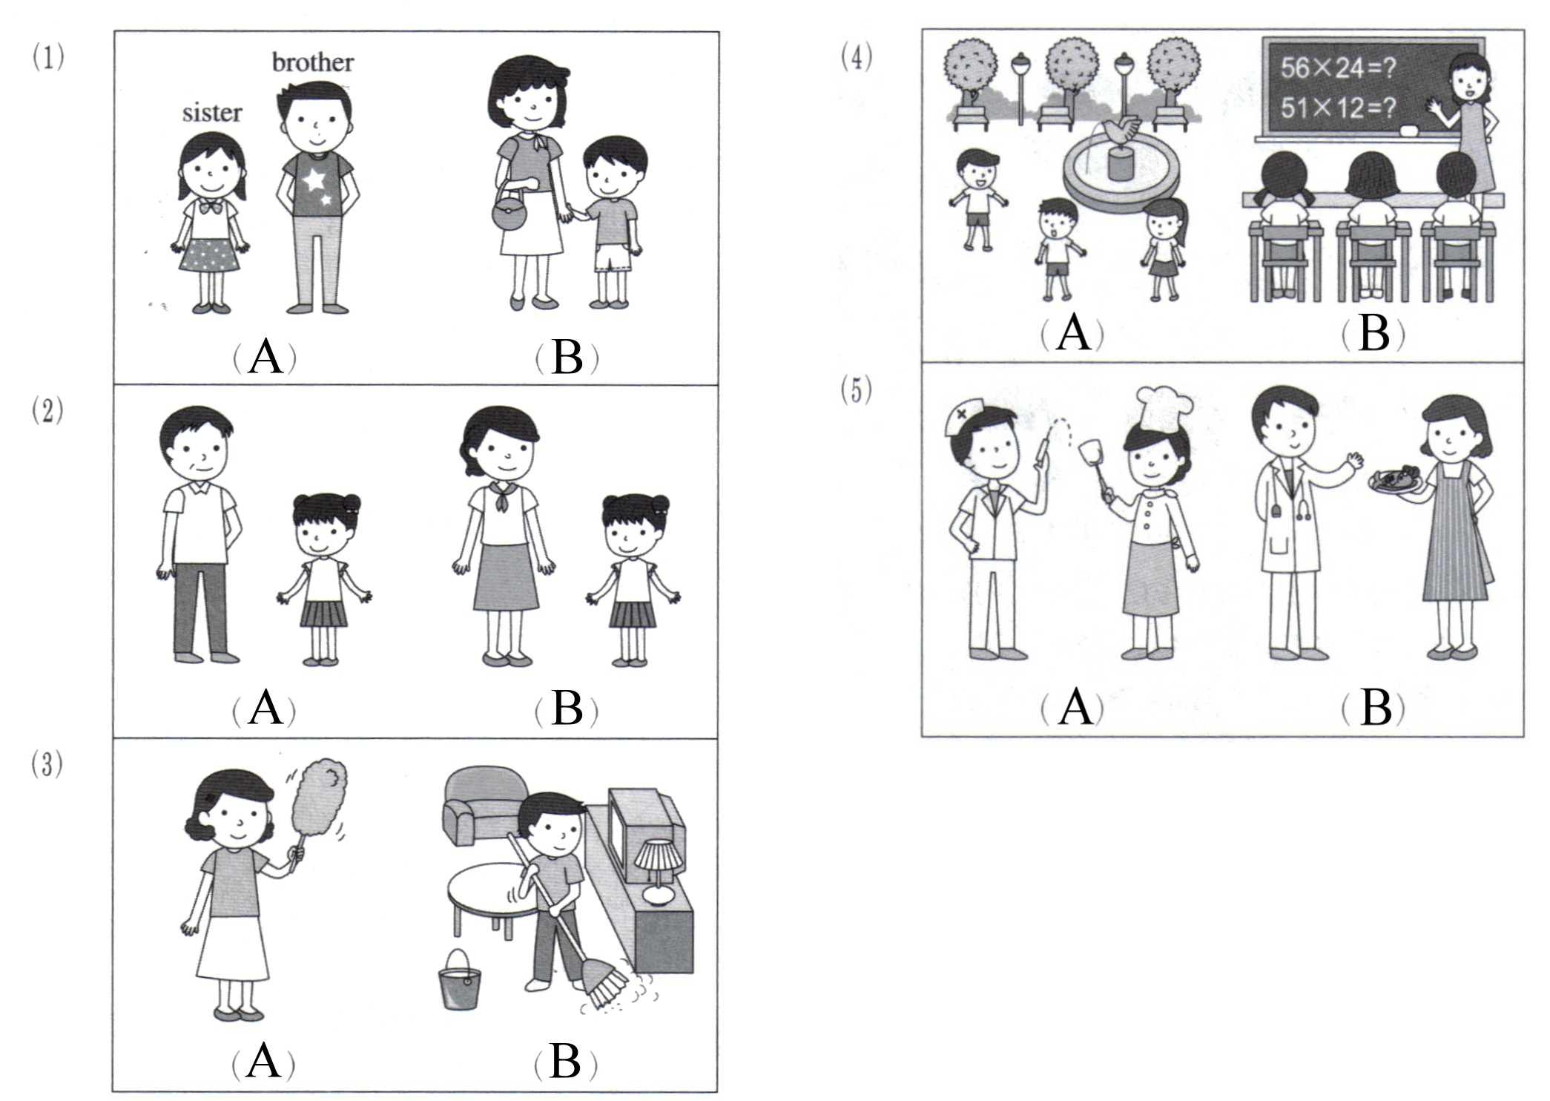
- 根據對話內容，正確的寫T，錯誤的寫F。(10%)
1. ( ) Ben is 12.
2. ( ) Tom’s sister is fine.
3. ( ) Mike’s new bike is blue.
4. ( ) The cat is big and beautiful.
5. ( ) Andy’s scooter is yellow, not red.

- 筆試 (70%)
- 文意字彙 (10%)
1. ( ) That’s a nice and p y scooter.
2. ( ) The little girl is very h y. She wants(想要) to eat ten hamburgers(漢堡).
3. ( ) Patty’s mom is a h fe.
4. ( ) Look at the p re! They are my friends, Amy and Emma.
5. ( ) Alice is beautiful, not u y.
- 文法與對話選擇 (10%)
1. ( ) Tom: How old ____ you? Ivy: I’m thirteen.
(A) is (B) are (C) am (D)X
2. ( ) Tom: What’s William’s phone number? Joe:______ phone number is 333-1234.
(A)He (B) Her (C) My (D)His
3. ( ) Tom: Is she your sister? Patty: ______. She’s my cousin, Amy.
(A) No, she is. (B) Yes, he is. (C) No, she isn’t. (D) Yes, she isn’t.
4. ( ) Tom: Is Miss Lin a nurse? Emma: No, she’s not. She’s a ______.
(A) aunt (B) doctor (C) cooks (D) old teacher
5. ( ) Fred is _____ student.
(A) my mother (B) your mother (C) mother (D)my mother’s
- 克漏字選擇 (10%)
Hello. My name is David. I’m twelve 1. . This is 2. cat, Mimi. 3. one year old. Mimi is 4. young cat. Mimi’s very 5. , and I am happy, too.
1. ( ) (A) year (B) old (C) years old (D) year old
2. ( ) (A) it (B) he (C) my (D) two
3. ( ) (A) She’s (B) He (C)Its (D) You’re
4. ( ) (A) an (B) a (C) X (D) not
5. ( ) (A) sad (B) happy (C) bad (D) yellow
- 根據此家族樹圖(family tree)，寫出相對應的親屬稱謂 (8%)
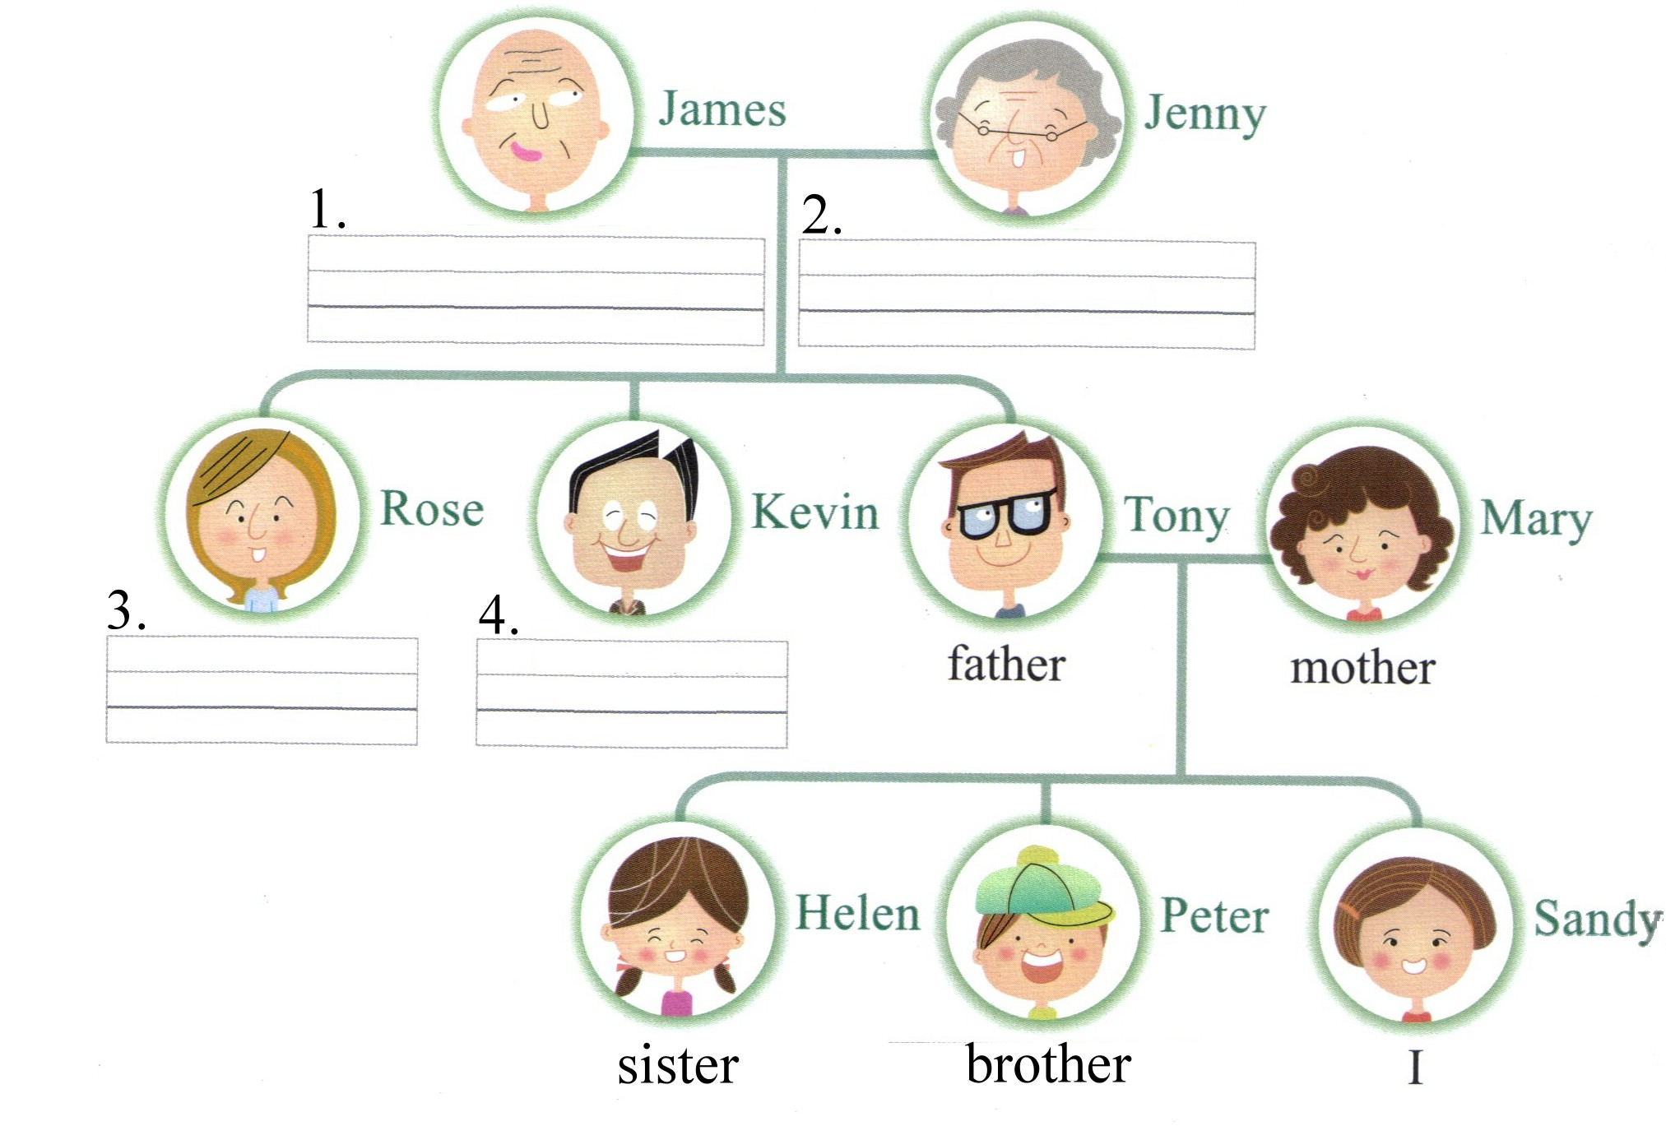
- 依提示作答 (16%，每題4分，錯一字或一標點符號皆扣一分)
- Alex is tall. Alex is strong. (將兩句合併成一句)
- Is Miss Chen a beautiful teacher? (用No詳答)
- Is David a young doctor? (用Yes詳答)
- her NAME is snow white. (將錯誤之處改正後，寫出正確的句子)
- 翻譯 (16%，每題4分，錯一字或一標點符號皆扣一分)
- Momotaro的父母很老。
- Ken是一隻肥貓。
- 我的爸爸44歲。(數字用英文書寫)
- 她的媽媽也是歌手。
一年級 英語 科 答案欄 （年級、科目請標示清楚，謝謝！）
聽力測驗
一、A B A B B
二、A B A B A
三、F T T F F
筆試
一、1.pretty 2.hungry 3.housewife 4.picture 5.ugly
二、B D C B D
三、C C A B B
四、1.grandfather 2.grandmother 3.aunt 4.uncle
五、1. Alex is tall and strong.
2. No, she isn’t a beautiful teacher.
3. Yes, he is a young doctor.
4. Her name is Snow White.

六、1. Momotaro’s parents are old.
2. Ken is a fat cat.
3. My father is forty-four (years old).
4. Her mother is a singer, too.

