高雄市立林園高級中學 國中部 100學年度 第 ㄧ 學期 一 年級 英語 科 第 二 次段考考卷
班級： 姓名： 座號：
_____________________________________________________________________________________________________
壹、Listening (共30分/每格2分)

0一.聽到的內容與圖片相符者打○，不符者打╳。
((  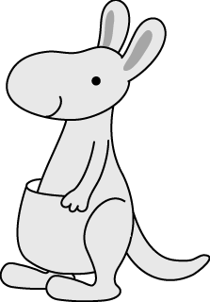  1. ( ) | (  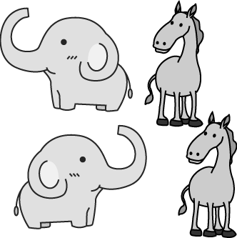  2. ( ) | 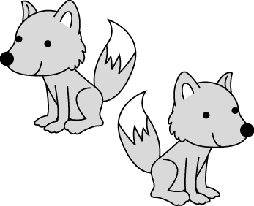  3. ( ) | 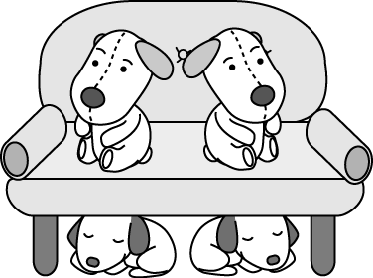  4. ( ) | 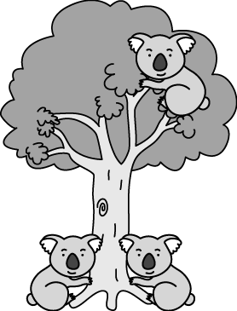  5. ( )

0二. 選出適當的答句。
（ ）(１)(Ａ) It’s not a picture. (Ｂ) Those are erasers. (Ｃ) A book bag.
（ ）(２)(Ａ) Yes, it’s for Dad. (Ｂ) No. It’s for Mom. (Ｃ) No. It’s for you.
（ ）(３)(Ａ) Guess! (Ｂ) Really? (Ｃ) It’s a box.
（ ）(４)(Ａ) No, it isn’t. (Ｂ) Yes, that’s an eraser. (Ｃ) No. It’s a ruler.
（ ）(５)(Ａ) That’s right! (Ｂ) Thank you very much. (Ｃ) Is it a card?

三. 根據圖片與聽到的問題，選出正確的答案。

(１)  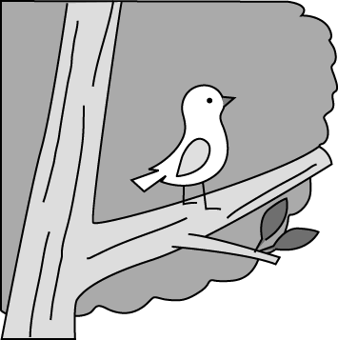 | (２)  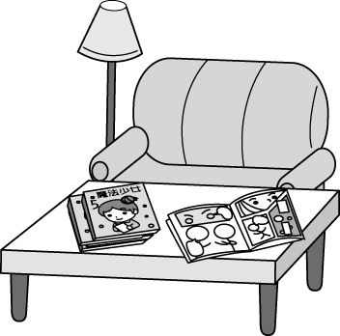 | (３)  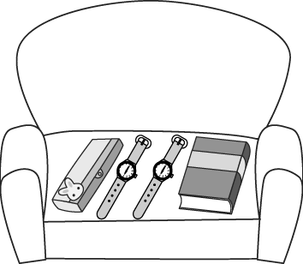 | (４)  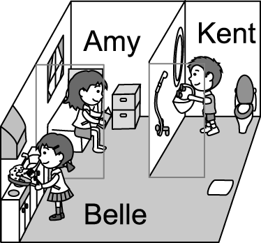 | (５)  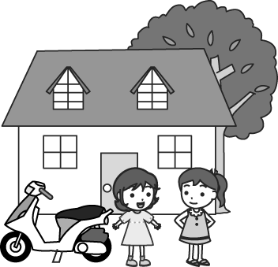

貳. Reading / Writing

一. 選出與另外二個不同性質或詞類的字(5%)
( )1. (A) lion (B) hippo (C) any
( )2. (A) sofa (B) cake (C) chair
( )3. (A) under (B) from (C) bed
( )4. (A) guess (B) brush (C) marker
( )5. (A) animal (B) many (C) some

二.選擇(20%)
( )1. Are they _____?
- brushs (B) housewifes (C) kangaroos (D) toies
( )2. A: Are these your workbooks? B: No, ____.
- they are (B) these aren’t (C) it’s not (D) they are Sam’s
( )3.A: ______? B: He is in the bedroom.
- Where is Ben? (B) Who is in the bedroom? (C) How is he? (D) Is Jack in the bedroom?
( )4.Are there ______ apples on the dining table?
- the (B) any (C) an (D) some
( )5.A: Is there a comic book in your school bag? B: ______.
- Yes, there is (B) Yes, they are (C) No, it isn’t (D) No, I’m not
( )6. _____ the zoo, we can see many different(不同的) animals.
(A)For (B) Behind (C) At (D) To
( )7. The red box is under the white box.
(A) The white box is on the red box. (B) The white box is behind the red box.
( )8. 選出劃線處發音與其他三個不同的
(A) these (B) three (C) teacher (D) set
( )9. 選出正確的句子
(A) There’s little bear in the picture. (B) There are two elephants in Taipei Zoo now.
(C) Formosan black bear are big and beautiful. (D) Bears are many girl’s favorite animals.
( )10. 選出正確的句子
(A) Jane’s parents buy(買) a pencil case for her. The pencil case is from Jane.
(B) Jacky has a gift from his father. The gift is for Jacky.
(C) On my birthday, my son gives(給) me a bag. The bag is a birthday gift for my son.

三. 課文克漏字(8 %)
(一)
John: 1 that over there?
Patty: It’s a guinea pig.
John: It’s very cute.
Patty: Yes, it is. Look! There are 2 rabbits here.
John: They are cute, too. Hey! Are there any koalas here?
Patty: No, there aren’t. 3 in the koala house.
(At the koala house)
Patty: There are many koalas 4 here.
John: One, two, three…six! Are there six koalas in the koala house?
Patty: No. There are seven.
John: Seven?
Patty: Look over there! There’s a small koala 5 Molly’s back.
( )1. (A)What (B) What’s (C) Who
(D) Who’s
( )2. (A) one (B) a (C) any (D) some
( )3. (A) There’s (B) There are (C) They
(D) They’re
( )4. (A) in (B) to (C) on (D) X
( )5. (A) in (B) to (C) on (D) X

(二)
1 my birthday today. I’m nine years old. Look at my birthday gifts. This watch is from my parents. That pencil case is from my sister. Those cute notebooks __2 from my cousin. They are 3 nice gifts.
( )1. (A) That’s (B) This (C) It’s (D) Today
( )2. (A) is (B) am (C) are (D) X
( )3. (A) very (B) really (C) fine (D) X (選錯的)

四. 閱讀測驗(12%)
(一)
Mom: Eddie, I’m home. Are you in?
Eddie: Yes, Mom. Welcome home. How are Grandpa and Grandma?
Mom: They are fine. And the cake is for you.
Eddie: Thanks, Mom.
Mom: Your grandma made(做) it for you. Where’s your father?
Eddie: Isn’t he in the living room?
Mom: No, he’s not there. Maybe he’s in the bathroom. Hey, no TV. Do your
homework.
Eddie: But I have no homework today.

( )1. Who is the cake from? (A) Eddie’s mom (B) Eddie’s grandma (C) Eddie’s dad (D) Eddie’s grandpa
( )2. What is “there”? (A) The living room. (B) The bathroom. (C) The house. (D) Grandpa’s home.
( )3. Which is true?(何者正確)
(A) Eddie’s mom is not home today. (B) Eddie’s father is not home today.
(C) Eddie’s doesn’t have any homework today. (D) Eddie’s grandparents live with(一起住) Eddie.

(二)

( )1. Which animals are not in Shou-shan Zoo?
- Brown Bears. (B) Zebras. (C) Giraffes. (D) Hippos.
( )2. Are there any kangaroos in Shou-shan Zoo?
(A) No, there aren’t any. (B) Yes, there are thirty-six.
(C) Yes, there are eighteen. (D) No, there are many.
( )3. Which is true(真實的) about the animals in the zoo?
(A) There are three hundred(百) animals in the zoo.
(B) There are twenty black bears and fifteen zebras.
(C) There are forty-four lions and thirty hippos.
(D) There aren’t any elephants in the zoo.

五. 依提示作答(10%)
- Is that a brush?(肯定簡答)______________________________________________________________________
- Are they your workbooks?(改為單數句)___________________________________________________________
- The glasses are on the table.(依劃線部分造原問句)__________________________________________________
- There aren’t any foxes in Taipei Zoo.(改成肯定句)___________________________________________________
- No, there aren’t any erasers in my pencil case.(造原問句)______________________________________________

六. 翻譯(15%)
1. 我最喜歡的玩具在那裡。_______________________________________________________________________
2. 這是毛筆，那是彩色筆。_______________________________________________________________________
3. A: 那些是她的家人嗎？ B: 沒錯！______________________________________________________________
4. 白球在箱子前面。_____________________________________________________________________________
5. A: 你頭上的那個是什麼？ B: 我的生日禮物！____________________________________________________

高雄市立林園高級中學 國中部 100學年度第 ㄧ 學期一 年級 英語科 第二次段考答案卷
班級： 姓名： 座號：

壹、Listening (共30分/每格2分)
0一.聽到的內容與圖片相符者打○，不符者打╳。
1. | 2. | 3. | 4. | 5.

0二. 選出適當的答句。
1. | 2. | 3. | 4. | 5.

三. 根據圖片與聽到的問題，選出正確的答案。
1. | 2. | 3. | 4. | 5.

貳. Reading / Writing
一. 選出與另外二個不同性質或詞類的字(5%)
1. | 2. | 3. | 4. | 5.
二.選擇(20%)
1. | 2. | 3. | 4. | 5.
6. | 7. | 8. | 9. | 10.
三. 課文克漏字(8 %)
(一)1. | 2. | 3. | 4. | 5.
(二)1. | 2. | 3.
四. 閱讀測驗(12%)
(一)1. | 2. | 3.
(二)1. | 2. | 3.

五. 依提示作答(10%)
1.
2.
3.
4.
5.

六. 翻譯(15%)
1.
2.
3.
4.
5.

