林園高中國中部一年級100學年度第一學期英文科第三次段考
年級： 班級： 姓名： 座號：
Part 1 聽力測驗 ( 每一題2分，共30分 )
第一題到第五題，請選出聽到的句子：
( ) 1. (A)Look at the teacher. (B)Listen to the teacher. (C) Write to the teacher.
( ) 2. (A) Meg is studying in her room. (B) Many students are in her room. (C) Maybe she is in her room.
( ) 3. (A)Be quiet. (B)Please wait. (C) Be good.
( ) 4. (A)His birthday party is on Saturday. (B)His welcome party is on Thursday. (C) Christmas party is on Thursday.
( ) 5. (A)It’s six o’clock. It’s time for the ball game.
(B)It’s six thirty. It’s time for the party.
(C)It’s six thirty. It’s time to watch the ball game.
第六題到第十題，請依照對話，回答問題：
( ) 6. (A)Yes, there are five. (B)No. There are four. (C)No. There are three.
( ) 7. (A)No. He is reading in his room. (B)Yes, he is talking with his grandpa. (C)No. He is talking with his friends.
( ) 8. (A)It’s Sunday. (B)It’s Saturday. (C)It’s Thursday.
( ) 9. (A) She is making cookies. (B) She is singing. (C)She is roasting a turkey.
( ) 10. (A) Amy (B)Meg (C) Patty
第十一題到第十五題，請根據圖片與聽到的問題，選出正確的答案。每一題播出兩遍。
( )11  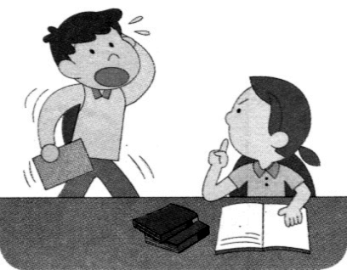 | ( )12  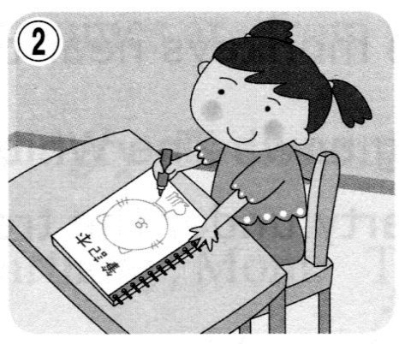 | ( )13  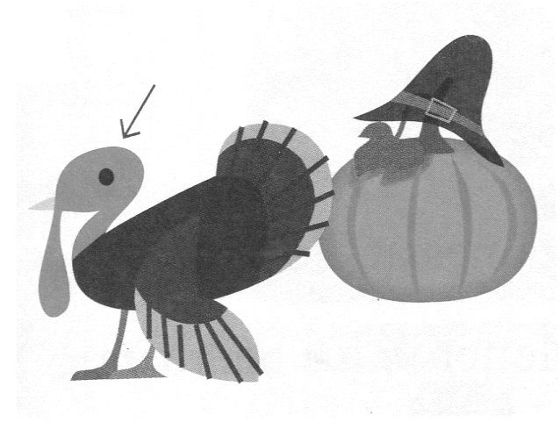 | ( )14  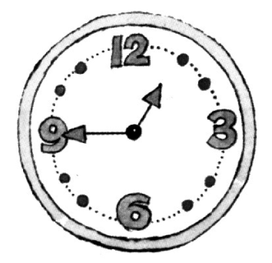 | ( )15  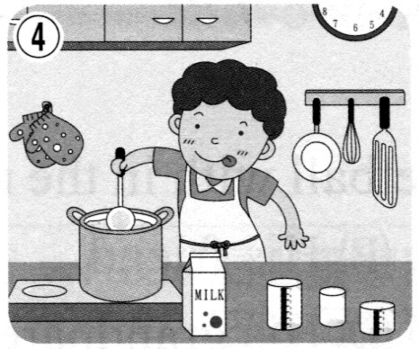
聽力測驗結束，請繼續以下非聽力測驗。

Part 2 非聽力測驗 ( 每一題2分，共70分 )
( ) 16. At the concert, there are many girls “Billy! Billy!”
(A)shout (B)shouting (C)talk (D)talking
( ) 17. Nick: Let’s to the museum! Jacky: Wait! I’m my homework now.
(A)go; doing (B)going; do (C)go; do (D)going; doing
( ) 18. is Thursday .
(A)Today; today (B)Today; it (C)It; today (D)It; now
( ) 19. Don’t on the bus, Ellen. You will(將會) make the bus dirty.
(A)letter (B)laugh (C)litter (D)later
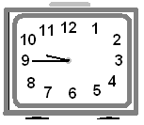
( ) 20. Girls, let’s our hands and sing songs together.
(A)wave (B)week (C)with (D)work
( ) 21. Mom, I’m hungry. Is dinner(晚餐) ?
(A) busy (B) ready (C) dirty (D) free
( ) 22. Look at the clock. What time is it?
(A)It’s fifteen after nine. (B)It’s fifteen to nine. (C)It’s a quarter to ten. (D)It’s half past nine.
( ) 23. Don’t the dog, Meg. It is dangerous(危險的).
(A)fight (B)shout (C)touch (D)wait
( ) 24. 選出錯誤的句子。
(A)Wendy, please put away the box. (B)Wendy, put away the box, please.
(C)Please put away the box, Wendy. (D)Put away the box, please, Wendy.
( ) 25. nice to your family and friends.
(A)Be (B)To (C)Don’t (D)Go
( ) 26. Allen: What’s Amy doing? Billy: She’s a turkey in the kitchen.
(A)running (B)roasting (C)ruling (D)using
( ) 27. Paul: Where is David? John: In the living room. his cellphone.
(A)He’s shout at (B)He’s puting (C)He’s makeing (D)He’s using

( ) 28. Patty: What your uncle doing? Meg: He is dancing Aunt.
(A) are; to (B)are; for (C) is; and (D) is; with
( ) 29. Mom’s birthday is coming. Sally and I making a birthday card and cookies Mom.
(A)am; to (B)am; for (C)are; to (D)are; for
( ) 30. Rita: Hey, my family are going to Japan for winter vacation(寒假). Andy:
(A)Let’s go. (B)Have a good time. (C)I see. (D)That’s right.
( ) 31. Henry: Ron: It’s Friday.
(A)What day is today? (B)What time is it? (C)What is it? (D)What time is the concert?
( ) 32. Jack: Are you free now? Rose:
(A) Yes, you are free now. (B) No. I am free. (C)Yes, I have time. (D)No. You are busy.
( ) 33. Teacher: Boys and girls, we are in the museum. shout, fight run in here.
(A)Please don’t; or (B)Please don’t; and (C)Don’t please; or (D)Don’t please; and
( ) 34. Mr. Chen: Amy, don’t watch TV. Amy: But this program(節目) is very good.
(A) Nice to meet you. (B)Do your homework. (C)Have a good time (D)No, sir.
( ) 35. Kenny: What are you doing, Joe? Joe: Going to school. Kenny: Why? Today is .
(A)Monday (B) Thursday (C)Friday (D)Saturday
( ) 36. Kevin: How about going to the concert Saturday morning? Chris: Great.
(A)on (B)at (C)in (D)from
( ) 37. Tina: What time is the Christmas party? Harry: It is seven o’clock.
(A)at (B)on (C)× (D)in
( ) 38. Mom: Patty, dinner is ready. Please Patty: OK.
(A) be quiet. (B) do your homework. (C) set the table. (D) wait a minute.

39 ~41

Read Jeff and Betty’s class schedule and answer the questions.
Course | Time | Days | Room
History | 9:00 ~ 10:00 | Mon. and Tue. | 120
Music | 11:00 ~ 12:00 | Mon. and Wed. and Fri. | 235
Art | 9:00 ~ 11:00 | Wed. and Thur. | 227
Math | 8:00 ~ 9:00 | Tue. and Wed. and Thru. | 314
French | 13:00 ~ 15:00 | Fri. | 215
English | 15:00 ~ 16:00 | Mon. ~ Fri. | 521

( ) 39. Jeff is in Room 215 now. What day is it?
(A) Monday. (B) Tuesday. (C) Wednesday. (D) Friday.
( ) 40. Betty is in Room 235. What day isn’t it?
(A) Monday. (B) Tuesday. (C) Wednesday (D) Friday.
( ) 41. Today is Wednesday and it is 9:30. What class do Jeff and Betty have?
(A) Math. (B) Music. (C) English. (D)Art
42 ~ 44
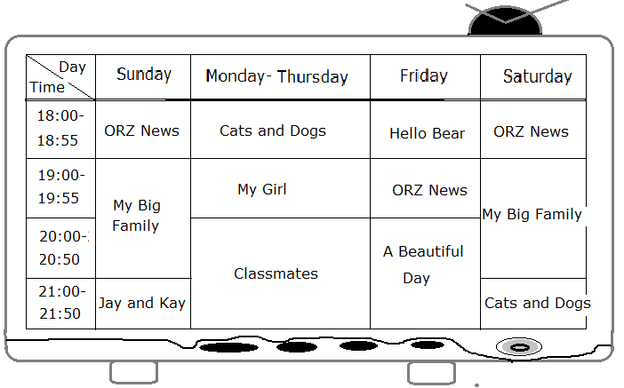

( ) 42. It’s nine thirty in the evening. “ Classmates” is on TV. What day is today?
(A) Monday. (B) Sunday. (C) Friday. (D) Saturday.
( ) 43. It’s 7:15 on Friday evening. What’s on TV?
(A) My Big Family. (B) Classmates. (C) ORZ News. (D) Cats and Dogs.
( ) 44. Today is Sunday. It’s 7:45 in the evening. What’s on TV now?
(A)Hello Bear. (B) My Big Family. (C) Jay and Kay. (D) Cats and Dogs.

45 ~ 47
It is morning now. Harry White is at the park. He is playing basketball with his friend, Ron Brown. Harry’s sister, Mary, is singing and dancing with her grandpa.
It is afternoon. Harry and his family are on a farm. There are many pretty farm animals. Mary is playing with some rabbits, and Harry is riding a horse. Their parents are sitting and talking under a big tree, and their grandparents are feeding the monkeys near the tree.
It is evening now. The White family is at home. They are having a party under the tree behind their house. They are very happy.
Feed 餵
( ) 45. Who is Harry playing basketball with in the morning?
(A)His sister. (B)His friend. (C)His parents. (D)His grandparents.
( ) 46. Where is Harry riding a horse?
(A)In the zoo. (B)On the farm. (C)Under a big tree. (D)Behind their house.
( ) 47. What is Harry’s father doing on the farm?
(A)He is having a party with his family. (B)He is singing and dancing with Mary.
(C)He is feeding the animals with his parents. (D)He is sitting under a tree and talking to his wife.

48 ~ 50
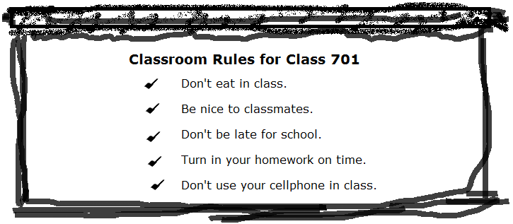
( ) 48. There are rules in Class 701.
(A) four (B)five (C)six (D)seven
( ) 49. Teacher: Don’t . Students: OK.
(A) be nice (B) follow the rules (C) use your cellphone (D) turn in your homework.
( ) 50. Which is NOT a rule in Class 701?
(A) Don’t do your homework in class. (B)Don’t be late for school.
(C)Don’t talk on a cellphone in class. (D) Don’t eat in Class.

錄音稿
第一題到第五題，請選出聽到的句子：
1. Listen to the teacher.
2. Meg is studying in her room.
3. Be quiet.
4. Christmas party is on Thursday.
5. It’s six thirty. It’s time to watch the ball game.
第六題到第十題，請依照對話及問題，選出正確的答案：
第六題：
Teacher: Hey, listen to me. There are some rules for you. Don’t eat, don’t run, don’t shout, and don’t fight in the classroom.
Students: OK! Teacher Dylan.
Teacher: Good! Now, open your books, please.
Question: Are there five rules for the students?
第七題：
Grandson: What are you doing, Grandpa?
Grandpa: I’m reading a book.
Grandson: How about Chuck? Is he at home?
Grandpa: Yes. He’s talking with his friends in the living room.
Question: Is Chuck talking with his grandpa in the living room?
第八題：
Patty: Let’s go to the museum today. OK?
Meg: Isn’t it Friday?
Patty: No. It’s Saturday today.
Meg: Oh, Yes. Let’s go now.
Question: What day is it today?
第九題：
Meg：What are you doing, Mom?
Mom: I’m roasting a turkey.
Meg: What are you doing, Grandpa?
Grandpa: I am making Christmas cookies. Come here and make cookies with me.
Question: What is Mom doing?
第十題
Meg: Amy, are you writing a letter?
Amy: No, Meg. I’m making a Christmas card.
Meg: Wow, Amy! It’s pretty. Who is it for?
Amy: It is for Patty.
Question: Who is making a Christmas card for Patty?
第十一題到第十五題，請根據圖片與聽到的問題，選出正確的答案。每一題播出兩遍。
( 11 ) | ( 12 ) | ( 13 ) | ( 14 ) | ( 15 )
( ) 11. Look at the picture. What is the girl talking to the boy? (A)Don’t fight. (B)Don’t run. (C) Be quiet.
( ) 12. Look at the picture. What is the student doing?
(A)She is doing her homework. (B)She is making cookies. (C) She is setting the table.
( ) 13. What is it in the picture? (A)It’s a cellphone. (B)It is a turkey. (C)It’s a monkey.
( ) 14. What time is it? (A)It’s a quarter to one. (B)It’s one forty-nine. (C) It’s twelve to nine.
( ) 15. Is your mother cleaning the kitchen? (A)Yes, she’s cleaning the kitchen. (B)No, she is not. (C)No, she is roasting a turkey.

聽力測驗結束，請繼續以下紙筆測驗

