高雄市立林園高級中學 國中部 100學年度 第 ㄧ 學期 二 年級 英文 科 第 一 次段考考卷
班級： 姓名： 座號：
聽力測驗
一、看圖作答 聽CD，根據圖片選出問題的答案。
A. 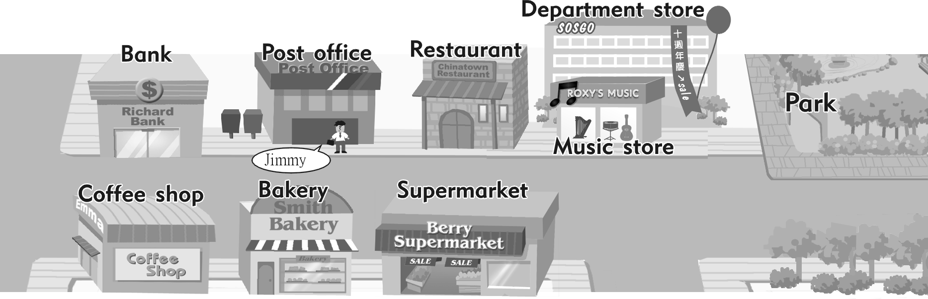B. 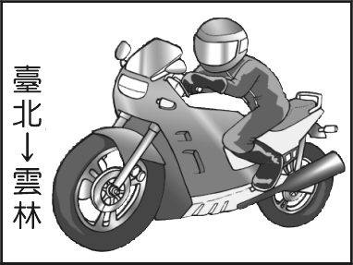 . 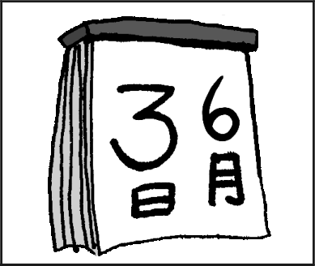
C. 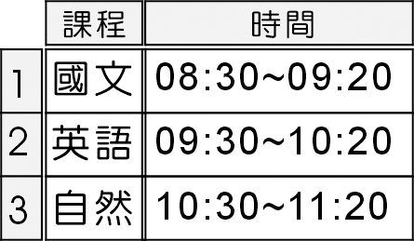
二、聽CD的問題，選出最適當的回應
6. (A) Yes, it will. (B) On September first.
(C) I won’t be there. (D) Last Tuesday.
7. (A) It’s under the elephant. Be careful!
(B) It’s behind the big supermarket. You have to turn left at the corner of Second Street and Third Street.
(C) It’s across from the class 202. You can see teachers there.
(D) Jo Jo’s Music Store is between the Car Museum and Lai Lai Hospital.
8. (A) It rained a lot. (B) It’s going to rain.
(C) It was hot. (D) It’s raining.
9. (A) I didn’t take the bus. I took the train.
(B) The train ticket costs NT$465.
(C) I won’t buy the ticket on the Internet.
(D) I’ll go there in David’s car.
10. (A) At the coffee shop. (B) Her brother. (C) English. (D) No, she isn’t.
三、對話測驗 聽完對話或敘述後，根據問題選出最適當的答案。
11.(A) At the Warner Theater. (B) At the Sogo Theater. (C) At the Second Theater.
(D) On the corner of the Second Street.
12.(A)Chicken. (B)Vegetables. (C)Moon cakes. (D)Beef.
13.(A)It will be at 12 at night. (B)It’ll be 7 in the morning. (C)It’ll be 12 p.m. (D) It will be 6.a.m.
14-15.（請看下圖）
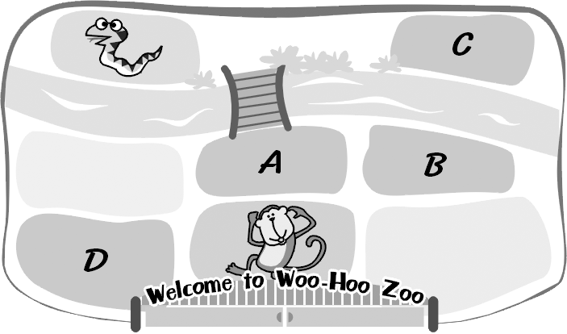
14.
(A) 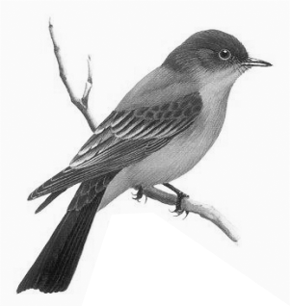 (B)  (C)  (D) 
15.(A)C (B)B (C)D (D)A
筆試試題
四、對話測驗（配分：5 分）
    - Mary: How did you go to your uncle’s house?
Andy:
(A) Twice a week. (B) By MRT. (C) Not always. (D) It looks old.
    - Andy: When will Dad come back?
Mrs. Wells:
(A) At 10:00 p.m. (B) Maybe last Sunday. (C) He called us this morning. (D) He goes to work at 8:00 a.m.
    - Jane: Stop!
George: Oh, I’m sorry! I didn’t see it.
(A) Go along this street and turn left. (B) The traffic light is red!
(C) Turn right at the traffic light. (D) Walk for two blocks and then turn right.
    - Nancy: How do you feel?
Lex:
(A) Yes, I feel good. (B) You look happy . (C) I want to be happy. (D)A little tired.
5.( ) Jack: How often do you go shopping?
Sophy:
(A) I have to wait a bus for a long time. (B) Once a week. (C) With my mom. (D) It’s fun.
五、看圖作答，從答案欄中選出最適當之答案代號填入答案格中。（配分：10 分）
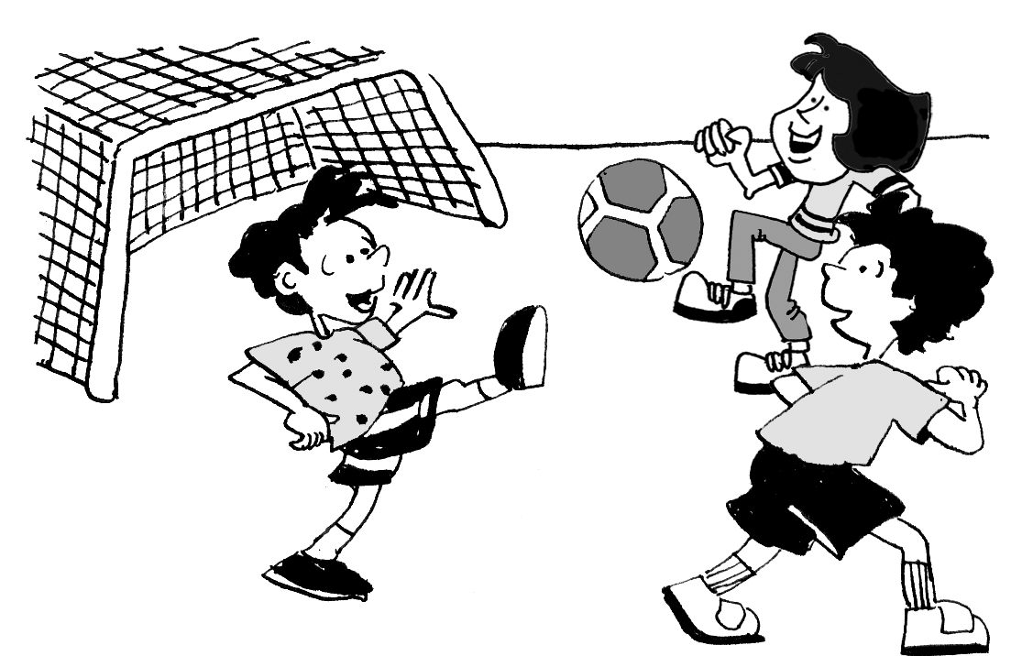 1. What are the boys going to do?
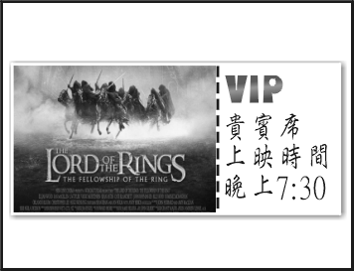 2.What time is the movie going to start?
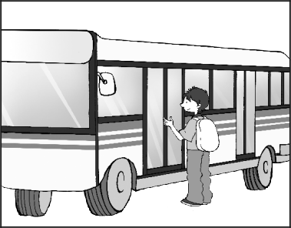 3.How does the student go to school?
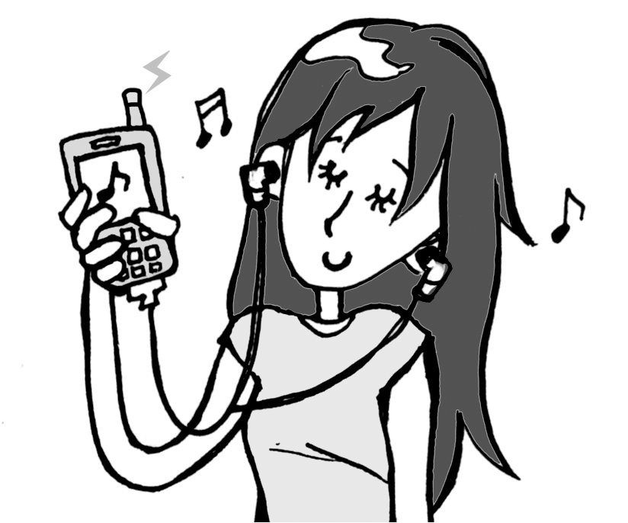 4.Does Mary listen to music on the radio?
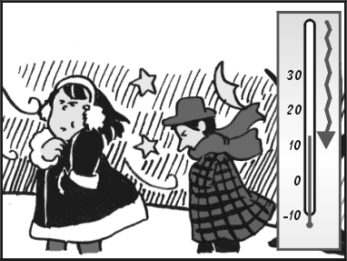 5.How’s the weather?
看圖作答之答案欄
(A) It’s getting rainy and cold. (B) He goes to school by train. (C)Yes, she listens to it on the phone. (D) It’s getting hot. (E) They are going to play soccer. (F) He goes to school by bus (G)They are going to play baseball. (H) No, she listens to it on the cellphone. (I) It’s going to start at seven in the morning. (J) It’s going to start at seven thirty in the evening
六、閱讀測驗（配分：10 分）
A.
Max: Are you going to cook?
Ken: Yes, I am. What do you want to eat?
Max: What do we have in the refrigerator? Do we have any cheese or pork?
Ken: No, we don’t have “any”! But we have a lot of vegetables.
Max: No, I don’t like vegetables. Do we have any fruit?
Ken: Yes, we have many apples.
Max: Great, I want an apple pie.
pie 派
( ) 1. What does “any” mean?
(A) apples (B) cheese or pork (C) vegetables (D) cheese or apples
( ) 2. Which is true?
(A) There isn’t pork in the refrigerator. (B) There are a lot of vegetables on the table.
(C) Max likes to eat vegetables. (D) Max is going to cook.
B.
( Amy got four voice mails. Please read them and answer the questions. )
 Hello, this is Kay. Will you play tennis with us on the court on Park Road tonight? Peter, Jim and I will be there at half past seven.
 Hey, it’s Lily Smith. I didn’t get your Chinese report. Please mail it again before 7 o’clock, or you will get zero this time. Thanks.
 This is Marcy’s Restaurant. Happy birthday! Come to our restaurant tonight, and you can get a free dinner tonight. Bring your friend to have dinner with you, and she/he has to pay just NT$100. Please call 07-6664512. Thank you very much.
 Amy, this is Mom. Don’t talk on the phone too long at night. I don’t want to see you still on the phone when I come home.
voice mail 語音留言 report 報告 or 否則 pay 付 when 當
( ) 3. Who probably is Lily Smith? probably 可能
(A) She isAmy’s parent. (B) She is Amy’s friend on the Internet.
(C) She is Amy’s sister. (D) She is Amy’s Chinese teacher.
( ) 4. Which is true?（何者為真？）
(A) Amy can get a special price if she has dinner at the restaurant tonight. if 如果
(B) Amy seldom talks on the phone at night. (C) Today is Amy’s boyfriend’s birthday (D) Amy has to mail the report and then she can play tennis with her friends.
C.
Join Our Basketball Team!

When? Next Monday
Where? The gym
Who? Anyone can give it a shot if you like basketball
and join us
How? Sign up and try out for the team; if you are
good enough, you’ll make the team
Why? Because it’s the best sport!

If you have any questions, please contact Mike Russo or Jeremy Kendall:

Mike Russo: Jeremy Kendall
0910666512 TEL: (07) 355-2190
mrusso@hotmail.com FAX: (07) 355-2687
 anyone 任何人 if 如果 sign up 登記 try out 參與選拔
best 最佳的 contact 聯絡 fax 傳真

( ) 5. If you have some questions, how can you contact them by computer?
(A) At (07) 355-2687. (B) At the gym.
(C) At mrusso@hotmail.com. (D) At 0910666512.
( ) 6. What does“give it a shot”probably mean?  probably 可能地 mean 意指
(A) You can play basketball every day.
(B) You can try to be on the team.  try 嘗試
(C) You can become thin.
(D) You can have fun with the players.

D.
Julia: Can you go to that new bookstore with me?
I need a notebook.
Liz: Now? It's too early. Today is Saturday.
There is still two hours before it opens.
Julia: Oh! I forgot. Then, what about going to
Star’s? I'm a little thirsty.
Liz: It's far from here. Let’s go to my cousin’s
house. I’ll make some good tea for you.
The tea is from Mt. A-li. And my cousin, Susan,
is a good baker; she is making lots of different
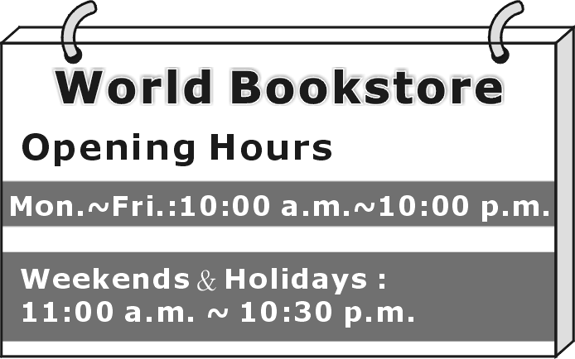
kinds of snacks.
Julia: Great. I love
tea break.

 before在…之前 forgot 忘記（forget過去式）
break休息 holiday 假日

( ) 7. At about what time do Julia and Liz have the conversation?  conversation 對話
(A) 9 a.m. (B) 8 a.m. (C) 2 p.m. (D) 8:30 p.m.
( ) 8. What is “Star’s”?
(A) A movie theater. (B) A bookstore. (C) A restaurant. (D) A coffee shop.
E.
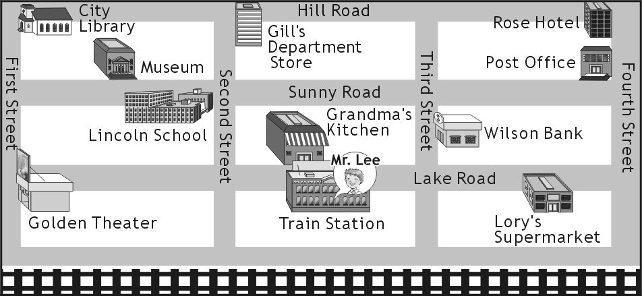

( ) 9. Look at the picture. How does Mr. Lee get to Rose Hotel?
(A) Turn left and walk along Lake Road. Turn right on Second Street and walk for
one block. It’s on the left.
(B) Turn right and go straight. Turn left on Third Street and go two blocks; then turn
right on Hill Road. It’s on the corner of Hill Road and Fourth Street.
(C) Turn left and then walk along Lake Road. It’s on the corner of Lake Road and First
Street.
(D) Turn right. Then turn left on Third Street ,and go straight. You’ll see it on the right.

( )10. Mr. Lee is at Golden Theater now, and he wants to meet Kate. This is how to get there.
Turn right and walk along First Street. Turn right on Hill Road and then walk a block.
It’s on your right. What is it?
(A) Lory’s Supermarket. (B) City Library. (C) Post Office. (D) Gill’s Department Store.

七、文意字彙 （20分）
1.________There are three chairs and a c h in our living room and we like to sit on them to watch TV.
- Alan: How many people is Mom going to i_______e to her birthday party?
Tina: I am not sure. Maybe a lot.
- I don’t want to go there. I always feel s e in a place like that.
- That rich businessman is having a big party to c_________e his daughter’s birthday on his own airplane.
- Jimmy is e_______t in speaking English so he likes to talk to foreigners in English.
- They are going to have a b e in their yard and eat lots of meat on the Moon Festival.
- Matt: Let’s take a trip to Korea! Amy:Wow, that sounds e_______g. I really can’t wait.
- The c ks in the department store are very nice and polite to people who are shopping there.
- Most people try to r x by playing computer games but they feel tired at last.
- Kitty always thinks that she is too fat so she keeps exercising to lose w_______t.
.
八、依提示作答（10分，錯一字扣一分）
      - How old will you be next year? （根據事實詳答，數字用英文）
      - David rode his bicycle to his friend’s house.
（用 by 改寫句子）
      - Mike drank a lot of milk and ate two apple pies.
（加入 tomorrow morning 改寫）
      - Monica went to school by train.（用 take 改寫）
__________________________________
      - What is Julie going to do tomorrow night?（以「拜訪叔叔」詳答）
九、整句翻譯（配分：15 分，錯一字扣一分）
- Amy每天要搭渡輪跨越高雄港上班。
- 我的爸爸是個很棒的律師，而且他總是面帶微笑。
- 不久的將來，你將會看到一些帶有感情的機器人而且它們會因不同的感覺而發出不同的聲音。
- 每天跟我們在健身房運動半小時，你就會變得苗條又健康。
5. 我的阿姨每年需到台北出差三到四次。
___________________________________

高雄市立林園高級中學 國中部 100學年度 第 ㄧ 學期 二 年級 英文 科 第 一 次段考答案卷
班級： 姓名： 座號： 得分：

一、聽力 10％  1 | 2 | 3 | 4 | 5
二、對答10％  6 | 7 | 8 | 9 | 10
三、對話 10％  11 | 12 | 13 | 14 | 15
四、對話測驗 5％
1 | 2 | 3 | 4 | 5
五、看圖作答 10％
1 | 2 | 3 | 4 | 5
六、閱讀測驗 10％
1 | 2 | 3 | 4 | 5
6 | 7 | 8 | 9 | 10
七、文意字彙 20％
1 | 2 | 3 | 4 | 5
6 | 7 | 8 | 9 | 10
八、依提示作答 10％ (錯一字扣一分 )
1.

2.

3.

4.

5.

九、整句翻譯 15％，每句三分、錯一字扣一分。
1

2

3

4

5

高雄市立林園高級中學 國中部 100學年度 第 ㄧ 學期 二 年級 英文 科 第 一段考答案卷解答 班級： 姓名： 座號：
一、聽力 10％
1 A | 2 C | 3 D | 4 B | 5 B
二、對答10％
6 B | 7 B | 8 D | 9 D | 10 B
三、對話 10％
11 A | 12 B | 13 C | 14 C | 15 A
四、對話測驗 5％
1 B | 2 A | 3 B | 4 D | 5 B
五、看圖作答 10％
1 E | 2 J | 3 F | 4 H | 5 A
六、閱讀測驗 10％
1 B | 2 A | 3 D | 4 A | 5 C
6 B | 7 A | 8 D | 9 B | 10 D
七、文意字彙 20％
1 couch | 2 invite | 3 strange | 4 celebrate | 5 excellent
6 barbecue | 7 exciting | 8 clerks | 9 relax | 10 weight
八、依提示作答 10％ 錯一字扣一分
1. I will be fifteen {fourteen} {sixteen } (years old) next year.
2. David went to his friend’s house by bicycle.
3. Mike will (is going to) drink a lot of milk and eat two apple pies tomorrow morning.
4. Monica took the train to school.
5. She is going to visit her uncle tomorrow night.
九、整句翻譯 15％，每句三分、錯一字扣一分。
1 Amy takes the ferry across Kaohsiung Harbor to work.
2 My father is a great lawyer, and he always wears a big smile on his face. (his face is always with a big smile on it)
3 In the near future, you will see some robots with feelings, and they will make different sounds for different feelings.
4
Exercise with us at the gym half an hour every day, and you will be slim and healthy.
5
My aunt has (needs) to go to Taipei on business three or four times every year.

