高雄市立林園高級中學國中部100學年度第一學期二年級英文科第三次段考考卷
範圍: L7—Review III 班級: 姓名: 座號:
-----------------------------------------------------------------------------------------------------
壹:聽力測驗(30%)

一:聽CD的二個敘述丶選出符合圖片的句子（每題２分）
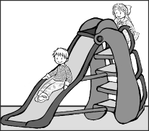
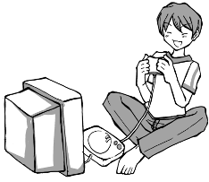
1. 2 3 4 5
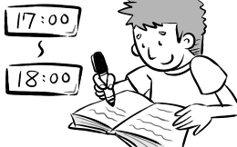
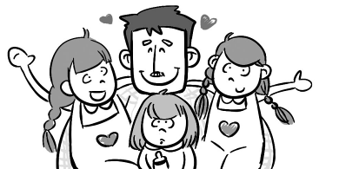
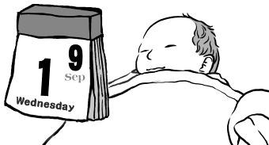

二、聽CD的問題，選出最適當的回應：（每題２分）
( ) 6. (A) We are going to land in ten minutes..
(B) We need to make some changes. (D) How about going shopping?
(C) It isn’t the Moon Festival
( ) 7. (A) You can show him the photo.
(B) He is too busy to meet you.
(C) Isn’t the milk warm enough for him?
(D) You can make a cake.
( ) 8. (A) Janet helped me. (C) Three hours.
(B) I began at five. (D) About four pieces of paper.
( ) 9. (A) Yes, it’s hard to hit the ball.
(B) No, it isn’t easy for me to hit the ball.
( C) It’s important for me to pass the exam.
(D) You may play it now.
( ) 10. (A) I don’t remember that. (C) It’s such a wonderful gift.
(B) A crazy idea. (D) A thank-you letter from James

三、選出出現在CD句中的單字：（每題２分）
( ) 11. (A) swing (B) in (C) child (D) these
( ) 12. (A) coat (B) cost (C) helpful (D) difficult
( ) 13.(A) watching (B) our (C) hour (D) fine
( ) 14. (A) up (B) will (C) last (D) angry
( ) 15. (A) basket (B) doll (C) by (D) door

貮、綜合評量: （每題２分）
( ) 16. Swimming in summer ╴╴╴ fun. .(A) be (B) is (C) are (D) has

( ) 17. It ╴╴╴ me 40 minutes to get there by bike

(A) made (B)wants (C)spent (D) took
( ) 18 ╴╴ is a lot of fun to play baseball . (A)This (B)It (C) That(D) What
.( )19. 選出錯誤的句子

(A) Becoming a doctor takes a long time.

(B) Sally just finished reading the book this morning.

(C) What would you like to drink, coffee or tea?
(D)How long did you take to wait for the plane?
( )20. Wearing this yellow tie made ╴╴╴ special.
(A) your (B) my (C) I (D)me
( )21 He can just sit down and write________ hours
(A) to (B) on (C) at (D) for
( )22.I will_____ my camera with me and _____ lots of photos.

(A) put ; put (B) make ; take (C) take ; take (D) do; do
( )23. Do you have any change？
(A)Yes, here is $ 0.50 (B)Looking different is cool. (C) Really? Thank you. (D) Sorry, I don’t want to change.
( )24. Is playing on the swing fun ?
(A)Yes, I have fun. (B)No, there isn’t (C) No, it’s fun.(D)Yes, it is.
( )25. Lisa fell on the ╴╴╴. (A) change (B)wind (C) pass (D)ground
( )26. ╴╴╴ late for work is bad.(A) Being (B) Is (C)You are (D)He is
( )27.I ╴╴╴ a lot of time ╴╴╴ at cute pandas(熊貓) at Taipei Zoo.
- take; looking(B)spend; looking (C)spend; look (D)spend; to look

( )28. 選出錯誤的句子.
(A)I’m not convenient to go there by bus (B) My hobby is collecting stamps. (C) We have to get a desk for Mike. (D) Mr. Hill gave me the ticket.
( )29 Jack is_____ his bike , but he can’t find it

(A) looking at (B) looking for (C) looking after (D) looking up
( ) 30. This book is very expensive. I can’t buy it.
=(A) This book is too expensive of me to buy it . (B) This book is too expensive for me to buy it (C) This book is too expensive for me to buy
(D)This book isn’t too expensive for me to buy.
( )31 John can ride a bike = (A) John is old enough to ride a bike.

(B) John is too old to ride a bike (C) John isn’t old enough to ride a bike

(D) John is so old that he can’t ride a bike
( )32.選出錯誤的句子
(A) He cooked me lunch (B) He cooked it of me.

(C) He sent it to me (D) He bought lunch for me.
( )33.A: How did you meet Scott? B: Well, ______. I met him at…..

(A) It’s a bedtime story. (B) It’s a long story. (C) It’s a life story.

(D) It’s a love story.

( )34. 選出錯誤的句子
(A) We need to change plane in Hong Kong.
(B)Do you have any change? I need to make a phone call.

(C) We made a few changes to our plan

(D) The leaves are starting to change color.
( )35 It was very kind_____ you to give me_____ a wonderful gift
- for; so (B) of; so (C) of; such (D) for; such
( )36選出錯誤的句子.
(A)He asked her to study English

(B) She told her to bring a dictionary

(C)I enjoy being your teacher

(D) She made a cake of her mom.

課文習作克漏字選擇
“ It’s _37__ time for leaves to change their home”, Daniel said, “ Some people
call _38__ dying . ‘ Will I die? “Freddie asked. ‘ Yes,” Daniel answered. ‘ We all __39__.” .Freddie’s friends started to fall one after _40_ ‘ I’m afraid of dying. I don’t want to die” said Freddie.

( )37.(A) a (B)an (C) the (D) X
( )38.(A)him (B) it (C) them (D) one
( )39 (A) do (B) are (C) will (D) have

( ) 40 (A) other (B) others (C)another (D) the other

My hobby is _41__ comic books .I have hundreds , maybe thousands. Comics
__42__ fun for me to read. My favorites are Batman and Hulk. I also like comic
books from Japan. But I can’t read Japanese, so it’s not possible for me to read those comic books . But I like the cartoons _43__ TV.
Every weekend I go out to find more comic books, old __44_ and new _44__
It’s hard to find some old comic books like Spider-Man. All comic fans want them.
So they _45__ a lot of money.

( ) 41 .(A) a collect (B) collect (C) collecting (D) collected
( ) 42. (A)are (B) has (C) have (D) is
( ) 43. (A) at (B) on (C) in (D) of .
( ) 44 .(A) it; it (B) one ; one (C) them ; them (D) ones ; ones
( ) 45. (A) change (B) spend (C) cost (D) take

閱讀測驗(每題2分,共10%)
Kelly is a very special student in my class. Her father is an American, and her mother is a Chinese. Kelly was born in New York and finished elementary school there. Then the family decided to move to Taiwan because Kelly’s father found a new job in Taipei. Kelly could speak only English, but her parents did not send her to a special school for foreign children. They wanted her to study in a regular junior high school and to make friends here.
Kelly has to work very hard at school. English is easy for her, of course. Math is OK, too. But Chinese and History are big headaches for her because she cannot read the books in Chinese. She often comes to me, her English teacher, to ask questions about Chinese and History. She is trying very hard, and I believe she will do well in Taiwan.
strict(嚴格) regular(一般的) paragraph(段落) elementary school(國小) foreign(外國) history (歷史)

( ) 46. Who wrote the two paragraphs?
- Kelly herself. (B) Kelly’s mother
(C)Kelly’s teacher. (D) Kelly’s classmate.
( ) 47. Why did Kelly’s family move to Taiwan?
- Kelly’s father changed his job.
- Kelly wanted to study in a foreign country.
- Kelly’s parents had many friends in Taiwan.
- Kelly’s father needed to learn Chinese to do business.
( ) 48. Who are They in the fist Paragraph?
(A)Kelly’s parents. (B)Kelly’s teachers.
(C)Foreign children. (D)Kelly’s American friends.
( ) 49. What does big headaches mean in the second paragraph?
(A)Useful ways. (B) Strict rules.
(C)Expensive books. (D) Difficult things.
( ) 50. Why does Kelly’s teacher believe she will do well in Taiwan.
(A)Her English is good. (B)Her math is OK.
(C)She works very hard (D)Her father is an American

二年級英文 科 第三次段考答案欄（年級、科目請標示清楚，謝謝！）
1 A 2.B 3.B 4.A 5.B 6.D 7.A 8.C 9.B 10.D
11.A 12.D 13.C 14.A 15B 16.B 17.D 18.B 19.D 20.D
21.D 22.C 23.A 24.D 25.D 26.A 27.B 28.A 29.B 30.C
31.A 32.B 33.B 34.A 35.C 36.D 37.C 38.B 39.C 40.C
41.C 42.A. 43.B 44.D 45.C 46.C 47.A 48.A 49.D 50.C

