高雄市立林園高級中學國中部 100學年度 第 ㄧ 學期 三 年級 英 語 科 第 ㄧ 次段考試題卷
班級： 姓名： 座號：
- 聽力測驗:20%
一、看圖辨義：每題2分，共10分
 根據聽到的內容，選出正確的圖片代碼。
1.  2. 3. 4. 5.
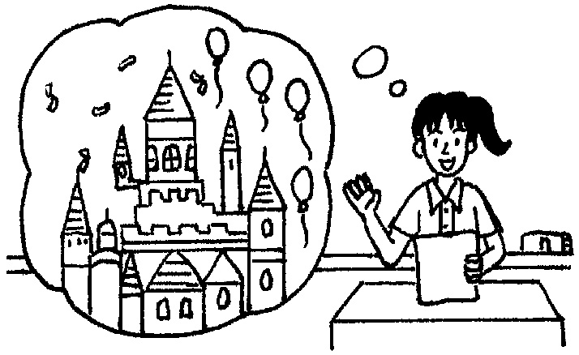

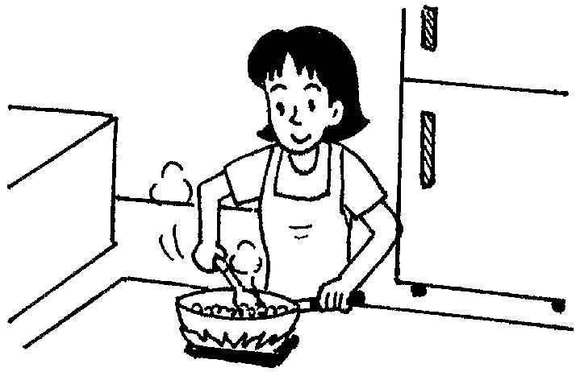
A. B. C.

D. E.
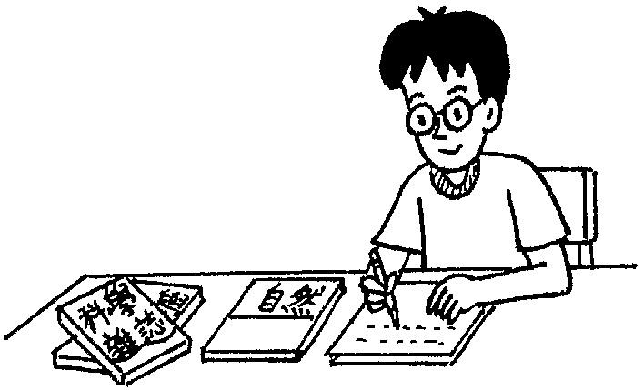
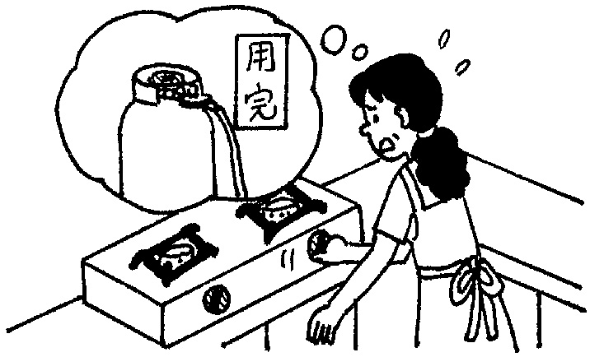

二、看表回答：每題2分，共10分
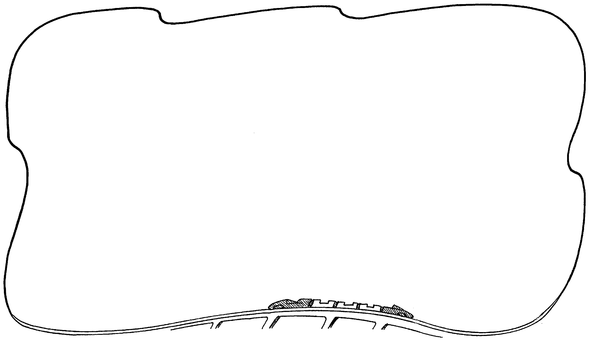
根據下列圖表與聽到的問題，選出正確的答案。

Wonderful Amusement Park
Ticket Prices (NT$) | Schedule
Under 3: free | Opening Hours: 9:00 a.m.－10:00 p.m.
Ages 3－11: NT$100 | Mickey Mouse Show: 10:30 a.m. ; 3:00 p.m.
Ages 12－15: NT$150 | Magic Show: 11: 00 a.m. ; 4:00 p.m.
Over the age of 15: NT$200 | Parade（遊行）: 5:00 p.m.
Over the age of 65: free | Fireworks（煙火大會）: 9:00 p.m.
* The park closes on the fourth Thursday every month.

( ) 1. (Ａ) Eleven. (Ｂ) Twelve. (Ｃ) Thirteen.
( ) 2. (Ａ) Mickey Mouse Show. (Ｂ) Magic Show. (Ｃ) Fireworks.
( ) 3. (Ａ) Tuesday. (Ｂ) Thursday. (Ｃ) Saturday.
( ) 4. (Ａ) NT$200. (Ｂ) NT$150. (Ｃ) Nothing.
( ) 5. (Ａ) 8:30 a.m. (Ｂ) 11:25 a.m. (Ｃ) 5:00 p.m.

貳、筆試部份:80%

- 閱讀測驗：每題2分、共20分

- May wants to introduce（介紹） the beauty of Taiwan to her foreign friends, Kim and Amy, but she doesn’t want to spend too much money. One day, on her way home, she gets a handbill from a man. There is a lot of traveling information on it. So May decides to take it home and discuss（討論） with her friends. Here is the handbill:
(1) What might the word handbill mean（意指）?
(A) A piece of paper which can show you the way home.
(B) A piece of paper which has a lot of information on it.
(C) A piece of paper which can give you a discount（折扣）.
(D) A piece of paper which can save your money.
(2) What might KLM be?
(A) A nice restaurant. (B) A famous supermarket. (C) A convenience store. (D) A travel company（公司）.
(3) If May wants to travel to the south of Taiwan, which is the best choice?
(A) Taiping Mountain. (B) Ocean Park. (C) Love River. (D) Taipei Zoo.
(4) Which one is the cheapest if May wants to go with her friends, Kim and Amy?
(A) Clarke Quay. (B) Ocean Park. (C) Love River. (D) Taiping Mountain.
(5) If May wants to have a hot spring bath（沐浴）during the trip, which place SHOULDN’T they go?
(A) Love River. (B) Yilan. (C) Ocean Park. (D) Taiping Mountain.

- Kelly: Excuse me. I’m new in the city. Is there a history museum around here?
Kevin: Yes, there is one. It’s just a few blocks away.
Kelly: How can I get there?
Kevin: Walk north. Cross the street at the traffic lights. There’s a library on the corner. Make a left turn here and go straight one block. Cross the street and walk for about two minutes. It’s on your right. Across from it is a gas station. You won’t miss it.
Kelly: Thank you very much.
Kevin: You’re welcome.
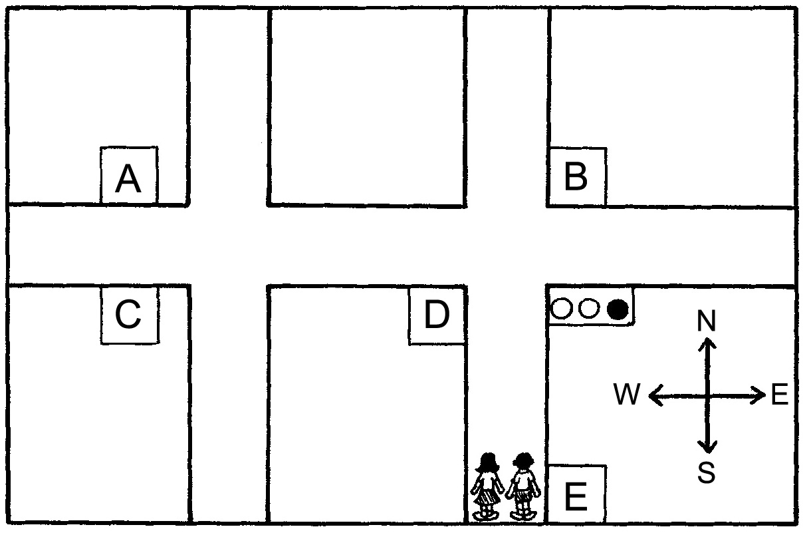
(1) What place is B?
(A) The museum. (B) The library. (C) The gas station. (D) We don’t know.
(2) If Kelly’s car runs out of gas, where can she go?
(A) E. (B) D. (C) B. (D) C.
(3) Which is the history museum?
(A) A. (B) B. (C) C. (D) D.
(4) What does new mean?（意指）
(A) Kelly wears new clothes.
(B) Kelly visits the city for the first time.
(C) Kelly wants to find a new history museum.
(D) Kelly went to the city last year.
(5) What does one in line three mean?
(A) A gas station. (B) traffic light. (C) A museum. (D) A library.

- 翻譯：每題3分、共15分
1.後來，這個有創意的美國人在佛羅里達州開始他真正的生意。
__________（片語），this ________ American started his _________ business in Florida.
2.根據報告, 世界各地的人們每一秒鐘殺害三隻鯊魚。
___________（片語） reports, people ________ the world ________ three sharks every second.
3.一天一顆番茄，醫生遠離我。（錯一字扣一分）
_____________________________________________
4.Peter說他沒有電腦就活不下去。（錯一字扣一分）
________________________________________
5.我想我可以為大家做玉米湯，如果我們找得到玉米罐頭和奶油。
I think I can _______ corn soup _______ everyone if we can find some _____ of corn and butter.

三、文法：每題1分、共15分
- Mr. Su has taught English ________ fifteen years. He’s the best English teacher in the school.
(A) in (B) for (C) since (D) from
- Tom’s father ________ to Japan on business（出差）, and he won’t be home until next month.
(A) went (B) has been (C) has gone (D) goes
- Jack hasn’t seen Jolin for two months, and he hopes ________ her soon.
(A) hearing from (B) not to hear about (C) to hear from (D) hearing
- She has cleaned the classroom.
(A) already (B) yet (C) also too (D) ever
- How long ________ on the phone? Aren’t you thirsty?
(A) did you talk (B) you’ve talked (C) have you talked (D) were you talking
- Michael Jackson ________ for two years.
(A) has died (B) is dead (C) has been dead (D) dies
- I have ________ finished my homework. It took me two hours to do it.
(A) ever (B) already (C) never (D) yet
- Mr. Brown asked us insects in class next week.
(A) talk about (B) talking about (C) talked about (D) to talk about
- John is afraid the dog may bite him when he walks by.
(A) to (B) of (C) for (D) that
- Mr. Chen’s company ________ the biggest one in Taiwan.
(A) turns out (B) turns out to be (C) turns around (D) turns into
- Johnny wants to know ________ his aunt and uncle can come to his party or not.
(A) whether (B) that (C) × (D) about
- Mary has no idea ________ she can watch her favorite TV programs.
(A) what (B) who (C) when (D) how
- Tell me .
(A) what did you happen (B) what you happened (C) what happened to you (D) what did you happen to
- Vivian didn’t know ________ with the sick dog and came to me for help.
(A) what could she do (B) what to do (C) what should she do (D) what to do it
- Can you tell me ________?
(A) how to cook (B) which one to buy it (C) where to believe (D) where to find

四、字彙填空：每題2分、共20分
- Doing your homework at the last minute is really a bad h____t.
- Sharks haven’t changed for a es though they appeared on earth earlier than dinosaurs.
- When we tried to turn on the s_____ve, we found there was no gas.
- David is good at singing and telling jokes. So he is very p r with his friends.
- Ms. Chan has been as busy as a bee since she started her new b s in Taipei
- Please tell me how to prevent cancer, heart d e, and skin problems..
- Winnie the Pooh（小熊維尼）is one of the most famous in the world.
- T rs like to spend more time on their friends than on their family.
- Lemons are full of v n C. They are good for one’s health.
- That colorful frog is p s. Don't touch it.

五、依提示作答：每題2分、共10分
- Linda was crazy about collecting Barbie dolls.
（加入Since then改寫句子）
________________________________________
- Can Daniel play tennis well?
I’d like to know that.（合併句子）
________________________________________
- Judy was happy….
Judy met a movie star yesterday.
（合併句子）
________________________________________
- Where is Jane going?
I don’t know….
（合併句子）
→ ________________________________________
- Jeff didn’t know what he could say.（改為名詞片語）
→________________________________________

高 高雄市立林園高級中學國中部 100學年度 第 ㄧ 學期 三 年級 英 語 科 第 ㄧ 次段考解答卷
壹、聽力測驗:20%
- 看圖辨義：每題2分，共10分
1. C | 2. D | 3. A | 4. E | 5. B
二、看表回答：每題2分，共10分
1. C | 2. A | 3. B | 4. C | 5. A

貳、筆試部分：80%
一、閱讀測驗：每題2分、共20分
1.
1. B | 2. D | 3. C | 4. B | 5. A
2.
1. B | 2. D | 3. A | 4. B | 5. C
- 翻譯：每題3分、共15分
1.
Later on | creative | real
2.
According to | around | kill
3.（錯一單字扣一分）
A tomato a day keeps the doctor away.
4.（錯一單字扣一分）
Peter said that he couldn’t live without computer.
5.
make | for | cans
- 文法：每題1分、共15分
1. B | 2. C | 3. C | 4. A | 5. C
6. C | 7. B | 8. D | 9. B | 10. B
11. A | 12. C | 13. C | 14. B | 15. A
- 字彙填空：每題2分、共20分
1. habit | 2. ages | 3. stove | 4. popular | 5. business
6. disease | 7. characters | 8. Teenagers | 9. vitamin | 10. poisonous
五、依提示作答：每題2分、共10分
1. Since then, Linda has been crazy about collecting Barbie dolls.
2. I’d like to know if/whether Daniel can play tennis well.
3. Judy was happy that she met a movie star yesterday.
4. I don’t know where Jane is going.
5. Jeff didn’t know what to say.

