高雄市立林園高級中學 國中部 100學年度 第 一 學期 三 年級 英語 科 第 二 次段考考卷
班級： 姓名： 座號：
A、聽力測驗
一、看圖辨義 10 %【根據聽到的內容，選出正確的圖片代碼】
1.  2. 3. 4. 5.
A. B. C. D. E.
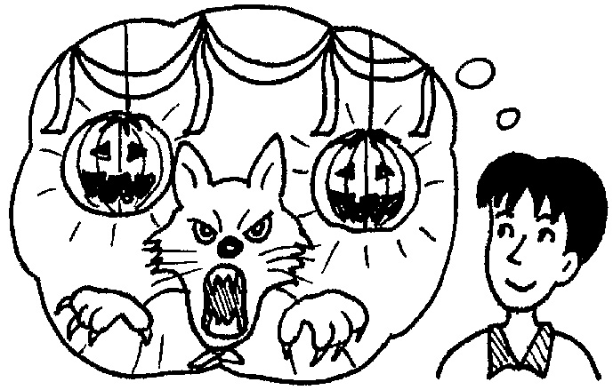
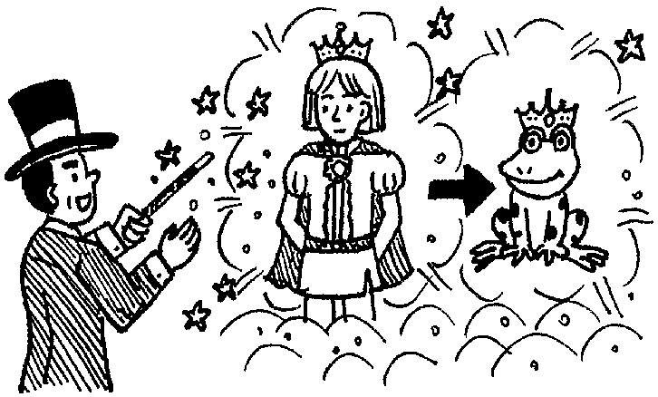
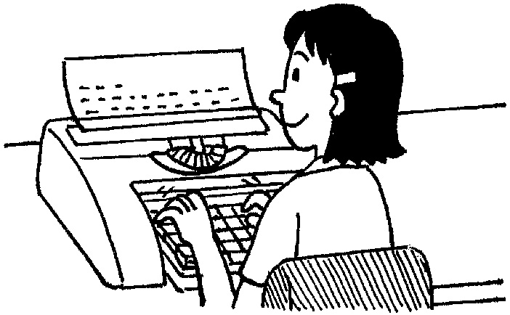
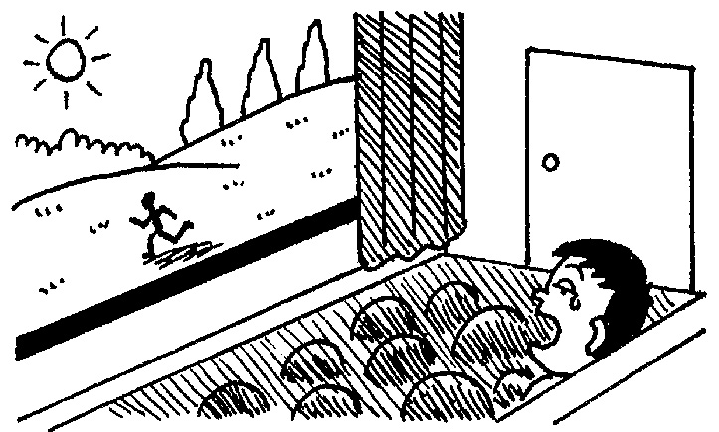
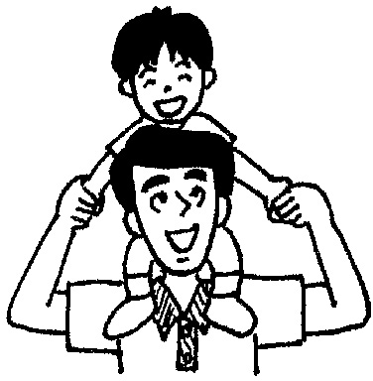

二、對話選擇 10%【根據聽到的句子，選出合適的回應】
( ) 1. (Ａ) No way!
(Ｂ) Don’t worry.
(Ｃ) You did a good job.
( ) 2. (Ａ) Let’s stop arguing.
(Ｂ) I know who I am.
(Ｃ) Cut it out. Be serious.
( ) 3. (Ａ) I’ll be back soon and bring something to eat for you.
(Ｂ) I am lost. I can’t find my mom anywhere in the supermarket.
(Ｃ) Sorry, dogs are not allowed in the church.
( ) 4. (Ａ) If you try your best, you will surely succeed in the near future.
(Ｂ) Another trick? I’m not interested in any more of your tricks.
(Ｃ) I took the story from the movie, Cinderella.
( ) 5. (Ａ) Yes, it is so interesting that I have already watched it twice.
(Ｂ) Yes, I will read it next weekend.
(Ｃ) No. I want to act in the role of the king.
B、紙筆測驗
一、文意字彙10%
1. J. K. Rowling is an e t writer. Her books are popular with both children and adults.
2. Students can have snacks and do activities at the student c er.
3. Let me in e my school to you. It’s the best school around here.
4. A long time ago, a w d turned a young prince into a giant.
5. The house b ngs to my uncle. He bought it last year.
6. If you keep going on. You will s d in the end.
7. We can often see a beautiful r w after it rains.
8. It is a great p re to work with Emily because she is friendly.
9. Mrs. Lee was m with Tony because he put his dirty clothes everywhere on the floor.
10. A: Is the woman m ried ? B: Yes. And she has two daughters.

二、填入正確的動詞形式或附加問句10%
1. Jacky has to (send) back to his home.
2. The window (break) by Eric yesterday.
3. A (bore) person never learns well.
4. How (amaze)! He used his magic power to clean our classroom!
5. Kevin is too young to know the answer, ?
三、文法選擇15%
( ) 1.Something to my brother yesterday.(A) was happen (B) was happened (C) happened (D) happens
( ) 2.A: When the men caught by the police? B: Last Sunday. (A) were (B) was (C) will (D) did
( ) 3.A: Mom, when will the soup be ready? B: Maybe later. It’s since two hours ago!
(A) cooked (B) be cooked (C) being cooked (D) been cooked
( ) 4.Some of the boys in the library are reading; are sleeping.
(A) others (B) the others (C) another (D) the other
( ) 5.The cartoon is joy, so many children like it. (A) filled (B) full with (C) full (D) filled with
( ) 6.Both Harry and his brother because their favorite singer is coming to Taiwan.
(A) look excited (B) looks excited (C) look exciting (D) looks exciting
( ) 7.Not only Eric but also I excited the news.
(A) are; about (B) are; with (C) is; with (D) am; about
( ) 8.The meal the cook made wasn’t my parents.
(A) satisfied with (B) satisfying to (C) satisfying with (D) satisfied to
( ) 9.The news of Steve Jobs’ death(死亡) made people . (A) surprise (B) surprised (C) surprising (D) surprises
( )10.It was hot. The little boy didn’t want to wear his coat, so I helped him .
(A) take it off (B) put it on (C) put on it (D) take off it
( )11.If you want to be kissed by the princess, you have to be the frog, ?
(A) haven’t you (B) do you (C) don’t you (D) have you
( )12. Shrek will turn back into a prince again if he finds his true love, ?
- won’t he (B) doesn’t he (C) does he (D) will he
( )13.My brother has never been to the US by himself, ? (A) does he (B) doesn’t he (C) has he (D) hasn’t he
( )14.The book is so expensive . (A) to buy it (B) that I can’t buy it (C) that I can’t buy (D) to buy
( )15.A: How could anyone love like him? B: I have no idea, either.
(A) so a bad guy (B) such bad a guy (C) so bad guy (D) such a bad guy

四、克漏字選擇10%
Here are some American holidays. Any one of them is popular, 1. ?
Holiday | What’s special?
New Year’s Day | - It’s always on the first day of the year.  - On the night of New Year’s Eve, people count down the final seconds before the new year comes.
Easter | 1. It 2. on the same date every year, but it’s always on Sunday.  2. Children decorate eggs and put them in the baskets with candy.
Halloween | - It’s on the last day of October.  - Children 3. like ghosts or witches.  - Children play “trick-or-treat” with people.
Thanksgiving | - It’s on the fourth Thursday of November.  - People are 4. eating a big turkey dinner.
Christmas | - People buy presents for their friends and family and send cards to them.  - People decorate the Christmas in their house.  - People go to church on that day.  - It’s the most 5. holiday in the US.
eve 前夕 decorate 裝飾 basket 籃子 witch 巫婆
( )1.(A) aren’t they (B) are they (C) is it (D) isn’t it
( )2.(A) is celebrated (B) was celebrated (C) isn’t celebrated (D) wasn’t celebrated
( )3.(A) are often dressed (B) often dress (C) are often worn (D) often wear
( )4.(A) interesting to (B) bored with (C) satisfied with (D) surprised at
( )5.(A) exciting (B) pleasure (C) succeed (D) amazed

五、閱讀測驗16%

The Old Man and the Sea
The Old Man and the Sea was Ernest Hemingway’s last and most famous work. The story was inspired by Hemingway’s
visiting Cuba and watching the fishermen.
In the story, a fisherman named Santiago, has not caught any fish for 84 days. All the people in the town are worried. On the 85th day, he jumps into the water and fights for three days with a giant fish. After killing the fish, he wants to take it to the town. But, the fish is too big to put in the boat, so it is eaten by sharks on the way home. Santiago has only the bones to show people. Although he doesn’t become rich, he is satisfied with what he did.
The book tells us the struggle between humans and nature. Some people think the book glorifies people, and other people point to Santiago’s respect for the fish. They think that nature and people are not enemies, but brothers.

 inspire 靈感 bone 骨頭 struggle 競爭 human 人類 nature 自然 glorify 彰顯 respect 尊敬 enemy 敵人
( )1.Why are all the people in the town worried about Santiago?
- Because he wants to leave Cuba. (B) Because he hasn’t caught a fish for 84 days.
(C) Because he doesn’t want to be a fisherman. (D) Because he only caught 85 fish.
( )2.What happens to the big fish on the way home?
(A)It’s too big, so Santiago let it go. (B) It’s saved by its family and friends.
(C) It’s too big to put in the boat, so Santiago eats it. (D) It’s eaten by sharks.
( )3.Which is true?
- The Old Man and the Sea is written by Santiago. (B) Santiago sells the fish and becomes rich.
(C) Hemingway’s last work is The Old Man and the Sea. (D) Santiago and Hemingway are brothers.

Baseball Game  The Elephants VS the Bulls  Time: Oct. 2, Sunday at 3:00 P.M.  Place: Public Baseball Court  Ticket: NT$300 per person | Are Exhibition  Treasures of India  Time: Oct. 3 through Oct. 23  Place: Taipei History Museum  Ticket: NT$120 for adults  NT$60 for students
Movie  Harry Potter VII  Time: 10:10 A.M. and 2:10 P.M.  Place: Dream Theater  Ticket:NT$330 for adults  NT$160 for students | Free Concert in the park  Great singers from the US and Canada  Time: Sep. 17, Saturday at 7:00 P.M.  Place: Da-Ann Forest Park
 bull 公牛 per 每 exhibition 展覽 treasure 寶物 India 印度 museum 博物館
( )4.Mr. Rowing and Mrs. Rowing are going to see Harry Potter VII with their two children ( 9 and 13 ). How much will
they have to pay?
(A) NT$890. (B) NT$780. (C) NT$990. (D)NT$980.
( )5.Which is true about these posters?
(A)The free concert will be held in the public baseball court.
(B) The art show will last for three weeks.
(C) The movie Horry Potter VII is shown once a day.
(D)The Elephants will play the Bulls on Saturday afternoon.

Good table manners are important. It is important to remember the table manners when we eat in a restaurant. Here are some examples for table manners.
˙If you find that your tableware is dirty, don’t use your napkin to clean it. Just ask the waiter or the waitress for another one.
˙What should you do when there is something between your teeth? Don’t cover your mouth with one hand and use the other
hand to pick your teeth. It’s better to go to the restroom to clean them.
˙Eat quietly. Don’t eat soup too loudly. And keep your mouth closed when eating.
˙Do not talk when your mouth is full. This will make other people sitting at the table sick.
 table manners 餐桌禮儀 tableware 餐具 napkin 餐巾 waitress 女服務生
cover 覆蓋 pick one’s teeth 剔牙 restroom 洗手間
( )6.What does one mean in the reading? (A) Tableware. (B) Napkin. (C) Table. (D) Soup.
( )7.What should we do if something is between our teeth while eating?
(A) Cover your mouth with the napkin and pick your teeth.
(B) Use the napkin to clean your teeth.
(C) Go to the restroom to clean your teeth.
(D) Cover your mouth with both your hands.
( )8.What is NOT true about the reading?
- Clean the tableware yourself when you find it’s dirty.
- It’s better to go to the restroom to pick your teeth.
- Eat soup quietly.
- Don’t talk when your mouth is full.

六、依提示完成或改寫句子8%
1. cancer / can / prevent / by / eat healthy food (完成句子)
2. The boy was seen to kick the dog by my brother. (以 My brother…改為主動句)
3. On-line games interest us.(用interested 改寫)
4. Peter was bored with math class. (用boring 改寫)

七、翻譯11%
1. Grace對你的到來感到很驚訝。 (3分)
2. 這個嬰兒喜歡被輕拍背部。(4分)
3. 他們一見鍾情，對不對？(4分)

高雄市立林園高級中學國中部100學年度第一學期三年級英語科第二次段考答案卷
班級： 姓名： 座號：
A、聽力測驗
一、看圖辨義10 % (每題2分)【根據聽到的內容，選出正確的圖片代碼】
1. |  | 2. |  | 3. |  | 4. |  | 5.
二、對話選擇10% (每題2分)【根據聽到的句子，選出合適的回應】
1. |  | 2. |  | 3. |  | 4. |  | 5.
B、紙筆測驗
一、文意字彙10%(每題1分)
1. |  | 2. |  | 3. |  | 4. |  | 5.
6. |  | 7. |  | 8. |  | 9. |  | 10.
二、填入正確的動詞形式或附加問句10%(每題2分)
1. |  | 2. |  | 3. |  | 4. |  | 5.
三、文法選擇15%(每題1分)
1. |  | 2. |  | 3. |  | 4. |  | 5.
6. |  | 7. |  | 8. |  | 9. |  | 10.
11. |  | 12. |  | 13. |  | 14. |  | 15.
四、克漏字選擇10%(每題2分)
1. |  | 2. |  | 3. |  | 4. |  | 5.
五、閱讀測驗16%(每題2分)
1. |  | 2. |  | 3. |  | 4. |  | 5.
6. |  | 7. |  | 8.
六、依提示完成或改寫句子8% (每題2分)
1.
2.
3.
4.
七、翻譯11%(第一題3分，二、三題各4分)
1.
2.
3.

