高雄市立林園高級中學 國中部 100學年度 第 二 學期 一 年級 英文科 第一次段考卷
班級： 姓名： 座號：
I. Listening Comprehension 聽力測驗 (共30分)
Part A 選出聽到單字的母音 (共10分，每題2分)
（ ）(１)(Ａ)[] (Ｂ)[u] (Ｃ)[ju]
（ ）(２)(Ａ)[] (Ｂ)[u] (Ｃ)[ju]
（ ）(３)(Ａ)[] (Ｂ)[u] (Ｃ)[ju]
（ ）(４)(Ａ)[] (Ｂ)[u] (Ｃ)[ju]
（ ）(５)(Ａ)[] (Ｂ)[u] (Ｃ)[ju]

Part B 答句題型：根據對話內容，正確的寫T，錯誤的寫F (共10分，每題2分)
（ ）(１) Amy is Ms. Lee’s daughter.
（ ）(２) Paul is calling Ms. Lee from the kitchen.
（ ）(３) Ms. Lee is going to the show with her dog.
（ ）(４) Lucky is a smart dog.
（ ）(５) Lucky can only dance and jump rope.

Part C 根據聽到的五個對話內容，將題號填入相符的圖片中 (共10分，每題2分)
(Ａ) | (Ｂ) | (Ｃ)
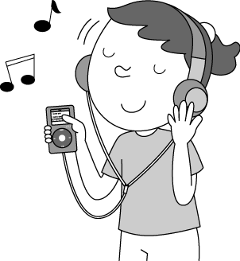 | 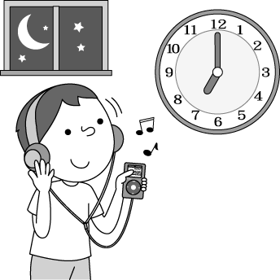 | 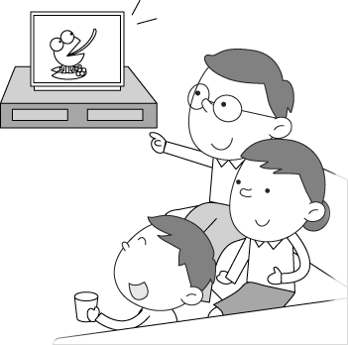
（ ） | （ ） | （ ）
(Ｄ) | (Ｅ) | (Ｆ)
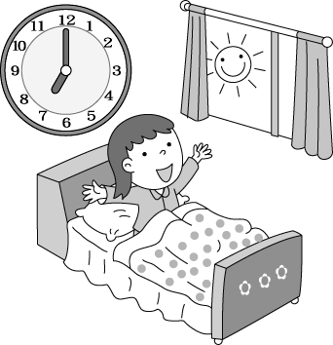 |  | 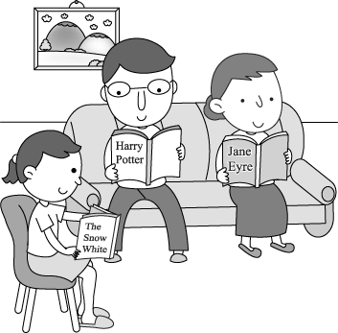
（ ） | （ ） | （ ）

II. Vocabulary 字彙測驗 (共10分，每題2分)
1. |  | Can you two s f the Net? (習作p.9, D,1)
2. |  | Tracy plays the g r after school every Wednesday.
3. |  | What e e can we help you?
4. |  | Mr. Anderson is not here now. Can you c l back later?
5. |  | Nate Robinson is only one h d and seventy-five tall. | (課本p.33 line 6)

III. Language Focus 語法測驗 (共10分，每題2分)
1. A: Can Molly cook? B: No, she .
(A) cannot | (B) can’t
(C) doesn’t | (D) isn’t
2. A: Danny and his brother surf the Net every day?
B: No, they .
(A) Don’t; doesn’t | (B) Can; can
(C) Are; aren’t | (D) Do; don’t
3. A: What time do you go to school?
B: _____________.
(A) About seven. | (B) At midnight.
(C) Every day. | (D) On Thursdays.
4. A: Does Bella English after school?
B: No, she a kite.
(A) studys; flys | (B) studies; flies
(C) study; flies | (D) studs; flys
5. are thirty-three thin in her mouth. (課本p.35, tongue twister)
(A) Their; tooth | (B) There; teeth
(C) They; tooth | (D) Their; teeth

IV. Fill in 填充題 (共20分/每格2分)
看圖填入適當的動詞和介係詞，並請依照上下文改變動詞形式。

My Family
Hello, my name is Jenny. (1) at the picture. These are my family. My younger sister, Emily, can (2) from one to one sixty. The boy standing next to Emily is my brother, Ted. He (3) basketball (4) an hour after school (5) day. He expects himself to be Jeremy Lin II. For me, I (6) (not) play basketball, (7) I like to paint (8) a brush very well. My parents usually (9) to see a movie (10) their free time.
 expect 期待  Jeremy Lin 林書豪  usually 通常地


V. Reading Comprehension 閱讀測驗 (共10分/每格2分)
Part A
Justin Huang今天收到了一封明信片，不過明信片中的書寫體考倒他了。他需要你根據明信片的內容，來幫他回答以下的問題：

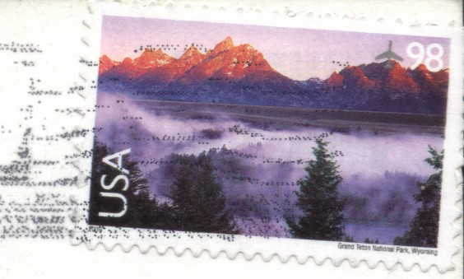

Dear Justin, March.28
My name is Kelly Anderson, a thirteen-year-old gilr from Boston, America. My favoriate singer is Avril Lavigne. I love to listen to her song befroe I go to bed.
In my free time, I like to play with my smart dog, Lily. She can catch a frisbee. We will join animal contest this weekend. May God bless us.
What do you like to do after school? I can’t wait to hear from you soon.
Kelly

Justin Huang
NO. 481, Linyuan N. Rd., Linyuan District, Kaohuiung City, 832,
Taiwan (R.O.C.)

 Boston 波士頓 May God bless us 願主保佑我們  hear from 得到…消息

1. Who send the postcard to Justin Huang?
(A) Avril Lavigne | (B) Lily Anderson
(C) Lily Lavigne | (D) Kelly Anderson
2.How old is the sender(寄信者)?
(A) Fifteen. | (B) Twelve.
(C) Thirteen. | (D) Seventeen.
3. What does the sender(寄信者) do this weekend?
(A) Join an animal contest. | (B) Play tennis with her friends.
(C) Go to the concert. | (D) Stay at home.

Part B (習作p.16)
What Do They Do on Weekends?
 | Swim | Play tennis | Play dodge ball | Roller-skate | Go to English class
Nora | ˇ | ˇ |  | ˇ | ˇ
Edward |  | ˇ |  |  | ˇ
Sunny | ˇ |  | ˇ | ˇ
Paul | ˇ |  | ˇ |  | ˇ
 class 課
4. What DON’T Edward and Paul do on weekends?
(A) Play dodge ball. | (B) Swim.
(C) Roller-skate. | (D) Play tennis.
5. A: Can you go to the movies with me this Saturday?
B: Sorry, I can’t. I have English class.
A: How about Sunday?
B: I can’t, either. I have a dodge ball game.
Who can B be?  either 也
(A) Nora. | (B) Paul.
(C) Sunny. | (D) Edward.

VI. Translation 翻譯 (共20分，每題4分)
1. 他每個星期天都早上十點以後起床。(習作p.15，B，2)
2. 她每天下班後去健身房嗎？(習作p.15,B，3)
3. A：這隻鳥會做什麼事情呢？B：牠會說哈囉。(課本p. 6)
4. Violet有一雙黑色的大眼睛。
5. A：Roy每個星期四在公園做什麼？B：他放風箏。

高雄市立林園高級中學 國中部 100學年度 第 二 學期 一 年級 英文科 第一次段考答案卷
班級： 姓名： 座號：
I. Listening Comprehension 聽力測驗 (共30分)
Part A (共10分，每題2分)
1. | 2. | 3. | 4. | 5.

Part B (共10分，每題2分)
1. | 2. | 3. | 4. | 5.
Part C根據聽到的五個對話內容，將題號填入相符的圖片中 (共10分，每題2分)
(Ａ) | (Ｂ) | (Ｃ)
（） | （） | （）
(Ｄ) | (Ｅ) | (Ｆ)
（） | （） | （）

II. Vocabulary 字彙測驗 (共10分，每題2分)
1. | 2. | 3.
4. | 5.
III. Language Focus 語法測驗 (共10分，每題2分)
1. | 2. | 3. | 4. | 5.
IV. Fill in 填充題 (共20分/每格2分)
1. | 2. | 3. | 4. | 5.
6. | 7. | 8. | 9. | 10.
V. Reading Comprehension 閱讀測驗 (共10分/每格2分)
Part A
1. | 2. | 3.
Part B
4. | 5.

VI. Translation 翻譯 (共20分，每題4分)
1.
2.
3.
4.
5.

一年級 英文科 第一次段考答案欄
I. Listening Comprehension 聽力測驗 (共30分)
Part A (共10分，每題2分)
1. C | 2. A | 3. C | 4. B | 5. A
錄音稿：(１) cute；(２) drum；(３) tune；(４) fruit；(５) gun

Part B (共10分，每題2分)
1. T | 2. F | 3. T | 4. T | 5. F
錄音稿：Paul: Hello. May I speak to Ms. Lee?
Amy: This is her daughter. Who’s calling.
Paul: This is Paul.
Amy: Sure. Hold on. She is in the kitchen.
Ms. Lee: Hi, Paul. What’s up?
Paul: We’re having an animal talent contest show. Are you coming? Your dog can do tricks.
Ms. Lee: Good idea. Lucky can jump rope, catch a ball, and even dance.
Paul: Great. See you.

Part C: 根據聽到的五個對話內容，將題號填入相符的圖片中 (共10分，每題2分)
(Ａ) | (Ｂ) | (Ｃ)
（1） | （X） | （5）
(Ｄ) | (Ｅ) | (Ｆ)
（2） | （3） | （4）
註：B圖未打叉者，不扣分。
錄音稿：(１) Boy: What do you do after school?
Girl: I listen to music.
(２) Boy: Do you get up at six every morning?
Girl: No, I don’t.
(３) Boy: Do you surf the Net on Thursday?
Girl: Yes, I do.
(４) Boy: What do you do with your parents on weekends?
Girl: We read story books on weekends.
(５) Boy: What are you doing in the living room?
Girl: We watch TV in the living room.

II. Vocabulary 字彙測驗 (共10分，每題2分)
1.surf | 2.guitar | 3.else
4.call | 5.hundred

III. Language Focus 語法測驗 (共10分，每題2分)
1.B | 2.D | 3.A | 4.C | 5.B

IV. Fill in 填充題 (共20分/每格2分)
1.Look | 2. count | 3. plays | 4. for | 5. every
6. don’t | 7. but | 8. with | 9. go | 10.in

V. Reading Comprehension 閱讀測驗 (共10分/每格2分)
Part A
1. D | 2. C | 3. A
Part B
4. C | 5.B

VI. Translation 翻譯 (共20分，每題4分，分段給分)
1. He gets up after ten (o’clock) every Sunday morning.
2. Does she go to the gym after work every day?
3. A: What can the bird do? B: It can say hello.
4. Violet has big black eyes.
5. A: What does Roy do at the park on Thursdays? B: He flies a kite.

