高雄市立林園高級中學 國中部 100學年度 第 二 學期 1 年級 英文 科 第 二 次 段考考卷
______ 範圍: Unit 4 ~ Review II 班級： 姓名： 座號： ___________
I、Listening Comprehension 聽力測驗 30%
一､根據聽到的內容，將相符的答案填入空格中 。
(１)  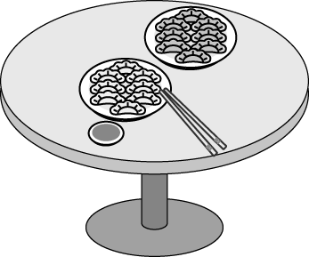 | (２)   | (３)  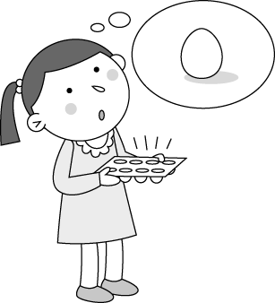 | (４)  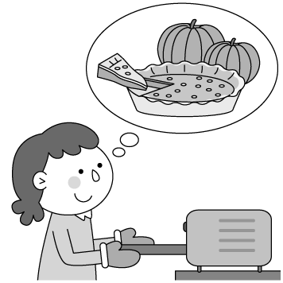 | (５)  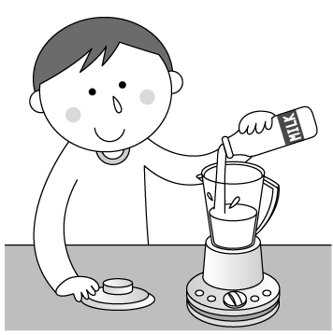

二､根據對話內容，正確的寫 T，錯誤的寫 F。
(１) Susan is going to a concert.
(２) Justin is a famous singer.
(３) Many boys love Justin.
(４) The concert is at four.
(５) People get there late.

三､根據聽到的對話與問題，選出正確的答案。
(１)(Ａ) Chinese food. (Ｂ) Cookies. (Ｃ) American food.
(２)(Ａ) It’s near the park. (Ｂ) It sells coffee. (Ｃ) It’s new.
(３)(Ａ) They have no money. (Ｂ) They have 100 dollars. (Ｃ) They have a lot of money.
(４)(Ａ) Chicken and Rice. (Ｂ) Rice. (Ｃ) Fish.
(５)(Ａ) It sells breakfast. (Ｂ) It sells only apple pies. (Ｃ) It sells anything.

II、Vocabulary 文意字彙10%
1. It’s lunch time. Let’s eat at Denny’s Shop. I have some c ns for free beef (牛肉) noodles.
2. A: I am w ng a gift for Max. Could you help me? B: Sure.
3. The fried noodles and fish soup at that r t are very delicious (美味的).
4. May is the f th month of the year. ｢習作P.29, Line 3｣
5. Thanksgiving Day is on the fourth Thursday of N er.
6. Cut these apples and bananas, and put them in the b er. Then you can get two glasses of juice.
7. I have two s ches and a bottle of soy milk for breakfast every day.
8. How many d ngs do they sell every day? ｢習作P.29,Line 15｣
9. There are so many food s ds for you to choose (選擇) at the night market.
10. Don’t w y about the price (價格), Mom. I can use my pocket money. ｢課本P55, Line 7｣

III、Language Focus 語法測驗 20%
1. A: Which animal ______ Sean’s favorite, an elephant or a giraffe? B: Both.
(A) are (B) is (C) do (D) does
2. Everyone in the classroom ______ the story very much.
(A) like (B) is liking (C) to like ( D) likes
3. In 2012, Mother’s Day is on _________.
(A) May ( B) March 13 (C) the thirteenth day of May (D) the third Sunday of May
4. How ______ ______ Elian drink every day?
(A) much glasses of water; does (B) much milk; does (C) many tea; do (D) many bottles of juice; do
5. A: What else _____you want? B: We____ want some rice balls.
(A) do; also (B) are; also (C) does; too (D) are ; really
6. A: ______ homework ________ have on the weekend? B: I am not sure.
(A) How much; do we (B) How many; are there (C) How much; is there (D) How many; does he
7. A: I need two bags of flour, please. _________ B: Sure. How much do you need? 「習作 P.27, Q3」
(A) Are they expensive? (B) By the way, do you have sugar? (C) Do you have any plates?
(D) How many bags do you have?
8. A: Who has sugar? I need some for my coffee. B: Teddy______.
(A) do (B) does a lot (C) has some (D) have
9. A: When can you go to a movie with me? B:________.
(A) It’s January 1. (B) I can play baseball in the morning. (C) That’s all right.
(D) How about next Monday?
10. A: How much ______ four bags of flour? B: ______ NT＄140.
(A) are; They’re (B) are; It’s (C) is; It’s (D) is; They’re

IV、Cloze Test 克漏字測驗10%
Dad: Today is your birthday. Let’s eat out this evening.
Mom: No, I don’t want to go out. I’d like to get some food and cook at home.
Dad: Really? OK….
(At the supermarket)
Dad: 1.
Mom: How about pizza and noodles? Andy and Cindy love 2. .
Dad: All right. We can cook both. Wow, the fish here is so fresh (新鮮的). Do we need some?
Mom: How much is 3. ?
Dad: 4. is about five pounds (磅).
Mom: Well, it’s too expensive! Then how about chicken? We 5. have chicken soup tonight.
Dad: Sure.

1. (A) What do you like for dinner?
(B) How much do you like?
(C) How is the food?
(D) Which do you like, chicken or turkey?
2. (A) it (B) her (C) him (D) them
3. (A) it (B) it’s (C) its (D) they
4. (A) Two hundred dollar (B) Two hundred dollars (C) One hundreds dollar (D) One hundreds of dollars
5. (A) don’t (B) can’t (C) can (D) are

V、Reading Comprehension 閱讀測驗 10%
Granny’s Kitchen Menu
Opening Hours: Tuesday ~Friday 11:00 a.m. ~ 10:00p.m.
Saturday~ Sunday 12:00p.m. ~12:00 a.m.
Salad Main Dish Dessert
Chicken Salad NT＄130 Double King Shrimp NT＄320 Strawberry Cake NT＄55
Caesar Salad NT＄70 Fried White Fish NT＄300 Apple Pie NT＄45
Fruit Salad NT＄120 Fried Chicken NT＄310 Pudding NT＄50
Roasted Steak NT＄290
Drinks Soup
Coffee/Tea (Hot/Iced) NT＄50 Tomato Soup NT＄80
Orange Juice NT＄60 Soup of Day NT＄50
Cola NT＄50

(The price above does not include 10% service charge)

◎ Value Lunch (only on Tuesday and Friday)
Set A
Salad 3 choose 1 , Fried Chicken or Fish, only NT$430
Set B
Salad 3 choose 1 , Double King Shrimp or Roasted Steak, only NT$450

＊ All value lunch sets include a main dish, a cup of soup, and a drink.
＊ You need to pay 10% service charge.

main dish 主菜 shrimp蝦 steak 牛排 dessert 甜點 strawberry 草莓 pudding 布丁 include 包括
price 價格 service charge 服務費 choose 選擇 value lunch 超值午餐 set 套餐 pay 付費
1. How many hours does Granny’s Kitchen open on Thursday?
(A) 9 (B) 10 (C) 11 (D) 12
2. What can you NOT order (點餐) in Granny’s Kitchen?
(A) pudding (B) pizza (C) cola (D) Caesar salad
3. Today is Tuesday. Edward is having lunch at Granny’s Kitchen. He orders fruit salad, tomato soup,
a cup of tea and double king shrimp. How much is his lunch?
(A) NT＄570 (B) NT＄550 (C) NT＄495 (D)NT＄450
4. Harry invited (邀請) his girlfriend, Teresa , to Granny’s Kitchen. Teresa loves fruit, seafood (海鮮), and
hot drinks. But she doesn’t like dessert. What may Harry order for Teresa?
(A) Fruit salad and strawberry cake.
(B) Steak and apple pie.
(C) Orange juice and fried chicken.
(D) Hot coffee and fried fish.
5. Which is true (正確的)?
(A) People can enjoy value lunch every day.
(B) My family can eat lunch at Granny’s Kitchen on Monday.
(C) All value lunch sets include a main dish, a cup of soup, and a drink.
(D) There is no service charge at Granny’s Kitchen.

VI、Translation into English 翻譯 20%
1. 媽媽一年三百六十五天,一天二十四小時都在照顧我,但我只有在母親節表達我的謝意。
( 數字請用英文 ) 「課本 P.48 Line 2-3」
2. 四月九日的早上,在博物館前有一場動物才藝競賽。 ( 數字請用英文 )
3. A: 要如何製作巧克力奶昔呢?
B: 你需要一小杯巧克力冰淇淋和一杯牛奶。「課本 P.71, Line 1-3」
4. 你哥喜歡哪種運動,網球,羽毛球還是棒球? 「習作 P.22, Q5」

高雄市立林園高級中學 國中部 100學年度 第 二 學期 1 年級 英文 科 第 二 次段考作答卷
範圍: Unit 4 ~ Review II 班級： 姓名： 座號：
I、Listening Comprehension 聽力測驗 30%
一 | 1. |  | 2. |  | 3. |  | 4. |  | 5.
二 | 1. |  | 2. |  | 3. |  | 4. |  | 5.
三 | 1. |  | 2. |  | 3. |  | 4. |  | 5.
II、Vocabulary 文意字彙10%
1. |  | 2. |  | 3. |  | 4. |  | 5.
6. |  | 7. |  | 8. |  | 9. |  | 10.

III、Language Focus 語法測驗 20%
1. |  | 2. |  | 3. |  | 4. |  | 5.
6. |  | 7. |  | 8. |  | 9. |  | 10.
IV、Cloze Test 克漏字測驗10%
1. |  | 2. |  | 3. |  | 4. |  | 5.
V、Reading Comprehension 閱讀測驗 10%
1. |  | 2. |  | 3. |  | 4. |  | 5.
VI、Translation into English 翻譯 20% (採分段計分,請儘量作答)
1.

2.

3.

4.

