高雄縣立林園高級中學 國中部 100學年度 第二學期 一 年級 英語 科 第三次段考考卷
範圍：Book2 Unit7 ~ Review3
Part I. Listening Comprehension 聽力測驗 （30 %）
0（I） 聽完三個句子後，選出最符合的句子代號。(共5題/每題2分)
１.  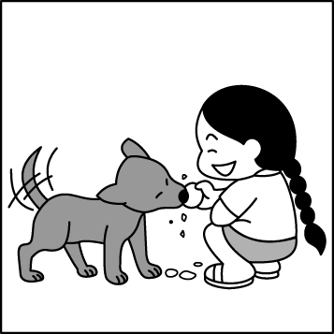 | 2.   | 3.  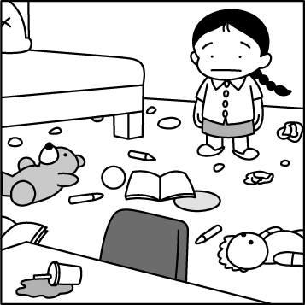 | 4.  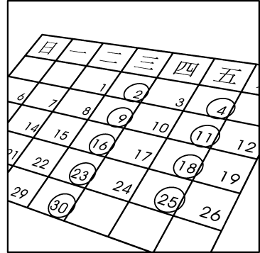 | 5.  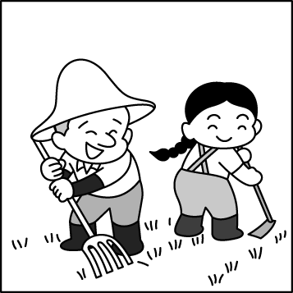
0
（II） 選出適當的答句或回應句。(共5題/每題2分)
6.(Ａ) I was in the park then. (Ｂ) I am doing homework at Amy’s home. (Ｃ) I was at school an hour ago.
7.(Ａ) No, we weren’t. (Ｂ) Yes, you were. (Ｃ) No, they weren’t.
8.(Ａ) No, there weren’t. (Ｂ) No, they weren’t. (Ｃ) Yes, there are.
9.(Ａ) The frogs there are cute. (Ｂ) It was open many years ago. (Ｃ) Now we can have dinner there.
10.(Ａ) Yes, their legs were short. (Ｂ) Yes, they are very cute. (Ｃ) No, they are hungry.

（III） 根據對話內容，正確的選 A，錯誤的選 B。(共5題/每題2分)
11. People go to Japan only for concerts.
12. The family go to Japan in February.
13. The family go to Japan twice a month.
14. Fuji Mountain is famous for its snow.
15. There is snow in Fuji Mountain in September.

Part II. Reading Comprehension 閱讀測驗 （70 %）(每題2分)
- 下列各題請依題意選出一個正確或最適當答案。
16. Look at that ___ cloud. It may rain later.
(A) dark (B) wet (C) beautiful (D) early
17. Good morning, everyone. Welcome to today’s ___ report.(報導)
(A) week (B) month (C) season (D) weather
18. A: What time do you ___ your dog? B: At about 6:30 a.m. and 7: 00 p.m. He doesn’t eat lunch.
(A) walk (B) keep (C) feed (D) wash
19. Andy, my brother, often does many things for us. He is really a great ___ to our family.
(A) vet (B) pet (C) help (D) friend
20. Tom and I are good friends. I always give(給) him a ___ welcome.
(A) warm (B) cold (C) whole (D) lifetime
21. A frisbee is like a ___, but you don’t have to worry about breaking(打破) it.
(A) river (B) pond (C) garden (D) plate
22. I ___ eat breakfast before 6 a.m., but I do it after 8 a.m. on weekends.
(A) always (B) never (C) seldom (D) often
23. Philip goes to the gym every two months. He goes there ___.
(A) twice a month (B) two months a year (C) six times a year (D) twice a season
24. A: ___ were you then? B: I was 19 then.
(A) How old (B) How many (C) How tall (D) How long
- I can take my new umbrella ___ me.
(A) to (B) for (C) of (D) with
- Hehuanshan is famous ___ its beautiful flowers and snow.
(A) on (B) for (C) with (D) about
【背面有題】
- A: ___ you home last night? B: No, I ___ at my grandparents’ new house.
(A) Were; wasn’t (B) Are; am (C) Were; was (D) Are; am not
- Which is correct(正確的)?
(A) We have a lot snow here in January. (B) It’s snowy a lot here in January.
(C) It’s a snowy day here in January. (D) There’s lots of snow here in January.
- A: Does your sister often get up late? B: No, ___
(A) she often does. (B) she seldom does. (C) she never is. (D) she doesn’t often
- Jenny’s aunt was here in Linyuan ___ ago.
(A) in 2011 (B) one month (C) last week (D) yesterday
- I’m not always on time. 最接近以下何句的意思?
(A) I’m never on time. (B) I am always late.
(C) I am sometimes late. (D) I am seldom on time.
- Peter: Taiwan is so beautiful. Bill: ____ I like Taiwan, too.
(A) Sure I do! (B) Come on! (C) I see! (D) You can say that again!
- Jane: Do you have a lot of rain here in summer? Carl: Not really. ____
(A) It’s usually sunny and dry. (B) It’s always a wet season.
(C) It sometimes rains a lot. (D) It’s rainy here in summer.
- Lily: It’s raining, and I am wet. Tina: ____
(A) I see. Get an umbrella now. (B) Here’s a dry towel for you.
(C) I hate rain, too. (D) Yes, it’s a rainy day.

(II) 下列題組請根據文意選出一個正確或最適當答案。
【35~38】
( Max and Ken are looking at a 35. )
Max: Look at this 36. in your arms! So beautiful!
Ken: That’s my pet, Mary.
Max: Really? She was so small. How old was she 37. ?
Ken: Umm….maybe two or three months old.
Max: Where were you two in the picture?
Ken: We were at my grandparents’ house.
Max: Your grandparents’ house is very big.
Ken: Well…that was their old house. They 38. there now.
35. (A) movie (B) pond (C) picture (D) girl
36. (A) baby (B) tadpole (C) skin (D) dog
37. (A) before (B) ago (C) then (D) yesterday
38. (A) live (B) weren’t (C) don’t live (D) are

Many people do not like rainy days but I really 39. it. I love watching and listening to the raindrops. It makes me feel very relaxed.
On rainy days, I like watching people walk under my window. It is fun to see all their
40. from my house on the tenth floor. They are just like flowers. I also love sitting by the window and drinking some hot tea. It is comfortable to be at home . I can do many things, 41. surfing the Net, watching TV or even reading books. I 42. feel bored. I love rainy days.

# raindrop雨滴 / make使… / feel感覺 / relaxed放鬆的 / fun有趣 / floor樓層 comfortable / bored無聊的

【39~42】

39. (A) need (B) want (C) hate (D) love
40. (A) heads (B) hair (C) hats (D) umbrellas
41. (A) like (B) of (C)with (D)for
42. (A) always (B) usually (C) often (D) never

【43~45】
Everyone has a favorite season. Fall is my mother’s favorite one. She loves to go to Alishan and see the trees at the beginning of fall. The leaves all turn orange, red, and yellow. It is so beautiful. Every year, my whole family go there. My sister and I like to go there because we can run and play outside. We really enjoy the fresh air. My dad also likes to go there because the whole family can be together. We usually go there in Dad’s car. It is about four hours to get there from our house. On the way, We listen to music, tell stories, and talk. Sometimes, we are tired, and my mom, my sister and I sleep in the car. But my dad can’t sleep. He is the driver!

# Alishan 阿里山 / beginning 開始 / leaves葉子 / turn轉變 / outside外面 / fresh 新鮮的
because 因為 / way途中 / tired 疲倦的

43. Why does the author’s sister like to go to Alishan?
# author 作者
(A) She likes to see the trees. (B) She likes to eat the oranges.
(C) She likes the mountain air. (D) She likes to sleep in the car.
- Today they start at 9:00 a.m. When may they get to Alishan?
# start 出發
(A) At about 1:00 p.m. (B) At about 2:00 p.m.
(C) At about 11:00 a.m. (D) At about 12:00 p.m.
- Why can’t the author’s dad sleep on the way?
# why 為何
(A) He has to tell stories. (B) He has to drive.
(C) He likes to see the trees. (D) He can’t sleep well in the car.

【46~50】
Perry: Hey, where were you last night? I was worried about you!
Camilla: Oh? I went to the movies with Eleanor at about 7:20 p.m.
Perry: Who is she?
Camilla: She was my classmate in elementary school. We were best friends in class.
Yesterday was her birthday, so we went to eat hamburgers, French fries, and fried chicken at McDonald’s after class. Then we went to the movies together.
Perry: Oh, I see! I was 49. you.
Camilla: What was wrong?
Perry: I was home alone last night and I was a little sad.
Camilla: Oh, that’s too bad! Are you OK now?
Perry: I think so.
# went “go”的過去式 / elementary school小學 / theater戲院 / What was wrong? 怎麼了？
alone 獨自 / a little 一點 / look for 尋找

46. Why was Perry looking for Camilla?
(A) He was not happy. (B) He was so great.
(C) He was sick. (D) He was happy.

【背面有題】
47. Where was Camilla last night?
(A) At home. (B) In the supermarket.
(C) In a movie theater. (D) In the bookstore.
48. Was Camilla alone last night?
(A)Yes, she went to eat dinner alone.
(B) No, she went to the library with Perry.
(C) Yes, she went to the elementary school alone.
(D) No, she went to McDonald’s with her best fried.
49. (A) looking for (B) listening to (C) going to (D) looking at
50. How is Perry now?
(A) Too bad. (B) Not so good. (C) So sad. (D) OK.

國一英文解答：
1. | 2. | 3. | 4. | 5. | 6. | 7. | 8. | 9. | 10. | 11. | 12. | 13. | 14. | 15.
C | A | B | C | A | A | A | A | C | B | B | B | B | A | A
16. | 17. | 18. | 19. | 20. | 21. | 22. | 23. | 24. | 25. | 26. | 27. | 28. | 29. | 30.
A | D | C | C | A | D | D | C | A | D | B | C | D | B | B
31. | 32. | 33. | 34. | 35. | 36. | 37. | 38. | 39. | 40. | 41. | 42. | 43. | 44. | 45.
C | D | A | B | C | D | C | C | D | D | A | D | C | A | B
46. | 47. | 48. | 49. | 50.
A | C | D | A | D

錄音稿：(１)(Ａ) The dog doesn’t eat anything.
(Ｂ) The dog plays the frisbee.
(Ｃ) The girl feeds the dog.
(２)(Ａ) The boy is always full after dinner.
(Ｂ) The boy is hungry before dinner.
(Ｃ) The boy always buys a lot of food.
(３)(Ａ) The girl’s room is very clean.
(Ｂ) The girl seldom cleans her room.
(Ｃ) There is always lots of food in the room.
(４)(Ａ) I always study English.
(Ｂ) I study English once a week.
(Ｃ) I study English every Wednesday and Friday.
(５)(Ａ) Kelly helps her dad on the farm.
(Ｂ) Kelly sells the milk at the market.
(Ｃ) Kelly always plays under the tree.
錄音稿：(6) Where were you last night?
(7) Were you and Susan busy yesterday?
(8) Were there any trees here before?
(9) The restaurant in front of your house is new.
(10) Do you see the tree frogs there?
11~15.
錄音稿： Many people go to Japan every year. Some go there for concerts. Some go there for famous singers. Some go there for beautiful mountain flowers. My family take me there every January and August. We go to Fuji Mountain. It is famous for its snow. It snows from April to October. I like there very much. We play with snow and make snowmen. We have a good time there.

