高雄市立林園高級中學 國中部 100學年度 第二學期二年級 英文科 第一次段考考卷
_________________________________________________________________________________________________________________________________________________________
第一部分:聽力練習(共30分) ※請把答案寫在答案卷上，再交出答案卷。※
- 選出出現在CD句中的單字： (10分)
1.(A) hard (B) someone (C) notice (D) cheering
2.(A) prince (B) gets (C) practice (D) tryout
3.(A) dare (B) excited (C) eat (D) medicine
4.(A) appear (B) grab (C) once (D) taste
5.(A) fall (B) legs (C) win (D) forgot

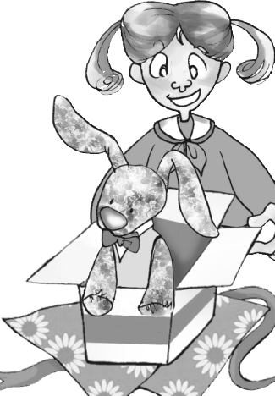
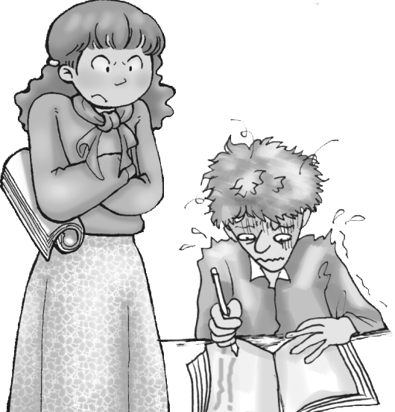
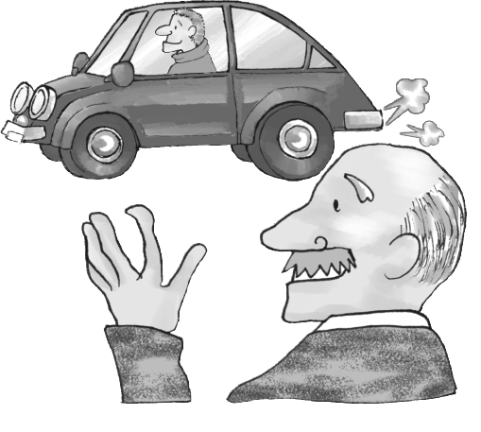
二、聽CD的二個敘述，勾選出符合圖片的句子：(10分)
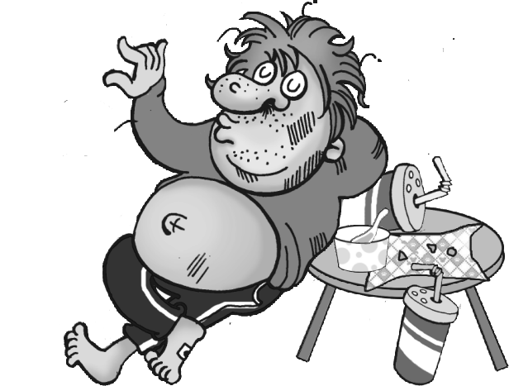
1. 2 3 4 5

A ( )B ( ) A ( )B ( ) A ( )B ( ) A ( )B ( ) A ( ) B ( )

三、聽Tina跟Matt的對話，判別下列描述的對(圈T)與錯(圈F)：(10分)
T F 1. Tina has only one brother.
T F 2. Tina's brother's birthday is this Wednesday.
T F 3. Tina's brother's birthday is on June 18th.
T F 4. Tina's brother is 17 years old.
T F 5. Tina's brother is quiet.

第二部分:筆試試題(共70分)
- 對話克漏字選擇(10分)
( Cindy and Billy are talking about Lisa's birthday party. )
Cindy: If I get an invitation, I'll go! 1.
Billy: Me too! If we 2. , we'll 3. a great party!
Cindy: But if we plan to go, we'll need to prepare some gifts for Lisa.
Billy: Oh, I have one for her already. By the way, who 4. us to the party if it rains?
Cindy: My brother. He can drive, and he has a car.
Billy: That 5. great!  invitation 邀請 by the way 對了
1. (A) Who will go to the party? | (B) Where is it? | (C) What about you? | (D) When is the party?
2. (A) don't go | (B) didn't go | (C) won't go | (D) couldn't go
3. (A) give | (B) miss | (C) visit | (D) have
4. (A) takes | (B) is taking | (C) took | (D) will take
5. (A) sounds | (B) looks | (C) tastes | (D) smells

- 閱讀測驗(10分)
Dear Terry:
I saw your grades, and I’m not happy. Your father and I want to have a talk after he comes home. When you get home from school, take out the trash. Then water the flowers and do your homework. Don’t forget to tell Ben not to come tonight. You need to do your homework. No video games or computer games. Your father and I will do something about your grades.
See you tonight,
Mom
1. What did Terry’s mom have Terry do after school?
(A) Talk with her. | (B) Buy some flowers. | (C) Finish his homework. | (D) Meet Ben at his house.
＊背面尙有試卷，請繼續作答。＊
2. What time may Terry take out the trash?
(A) 5:50 a.m. | (B) 6:10 p.m. | (C) 6:30 a.m. | (D) 11:00 p.m.
3. Which is NOT true?
(A) Terry’s mom wants Sam’s friend not to come over. | (B) Terry’s parents didn’t tell Sam to do the dishes.
(C) Terry did badly on the tests. | (D) Terry’ s mom won’t be glad if Sam gets good grades.
4. Why was Terry’s mom not happy?
(A) Because Terry’s good grades. | (B) Because Terry didn’t do his homework.
(C) Because Terry didn’t listen carefully. | (D) Because Terry got bad grades.
5. Who did Terry’s mom ask not to come tonight?
(A) Terry’s friend, Ben. | (B)Terry’s teacher. | (C) Terry’s father. | (D) Nobody.

六、文法選擇(20分)
1. When did you see Mrs. Lin with a young man in the hotel?
(A) to talk | (B) talking | (C) talked | (D) talks
2. Don’t you think the table looks like ?
(A) a frog | (B) soft | (C) heavily | (D) well
3. If you late again, you’ll have to clean the car.
(A) will be | (B) came | (C) are | (D) coming
4.Andy likes to read comic books. They always make him a lot.
(A) laughing | (B) laughed | (C) laugh | (D) to laugh
5.Dad me not to run around.
(A) let | (B) made | (C) had | (D) asked
6. Jeremy is very tall, and he is the basketball team now.
(A) of | (B) on | (C) in | (D) with
7.The teacher says, “ The student will the mistake.”
(A) pay for | (B) put on | (C) look at | (D) turn off
8. You have to be careful you ride a bike.
(A) with | (B) so | (C) when | (D) before
9. Alex was excited after .
(A) he will dance with Jenny | (B) Kate invited him to the party
(C) he watches the magic show | (D) he is talking on the phone
10. Before you go outside, remember to the jacket.
(A) turn off | (B) turn on | (C) put on | (D)get on

七、文意字彙(20分)
1. It is not p e to talk with your mouth full.
2. I want you all to be q t and listen carefully.
3. Tomorrow will be the last c e to see the movie star.
4. All the evidences p t to the same suspect. evidence證據 suspect嫌疑犯
5. Jeremy Lin is a f s basketball player.
6. How many c es will you put on the woman’s birthday cake?
7. We will visit England and stay in an old c e in the country.
8. Sue d ped her glasses when she was at the party last night.
9. “May I b w your cell phone for a minute,Mom?” Sam asked.
10. The teacher agreed to l d her student a new dictionary.

八、整句翻譯(10分) （每題2分，分段給分。）
1. 你想要其他的學生注意到你跳舞以及帶領歡呼加油嗎？
2. 我們正在尋找幾個勤勞努力、活潑外向且願意幫忙的學生。
3. 這不會花任何錢，而且你只要花一點點時間參與選拔。
4. 在你要試著救其他人之前，想想我說的話。
5. 假如有任何人可以治癒我女兒，他將可成為她的丈夫。

※試題結束，請交出答案卷。※

高雄市立林園高級中學 國中部 100學年度 第二學期二年級 英文科 第一次段考答案卷
班級: 姓名: 座號: 分數:
第一部分:聽力練習(共30分)
一、選出出現在CD句中的單字：(10分)
1 | 2 | 3 | 4 | 5

- 聽CD的二個敘述，勾選出符合圖片的句子：(10分)
1A ( )B ( ) | 2 A ( )B ( ) | 3A ( )B ( ) | 4A ( )B ( ) | 5A ( )B ( )

三、聽Tina跟Matt的對話，判別下列描述的對(圈T)與錯(圈F)：(10分)
1 T F | 2 T F | 3 T F | 4 T F | 5 T F

第二部分:筆試試題(共70分)
- 對話克漏字選擇(10分)
1 | 2 | 3 | 4 | 5

- 閱讀測驗(10分)
1 | 2 | 3 | 4 | 5

六、文法(20分)
1 | 2 | 3 | 4 | 5
6 | 7 | 8 | 9 | 10

七、文意字彙(20分)
1 | 2 | 3 | 4 | 5
6 | 7 | 8 | 9 | 10

八、整句翻譯(10分) （每題2分，分段給分。）
1

2

3

4

5

高雄市立林園高級中學 國中部 100學年度 第二學期二年級 英文科 第一次段考 聽力測驗解答
本測驗內容將唸2 遍，聽力測驗開始：
一、選出出現在CD句中的單字：。
CD出處：（合聲國中英語 聽力診斷題庫完全手冊 第四冊 Review I A、發音題型二、選出出現在CD句中的單字）

CD內容：一、選出出現在CD句中的單字：
1. I can hear someone knocking on the door.
2. My father often makes me practice the violin.
3. Don’t forget to take the medicine.
4. Once upon a time, there was a boy. He had a golden bird.
5. Don’t fall to your knees. I won’t forgive you
二、聽CD的二個敘述，勾選出符合圖片的句子：

CD出處：（合聲國中英語 聽力診斷題庫完全手冊 第四冊 LESSON2 C、圖片題型二、聽CD的二個敘述，勾選出符合圖片的句子：
CD內容：二、聽CD的二個敘述，勾選出符合圖片的句子：
1. A: Lily likes to play with the doll when she has free time.
B: Lily was happy when she opened the box.
2. A: After Robert knocked on the door, I opened it.
B: I saw Robert when I went jogging.
3. A: Todd’s mom became angry when he didn’t finish his homework on time.
B: Todd finished his homework before dinner.
4. A: Mr. Anderson didn’t get well after his son drove him to see the doctor.
B: Bob went out after he said goodbye to his father.
5. A: He still felt hungry after he had his lunch.
B: He needs to exercise.

- 聽Tina跟Matt的對話，判別下列描述的對(圈T)與錯(圈F)
CD出處：（合聲國中英語習作聽力p61：)
CD內容三、聽Tina跟Matt的對話，判別下列描述的對(圈T)與錯(圈F)：(10分)

Matt: Hi, Tina. How many brothers and sisters do you have?
Tina: I have only one brother. His name is Peter. Guess what? His birthday is this Thursday.
Matt: Really? So his birthday is on June 8th, right?
Tina: That's right.
Matt: How old is he?
Tina: He's seventeen years old.
Matt: What's your brother like?
Tina: Well, I think he's funny, and he's very helpful.

Q1. Tina has only one brother.
Q2. Tina's brother's birthday is this Wednesday.
Q3. Tina's brother's birthday is on June 18th.
Q4. Tina's brother is 17 years old.
Q5. Tina's brother is quiet.

本測驗內容結束。

高雄市立林園高級中學 國中部 100學年度 第二學期二年級 英文科 第一次段考解答卷
第一部分:聽力練習(共30分)
一、選出出現在CD句中的單字：(10分)
1  B | 2  C | 3  D | 4  C | 5  A
二、二、聽CD的二個敘述，勾選出符合圖片的句子： (10分)
1  A ( ) B ( ✓ ) | 2  A ( ✓ ) B ( ) | 3  A ( ✓ ) B ( ) | 4  A ( )B ( ✓ ) | 5  A ( ) B ( ✓ )
三、聽Tina跟Matt的對話，判別下列描述的對(圈T)與錯(圈F)：(10分))
1 T F | 2 T F | 3 T F | 4 T F | 5 T F

第二部分:筆試試題(共70分)
四、對話選擇(10分)
1.  C | 2.  A | 3.  B | 4.  D | 5.  A

五、閱讀測驗(10分)
1.  C | 2  B | 3.  D | 4.  D | 5.  A

- 文法(20分)
1.  B | 2  A | 3.  C | 4.  C | 5.  D
6.  B | 7.  A | 8.  C | 9.  B | 10.  C

- 文意字彙(20分)
1.  polite | 2.  quiet | 3.  chance | 4.  point | 5.  famous
6.  candles | 7.  castle | 8.  dropped | 9.  borrow | 10.  lend

八、整句翻譯(10分)（每題2分，分段給分。）
1. （Do you want other students to notice）( you dancing and leading the cheers?)

2.( We are looking for several hard-working,)( outgoing, and helpful students. )

3.( It doesn't cost anything,)( and you only have to spend a little time trying out.)

4.( Before you try to save anyone else,)( think about my words. )

5.( If anyone can cure my daughter, )(he will be her husband. )

