高雄市立林園高級中學 國中部100學年度 第二學期 二年級 英文科第二次段考考卷
範圍：L4~Review II 班級： 姓名： 座號：
壹：聽力評量（30%）
- 聽CD的兩個敘述，寫出符合圖片的答案代號10％
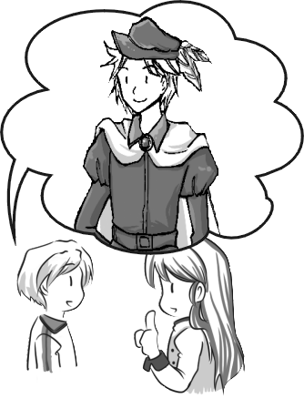
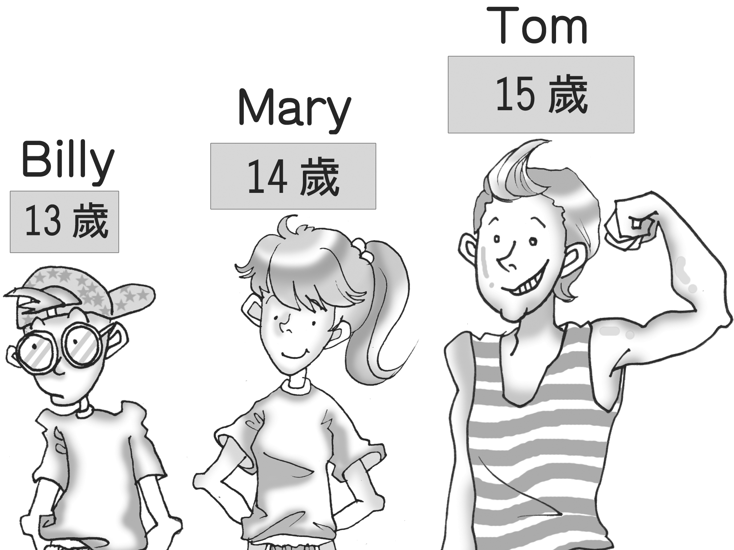
1. 2. 3. 4.
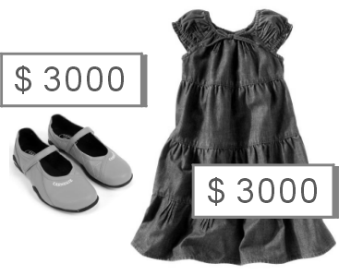


5.
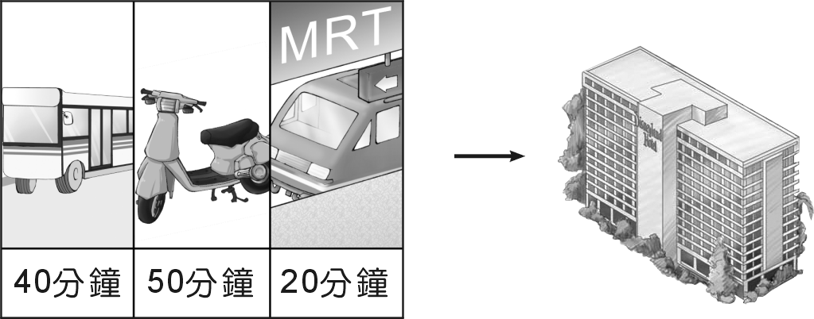

二、聽CD的對話，寫出符合的答案代號10％
( ) 1. A: The woman gave the wrong answer.
B: The woman can’t answer the question at once.
( ) 2. A: The man is going to take a driving test.
B: The man did well on the driving test.
( ) 3. A: The white dog is the thinnest.
B: The white dog is the youngest.
( ) 4. A: The man’s camera is cheaper than the woman’s.
B: The man’s camera is more expensive than the woman’s.
( ) 5. A: The boy got more candy than the girl.
B: The girl got more candy than the boy.
三、聽CD的短文後，回答下列問題10％
( ) 1. (A) Karen’s cousin. (B) Karen’s friend. (C) Karen’s brother. (D) Karen’s dad.
( ) 2. (A) It looks cuter than the pink one. (B) It’s cheaper than the pink one. (C) It looks nice.
(D) It looks more modern than the pink one.
( ) 3. (A) In a library. (B) In a department store. (C) At a birthday party. (D) At school.
( ) 4. (A) He likes watches. (B) He needs one to notice the time. (C) His mom doesn’t have one.
(D) He doesn’t have to spend too much money.
( ) 5. (A) A bag. (B) A pretty watch. (C) A nice pair of shoes. (D) A blue dress.

貳：書寫評量（70%）
一、文意字彙10%
_________ 1. If you want to keep healthy, you must have c t eating habits and enough sleep. habit習慣
_________ 2. I think the tail of the dog is about 15 c rs long.
_________ 3. There are eight p ts in solar system. Jupiter is the largest one.
solar system太陽系 Jupiter木星
_________ 4. People can’t d r just like that. I think the man is somewhere in the house. somewhere某處
__________ 5. Tickets are $450 for a ts and $300 for children.
__________ 6. I’ll ask Sam to take me to visit some famous s ts in New York after I get there.
__________ 7. Jane is kind and friendly, so she is p r with her classmates.
__________ 8. Sally was excited because she won the n l dancing contest yesterday. contest比賽
__________ 9. The movie is about special creatures from the o n. They lived under the water 2,000 years
ago.
__________ 10. It’s s g that Sandy came earlier today. She’s always late for school.

二、文法選擇20%
- If there are _______ people driving, we will have cleaner air.
(A) fewer and fewer (B) less and less (C) little and little (D) more and more
- I have ______ money than you, but I am _______ than you.
(A) more; happily (B) little; very happier (C) fewer; more happily (D) less; much happier
- This is Mr. Hudson’s ______ book. It just came out ______ Friday.
(A) lately; last (B) later; late (C) latest ; last (D) late; latest
4. It was cloudy in the morning. Then in the afternoon the weather got _______ and it started to rain.
(A) badly (B) more bad (C) more badly (D) worse
5. Jane is fifty years old. Jessica is thirty years old.
(A) Jane is as young as Jessica. (B) Jane is not as old as Jessica. (C) Jane is older than Jessica.
(D) Jane is younger than Jessica.
6. 選出錯誤的句子。
(A) Amy is more beautiful than any other girl on the team.
(B) Amy is the most beautiful girl on the team.
(C) Amy is more beautiful than else everyone on the team.
(D) Amy is more beautiful than all the other girls on the team.
7. Lisa just learned ______ her best friend is going to move.
(A) that (B) although (C) when (D) however
8. Sarah: Hello, this is Jason . May I speak to Sam?
Jenny: Sorry. ______________. 選出最不恰當的回答。
- I’m afraid you have the wrong number.
- He left for New York last night.
(C) Just leave the door open.
(D) He’s busy now. I’ll ask him to call you back later.
9. I don’t think Chinese is _____ important than English. They are both useful.
(A) better (B) less (C) not as (D) the more
10. Alex wants to lose weight. He’s trying to exercise _____ and eat ______.
(A) less; more (B) more; less (C) fewer; less (D) less; fewer

三、挑錯並改正10%(（每題兩分，選項及訂正部分全對才給分）
( ) _________ 1. The water on the ground changes to very thin ice because the low temperature.
(A) (B) (C) (D)
( ) _________ 2. Jenny was the sad of the three people when they heard the bad news.
(A) (B) (C) (D)
( ) _________ 3. Sandy is the tallest girl but she always has the little food in her class.
(A) (B) (C) (D)
( ) _________ 4. A: I spent $30,000 buying the bicycle. B: Wow, your bicycle is more expensive than I.
(A) (B) (C) (D)
( ) _________ 5. By make sounds, blue whales can communicate with each other in the water.
(A) (B) (C) (D)
四、克漏字選擇 10%
“Night Market” is a special culture in Taiwan. There are some night markets in every city.
Fengchia Night Market is 1 famous in Taichung. During the night, people always talk 2
and vendors work hard. You can not only eat all kinds of food in Taichung but also find something
interesting. Most important of all, the things there are 3 than those at other places. However,
shoppers must be very 4 because some people sell fakes. The streets are busy, so cars run as
slowly as snails. 5 you want to have a good time at Fengchia, go there on foot.
culture文化 vendor小販 not only…but also不只…而且… fake冒牌貨 snail蝸牛
( ) 1. (A) the more (B) the most (C) much (D) such a
( ) 2. (A) noisily (B) noisy (C) noise (D) noisier
( ) 3. (A) much cheaper (B) more cheaper (C) the cheapest (D) very cheap
( ) 4. (A) carefully (B) more careful (C) careful (D) more carefully
( ) 5. (A) That (B) If (C) In this way (D) Even
五、閱讀測驗10%
(一) Look at the notice and answer the questions.
Pet Dog | Cindy’s dog | Tom’s dog | Andy’s dog | Mary’s dog
price | NT$15,000 | NT$30,000 | NT$45,000 | NT$20,000
color | white | yellow | black | brown
size | small | medium | large | medium
weight | 5 kg | 10 kg | 15 kg | 10 kg
age | 2-year-old | 8-month-old | 1-year-old | 20-month-old

1. Which is the heaviest of all the dogs?
  - Tom’s dog. (B) Mary’s dog. (C) Andy’s dog. (D) Cindy’s dog.
- Which is the oldest of all the dogs?
  - The brown dog. (B) The black dog. (C) The white dog. (D) The yellow dog.
- Which is true about the notice?
  - The black dog is smaller than the yellow one.
  - The yellow dog is the cheapest of all.
  - The brown dog costs less than the black one.
  - The yellow dog is not as heavy as the brown one.
(二)
Lily’s Bookstore ＊ Anniversary Sale！ Dec.1 ~ Dec. 31
Items | Usual Price | Anniversary Sale
Comic books | NT$300 each | 20% off
Storybooks | NT$200 each | 30% off
Magazines | NT$150 each | 20% off
Dictionaries | NT$500 each | 40% off
Albums | NT$400 each | 20% off
CDs | NT$300 each | 30% off
Open: Tue. ~ Sun. 10:30 a.m. ~ 10:00 p.m.
＊item項目 album專輯 anniversary週年慶 usual平常的
- Which is the most expensive during the anniversary sale?
(A) An album. (B) A comic book. (C) A dictionary. (D) A CD.
- Helen bought one dictionary and four storybooks on December 5. How much did she pay?
(A) More than NT$1,000. (B) At least NT$900. (C) Less than NT$800.
(D) Less than NT$900.

六、翻譯10%【每題兩分，分段給分】
1. 捷運是到體育館最方便的方式。
2. 當工程師要比當律師有趣。
3. 在過去，人們相信地球是平的。
4. 人們很驚訝風能移動那些石頭。
5. 雖然昨天下著雪，Lisa仍然去慢跑。（Even…., Lisa….）

高雄市立林園高級中學 國中部100學年度 第二學期 二年級 英文科第二次段考答案卷
範圍：L4~Review II 班級： 姓名： 座號：
- 聽力評量30%
一、聽CD的兩個敘述，寫出符合圖片的答案代號10％
1. | 2. | 3. | 4. | 5.
二、聽CD的對話，寫出符合的答案代號10％
1. | 2. | 3. | 4. | 5.
三、聽CD的短文後，回答下列問題10％
1. | 2. | 3. | 4. | 5.
- 書寫評量70%
一、文意字彙10%
1. | 2. | 3. | 4. | 5.
6. | 7. | 8. | 9. | 10.
二、文法選擇20%
1. | 2. | 3. | 4. | 5.
6. | 7. | 8. | 9. | 10.
三、挑錯並改正10%(（每題兩分，選項及訂正部分全對才給分）
1.  ( ) ____________ | 2.  ( ) ____________ | 3.  ( ) ____________ | 4.  ( ) ____________ | 5.  ( ) ____________

四、克漏字選擇 10%
1. | 2. | 3. | 4. | 5.
五、閱讀測驗10%
1. | 2. | 3. | 4. | 5.
六、翻譯10%【每題兩分，分段給分】
1.

2.

3.

4.

5.

