高雄市立林園高級中學 國中部 100學年度 第二學期二年級 英文科 第三次段考考卷
______________________________________________________________________________________________
- 請把答案畫在答案卡上，再交出答案卡。※

第一部分:聽力練習(共30分)
- 聽CD的二個敘述，選出符合圖片的句子：(10分)
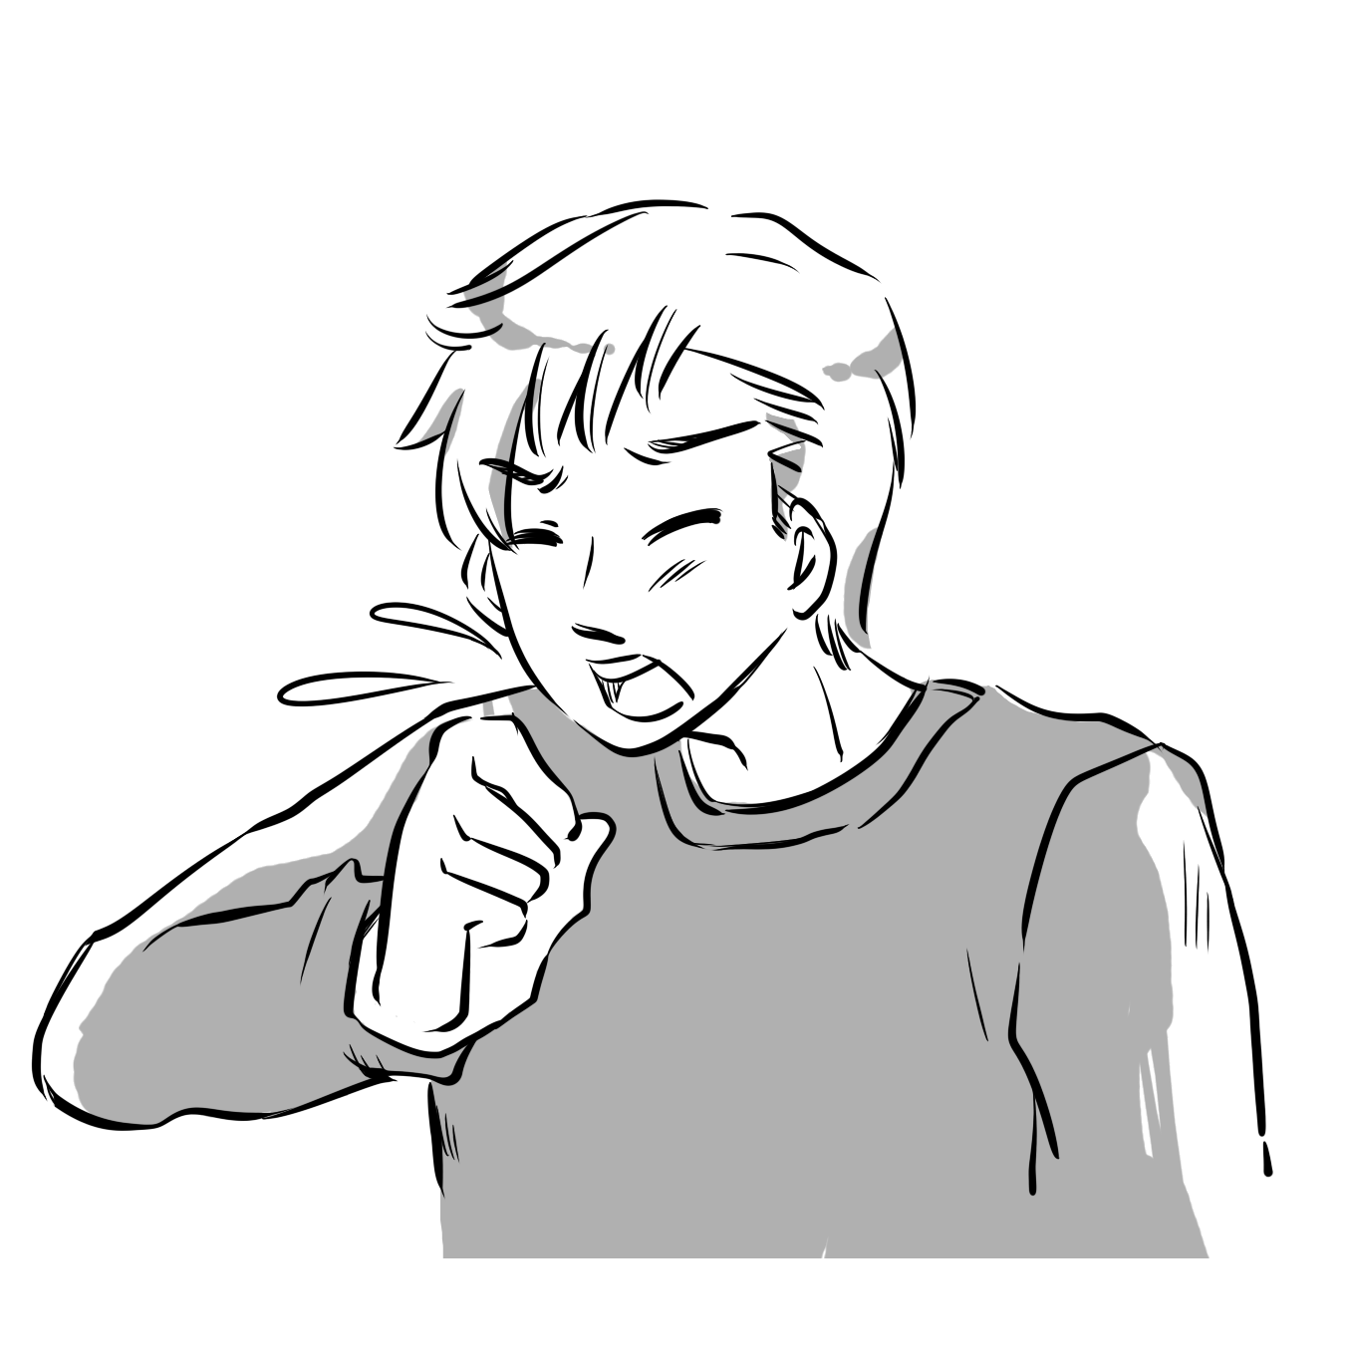
. 1 2 3 4 5
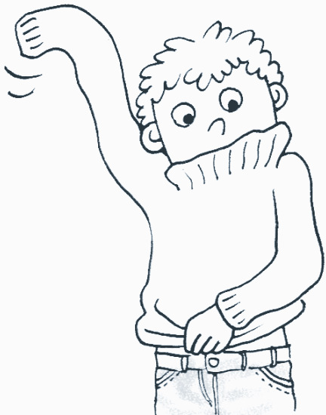
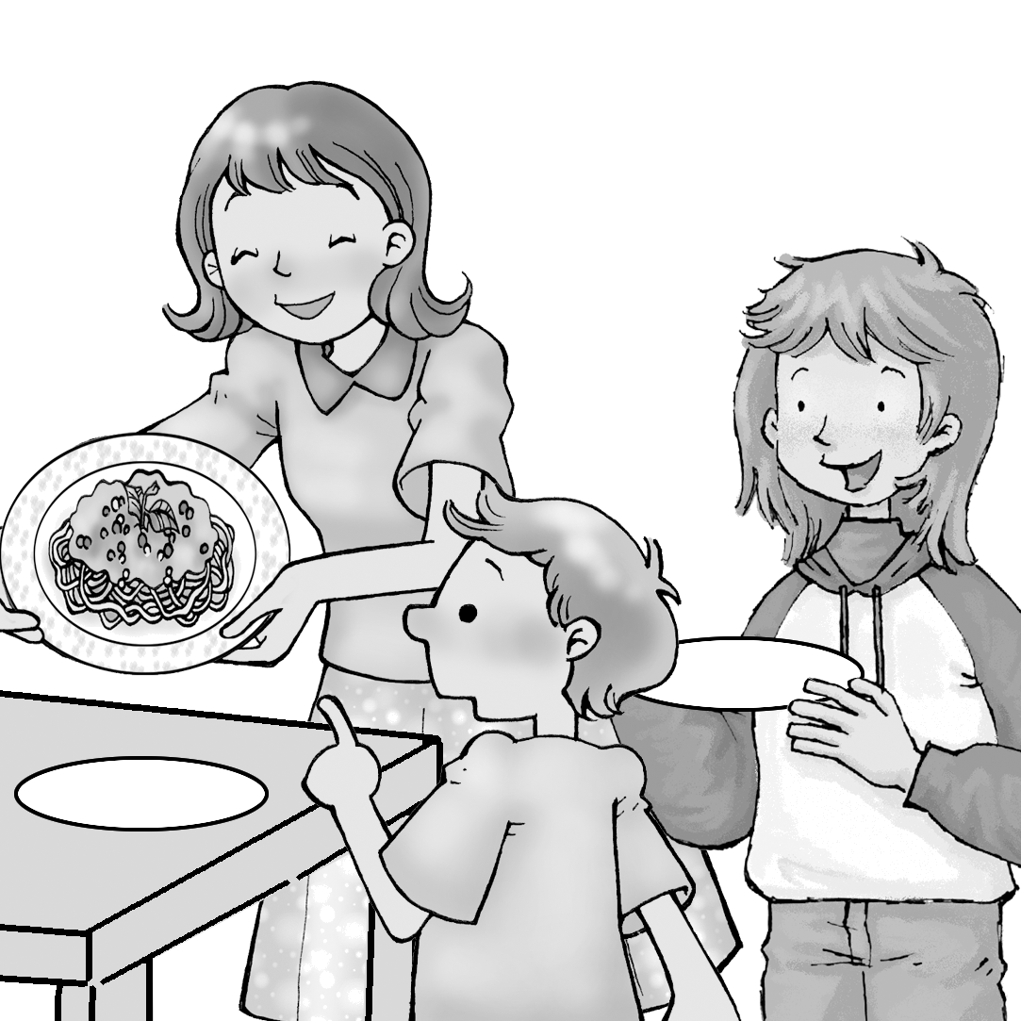
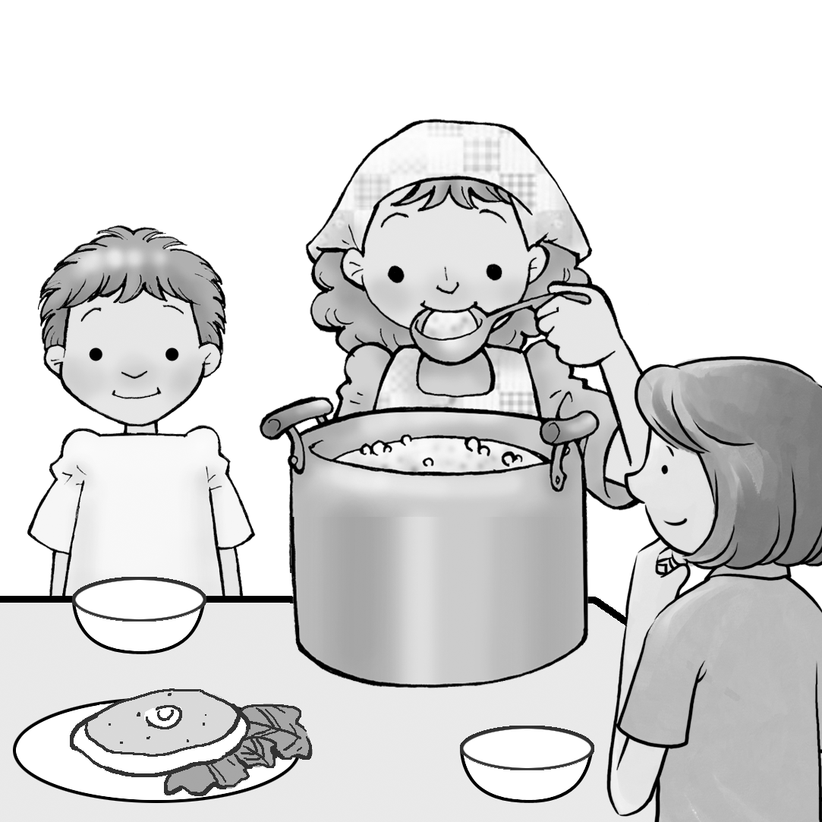
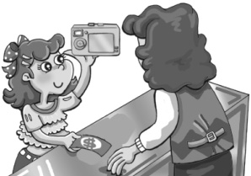
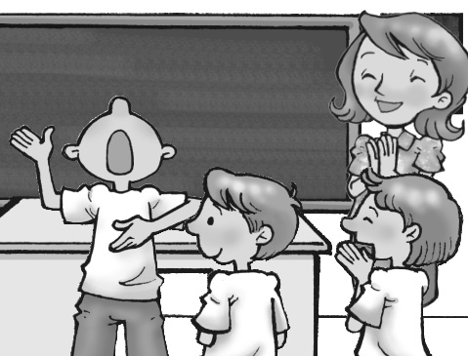

A ( ) B ( ) A ( )B ( ) A ( ) B ( ) A ( ) B ( ) A ( )B ( )

二、聽CD的對話，選出正確的句子：(10分)
6.( A): The woman will pick up the man.
(B): Billy will pick up the man.
7. (A): The woman got an apartment from Mr. Peterson.
(B): The woman borrowed a sports car from Mr. Peterson.
8. (A): The shoes are not comfortable for the woman to wear.
(B): The woman will take the larger shoes.
9. (A): Simon is sad because he didn’t pass the test.
(B): Simon is worried about his test.
10. (A): Only drinking water makes the woman slim.
(B): Eating a lot of fruit makes the woman’s skin look beautiful.
三、聽CD的短文後，回答下列問題：(10分)
11. (A) 22 years old. (B) 12 years old. (C) 10 years old. (D) We don’t know.
12. (A) Motorcycle. (B) Music. (C) Books. (D) Fish dish.
13. (A) Baseball. (B) Tennis . (C) Badminton. (D) Basketball.
14. (A) Play the piano. (B) Ride a motorcycle to the beach. (C) Swim. (D) Reading.
15. (A) The writer met Emily when she was a kid.
(B) Both of them are good at math.
(C) They seldom call each other now because they are not in the same school.
(D) Both of them can play the guitar.

第二部分:筆試試題(共70分)

四、單字選擇：(20分，每題2分)
16. After a long discussion, our classmates to take a trip to Taipei.  discussion討論
(A) keep (B) decide (C) check (D) cough
17.Alex can’t work today because he has a fever and a .
(A) medicine (B) prescription (C) temperature (D)headache
18.Don’t , Sally. It’s just a bad cold. (課本L7p83)
(A) worry (B) scared (C) break (D) melt
19.What time will you in town? (課本L9p112)
(A) fix (B) arrive (C) point (D) leave for
20. Eating mangos gives you not only healthy skin but also good . (課本L8p96)
(A)exercise (B) fiber (C) eyesight (D) weight
21. In summer, I like to eat _________because they are sweet and juicy.
(A) guavas (B) watermelons (C) papayas (D) lemons
22.At the cinema, we met Alic. She sold there. (課本L9p109)
(A) freezers (B) snakes (C) fingernails (D) popcorn
23. I didn’t do well on the test. My are very poor.
(A)grades (B) grapes (C) groups (D) grams ＊背面尙有試卷，請繼續作答。＊
24.Peter was so that he cheated in the exam.
(A) smart (B) stupid (C) dark (D) lucky
25.My roommate and I did have many things in . For example, we both like rock and roll music.
(A) excited (B) difference (C) common (D) heart (課本L9p108)

五、文法選擇：(20分，每題2分)
26. Because of Jermery, many people are in basketball now.
(A) interested (B) interest (C) interesting (D) interests
27. Not only Terry but also his brother a big basketball fan.
(A) is (B) are (C) were (D) to be
28. My job is exciting. So is .
(A) me (B) my (C) mine (D) I
29. Sally was writing something someone called.
(A) if (B) after (C) when (D) though
30. After you drink a lot of wine, you shouldn’t .
(A) driving (B) to drive (C) drove (D) drive
31. The movie is boring, so I feel bored _______ it.
(A) at (B) with (C) to (D) in
32. Mike, remember to the lights before you leave.
(A) turn off (B) turn off it (C) take it off (D) take off it
33. Most people know Taiwan is famous its tea and night marktes.
(A) by (B) on (C) for (D) to
34. Tina can’t swim,and can Alex.
(A) neither (B) either (C) so (D) too
35. It’s not good to stay up late ___________ the net.
(A) get (B) surfing (C) surf (D) getting

六、克漏字選擇： (10分，每題2分) (習作p48)
Manners are different in every country. For example, in Japan, you have to 36. your shoes before you go into someone's house. But in America, you don't need to dothis. And 37. you eat a meal, do you finish everything? In some countries, you have to finish everything. This is polite. In 38. countries, you need to leave some food on the plate. You leave food because you are 39. . The cook will be happy to see that. When you visit a different country, 40. their manners.  manners 禮節 plate 盤子

36. (A) put away (B) try on (C) try out (D) take off
37. (A) when (B) before (C) or (D) after
38. (A) another (B) the others (C) other (D) others
39. (A) hungry (B) full (C) thisty (D) tired
40. (A) learing (B) to learn (C) learn (D) learns

七、對話選擇： (10分，每題2分)
Nora: It’s really boring. 41 ,Polly?
Polly: How abot going to the movies? There are usually some good ones on Friday night.
42 at today’s newspaper.
Nora: Hey, Batman III《蝙蝠俠III》will be released tonight. It should be a great movie.
Polly: 43 I like comedies. 44 , Love & Other Drugs 《愛情藥不藥》?
Nora: Ok. I love that ,too. 45 . release放映 comedy喜劇
41. (A) Should we see movies (B) What do you want to have for lunch
(C) Do you play baseball (D) What are we going to do tonight
42. (A) Let’s take a look. (B) Don’t do that. (C) Be good. (D) See you.
43. (A) Good idea. (B) I like it, too. (C) No problem. (D) I don’t think so.
44. (A) How about you (B) How about this one (C) What’s the matter (D) Why not
45. (A) Watch out (B) See you later (C) Don’t do that (D) Never mind ＊尙有試卷，請繼續作答。＊

八、閱讀測驗：(10分，每題2分)
( Q46-Q48 )
I had an accident and hurt my leg, and I couldn’t go to school for a week. How did it happen? Well, I was riding very fast when a stupid cat suddenly came out to the street. The cat was fine, I didn’t hit it, but I fell off my bike and my leg was hurt badly. So all I could do was lie in bed and rest. I turned on the TV in the afternoon, but my mom told me to turn it off. She said I needed to sleep and rest, and she took away the remote from me. But having nothing to do really made me bored, so I started to read some English novels and I found they are quite interesting.
I went back to school today. I usually walk to school by myself, but it was raining today, so my mom drove me there. Both my classmates and the teachers are glad that I could come back to school to study. I was happy, too.
 lie 躺 remote 遙控器 novel 小說
46. Why did the writer have the accident?
(A) He drank too much. (B) He didn’t want to hurt the cat.
(C) He was talking on the cellphone when he hit the bike. (D) He was tired and didn’t notice the car.
47. What could the writer do at home during the week he didn’t go to school?
(A) Go shopping with his mom. (B) Clean his room.
(C) Ride his bike. (D) Read books.
48. How did the writer go to school today?
(A) On foot. (B) By car. (C) By bus. (D) By bike.

( Q49-Q50 )
The boy group, Hau Jiau Shiang Chi(浩角翔起) is formed by Hauzi(浩子)& A-shiang(阿翔 ) several years ago. At that time, they told interesting jokes on TV. However, they were poor and needed to make monkey by doing several jobs then. Hauzi worked as a lighting engineer, and A-shiang helped his friends assemble machines. Though they worked for long hours and made little money, they were still optimistic and never “gave up”making people happy. When they were invited to co-host a TV program in 2006 ,the turning point of their lives came. From then on, they became not only famous but also popular. What a wonderful example they are!

form 組成 lighting engineer 燈光師 assemble安裝 optimistic樂觀的 co-host共同主持
49. What do “gave up”mean?
(A) Do it again. (B) Say ” Yes” to others. (C) Give things to others. (D) You don’t want to try any more.
50. What did Hauzi(浩子) do before he became famous ?
(A) He worked as a lighting engineer. (B) He assembled all kinds of machines.
(C) He sang songs. (D) He didn’t have a job.

※試題結束，請把答案畫在答案卡上，再交出答案卡。※

高雄市立林園高級中學 國中部 100學年度 第二學期二年級 英文科 第三次段考答案卷

第一部分:聽力練習(共30分)
- 聽CD的二個敘述，選出符合圖片的句子：(10分)
1  A | 2  A | 3  A | 4  B | 5  B
- 聽CD的對話，選出正確的句子：(10分)
6  B | 7  A | 8  A | 9  B | 10  B

- 聽CD的短文後，回答下列問題：(10分)
11  A | 12  D | 13  B | 14  B | 15  A

第二部分:筆試試題(共70分)

四、單字選擇：(10分，每題1分)
16  B | 17  D | 18  A | 19  B | 20  C | 21  B | 22  D | 23  A | 24  B | 25  C
五、文法選擇：(20分，每題2分)
26  A | 27  A | 28  C | 29  C | 30  D | 31  B | 32  A | 33  C | 34  A | 35  B
六、克漏字選擇：：（10分，每題2分)
36  D | 37  A | 38  C | 39  B | 40  C

七、對話選擇：((10分，每題2分)
41  D | 42  A | 43  D | 44  B | 45  B

八、閱讀測驗：(10分，每題2分)
46  B | 47  D | 48  B | 49  D | 50  A

高雄市立林園高級中學 國中部 100學年度 第二學期二年級 英文科 第三次段考 聽力測驗
本測驗內容將唸2 遍，聽力測驗開始：
※請錄音人員注意，聽力測驗內容二、三大題題號唸法有修改,題號請連續。※
一、聽CD的二個敘述，選出符合圖片的句子：(10分)
CD出處:( B4 Review III ( C)、圖片題型二/p47)
1. A: Peter has a cough.
B: Peter has a fever.
2. A: Jack put on the sweater by himself.
B: Sally helped Jack put on the sweater.
3. A: Mrs. Harper has two children, and so does
Mrs. Lin.
B: Mrs. Harper doesn’t have two children, and
Mrs. Lin doesn’t, either.
4. A: Glenda bought not only a camera but also
a cellphone.
B: Glenda didn’t buy a cellphone, but she bought a
camera.
5. A: I’m bored with the class because it is boring.
B: I’m interested in the class because it is interesting.

二、聽CD的對話，選出正確的句子：(10分)

CD出處：（B4 L8( D)、答題句型二/p40-41）.

6. (M): Could you take me to the theater now?
(F): Sorry, I can’t, but I’ll have Billy pick you up soon.
7. (M): What happened? You look excited.
(F): Mr. Peterson gave me not only an apartment but also a sports car.
8. (M): Those new shoes look good on you.
(F): Thanks, but they’re too small. I’m going to take them off.
9. (F): Simon, are you worried about your math test?
(M): Yes, I’m afraid I won’t pass it. Now what can I do?
10. (M): Why does your skin look so nice?
(F): Eating fruit and drinking a lot of water not only keep me healthy but also make me beautiful.

三、聽CD的短文後，回答下列問題：(10分)
CD出處：（B4 L9( D)、答題句型三/p40-41）.

Emily is my best friend. I met her when we were both 10. She was nice and funny, and both of us were interested in piano. So we became friends quickly. After 12 years, we still communicate with each other all the time though we are not in the same school now.
Emily and I have many things in common.
For example, she is good at playing tennis and
swimming, and so am I. I like reading, and so does she. She doesn’t like math, and neither do I. But there are some differences between us, too. For example, she likes to eat seafood, but I don’t. I like to ride a motorcycle; she likes to drive. But even though we have some differences, we are still best friends.

Questions:
11. How old is the writer?
12. What doesn’t the writer like?
13. If the writer and Emily want to play sports on
Sunday, what kind of sports might they play?
14. What won’t Emily want to do when she has free time?
15. Which is true?

聽力測驗結束。

