高雄市林園高中（國中部）100學年 第二學期 第一次段考 國三英文試卷（劃卡）
班級： 姓名： 座號
第一部份單選：下列各題(題號1~20)，請依據題意選出一個正確或最佳的答案。
【每題二分】
1. Mr. Wang bought an MP4 for NT$3,800. What’s more expensive than MP4?
〈A〉A bicycle.
〈B〉A cap.
〈C〉A coat.
〈D〉A baseball glove.
2. The doctor said the young man might become _______ because his eyes were badly hurt.
〈A〉blind 〈B〉proud 〈C〉strong 〈D〉stupid
3. Good students should ______ yourself in public.
〈A〉tear 〈B〉cover 〈C〉behave 〈D〉spill
4. Businessmen always keep a saying “ ______ are always right.” in their mind.
〈A〉Shopkeepers 〈B〉Customers 〈C〉Mailmen 〈D〉Secretaries
5. Thousands of ________ visit A-Li Mountain to watch the beautiful cherry blossoms in spring.
〈A〉grass 〈B〉kangaroos 〈C〉lanterns 〈D〉tourists
6. Mom wants to buy cheaper things, so she never misses the chance for a _______ sale.
〈A〉cent 〈B〉bargain 〈C〉row 〈D〉planet
7. Linda’s sister tried to keep ______ by taking exercise every day.
〈A〉scared 〈B〉 boiling 〈C〉slim 〈D〉shy
8. Attention, please. The train to Tainan will leave from ______ 4 in five minutes.
〈A〉Plat 〈B〉Platform 〈C〉Pipe 〈D〉Post office
9. It is not right to park your car on the _________.
〈A〉sidewalk 〈B〉stove 〈C〉salad 〈D〉seatbelt
10. My father doesn’t like to eat out because there are too many _______ on the menu.
〈A〉hosts 〈B〉examples 〈C〉magazines 〈D〉choices
11. Jenny and her husband will have dinner at a _______ restaurant on her birthday.
〈A〉empty 〈B〉 correct 〈C〉romantic 〈D〉delicious
12. Get up early, ______ you can have breakfast at home.
〈A〉or 〈B〉but 〈C〉so 〈D〉than
13. It was nice to see Tracy again after such a long time. I ______ her for three years.
〈A〉didn’t see 〈B〉won’t see 〈C〉haven’t seen 〈D〉hadn’t seen
14. Several children are busy _______ in the sand to build a castle.
〈A〉depending 〈B〉digging 〈C〉deciding 〈D〉disappearing
15. Don’t to forget ______ a bottle of apple juice for me when you come back.
〈A〉buy 〈B〉buying 〈C〉to buy 〈D〉and buy
16. Lisa: Where can you put the map?
Tony: Don’t worry. I’ll _______ and put it into the box.
〈A〉find it out 〈B〉turn it on 〈C〉give it up 〈D〉roll it up
17. Mr. Wang doesn’t have free time this evening, and Mrs. Wang doesn’t, either. So _____ Mr. Wang ____ Mrs. Wang will come to the party tonight.
〈A〉both;and 〈B〉neither;nor 〈C〉either; or 〈D〉not only;but also
18. How ________ ! Many people love to read it.
〈A〉an interesting novel it is 〈B〉interesting is the novel
〈C〉an interesting is it 〈D〉interesting the novel is
19. ________ Jane ______ her husband wants a ticket to the baseball game. They both love baseball very much.
〈A〉Both;and 〈B〉Not only;but also 〈C〉Either;or 〈D〉Neither;nor
20. What _______________ ! Taipei 101 is the tallest building in Taiwan.
〈A〉tall is the building 〈B〉tall the building is
〈C〉a tall building it is 〈D〉is the tall building

第二部份題組：共六個題組〈題號21~40〉，請依據選文或圖表資料，選出一個正確或最佳的答案。
【21-35題每題2分 / 36-45題每題3分】
題組一

Seeing a movie is a popular activity on weekends. People 21 go to the theater
21 watch a movie on TV at home. I am one of those 22 enjoy movies at home. I
don’t like sitting in the theater with people 23 may bother me during the movie. So, every Friday I always pick up some videos from the shop 24 home after work and watch videos at home on Saturdays.

21. 〈A〉both;also 〈B〉neither; nor 〈C〉whether; or 〈D〉either; or
22. 〈A〉that 〈B〉who 〈C〉which 〈D〉what
23. 〈A〉who 〈B〉which 〈C〉whether 〈D〉X
24. 〈A〉in my way 〈B〉on my way 〈C〉on my way to 〈D〉on the road

題組二
March 28, 2012
Dear Alice,
Thank you for the lovely birthday card. I’m teaching well in junior high school now and enjoying my life. You must be nervous and study hard for the exam on June ninth and tenth. Don’t worry too much. I want to give you some advice and hope it will help you.
First, pay attention to your teachers and always take notes in class. If you have any questions, ask your teachers right after class. When you understand the lesson well, it will be easier to remember all the things you need to memorize.
Second, you have to live a healthy life. Eating healthy food and doing exercise are really helpful for you to get through this hard time. It can help you both keep a healthy body and be relaxed.
Last, taking enough rest is also important. Always remember to take a fifteen-minute break after studying for a long time. It is fine to see a movie, listen to music, or talk to friends after some tests, too.
Just take it easy, I know you will do well. I’m always here for you. Call me or e-mail me if you have any problems.
Best wishes,
Jane
memorize 記憶

25. What is Jane?
〈A〉A student. 〈B〉A doctor. 〈C〉A teacher. 〈D〉A dentist.
26. Who needs to study hard for the exam now?
〈A〉Amy. 〈B〉 Alice. 〈C〉 Joe. 〈D〉Jane.

27. Which is not the advice Jane gave Alice?
〈A〉Live a healthy life. 〈B〉Take enough rest and relax.
〈C〉Pay attention in class. 〈D〉Buy a book to improve her English.
28. Which is true?
〈A〉Alice passed an exam last year.
〈B〉Jane sent a birthday card to Alice.
〈C〉A short break after a long time of studying is good for preparing for a test.
〈D〉Alice is going to be a teacher soon.

題組三

As a student, you can help reduce the environmental impact at school.
Things you could do include：
- save energy
- reduce waste at school
- recycle the plastic bottles which are used
- try to walk, ride a bike, or take a bus to school

1. reduce 減少 2. environmental 環境的 3. impact影響 4. include 包括
5. energy 能源
29. What is NOT the greener way to get to school?
〈A〉Walk. 〈B〉Go by car. 〈C〉Ride a bike. 〈D〉Take the MRT.
30. Which suggestion〈建議〉can’t save energy?
〈A〉Turn off computers when you are out.
〈B〉Turn off lights when you finish using them.
〈C〉Set up recycling cans in the classroom.
〈D〉Eat the food which is grown in heated greenhouses.
31. Which way can’t cut down the amount〈數量〉of waste?
〈A〉Buy bottled water. 〈B〉Reuse the old textbooks.
〈C〉Use both sides of paper. 〈D〉Reduce packaged goods.

題組四

Winnie: Mom, I can’t stand anymore. I’ve thrown up three times so far.
Mrs. Li: What did you eat today?
Winnie: Nothing special. I only ate a sandwich on the table for breakfast.
Mrs. Li: What?! Oh, no. The sandwich I took out of the refrigerator this morning
had turned bad, so I wanted to throw it away later. No wonder you don’t feel comfortable. Let’s go to the hospital right now!
Winnie: But, Mom, the hospital doesn’t open today. Maybe we can only go to take some medicine in the pharmacy.
Mrs. Li: Ok, but you will have to go to a doctor tomorrow.
Winnie: I will.
pharmacy 藥局

Health Hospital

Open Hours: Mon.~Fri.
〈9:00 a.m.~12:00 a.m./ 1:00 p.m.~9:00 p.m.〉
Sat.（9:30a.m.~11:30a.m.）
Fee: NT$ 150 per person ( the elders over 65 are free)
Please call at 07-6412059

32. On what day did the conversation happen?
〈A〉Monday. 〈B〉Friday. 〈C〉Saturday. 〈D〉Sunday.
33. Where will Winnie and Mrs. Li go finally?
〈A〉The school. 〈B〉The Health Hospital.
〈C〉The pharmacy. 〈D〉The kitchen.
34. Why did Winnie feel sick?
〈A〉She had too much food. 〈B〉She had the sandwich turning bad.
〈C〉She didn’t have anything all day. 〈D〉The refrigerator doesn’t work.

題組五
Colorful Shop
Dresses NT$ 3600 → NT$ 1080
Skirts NT$ 2600 → NT$ 1300
Hats NT$ 1000 → NT$ 600
Shoes NT$ 4500 → NT$ 1800
Gloves NT$ 800 → NT$ 320
Bags NT$ 3000 → NT$ 2100
Belts NT$ 1200 → NT$ 720
Coats NT$ 4200 → NT$ 2100
Pants NT$ 2000 → NT$ 1000

NT$5000 Get NT$500 Back!
From March 29 to April 5

35. How many days of sale does Colorful Shop last?
〈A〉Eight. 〈B〉Forty. 〈C〉Thirty-nine. 〈D〉Twenty-two.
36. Which one does Colorful Shop NOT sell?
(A) 〈B〉 〈C〉 〈D〉

37. Mrs. White is planning to buy some new clothes for her family. She wants to buy a skirt for herself, a belt and a pair of blue pants for her husband, and two pairs of beautiful shoes for her two daughters.
How much should she pay?
〈A〉NT$6620 〈B〉NT$6120 〈C〉NT$14800 〈D〉NT$14300
題組六
Many teenage boys in Taiwan dream about playing in the NBA some day. Jeremy Lin, a Taiwanese American, also dreamed about joining the NBA when he was a kid. Recently, his dream has come true. Jeremy Lin becomes a famous player and is called “Linsanity.”
Jeremy Lin was born in California on August 23rd, 1988. Both his parents are from Taiwan, but they moved to the U.S.A. in the 1970s. By the time Jeremy was in high school, he was so good at basketball that he became the captain of the basketball team. Yet, Jeremy was not only a talented basketball player, but also a very diligent student. After Jeremy graduated from high school, he went to Harvard University and majored in Economics. He also joined Harvard’s basketball team and soon became the team’s start player.
Jeremy Lin has now graduated from Harvard University. He is 24 years old, 191 centimeters tall, and weighs 91 kilograms. Jeremy signed with New York Knicks in2011. If everything goes well for him, we will be able to see Jeremy on TV playing for Knicks in the NBA season.
- recently最近 2. captain 隊長 3. talented 有天賦的
4. diligent勤勉的 5. major in 主修 6. Economics經濟學
7. sign 簽約

38. “Linsanity” means people are ______ for Jeremy Lin.
〈A〉crazy 〈B〉wise 〈C〉homeless 〈D〉polite
39. Which is true?
〈A〉Jeremy Lin went to Harvard University.
〈B〉Jeremy Lin was not a very hard-working student.
〈C〉Jeremy Lin is the captain of the Golden State Warriors.
〈D〉Jeremy Lin is the first American in the NBA.
40. Which is NOT true?
〈A〉Jeremy Lin is a Taiwanese American.
〈B〉Jeremy Lin didn’t join Harvard’s basketball team. 〈C〉Jeremy Lin was born in California on August 23rd, 1988. 〈D〉Jeremy Lin dreamed about joining the NBA when he was a kid.

題組七
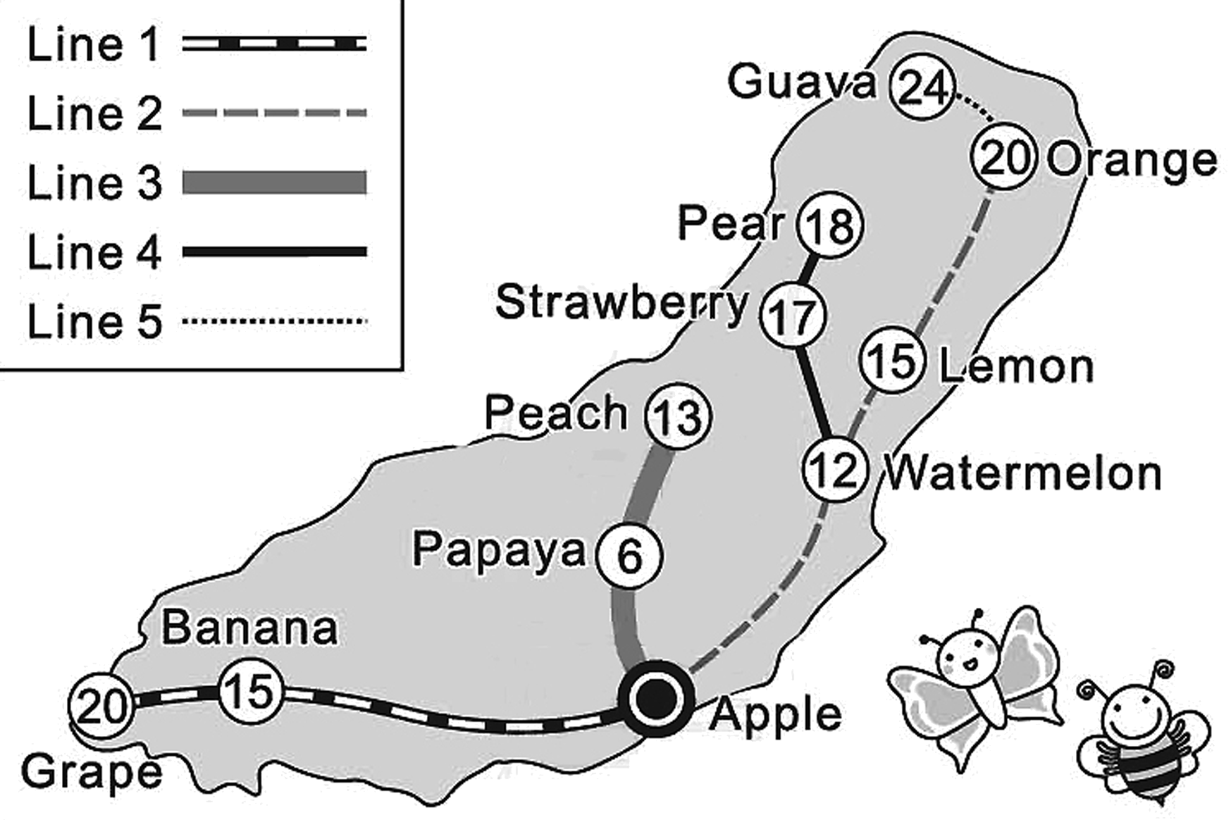
Bee and Butterfly live in Apple City on Fruit Island. There are five train lines on this island. Below is a map in the Apple Station. The number inside each station circle is the ticket price from the Apple Station to that station.

circle 圓圈

41. Bee and Butterfly are now at the Apple Station. They are going to Pear for the Honey Festival.
What is the total cost they have to pay for their train ticket?
(A) $18 (B) $12 (C)$ 17 (D)$36
42. Bee and Butterfly will spend the night in Pear for the Honey Festival. The next day, they plan to visit a friend in Banana. How many train lines will they need to take the next day?
(A) 2 (B) 3 (C) 4 (D) 5

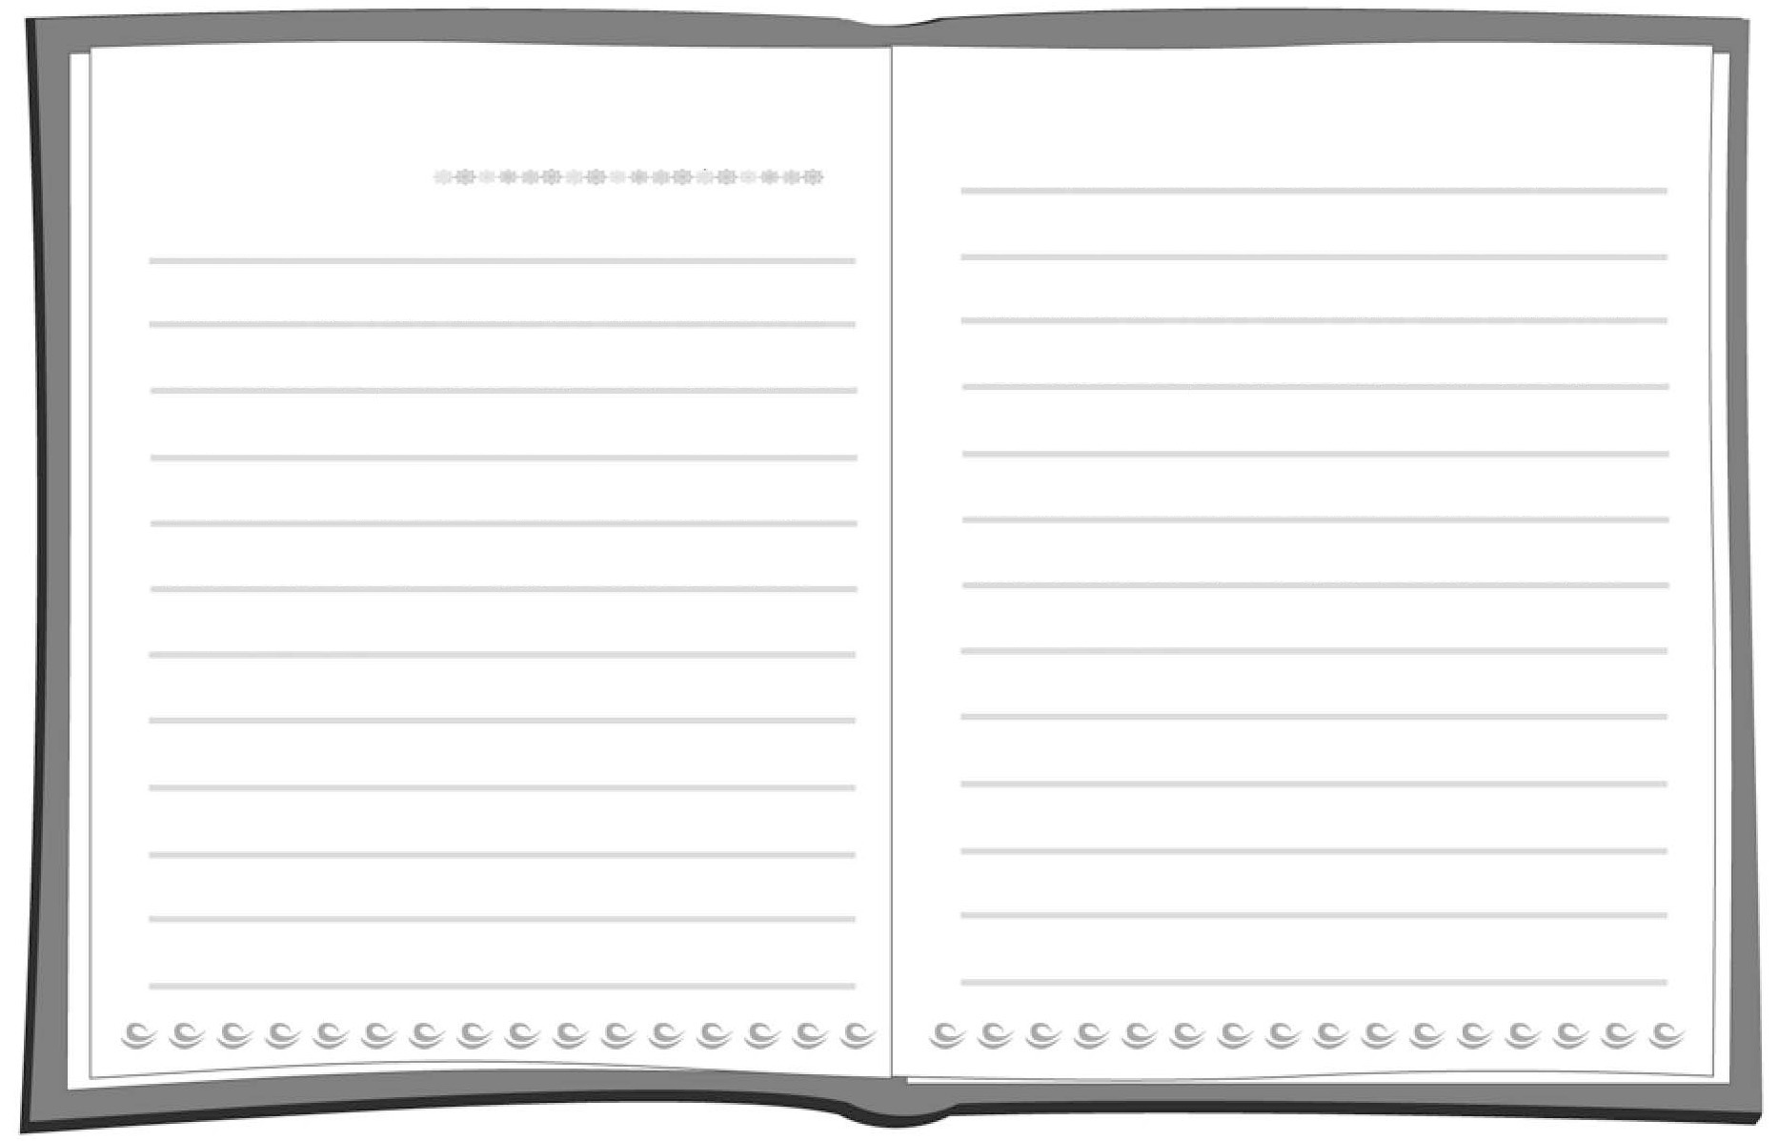
題組八
Weather:
Date: Mar. 28, 2012
Dad could not drive me to school
this morning, so I had to take the
bus. On the bus I saw an old man.
He looked very weak. There were
many people on the bus, but no one
gave him a seat. I stood up and
gave my seat to him. He thanked
me and asked me about my name
and my school. We talked happily.

Later, in the first class, Mr. Du came in and asked me to go to the front. I was a little afraid. Then he told the class what I did on the bus this morning. He knew it because he got a phone call from the old man. Mr. Du said that I could be a good example to my classmates. I was so happy! It was really a good day for me.

43. What did the student do on the bus?
(A) He fell and got hurt.
(B) He called his teacher.
(C) He talked to the driver.
(D) He gave his seat to an old man.
44.Who is He in the last paragraph?
(A) Mr. Du.
(B) The old man.
(C) The student’s father.
(D) The student’s classmate.
45.What’s the weather like on March 28, 2012?
(A) Windy. (B) Sunny. (C) Rainy. (D) Cloudy.

三年級 英文科 第一次段考答案欄（年級、科目請標示清楚，謝謝！）
【1-35题，每題2分/36-45题，每題3分】
1-5 CACBD
6-10 BCBAD
11-15 CCDBC
16-20 DBDBC
21-25 DBABC
26-30 BDCBD
31-35 ADCBA
36-40 DBDAB
41-45 DBDAD

