高雄市立林園高級中學 國中部 101學年度 第 ㄧ 學期 1年級 英語 科 第 ㄧ 次段考考卷
範圍: Get Ready~Lesson 2 班級： 姓名： 座號：
I、Listening Comprehension 聽力測驗 30%
一､聽 CD, 選出所聽到的字詞。 10%
1. (A) cook (B) walk (C) work
2. (A) book (B) cellphone (C) special
3. (A) sister (B) actor (C) juice
4. (A) skates (B) these (C) boys
5. (A) teacher (B) computer (C) museum

二､聽 CD, 配合圖片選出最適當的答案。 10%
1. 2.
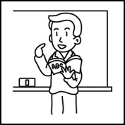

3. (A)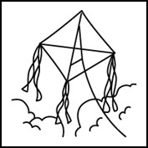 (B)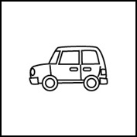 (C)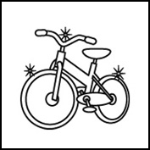

4.
(A)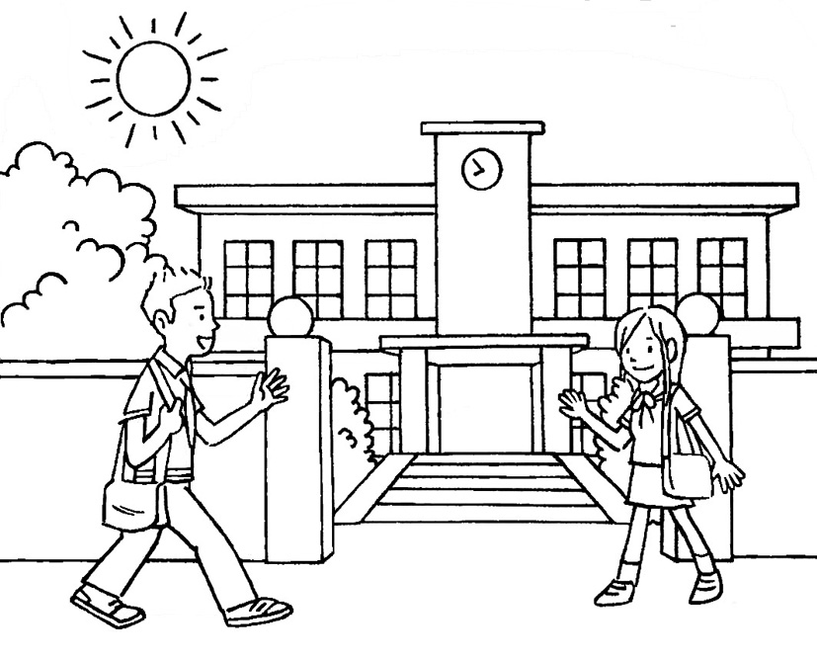 (B)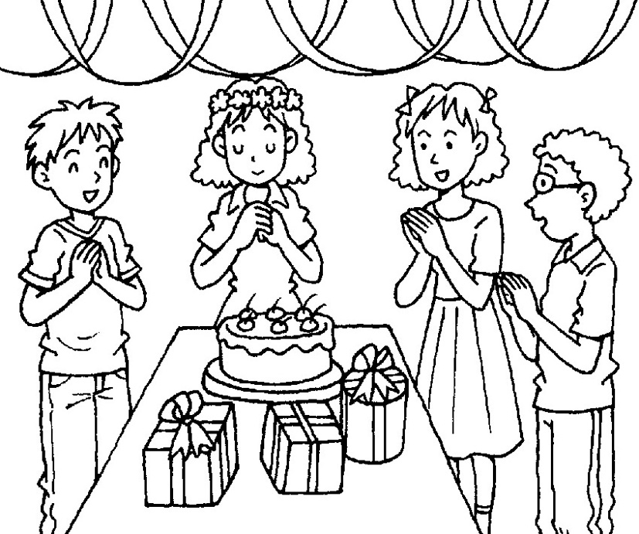 (C)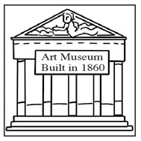
5.
(A)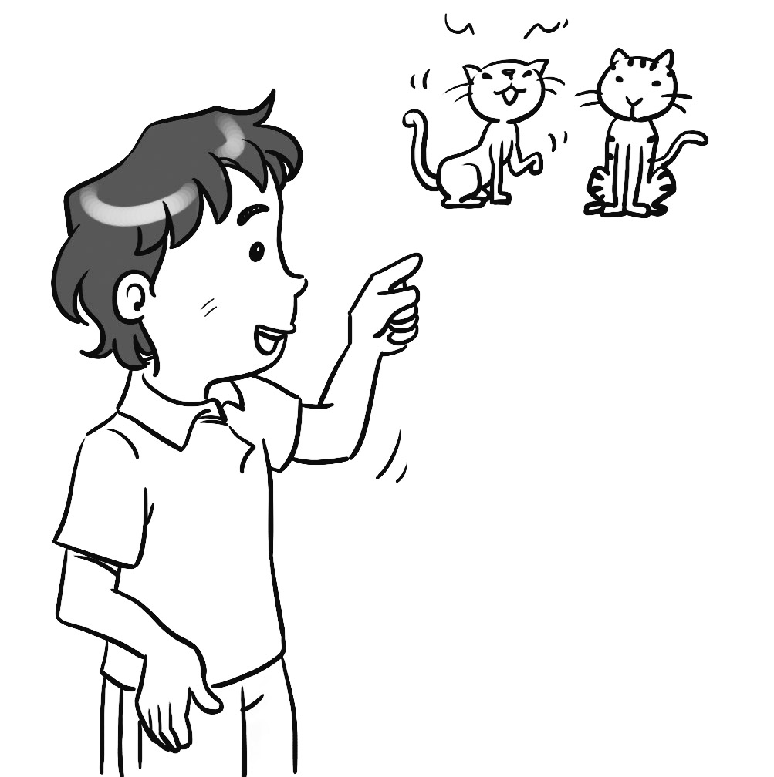 (B)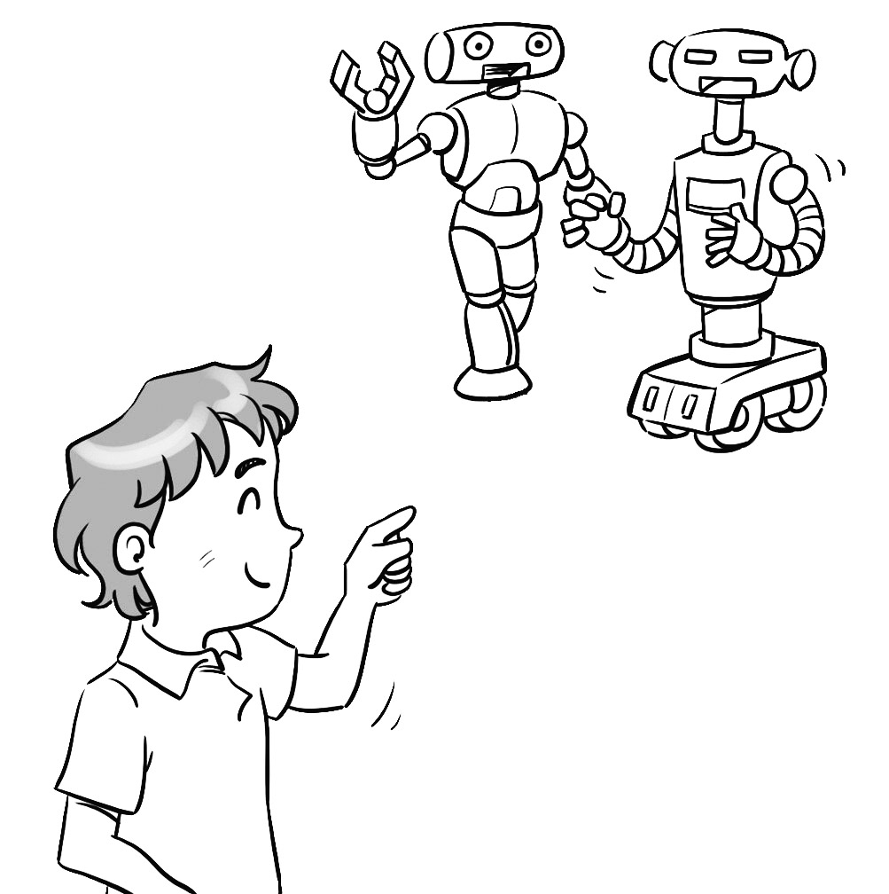 (C)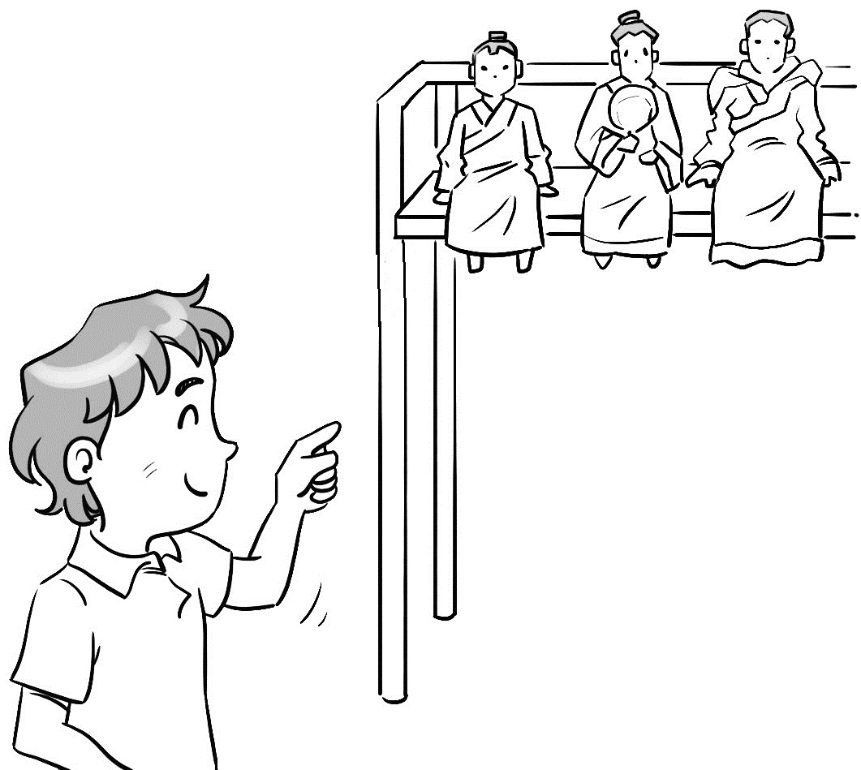

三､聽 CD, 選出適當的回應句。 10%
1. (A) Nice to meet you. (B) No, I’m not. (C) Yes, thank you.
2. (A) It is my pen. (B) It’s not my puppy. (C) I am an engineer.
3. (A) Sally is a computer engineer. (B) Yes, it is. (C) Sally is my friend.
4. (A) Oh, how special! (B) No, they aren’t. (C) I’m fine.
5. (A) I’m at home. (B) Are you at home? (C) Thank you.

II、Look and Write 改寫 10%
Part A. 請將小寫印刷體改寫成大寫印刷體，或將大寫印刷體改寫成小寫印刷體 5%
1. dance 2. right 3. jacqueline 「習作 P.2」 4. SWEET 「習作 P.2」 5. FISH

Part B. 請將下列名詞改成複數形 5%
1. hamburger 2. bus 3. monkey 4. man 5. housewife

III、Vocabulary 文意字彙 5%
1. The dragon king is big and s ng. ｢課本 P.29｣
2. Cindy: Tom’s sister is my Chinese teacher. Tina: What a s se！
3. A: Are you a kung fu m er? B: Yes, we are. 「習作 P.11」
4.Leonardo da Vinci (達文西) is a great p er . His paintings are so beautiful.
5.The hand puppet shows here are very p ar. ｢課本 P.22｣

IV、Language Focus 語法測驗 20%
1. A: Is your mother a housewife? B: She is a doctor.
(A) Yes, she’s. (B) No, she’s a housewife. (C) Yes, she is. (D) No, she isn’t.
2. Mr. Wang is English teacher.
(A) the students (B) the students’s (C) the students’ (D) an student
3. A: B: They are kites.
(A) What is this? (B) What is it? (C) What are those? (D) Are those kites?
4. A: Is that egg? B: No, it’s ball.
(A) an; a (B) ×; a (C) a; an (D) ×; an
5. A: Are these Peter’s bags? B: No, .
(A) those aren’t (B) they are (C) these aren’t (D) they aren’t
6. Good afternoon, .
(A) Mrs. Helen (B) Mrs. Chen Helen (C) Mrs. Helen Chen (D) Helen Chen Mrs.
7. A: Hi, I’m George Brown. ___________ B: Jackson Lin. 「習作 P.4, Q3」
(A) What’s her name? (B) Are you George Brown ? (C) What’s your name? (D) How are you?
8. A: What is name? B: Fred.
(A) her; He’s (B) his; He’s (C) he; His (D) he’s; He’s
9. A: ______________ B: It’s 2918-9393. 「習作 P.4, Q1」
(A) What’s his name? (B) What is this? (C) How are you? (D) What’s your telephone number?
10. A: Your robot dog, Cody, is very cute. B:
(A) Thank you. (B) I’m fine. Thanks. (C) You, too. (D) You’re welcome .

V、Cloze Test 克漏字測驗10%
Stanly: My name is Stanly. (１)
Fanny: (２) Fanny.
Stanly: Nice to meet you.
Fanny: (３)
Stanly: My classroom __(４)___ Room 101. And your classroom?
Fanny: Really? I’m in Room 101, too. We are ( 5 ) !
(1)(Ａ) Nice to see you. (Ｂ) Who are you? (Ｃ) How about you? (Ｄ) Thank you.
(2)(Ａ) I’m (Ｂ) My name (Ｃ) She’s (Ｄ) This is
(3)(Ａ) Thank you. (Ｂ) You’re welcome. (Ｃ) Nice to see you. (Ｄ) Nice to meet you, too.
(4)(Ａ) am (Ｂ) is (Ｃ) x (Ｄ) are
(5)(Ａ) teachers (Ｂ) classmates (Ｃ) boys (Ｄ) girls

VI、Reading Comprehension 閱讀測驗 10%
Look at the family tree, and answer the questions.
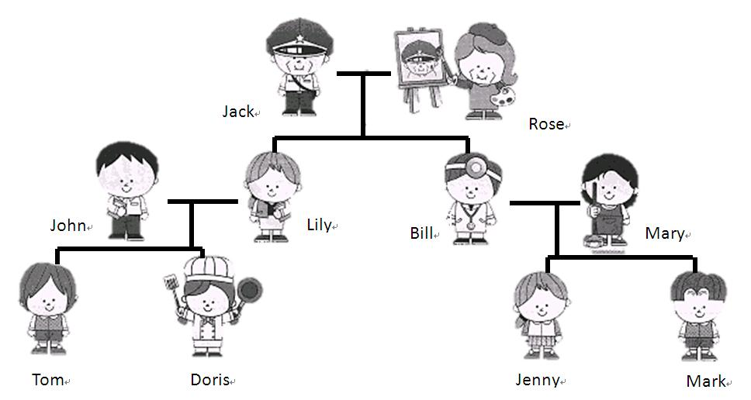
1. Look at the picture. Jack is a _________.
(A) salesman (B) doctor (C) police officer (D) teacher
2. I am Jenny. My mom, _______, is always (總是) at home. She is a housewife.
(A) Rose (B) Doris (C) Lily (D) Mary
3.Who is Bill?
(A) Mary’s brother. (B) Mark’s dad. (C) Jack’s brother. (D) Tom’s father.
4. Is Doris a computer engineer?
(A) Yes, she is. She is a computer engineer. (B) No,she isn’t. She is a teacher.
(C) Yes, she is. She is a housewife. (D) No,she isn’t. She is a cook.
5. Which is true? (何者正確)
(A) Jenny and Mark’s dad is a doctor . (B) Rose is Bill’s grandma.
(C) Lily and Mary are cooks. (D) Tom and Jenny’s grandfather ,John, is a police officer.

VII、Write Sentences 依提示作答 8%
1. This is the boy’s robot. (改為複數句) 「習作 P.12」 4%
2. Is the girl sad? (請先簡答,再以happy詳答) 4%

VIII、Translation into English 翻譯 7%
1.這些風箏是小孩們最喜愛的玩具。 「習作 P.12」 3%
2. A: 那些人是誰？ B: 他們是電視記者。 「習作 P.12」 4%

高雄市立林園高級中學 國中部 101學年度 第ㄧ學期 1年級 英語 科 第ㄧ次段考作答卷
範圍: Get Ready~Lesson 2 班級： 姓名： 座號：
I、Listening Comprehension 聽力測驗 30%
一、 | 1. |  | 2. |  | 3. |  | 4. |  | 5.
二、 | 1. |  | 2. |  | 3. |  | 4. |  | 5.
三、 | 1. |  | 2. |  | 3. |  | 4. |  | 5.

II、Look and Write 改寫 10%
Part A. | 1. |  | 2. |  | 3. |  | 4. |  | 5.
Part B. | 1. |  | 2. |  | 3. |  | 4. |  | 5.

III、Vocabulary 文意字彙 5%
1. |  | 2. |  | 3. |  | 4. |  | 5.

IV、Language Focus 語法測驗 20%
1. |  | 2. |  | 3. |  | 4. |  | 5.
6. |  | 7. |  | 8. |  | 9. |  | 10.

V、Cloze Test 克漏字測驗10%
1. |  | 2. |  | 3. |  | 4. |  | 5.

VI、Reading Comprehension 閱讀測驗 10%
1. |  | 2. |  | 3. |  | 4. |  | 5.

VII、Write Sentences 依提示作答 8% (採分段給分,請同學踴躍作答)
1.

2.

VIII、Translation into English 翻譯 7% (採分段給分,請同學踴躍作答)
1.

2.

＜作答完畢時，請繳交此答案卷即可＞

高雄市立林園高級中學 國中部 101學年度 第ㄧ學期 1年級 英語 科 第ㄧ次段考解答卷
I、Listening Comprehension 聽力測驗 30%
一、 | 1. | C | 2. | B | 3. | B | 4. | A | 5. | C
二、 | 1. | C | 2. | B | 3. | A | 4. | C | 5. | C
三、 | 1. | C | 2. | C | 3. | B | 4. | B | 5. | C

II、Look and Write 改寫 10%
Part A. | 1. | DANCE | 2. | RIHGT | 3. | JACQUELINE | 4. | sweet | 5. | fish
Part B. | 1. | hamburgers | 2. | buses | 3. | monkeys | 4. | men | 5. | housewives

III、Vocabulary 文意字彙 5%
1. | strong | 2. | surprise | 3. | master | 4. | painter | 5. | popular

IV、Language Focus 語法測驗 20%
1. | D | 2. | C | 3. | C | 4. | A | 5. | D
6. | C | 7. | C | 8. | B | 9. | D | 10. | A

V、Cloze Test 克漏字測驗10%
1. | C | 2. | A | 3. | D | 4. | B | 5. | B

VI、Reading Comprehension 閱讀測驗 10%
1. | C | 2. | D | 3. | B | 4. | D | 5. | A

VII、Write Sentences 依提示作答 8% (採分段給分,請同學踴躍作答)
1. These are the boys’ robots.
2. No, she isn’t. She is happy.

VIII、Translation into English 翻譯 7% (採分段給分,請同學踴躍作答)
1. The/These kites are (the) children’s favorite toys.
2. Who are those people/persons? They are TV reporters.

