高雄市立林園高級中學 國中部 101學年度 第 ㄧ 學期 一 年級 英語科 第 三 次 段考考卷
班級： 姓名： 座號：

A.聽力測驗
- 聽CD，若符合圖意或表格內容的選 A，否則選 B： (每題2分)
1.(A) True (B) False 2.(A) True (B) False 3. (A) True (B) False
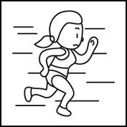 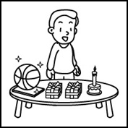 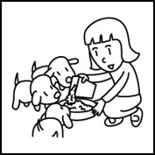
4(A) True (B) False 5. (A) True (B) False
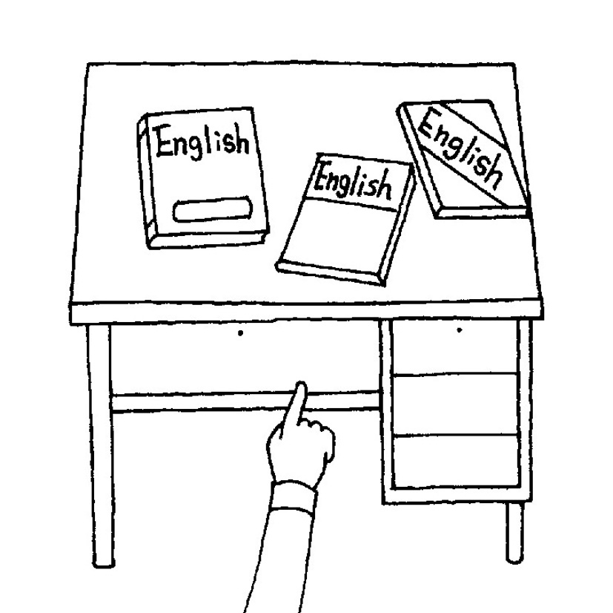 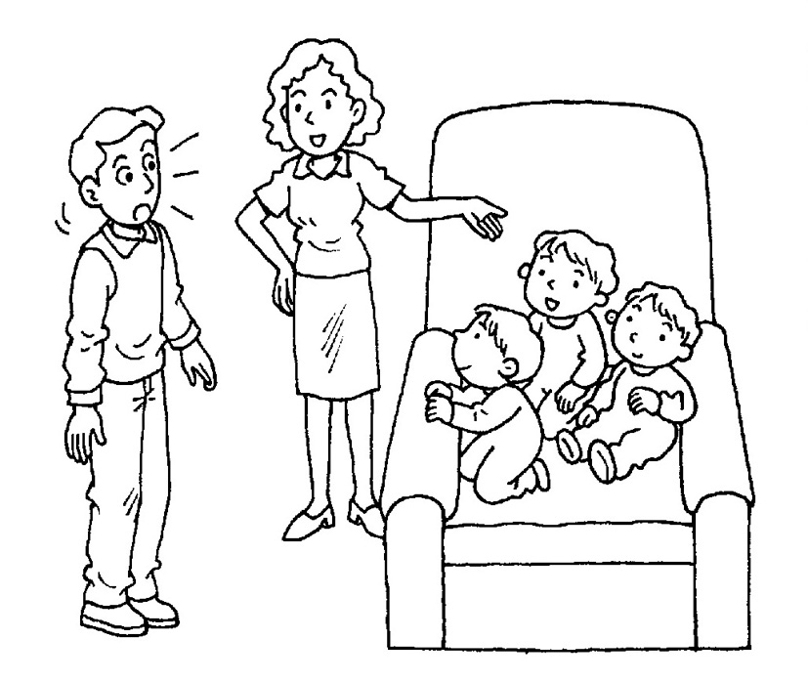

- 聽CD，選出適當的回應句 (每題2分)
6.(A) I’m swimming. (B) You’re singing a song. (C) They’re roller-skating.
7.(A) He’s fine. Thank you. (B) His name is Michael Chang. (C) He’s in the yard.
8.(A) Oops, I’m sorry. (B) I have to go now. (C) Let’s shout！
9.(A) Yes, there are. (B) Yes, there is. (C) No, there are not.
10.(A) No, there isn’t a kite in the museum. (B) Yes. It is a toy museum. (C) They are my toys.

- 聽CD，根據短文，選出正確答句 (每題2分)
- 短文一
11.(A) A park. (B) A puppy (C) A yard.
12.(A) It’s big. (B) It’s beautiful. (C) It’s not beautiful.
13.(A) No, it isn’t. (B) No, there isn’t. (C) No, there aren’t.
- 短文二
14.(A) They are crying over there.
(B) They are painting their chairs.
(C) They are training the puppy.
15.(A) She is crying over there.
(B) She is painting.
(C) She is playing with the dog.

B.紙筆測驗
- 文意字彙 (每題2分)
16.Let’s go to the new _________ near our house. I want to order(點) a steak.(牛排)
(A)restaurant (B)toy shop (C)art museum (D)bus stop 【習作p40】
17.Please have your ________.
(A)busy (B)breakfast (C)beside (D)back 【習作p34】
18. Are you ________ a ball in your hand?
(A)holding (B)shouting (C)hold (D)enjoy
19.Two birds are in the_______. They can’t fly(飛) freely(自由地)
(A)here (B)cage (C)factory (D)shop 【習作p34】
20.The doll is _________ the robot and the toy dragon.
(A)so (B)between (C)very (D)of 【習作p35】
21.Taiwan is a small but beautiful ____________.
  - island (B)leaf (C)master (D)Canada
22.It’s time for lunch. The students are ___________
(A)hungry (B)shy (C)tall (D)smart 【習作p40】
23.Twenty-five and fifteen are ______________
(A)fourteen (B)fourty (C)four (D) forty
24.I __________ to bring(帶) my English book.
(A)forget (B)fish (C)front (D)fifteen
25.There is a bird on Ben’s __________
- show (B)shout (C) shoulder (D)build
- 語法測驗 (每題2分)
26.A：Let’s run______ to John.Hurry！ B：OK.
(A)over (B)behind (C)at (D)in
27.Jack is _______ in the pool(泳池)
(A)swim (B)swimming (C)siming (D)not swim
28.A：______ a beautiful girl！What’s her name? B：Mary.
(A)How (B)Here (C)What (D)She
29.The boats are _____ five different colors.They’re so beautiful..
(A)at (B)in (C)on (D)for
30.Jack is standing __________ his brother.
(A)in (B)beside (C)between (D)out
31.Today is Mary’s birthday.This is a doll _______ her
(A)to (B)for (C)in (D)with
32.Wait for _____,please！It’s dark here.
(A)we (B)me (C)I (D)my 【習作31】
33.It’s cold outside.(外面) Let’s ______________ out.
(A)not go (B)not to go (C)not going (D)go not
34.Everything on the desk ________ great
(A)is (B)am (C)are (D)be
35.A girl is _______frisbee in the park. She’s very happy.
(A)playing (B)doing (C)riding (D)feeding
36. A：Where are Mike and Jane _______? B：They’re _______ Japan.
(A)for；from (B)to；from (C)from；from (D) in；from
37. My grandma is good at cooking. And she is ______a big meal(餐點) ____us.
(A)welcoming；to (B)washing；to (C) preparing；for (D)prepare；to
38. Let’s dance with _____________.
(A)they (B) she (C)he (D)them
39. Jessica is ________on the chair and watching TV
(A)sit (B)siting (C)sitting (D)sits
40. __________ there any food in your room?
(A)Are (B)Is (C)How (D)What
- 對話測驗 (每題2分)
41.A：Isn’t there a doll in the box? B：No, __________.
(A)there is (B)there’s (C)it isn’t (D) there isn’t
42.A：Is Mr. and Mrs. Brown’s house big? B：Yes, _____________ house is big.
(A)them (B)their (C)they (D)theirs 【習作p31】
43.A：Are the students ___________ on the bus? B：Yes,they are.
(A)gets (B)geting (C)getting (D)get 【習作p29】
44.A：What is your mother doing? B：_______________
(A)She is at home. (B)She sleeping (C)She is watching TV. (D)She is fine.
45.A：I am hungry. B：______________ 【習作p41】
(A)Let’s play frisbee. (B)Let’s sing a song. (C)Let’s have some food there. (D)Let’s sleep.
46.A：Where is the boat? B：_____________ 【習作p41】
  - It’s on the truck. (B) They’re on the truck. (C)They’re in here. (D)This is a boat.

- 閱讀測驗
- Barbara：Look, there are many people in front of the stadium.(體育館)What are they doing?
Diane：They are waiting for A-mei’s special show.
Barbara：Wow! Cool!
Diane：The fans (歌迷)are singing A-mei’s song and dancing.
Barbara：They are really(真地) crazy.(瘋狂的)
Diane：This is the way to show their love to Amei..
47.Who are “They”?
(A) )Amei and her friends. (B) Diane and Barbara. (C) Amei and her fans. (D)Amei’s fans.
48.According to (根據)the reading, what aren’t Amei’s fans doing?
(A) They are not standing in line. (B) They are not waiting for Amei’s show.
(C) They are not dancing. (D) They are not painting.

- Welcome to my hometown (家鄉), Linyuan. My name is Sean. Let me introduce(介紹)my hometown to you. In front of my school, there is one supermarket. There, you can buy some food,like milk, cookies or vegetable.(蔬菜). Along the Fenglin Rd.(鳳林路) ,you can see the gas station.(加油站) There are three buildings opposite(對面的) the gas station. After school , I always study in the library and read some interesting(有趣的) books there. Look at this map(地圖) and answer (回答)these questions.(問題)
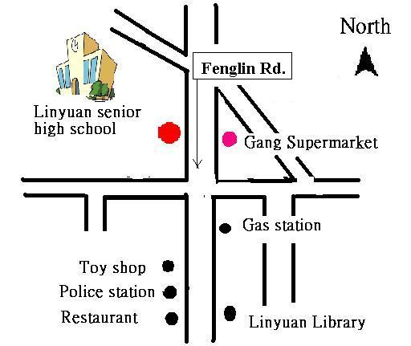

49.Which(哪一個) is true?.
(A)Sean always studies (讀書)at home. (B)This is a map about Japan.
(C)Linyuan is a small town. (D)The toy shop is between the police station and the restaurant.
50.Where is the restaurant?
(A)It’s in front of the Linyuan Library. (B)It’s between the police station and the toy shop.
(C)It’s beside the toy shop. (D)It’s under the bus stop
一年級 英文科 第 三 次段考答案欄（年級、科目請標示清楚，謝謝！）
A.聽力ABABB CCABB CBBBA
B.紙筆 ABABB AADAC ABCBB BBAAA CCDCB DBCCC ADDCA

