高雄市立林園高級中學 國中部 101學年度 第一學期 二 年級 英語 科 第一次段考考卷
範圍：Book3 Unit1 ~ Review1
Part I. Listening Comprehension 聽力測驗 （30 %）
0(I) 選出符合句子描述的圖片。(共10分/每題2分)
0 (１) ( 2 )
(Ａ) | (Ｂ) | (Ｃ)
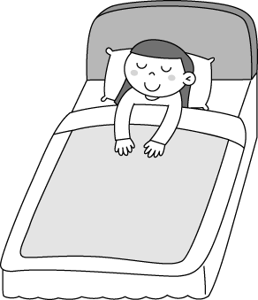 | 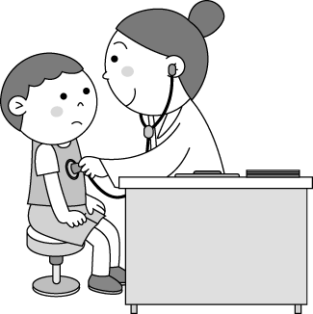 | 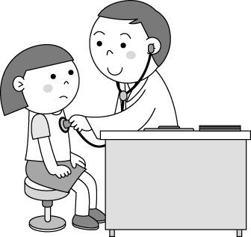
(Ａ) | (Ｂ) | (Ｃ)
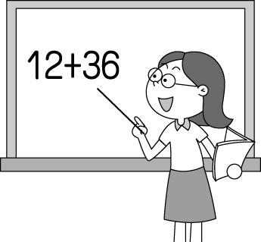 | 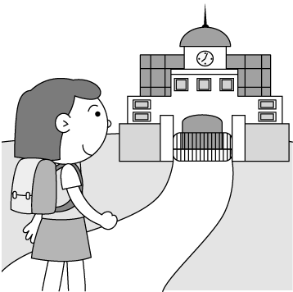 | 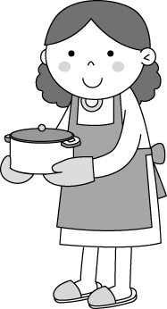
(３) ( 4 )
(Ａ) | (Ｂ) | (Ｃ)
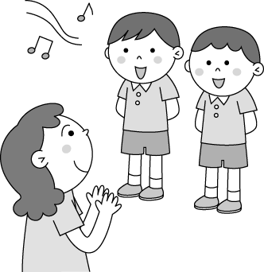 | 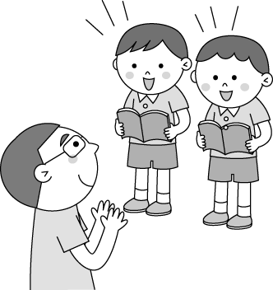 | 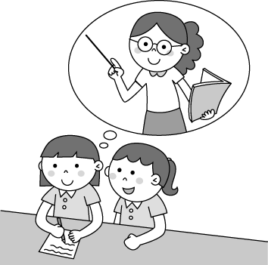
(Ａ) | (Ｂ) | (Ｃ)
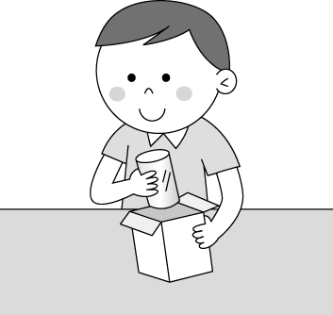 | 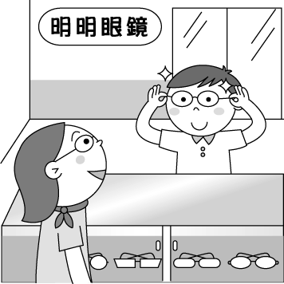 | 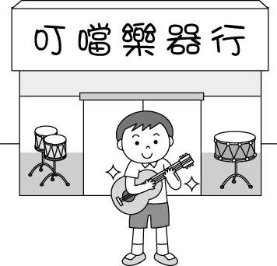
(５)
(Ａ) | (Ｂ) | (Ｃ)
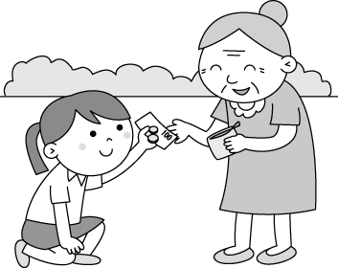 | 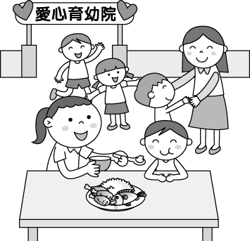 | 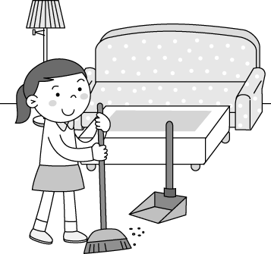

(II) 選出適當的答句。(共10分/每題2分)
(１)(Ａ) No. It’s cheap. (Ｂ) Yes, it’s a nice hat. (Ｃ) Yes, my mom made it for me.
(２)(Ａ) It’s my sister’s. (Ｂ) My sister plays it every day. (Ｃ) The sea lions can play volleyball, too.
(３)(Ａ) Because today is my birthday. (Ｂ) Mr. Smith opened the toy shop two years ago.
(Ｃ) They’re from my cousin. He sent them to me last week.
(４)(Ａ) Yes, they’re yours. (Ｂ) No, they’re not mine. (Ｃ) Sorry, I don’t have any.
(５)(Ａ) You’re so kind. (Ｂ) You’re welcome. (Ｃ) Yes, maybe I can do it someday.

0(III) 根據對話內容，選出正確的答案。(共10分/每題2分)
(１)(Ａ) Ken’s tests this morning. (Ｂ) Their favorite school subjects. (Ｃ) Ken’s study plans for the coming tests.
(２)(Ａ) Before dinner. (Ｂ) Before the tests. (Ｃ) After school yesterday.
(３)(Ａ) He got 65 on the history test. (Ｂ) He did well on the history test. (Ｃ) The science test was easy for him.
(４)(Ａ) He got up at 2 a.m. (Ｂ) He got up at 5 a.m. (Ｃ) He got up at 7 a.m.
(５)(Ａ) Sang karaoke. (Ｂ) Used the computer. (Ｃ) Did homework after dinner.

Part II. Reading & Writing Comprehension讀寫測驗 （70 %）
- 下列各題請依題意選出一個正確或最適當答案。(20%)
1. Alex ___ the Net on weekends, and Rosa does, too.
(A) surf (B) surfed (C) surfs (D) is surfing
2. A: There’s an eraser on the floor. Is it ___ , Dominic?
B: No. My eraser is here. Ask Amy. Maybe it’s ___.
(A) hers; yours (B) yours; mine (C) hers; mine (D) yours; hers
3. A: Kevin didn’t come to school. ___ you worried about him? B: Sure I ___.
(A) Are; do (B) Don’t; do (C) Aren’t; am (D) Weren’t; did
4. Many places in Taiwan, Hualien and Kenting, ___, are very beautiful.
(A) in fact (B)for example (C) of course (D) in person
5. A: ___ the trip to the USA fun? B: Yes, we enjoyed it a lot.
(A) Was (B) Did (C) Do (D) Are
6. ___ vest is that over there? It’s so big!
(A) How (B) What (C) Why (D) Whose
7. My boyfriend gave ___ the day before yesterday.
(A) to me it (B) it for me (C) me it (D) it to me
8. ___ the past, Ms. Chen taught art ___ a fun way.
(A) For; on (B) In; with (C) During; for (D) In; in
- Lily: Hey, Milo. I had a lot of fun during the camping(露營). Milo: ___ I didn’t sleep for the two nights there.
(A) Thanks to you. (B) That’s nice! (C) Poor you! (D) That’s very kind of you.
- Molly: How was your winter vacation? Annie: ____
(A) Yes, I played dodge ball then. (B) I planned a party at the beach this winter.
(C) Great. I visited many interesting places. (D) Not so good. It rained a lot this summer.

- 克漏字:請根據文意選出一個正確或最適當答案。(10%)
( 1. the lunch time)
Mochi: Do you have any 2. story books, John?
John: Sure. 3.
Mochi: Some poor kids don’t have any good books 4. maybe we can donate some to them.
John: I see, and maybe we can ask 5. people to join us.
Mochi: Good idea!

1. (A) For (B) On (C) In (D) During
2. (A) child’s (B) childs’ (C) children’s (D) childrens’
3. (A) What happened? (B) Why do you ask? (C) Just kidding! (D) Don’t worry!
4. (A) because (B) ,so (C) ,but (D) ,then
5. (A) more (B) poor (C) a lot (D) interesting

- 閱讀測驗:請根據文意選出一個正確或最適當答案。(18%)

John: What’s your favorite class? Mine’s math.
Lora: English, for sure.
John: Really? Why?
Lora: It’s fun to speak a second language. I feel like a different person.
John: That’s interesting. But what about the homework? It’s so hard.
Lora: Every class has homework, right?
John: That’s true. Hey, do you want to study together for the next week’s test?
Lora: Of course! Two heads are better than one.

*language 語言 *feel like 覺得像 *hard 難的

1. Learning English is _____ for Lora.
(A) too hard (B) interesting (C) different (D) wrong
2. What doesn’t John like about the English class?
(A) Homework. (B) Tests. (C) The English teacher. (D)The English lessons.
3. What does “ Two heads are better than one” mean(意思是..)?
(A) People with two heads are smart. (B) Working together is a good idea.
(C) Working is hard for everyone. (D) One person can’t work alone(獨自).
4. Which is true?
(A) Lora doesn’t do her homework. (B) English is John’s favorite class.
(C) Lora and John can’t study together. (D) Lora and John have different favorite classes.

Hualien, Sep. 30
Dear Jenny,
How are you? This week we had our Moon Festival here. My mother bought moon cakes. My family had
a barbeque on our balcony. Some friends come to our house. We ate, talked and watched the full moon. It was
a beautiful night ,and the moon was very bright and clear.The Moon Festival is a special time for Chinese. Some people say there is a rabbit in the moon! What do you think? I hope you can come and visit us someday . We can look for the rabbit together!
Your friend,
Victor

*barbeque 烤肉 *balcony 陽台 *bright 明亮的 *clear 清楚的

5. Where does Victor live?
  - America (B) China. (C) Taiwan. (D) Japan
- What did Victor’s mother buy for the Moon festival?
(A) A rabbit. (B) Pomelos. (C) Moon cakes. (D) A full moon.
- What did Victor do on the Moon Festival?
(A) Make moon cakes. (B) Sang karaoke. (C) Caught rabbits. (D) Chatted with his family.
- How was the weather on the night of the Moon Festival this year?
(A) It was sunny. (B) It was cloudy. (C) It was rainy. (D) It was nice.
- Which is true?
(A) Jenny wrote this letter in September. (B) Victor was full because he had a barbeque on the Moon Festival.
(C) The Moon Festival is special for people in Taiwan. (D) Most Chinese people look for a rabbit in the moon.

- 文意字彙(5%)
- Sally is a w l mother. She takes good care of her son.
- A: Do you like the cake? B: Sure, it’s d s. Do you want some?
- It’s very g s of you to donate so much money.
- Kenny’s shoes are too small. He needs a new p r.
- A: What did you do on the weekend? B: I didn’t do anything s l. I just read at home.

( V ) 寫出下列動詞過去式(5%)

1. know 2. listen 3. put 4. take 5. buy

( VI ) 中譯英 (12%)
- 這兩個孩子彼此為對方做了很多柚子帽。
- 她教了我們許多關於月亮的英文歌曲。
- 在那場海獅表演最後，每個人都鼓掌了。
- 過去，他時常在英文課上看漫畫。

高雄市立林園高中國中部101學年度第一學期第一次段考二年級英語科
【答案卷】 Class No. Name
- Listening Comprehension 聽力測驗 （３０%，每題2分）

一 |  | (1) | (2) | (3) | (4) | (5)
二 | 1. | (1) | (2) | (3) | (4) | (5)
二 | 2. | (1) | (2) | (3) | (4) | (5)

- Reading & Writing Comprehension讀寫測驗 （70%）

(I) 下列各題請依題意選出一個正確或最適當答案。(20%)
1. | 2. | 3. | 4. | 5.
6. | 7. | 8. | 9. | 10.

(II) 克漏字:請根據文意選出一個正確或最適當答案。(10%)
1. | 2. | 3. | 4. | 5.

(III) 閱讀測驗:請根據文意選出一個正確或最適當答案。(18%)
1. | 2. | 3. | 4.
5. | 6. | 7. | 8. | 9.

(IV) 文意字彙 (5%)
1. | 2. | 3. | 4. | 5.

(V) 寫出下列動詞過去式 (5%)
1. | 2. | 3. | 4. | 5.

( VI ) 翻譯 (12%)
1.
2.
3.
4.

