高雄市立林園高級中學 國中部 101學年度第一學期 二年級英語科 第二次段考考卷
班級： 姓名： 座號：
- 聽力測驗(選出最適當的答案)
一、聽到的內容與圖片相符者打○，不符者打╳(10%)
(1) 哈！哈！   | (2)  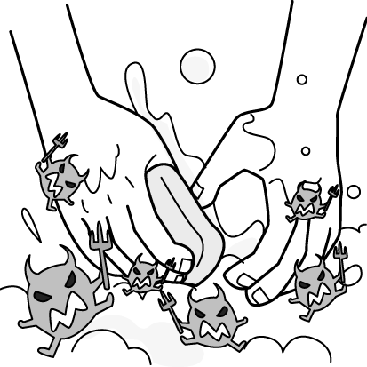 | (3)  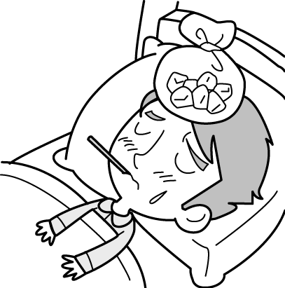 | (4)  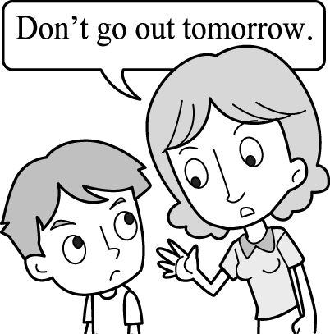 | (5)  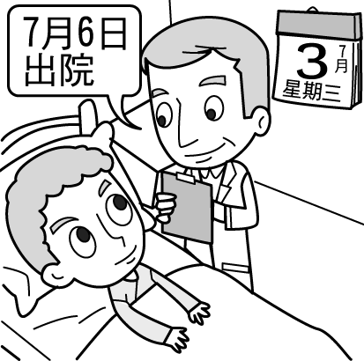
二、聽問句，選出適當的答句(10%)
( )1.(A) I’m a farmer. (B) I play tennis every day. (C) I can do a lot of hard work.
( )2.(A) I want to study in America. (B) I’m planning a summer trip. (C) I plan to give Mom a surprise.
( )3.(A) He’s clapping his hands. (B) He took a bow on the stage. (C) Very well. He’s a great singer.
( )4.(A) Yes, she wants to be a good actress. (B) Yes, she began to write the stories last month.
(C) Yes, she often shares her acting skill with others.
( )5.(A) I have a good idea. (B) I hate watching TV. (C) I like to sing karaoke.
三、根據短文內容，選出正確的答案(10%)
( )1.(A) She couldn’t find her ring. (B) She couldn’t play the piano. (C) She couldn’t attend a wedding.
( )2.(A) Forty-five minutes. (B) Sixty minutes. (C) Ninety minutes.
( )3. (A) At 6:15. (B) At 6:30. (C) At 6:45.
( )4. (A) At 6:50. (B) At 7:10. (C) At 8:50.
( )5. (A) In the coffee pot. (B) Near the trash can. (C) On the kitchen mat.

- 紙筆測驗
一、文意字彙10%
1.Mr. Chen went to the h al last night because he had a terrible stomachache.
2.The mother is worried; her baby has a high f er and is coughing.
3.Having r ar eating habits is good for your health.
4.Dr. Liu always gives us some good a ce.
5.The actress can m ze all of the lines soon .
6.Ms. Chen had a sore t t, so she went to see a doctor .
7.Eve seldom dries her hair after washing it, so she often has a h che.
8.Mark likes to do e se at the gym every day, so he is very strong.
9.They f y got home at 10 p.m. last night.
10.My father sets a good e le for the workers in his factory.

二、文法選擇10%(選出最適當的答案)
( ) 1. is not easy for him on the wire(鋼索) until now.
(A) It; to stand (B) That; to stand (C) That; standing (D It; standing
( ) 2. Saying and doing different things. (A) is (B) was (C) were (D) are
( ) 3. Scott kept to this song because he likes it very much. (A) listen (B) listening (C) to listen (D) listened
( ) 4. Vick decided his job and begin stories.
(A) give up; write (B) to give up; write (C) to give up; to write (D) giving up; writing
( ) 5. It’s 9:05. = It’s . (A.) nine to five (B) nine past five (C) five to nine(D) five past nine
( ) 6. Playing computer games fun for students. (A) are (B) was (C) were (D) is
( ) 7. He playing the piano at home on weekends.(A) needs (B) plans (C) enjoys (D) wants
( ) 8. The teacher wasn’t playing soccer, but the children . (A) are (B) were (C) is (D) was
( ) 9. Cherry isn’t , so she can’t drive a car . (A) enough old (B) old enough (C) enough kind (D) kind enough
( )10. A: you on the phone at 11:00 p.m. ? B: Yes. My boyfriend called me.
(A) Were; talking (B) Do; talk (C) Were; talked (D) Are; talking

三、依提示填入正確的動詞形式10% (每格不限填一個字， 全對才給分)
1. I (wear) it at that time.
2. They ( take off ) their shoes and went into the house.
3. They plan (go) to the new theater to see a movie tonight.
4. (Study) hard, and you will get good grades on tests.
5. Hank is sick, so he gave up (run) the marathon(馬拉松).

四、克漏字選擇10%(選出最適當的答案)
Johnny: How was your test today?
Nancy: It was very terrible. I was too nervous, so my stomach 1. very much.
Johnny: Poor girl. Did you go to see a doctor?
Nancy: Yes, the doctor 2. me 3. relax. He also gave me some medicine. I need to 4. it three times a day.
I learn a lesson: 5. care of my body is important.
Johnny: That’s right.  nervous緊張的 relax 放鬆
( )1. (A) was hurt (B) hurts (C) hurted (D) hurt
( )2. (A) told (B) tells (C) was telling (D) telled
( )3. (A) for (B) from (C) of (D) to
( )4. (A) get (B) eat (C) take (D) have
( )5. (A) Take (B) Taking (C) Took (D) Takes

五、閱讀測驗18%(選出最適當的答案)
(I)
Jimmy’s girlfriend will come this week, so he cleaned his house last week. Look at his schedule and answer the questions.
 | Sunday | Monday | Tuesday | Wednesday | Thursday | Friday | Saturday
Sweep the floor | 8:00 |  | 9:00 | 9:00 | 9:30 |  | 9:00
Mop the floor | 9:00 |  | 10:00 |  | 10:30 |  | 10:00
Wipe the windows | 14:30 |  |  | 15:00 |  |  | 15:00
Take out the trash | 21:30 | 21:00 | 21:30 | 21:30 | 22:00 | 21:00
schedule 日程表 answer 回答 question 問題
( )1. What was Jimmy doing at thirty after ten last Thursday?
(A) He was sweeping the floor. (B) He was mopping the floor.
(C) He was wiping the windows. (D) He was taking out the trash.
( )2. What did Jimmy do in the afternoon last week?
(A) He wiped the windows. (B) He took out the trash. (C) He mopped the floor. (D) He swept the floor.
( )3. How many times did Jimmy take out the trash last week?
- Three times. (B) Four times. (C) Five times. (D) Six times.
( )4. What didn’t Jimmy do last week?
(A) Take care of his sister. (B) Sweep the floor. (C) Wipe the windows. (D) Mop the floor.

(II)
Vicky and her classmates interviewed three men at school today. One is a mailman, another is a singer, and the other is a
police officer. They talked about their jobs in the class. After the interview, fifteen students want to become police officers because they want to help more people, and twelve students want to become mail carriers. How about Vicky? She and other three students love singing, so they want to be singers in the future.
( )5. What are the three men’s jobs?
(A) A singer, a police officer, and a mail carrier. (B) A farmer, a police officer, and a TV reporter.
(C) A mail carrier, a teacher, and a police officer. (D) A singer, a student , and a mail carrier.
( )6. Why do the fifteen students want to become police officers?
(A) They hate singing. (B) They like interviewing people.
(C) They want to help people. (D) They love to sing for people.
( )7. How many students want to be mail carriers?
(A) Fifteen. (B) Twelve. (C) Twenty. (D) Twenty-seven.
( )8. What does Vicky love doing?
(A) Talking about her jobs. (B) Writing letters. (C) Playing the piano. (D) Singing.
( )9. How many students want to be singers in the future? (A) One. (B) Four. (C) Five. (D) Twenty.

六、依提示作答及翻譯12%(每題3分，分段給分)
1. She is an actress.(加入plan改寫)
2. What do you do during the vacation? (加入want改寫)
3. 五點十五分時，那記者正在採訪一位警察。(…quarter…)
4. 對Jessica來說，在半小時內準備一餐並不難。(It’s…)

高雄市立林園高級中學國中部 101學年度第一學期 二年級英語科 第二次段考答案卷
班級： 座號： 姓名：
- 聽力測驗(選出最適當的答案)
一、聽到的內容與圖片相符者打○，不符者打╳ 10%
1. |  | 2. |  | 3. |  | 4. |  | 5.
二、聽問句，選出適當的答句10%
1. |  | 2. |  | 3. |  | 4. |  | 5.
三、根據短文內容，選出正確的答案10%
1. |  | 2. |  | 3. |  | 4. |  | 5.

- 紙筆測驗
一、文意字彙10%
1. |  | 2. |  | 3. |  | 4. |  | 5.
6. |  | 7. |  | 8. |  | 9. |  | 10.
二、文法選擇10% (選出最適當的答案)
1. |  | 2. |  | 3. |  | 4. |  | 5.
6. |  | 7. |  | 8. |  | 9. |  | 10.
三、依提示填入正確的動詞形式10% (每格不限填一個字， 全對才給分)
1. |  | 2. |  | 3. |  | 4. |  | 5.
四、克漏字選擇10%(選出最適當的答案)
1. |  | 2. |  | 3. |  | 4. |  | 5.
五、閱讀測驗18%(選出最適當的答案)
1. |  | 2. |  | 3. |  | 4.
5. |  | 6. |  | 7. |  | 8. |  | 9.
六、依提示作答及翻譯12%(每題3分，分段給分)
1.
2.
3.
4.

高雄市立林園高級中學國中部 101學年度第一學期 二年級英語科 第二次段考答案卷(解答)
A、聽力測驗
一、聽到的內容與圖片相符者打○，不符者打╳(10%)
1. |  | 2. |  | 3. |  | 4. |  | 5. | 
二、聽問句，選出適當的答句(10%)
1. | A | 2. | A | 3. | C | 4. | A | 5. | C
三、根據短文內容，選出正確的答案(10%)
1. | A | 2. | C | 3. | B | 4. | B | 5. | A
B、紙筆測驗
一、文意字彙10%
1. | hospital | 2. | fever | 3. | regular | 4. | advice | 5. | memorize
6. | throat | 7. | headache | 8. | exercise | 9. | finally | 10. | example
二、文法選擇()10%
1. | A | 2. | D | 3. | B | 4. | C | 5. | D
6. | D | 7. | C | 8. | B | 9. | B | 10. | A
三、依提示填入正確的動詞形式10% (每格不限填一個字， 全對才給分)
1. | was wearing | 2. | took off | 3. | to go | 4. | Study | 5. | running
四、克漏字選擇10%
1. | D | 2. | A | 3. | D | 4. | C | 5. | B
五、閱讀測驗18%
1. | B | 2. | A | 3. | D | 4. | A
5. | A | 6. | C | 7. | B | 8. | D | 9. | B
六、依提示作答及翻譯12%(每題3分，分段給分)
1. | She plans to be an actress.
2. | What do you want to do during the vacation?
3. | The reporter was interviewing a police officer at a quarter past(after) five.
4. | It’s not difficult for Jessica to prepare a meal in half an hour.

一錄音稿：(１) Writing story books is hard for the man.
(２) It’s important to wash hands before meals.
(３) Having a high fever is terrible.
(４) Mrs. Tsai is telling her son not to go out tomorrow.
(５) The doctor told the man to stay in the hospital until July third.

二錄音稿：(１) What do you do?
(２) What are your future plans?
(３) How does he sing?
(４) Did she start to memorize the lines?
(５) I enjoy reading. What about you?

三錄音稿： Mrs. Yang was sad yesterday afternoon because she couldn’t find her wedding ring. She looked everywhere in the house for one and a half hours, but she just couldn’t find it. It wasn’t on the living room sofa. It wasn’t on the dining table or on the kitchen floor. At half past six, Mr. Yang came home from work. Mrs. Yang asked him for help. At ten after seven, he finally found his wife’s ring in the coffee pot. Mrs. Yang was very happy and gave him a big kiss.

Q1: Why was Mrs. Yang sad yesterday afternoon?
Q2: How long did Mrs. Yang look for the ring?
Q3: What time did Mr. Yang come back from work?
Q4: What time did Mr. Yang find the ring?
Q5: Where did Mr. Yang find the ring?

