高雄市立林園高級中學 國中部 101學年度 第 ㄧ 學期 二 年級 英語 科 第 三 次 段考考卷
班級： 姓名： 座號：
一、聽力測驗
0 看圖選出最適當的答案。
(１)  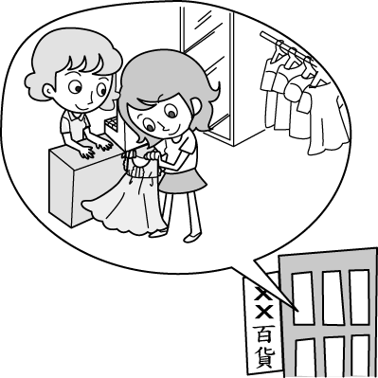 | (２)  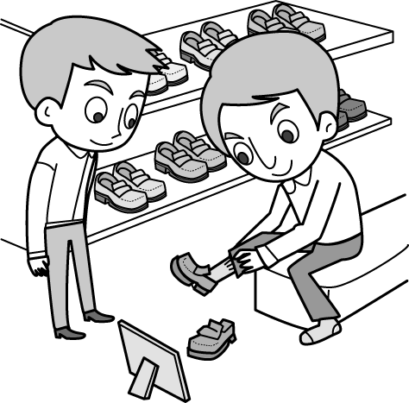
（ ） | （ ）
(３)   | (４)  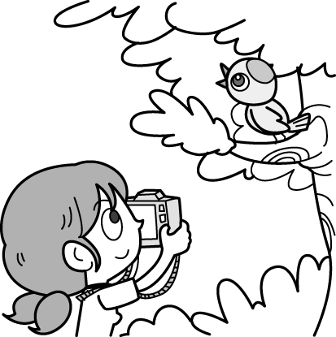
（ ） | （ ）
(５)
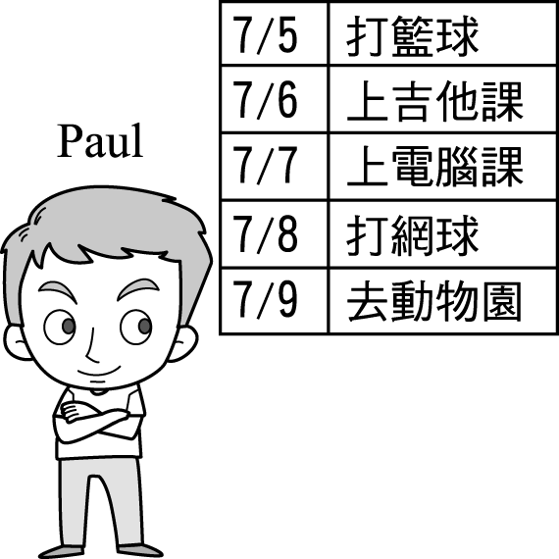
（ ）
0 選出符合句子描述的圖片。
(6)
(Ａ) | (Ｂ) | (Ｃ)
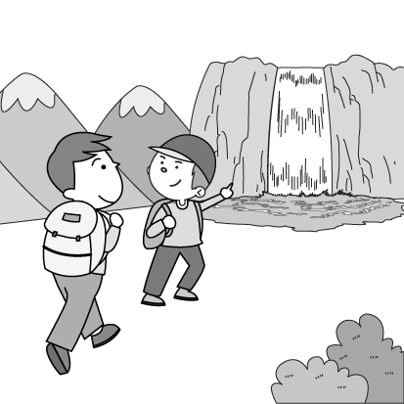 | 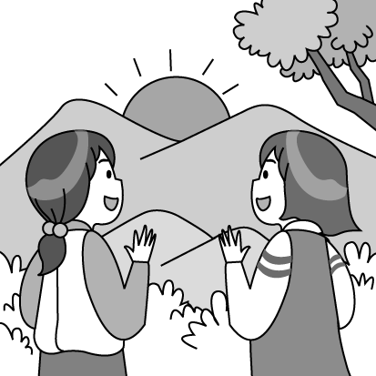 | 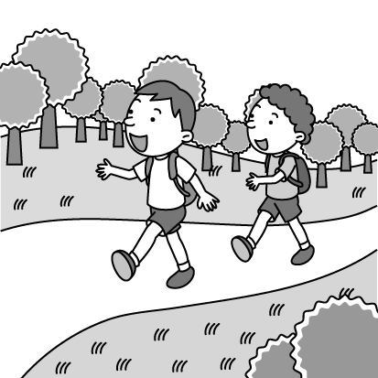
(7)
(Ａ) | (Ｂ) | (Ｃ)
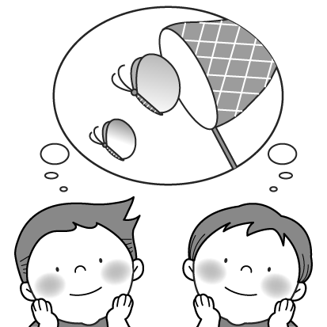 | 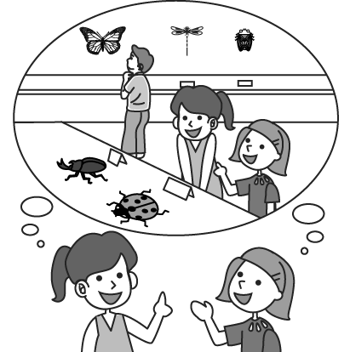 | 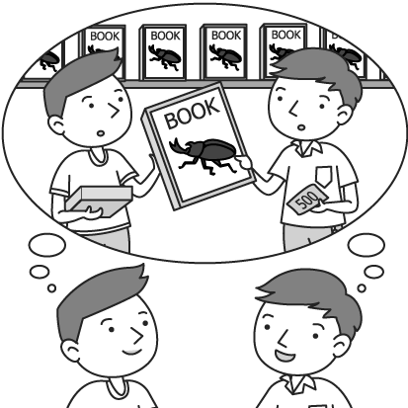
(8)
(Ａ) | (Ｂ) | (Ｃ)
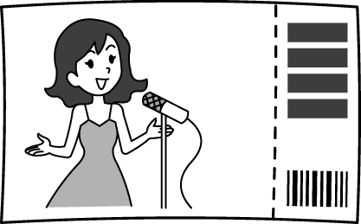 |  | 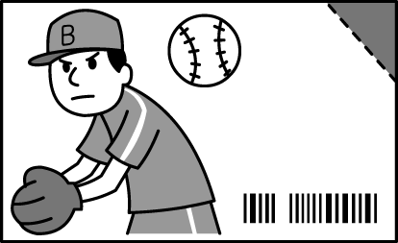

(9)
(Ａ) | (Ｂ) | (Ｃ)
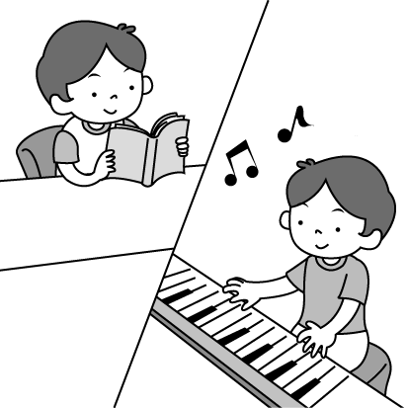 | 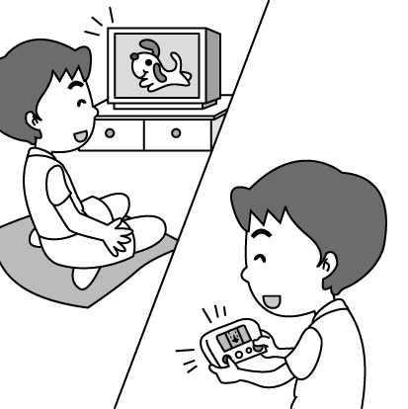 | 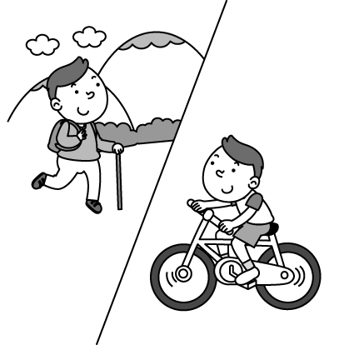
(10)
(Ａ) | (Ｂ) | (Ｃ)
 | 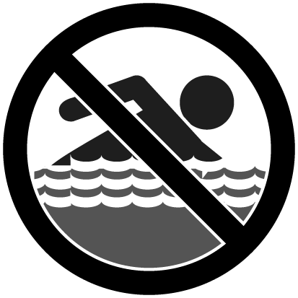 | 
0 選出適當的回應句。
（ ）(11)(Ａ) On a bike. (Ｂ) I can walk there. (Ｃ) I have a scooter.
（ ）(12)(Ａ) There aren’t any buses. (Ｂ) They went there on foot. (Ｃ) No, they didn’t wait for the bus.
（ ）(13)(Ａ) OK. I like to go surfing. (Ｂ) Well.. Can we go fishing there? (Ｃ) Sure. I enjoy surfing the Net very much.
（ ）(14)(Ａ) They went sailing. (Ｂ) They came by ship. (Ｃ) They went on a boat trip last month.
（ ）(15)(Ａ) Great. I went mountain climbing. (Ｂ) Sure, you can join my trip to the beach next time. (Ｃ) Not bad. I even went sailing with some friends.
二、字彙選擇
( ) 16.0We need to do some for the trip to Taipei.
(Ａ)show (Ｂ) shorts (Ｃ) shopping (Ｄ) share
( ) 17. He ______ hard to finish his homework, and he made it finally.
(Ａ) tried (Ｂ) tired (Ｃ) tie (Ｄ) tries
( ) 18.0He is wearing blue today.
(Ａ) dress (Ｂ) jeans (Ｃ) skirt (Ｄ) coat
( ) 19.0 in the mountains is lots of fun.
(Ａ) Go camping (Ｂ) Going camping (Ｃ) Going sailing (Ｄ) Go hiking
( ) 20.0Many people cannot a plane, but they enjoy a plane.
(Ａ) take; taking (Ｂ) take; flying (Ｃ) fly; taking (Ｄ) fly; flying
( ) 21.0Miss Wang takes good care of many flowers and in her garden.
(Ａ) planes (Ｂ) plates (Ｃ) plants (Ｄ) plans
( ) 22.0My dad enjoys going _____ in his free time.
(Ａ) climbing mountains (Ｂ) climbing a mountain (Ｃ) mountain climbing (Ｄ) mountains climbing
( ) 23.0It a lot of money and a lot of time to go shopping at a department store.
(Ａ) takes; costs (Ｂ) takes; takes (Ｃ) spends; spends (Ｄ) costs; takes
( ) 24.0 A: Excuse me. We are ______. How do we get to the police station?
B: It is next to the department store. You won’t it.
(A)miss, lose (B)lose, miss (C)lost, miss (D)miss, lost
三、文法選擇
( )025.0He bought his daughter a new cellphone.
(Ａ) for (Ｂ) to (Ｃ) × (Ｄ) of
( )0263Ken: What you have for lunch?
Tim: Fried noodles. How about you?
(Ａ) will; × (Ｂ) do; go (Ｃ) are; go (Ｄ) are; going
( ) 27.0There many people at the gym this weekend.
(Ａ) are going to have (Ｂ) will be (Ｃ) will have (Ｄ) is going to be
( ) 28.0A: How much the coat? B: Two thousand dollars.
(Ａ) spend (Ｂ) cost (Ｃ) is (Ｄ) are
( ) 29.0A: Did Jay a plane to America yesterday? B: Yes, he went there ______ plane.
(Ａ) take; by (Ｂ) take; took a (Ｃ) by; took a (Ｄ) by; by
( ) 30.0 a new house, he works three different jobs.
(Ａ) Buy (Ｂ) By buying (Ｃ) Buying (Ｄ) To buy
( ) 31.0Go straight two blocks, you’ll see the bookstore on your right.
(Ａ) in; × (Ｂ) for; and (Ｃ) on; and (Ｄ)×; or
( ) 32.0There’s a new supermarket the corner of Lake Road and First Street.
(Ａ) in (Ｂ) between (Ｃ) behind (Ｄ) on
( ) 33.0The post office is the police station and the coffee shop.
(Ａ) next to (Ｂ) on the corner of (Ｃ) between (Ｄ) from
( ) 34.0Here comes _______.
(Ａ) the bus (Ｂ) my parents (Ｃ) he (Ｄ) she
( ) 35.0How long will it ______ to go to school from here?
(Ａ) spend (Ｂ) cost (Ｃ) take (Ｄ) are

四、克漏字測驗
Dear Peter,
How are you?
I’m sorry. I can’t go to your birthday party tonight because my brother ___(36)___ in the hospital, and I am going to visit him. My mom and I ___(37)___ with him tonight and tomorrow.
I ___(38)___ you five minutes ago, but no one answered the phone. Maybe you __(39)____ for the party then.
Happy 15th birthday.
Kevin
Dea
 answer 接（電話）

（ ）(36)(Ａ) was (Ｂ) is (Ｃ) will be (Ｄ) is going to be
（ ）(37)(Ａ) stayed (Ｂ) were staying (Ｃ) are staying (Ｄ) will stay
（ ）(38)(Ａ) called (Ｂ) call (Ｃ) am calling (Ｄ) will call
（ ）(39)(Ａ) prepared (Ｂ) were preparing (Ｃ) are preparing (Ｄ) are going to prepare
0
There are many different (40) to go to school. Some students go to school (41) foot. Some students go to school by bus. Some students (42) a train to school.
Aaron goes to school in a special way. He lives on a small island in Penghu（澎湖）. He gets up at six and takes a (43) to his school in Magong（馬公）. He (44) lots of time getting to school every day. It’s tiring but he is happy because it is a joy for him to learn new things in school!
 island 島 tiring 累人的 joy 喜悅
（ ）(40)(Ａ) stations (Ｂ) roads (Ｃ) trails (Ｄ) ways
（ ）(41)(Ａ) with (Ｂ) on (Ｃ) at (Ｄ) in
（ ）(42)(Ａ) fly (Ｂ) walk (Ｃ) take (Ｄ) wait
（ ）(43)(Ａ) boat (Ｂ) car (Ｃ) scooter (Ｄ) taxi
（ ）(44)(Ａ) costs (Ｂ) spends (Ｃ) takes (Ｄ) uses

五、閱讀測驗
011
Jack and his classmates, David and Ken, are going on a four-day vacation. They will leave Taipei on February 27 and return to Taipei on the last day of the vacation.
Before the trip, Jack checks the weather forecast online. Here is the forecast about the cities they plan to visit.
（ ）(45) They will arrive in Kaohsiung on the third day. How will the weather be?
(Ａ) Rainy. (Ｂ) Windy. (Ｃ) Sunny. (Ｄ) Cloudy.
（ ）(46) ___________ have sunny days during the vacation.
(Ａ) Taipei and Tainan. (Ｂ) Taichung and Kaohsiung.
(Ｃ) Taipei and Taichung (Ｄ) Kaohsiung and Tainan.

0
The bar chart shows how the students in Ms. Chen’s class go to school. Look at it and answer the questions.
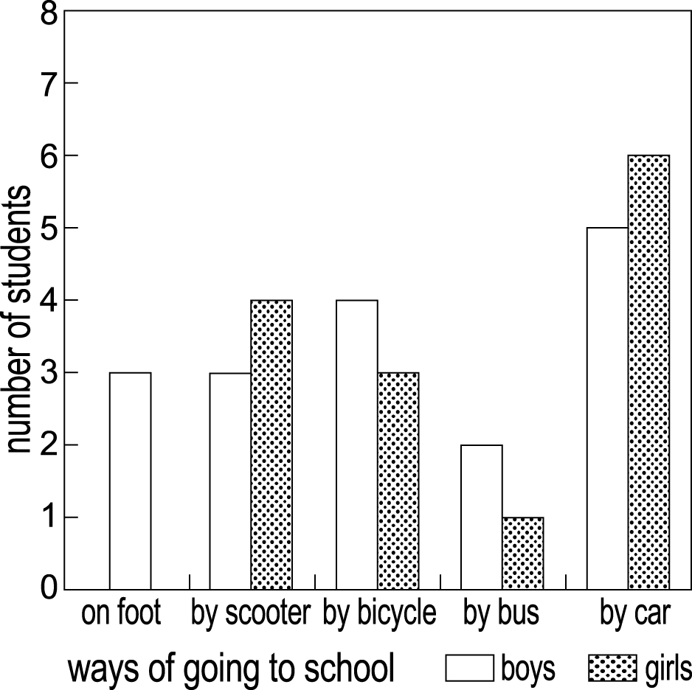
 bar chart 長條圖
（ ）(47) How many different ways do the boys go to school?
(Ａ) Two. (Ｂ) Three. (Ｃ) Four. (Ｄ) Five.
（ ）(48) How many students go to school by bus?
(Ａ) Five. (Ｂ) Six. (Ｃ) Four. (Ｄ) Three .
（ ）(49) How many students are there in Ms. Chen’s class?
(Ａ) 28 (Ｂ) 30 (Ｃ) 31 (Ｄ) 32
0
There are four food shops on Robert’s way to school.
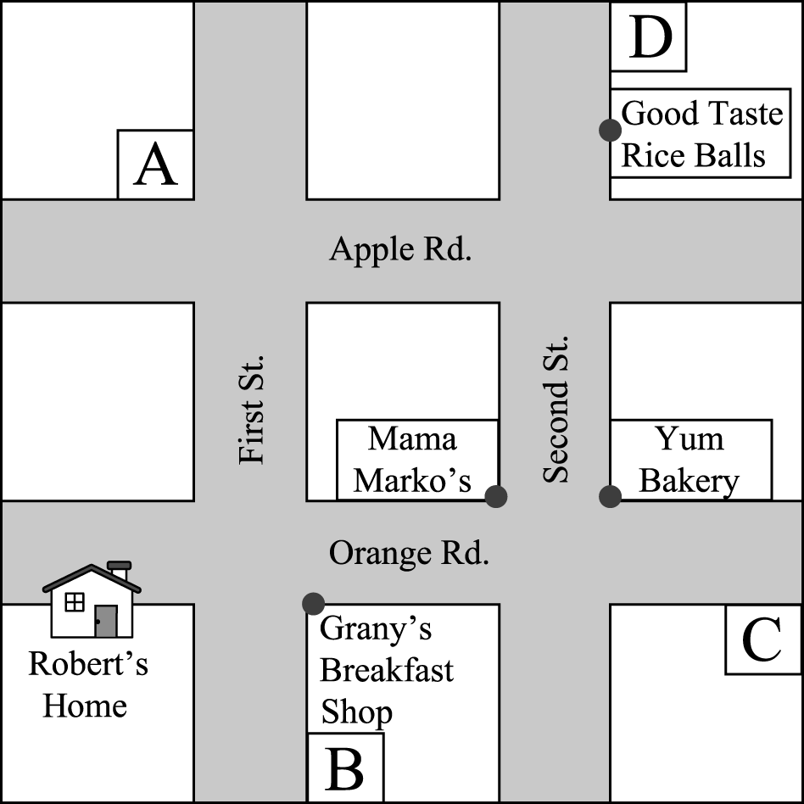
（ ）(50) Robert passes three shops on his way to school in the morning. Look at the map. Which place is most likely（最有可能）to be Robert’s school?
(Ａ) A . (Ｂ) B . (Ｃ) C . (Ｄ) D .

二年級 英語 科 第 三 次段考答案欄（年級、科目請標示清楚，謝謝！）
(１)(Ｃ)； (２)(Ａ)； (３)(Ｃ)； (４)(Ａ)； (５)(Ｂ)
(6)(Ａ)； (7)(Ｂ)； (8)(Ａ)； (9)(Ｃ)； (10)(Ｃ)
(11)(Ａ)； (1２)(Ｂ)；(1３)(Ａ)；(1４)(Ｂ)；(15)(Ｃ)
(16)(C )； (17)(A )； (18)(B )； (19)(B )； (20)(Ｃ)
(21)(Ｃ)； (2２)(C )；(2３)(D )；(2４)(C )；(2５)(C )
(26)(Ａ)； (27)(Ｂ)； (28)(C )； (29)(A )； (30)(D )
(31)(B )； (3２)(D )；(3３)(Ｃ)；(3４)(Ａ)；(3５)(C )
(36)(B )； (37)(D )； (38)(Ａ)； (39)(B )； (40)(D )
(41)(B )； (4２)(C )；(4３)(A )；(4４)(B )；(4５)(D )
(46)(D )； (47)(D )； (48)(D )； (49)(Ｃ)； (50)(Ｃ)

