高雄市立林園高中國中部101學年度第1學期三年級英語科第1次段考 試題
************************************************************************************

聽力測驗 每題2分 共20分
一、聽CD內容，把符合圖片的句子選項代碼 (A) 或 (B) 寫在答案卷上。

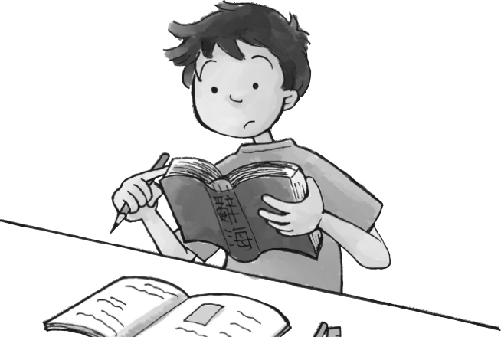


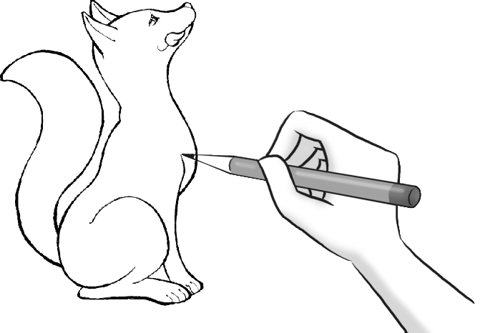
1. 2. 3. 4. 5.

二、根據聽力內容完成確認單，完成打 O，未完成打 X，並把答案寫在答案卷上。

- clean the bathroom
- clean the kitchen
- mop the floor
- take out the garbage
- wash the dishes

紙筆測驗 共80分
三、文意字彙 每題2分 共20分
1.Every student has to learn at least one f ___ n language.
2.It’s cold. I need a b ___ t to keep warm .
3.Pete is cleaning the b ___ b in the bathroom.
4.The mail carrier put a letter into the m ___ x .
5.There is a l ___ p on the desk.
6.It’s raining. You need an u ___ a when you go to school.
7.The boss is looking for a hard-working and h ___ t man.
8.The people in this town need a b ___ e to cross the river.
9.Tom’s friends will give him a big s ___ e at his birthday party.
10.Taiwanese always use c ___ ks to eat rice.

四、寫出下列動詞的過去分詞 每題2分 共10分
1. see 2.teach 3.win 4.eat 5.know

五、文法選擇 每題2分 共10分
1.Tom: How many times ___ you ___ to America?
Lisa: 12.
(A)do; go (B)have; gone (C)are; going (D)have; been
2.Rex has lived in this town since ___ .
(A)more than 20 years (B)he was a kid (C)a long time (D)from last year

背面有題，繼續作答
3.Tina is going to have ___ . She has ___ to the hospital.
(A)a baby; been (B)a bath; went (C)a bath; gone (D)a baby; gone
4.That book ___ by a lot of people for 10 years .
(A)had read (B)has been read (C)had been readed (D)was reading
5.The medicine has to ___ in a cool and dry place.
(A)put (B)be put (C)have put (D)be putting

六、克漏字填充 每題2分 共10分
(Ben and Pete are waiting __1__ the garbage truck.)
Ben: Has the garbage truck arrived?
Pete: No, it hasn’t arrived. Have you separated the recycling __2__ the garbage?
Ben: Yes. I packed the recycling into different bags and put them outside __3__ the mat.
Pete: Have you seen the dog next door? Watch __4__ ! Sometimes he comes and bites the bags. He likes to “unpack” the garbage __5__ you!

七、克漏字選擇 每題2分 共10分
Maybe you have seen Judy Smith. She is now a 9 grade student at our school.
Judy is from Portland, USA. She __1__ to Kaohsiung in August. She __2__ at our school for two months, and she __3__ herself and __4__ many friends.
Last week, Judy __5__ on a school trip with her classmates. They all had a good time.
- (A)is moving (B)has moved (C)moved (D)wouldn’t stop
- (A)is going to be (B)will be (C)was (D)has been
- (A)is enjoying (B)has enjoyed (C)enjoyed (D)will enjoy
- (A)has made (B)is making (C)will make (D)should make
- (A)was going (B)has gone (C)went (D)will go

八、句型與翻譯 每題4分 共20分
1.How long have you studied English? (用8年以完整句子回答)

2.The letter was written by Sam. (改成主動句型)

3.Jean has already fed the dog. (加入yet改寫成否定句)

4.凱文的棒球帽被風吹走了。

5.泰德自從5歲起就住在這裡。

高雄市立林園高中國中部101學年度第1學期三年級英語科第1次段考 答案卷

班級： 座號： 姓名：
************************************************************************************

一、聽CD內容，把符合圖片的句子選項代碼 (A) 或 (B) 寫在答案卷上。 每題2分 共10分
1. | 2. | 3. | 4. | 5.

二、根據聽力內容完成確認單，完成打 O，未完成打 X。每題2分 共10分
1. | 2. | 3. | 4. | 5.

三、文意字彙 每題2分 共20分
1. | 2. | 3. | 4. | 5.
6. | 7. | 8. | 9. | 10.

四、寫出下列動詞的過去分詞 每題2分 共10分
1. | 2. | 3. | 4. | 5.

五、文法選擇 每題2分 共10分
1. | 2. | 3. | 4. | 5.

六、克漏字填充 每題2分 共10分
1. | 2. | 3. | 4. | 5.

七、克漏字選擇 每題2分 共10分
1. | 2. | 3. | 4. | 5.

八、句型與翻譯 每題4分 共20分 (錯1字扣1分，扣完為止)
1.
2.
3.
4.
5.

高雄市立林園高級中學國中部101學年度第1學期三年級英語科第1次段考 解答
********************************************************************************
一、聽CD內容，把符合圖片的句子選項代碼(A)或(B)寫在答案卷上。每題2分 共10分
1.B | 2.B | 3.A | 4.B | 5.A

二、根據聽力內容完成確認單，完成打 O，未完成打 X。每題2分 共10分
1.O | 2.X | 3.O | 4.O | 5.X

三、文意字彙 每題2分 共20分
1.foreign | 2.blanket | 3.bathtub | 4.mailbox | 5.lamp
6.umbrella | 7.honest | 8.bridge | 9.surprise | 10.chopsticks

四、寫出下列動詞的過去分詞 每題2分 共10分
1.seen | 2.taught | 3.won | 4.eaten | 5.known

五、文法選擇 每題2分 共10分
1.D | 2.B | 3.D | 4.B | 5.B

六、克漏字填充 每題2分 共10分
1.for | 2.from | 3.on | 4.out | 5.for

七、克漏字選擇 每題2分 共10分
1.C | 2.D | 3.B | 4.A | 5.C

八、句型與翻譯 每題4分 共20分 (錯1字扣1分，扣完為止)
1.I have studied English for eight years.
2.Sam wrote the letter.
3.Jean hasn’t fed the dog yet.
4.Kevin’s baseball cap was blown away by the wind.
5.Ted has lived here since he was five years old.

