高雄市立林園高級中學國中部101學年度第一學期三年級英語科第二次段考 試題卷
一、聽CD的二個敘述，勾選出符合圖片的句子：（每題２分, 共10分）
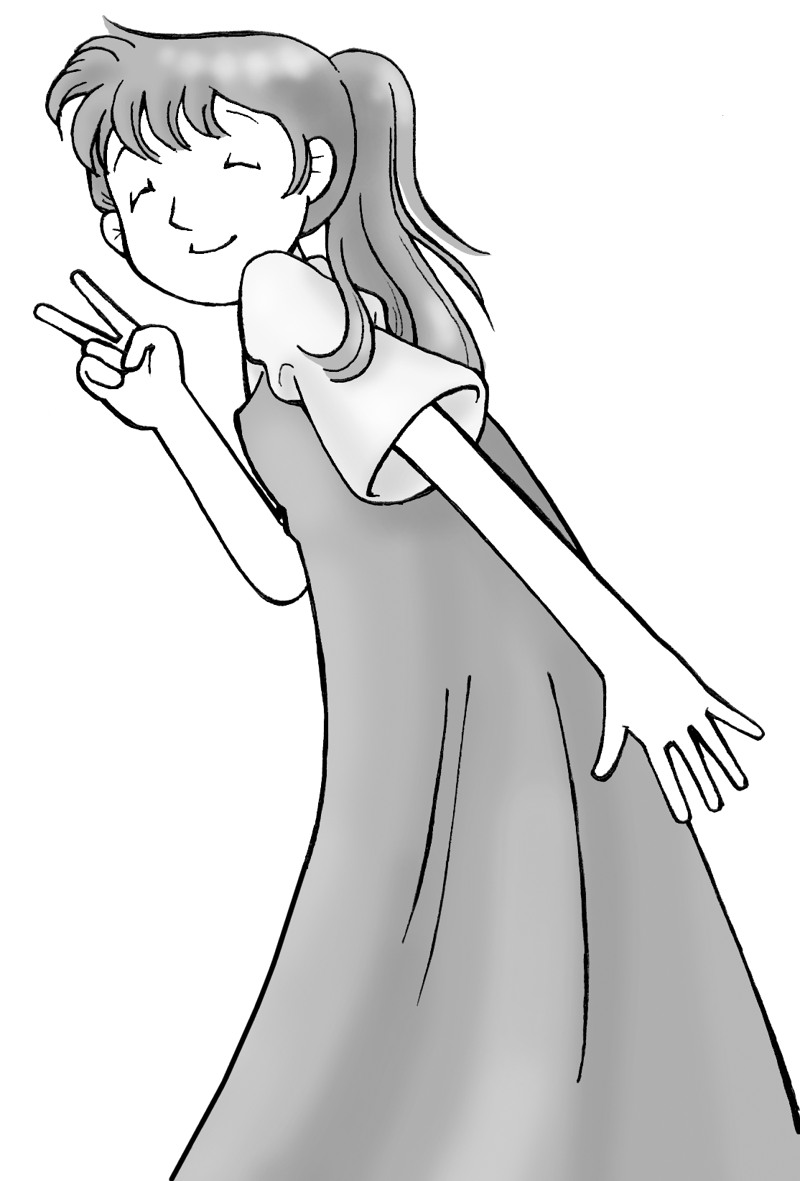
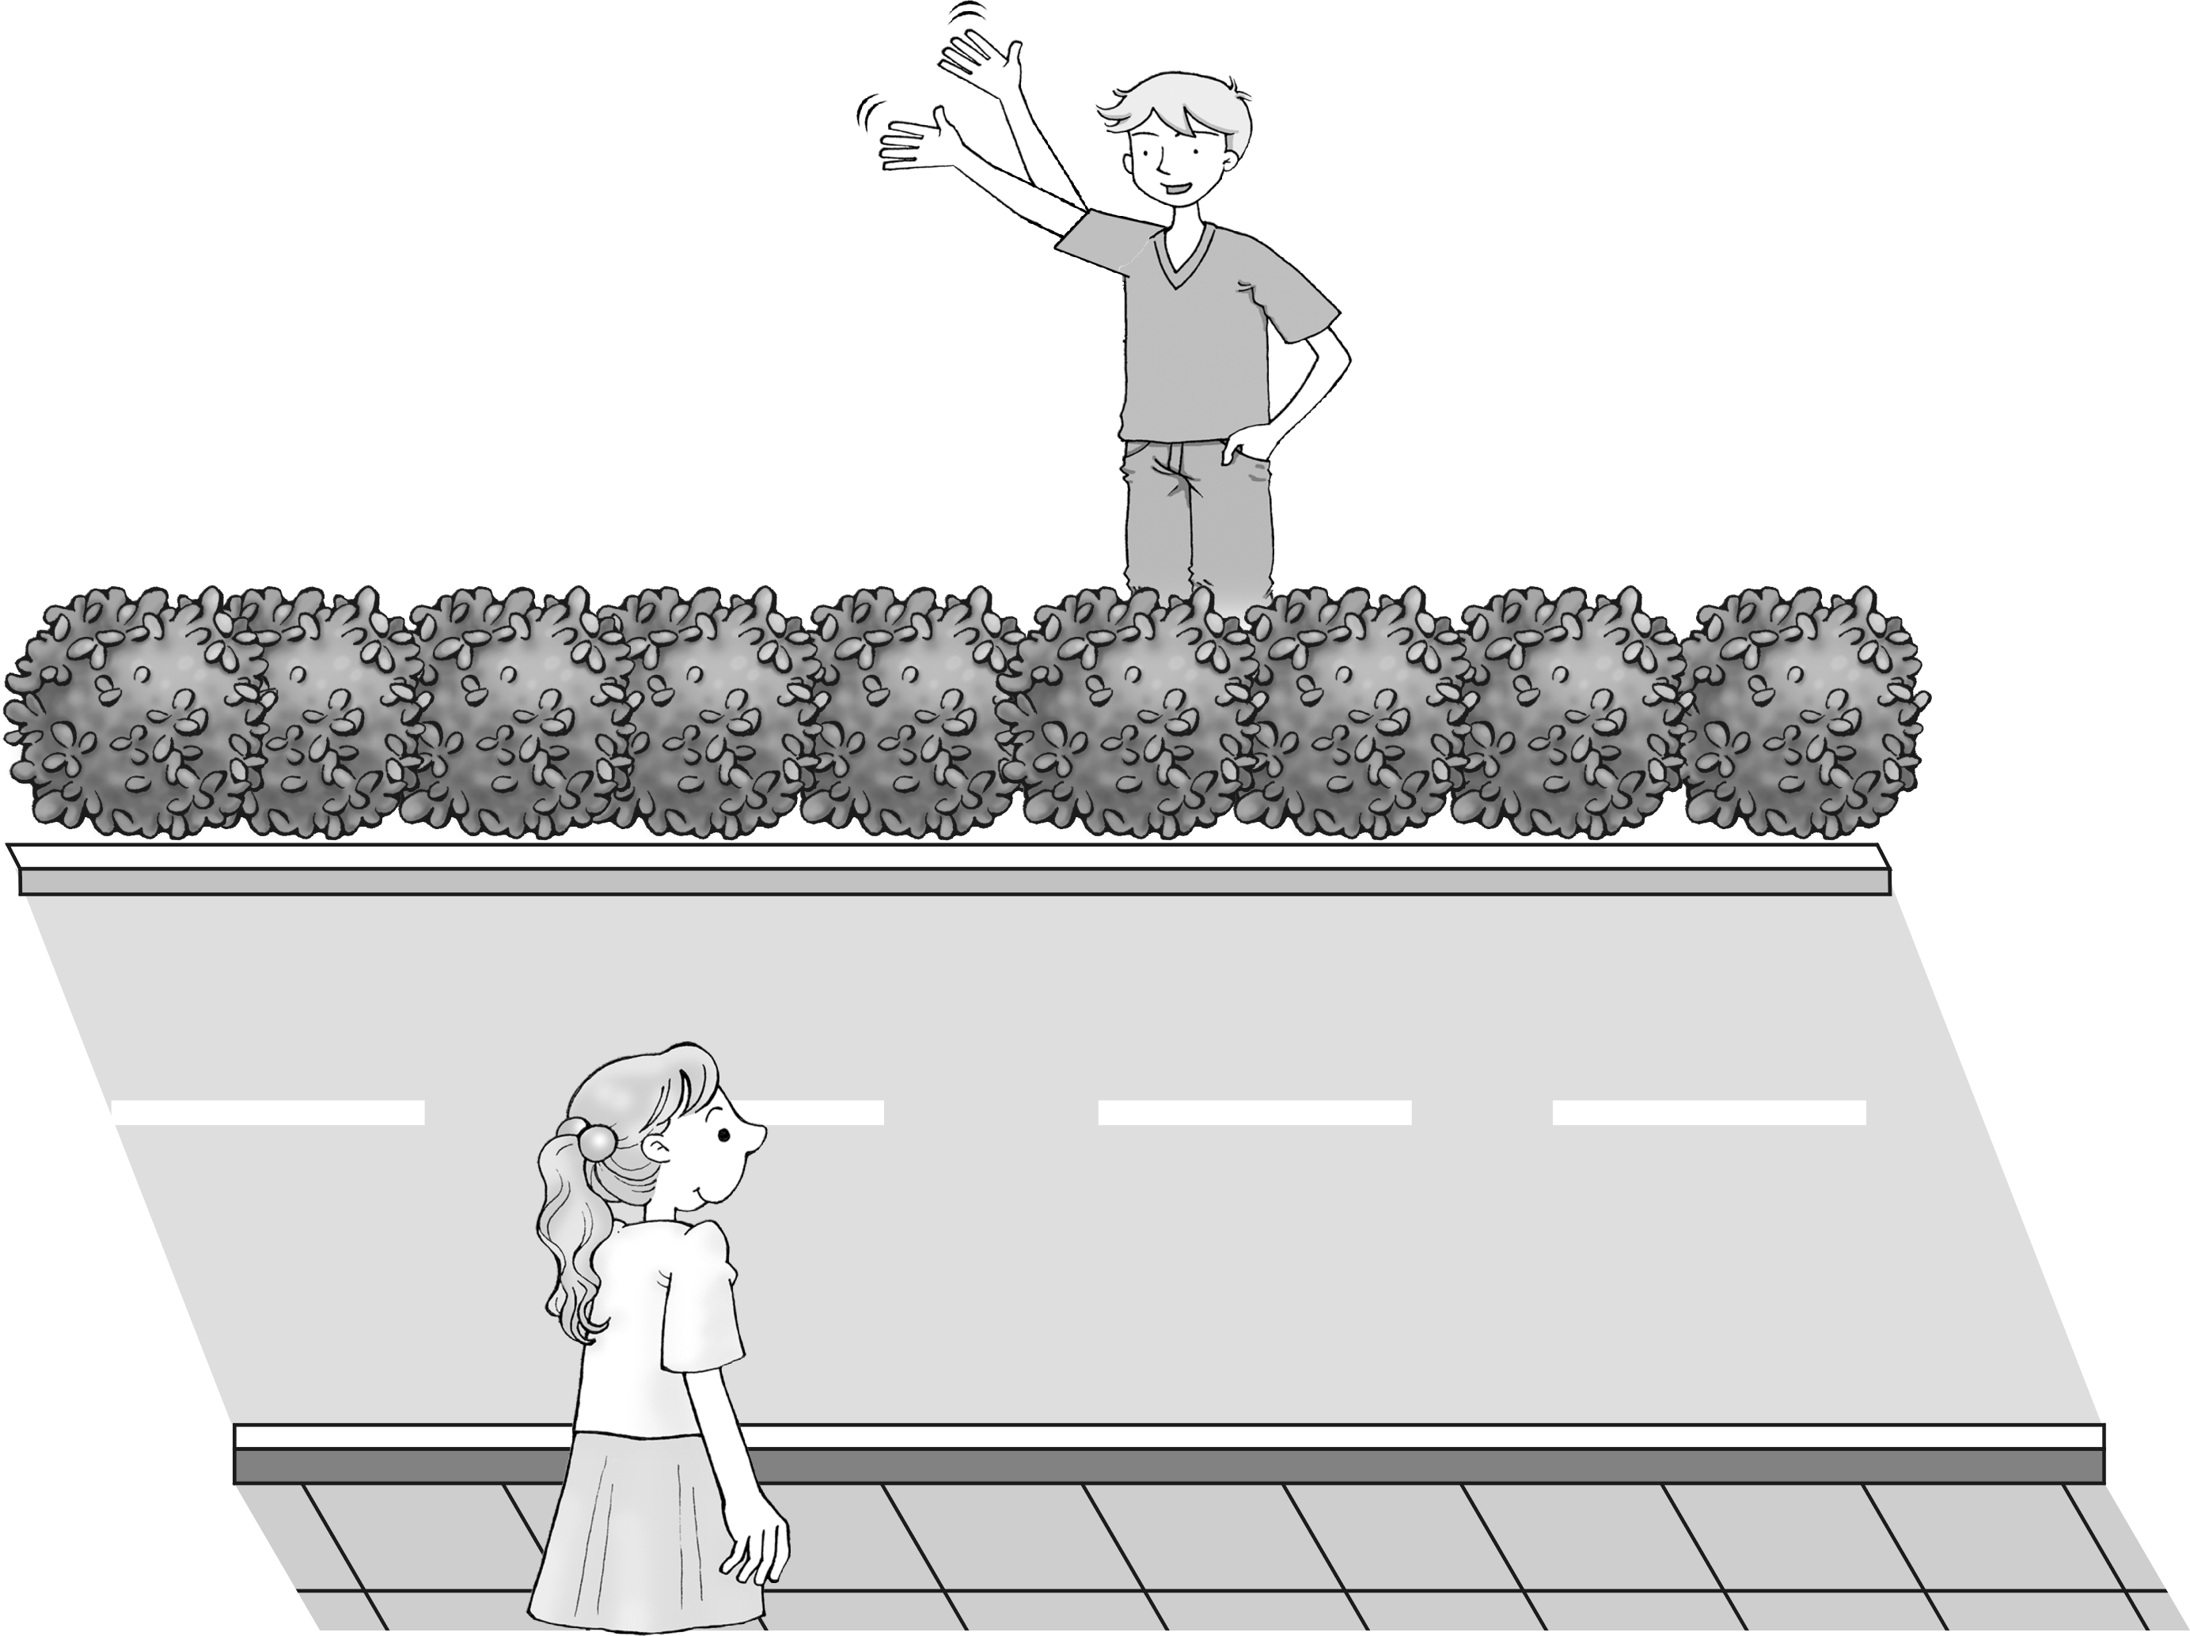

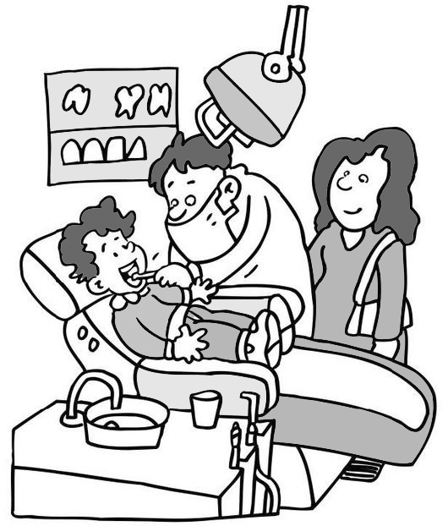
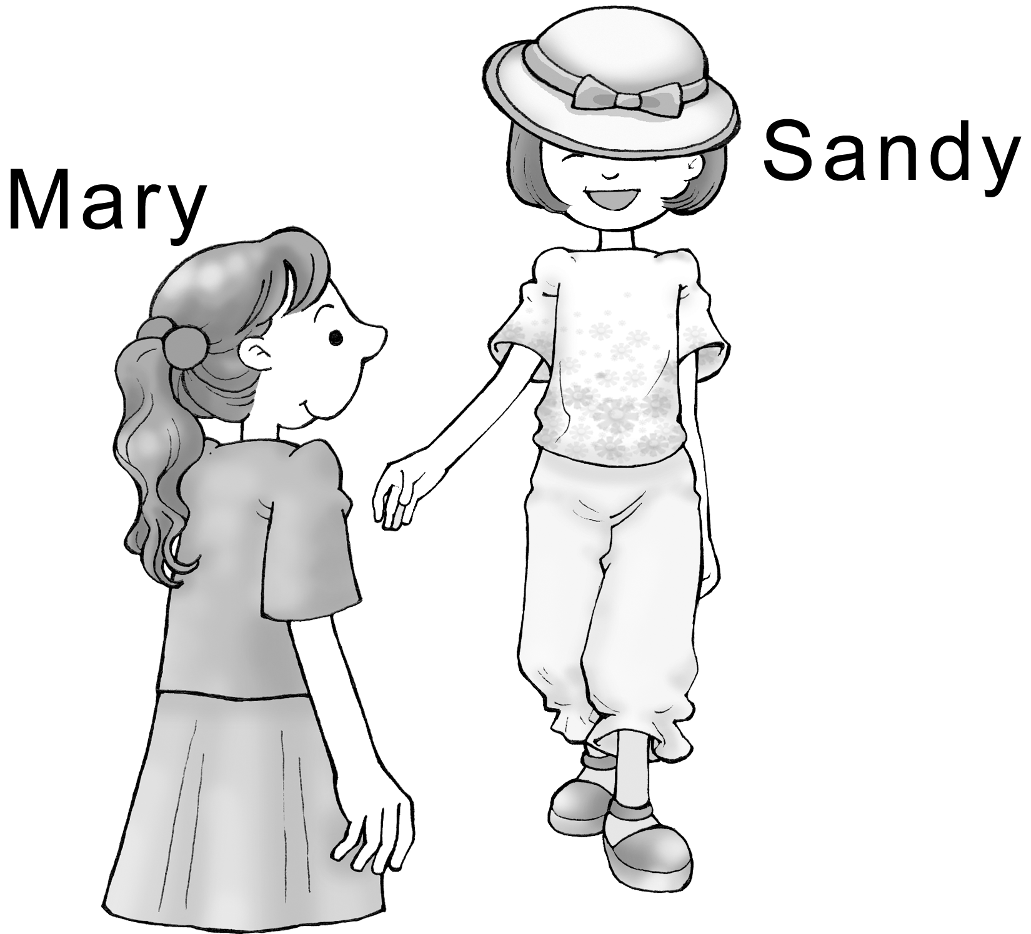
1. 2. 3. 4. 5.

A ( ) B ( ) A ( ) B ( ) A ( ) B ( ) A ( ) B ( ) A ( ) B ( )
二、聽CD的問題，選出最適當的回應：（每題２分, 共10分）
( ) 1.  (A) I like the clean one.  (B) It’s you who took the picture.  (C) It’s taken by my camera.  (D) The one that was taken in the zoo. | ( ) 2.  (A) I think it belongs to Mary.  (B) It’s not mine. I think it’s Bill’s.  (C) It was Bill who had the idea.  (D) There’s something wrong with Bill. | ( ) 3.  (A) She lives on the third floor.  (B) She is a good neighbor.  (C) Her daughter is my classmate.  (D) Anita Wells.
( ) 4.  (A) The kid who was saved is Bobby.  (B) She doesn’t like the one who saved  the kid.  (C) I know Kevin likes kids.  (D) Yes, he is Kevin’s brother. | ( ) 5.  (A) I’ve told you not to make fun of him.  (B) All right. I can let you use my new  motorcycle.  (C) I think so. I usually listen to English  radio when I take the bus.  (D) That’s right! You should use your time well.

三、文意字彙（每題2分, 共10分）
1. This is my first year as a teacher. I don’t have much e e in teaching.
2. It’s dangerous to ride a mortorcycle on the s k.
3. You work so hard; I believe you will s d one day.
4. Your h g is awful. Please make it clearer and tidier.
5. J.K. Rowling finds great p e in reading, and she enjoys reading novels most.

四、文法選擇（每題2分, 共22分）
( )1.The man _______ a black jacket is Obama.
(A)wears (B)in (C)with (D)has
( )2. The woman _______ is talking with my mom is 50 years old.
(A)that (B) which (C) where (D) what
( )3.The party ________ Jolin Tsai held was on last Sunday.
(A) who (B) X (C) what (D) when
( )4. You are listening to the song written by Jay Chou.
(A) who had (B) which was (C) what was (D) who was
( )5. Jeremy Lin is my oldest friend because he is someone I grew up _______.
- for (B) off (C)with (D) of
( )6. I didn’t go to bed _________ I finished my English homework.
(A)because (B)or (C)since (D)until
( )7. I asked Nina to send me a photo _________, but she said no.
(A)at herself (B) on herself (C) in herself (D) of herself
( )8. My sister, ________ likes to eat banana, is good at dancing.
(A)who (B)that (C)which (D)where
( )9. Candice who your best friend your help now.
(A)be; need (B) am; need (C) are; needs (D) is; needs
( )10.This is the park _______ we met for the first time.
(A) at (B) in where (C) in which (D) in
p.1
( )11. All ________ we do every day is sit inside and study.
(A) that (B) which (C) who (D) what

五、填入適當的片語，請適時變化其時態。（每題2分, 共6分）
fall off keep fit keep in touch fall asleep keep warm
1. Ms. Huang was very angry with me because I ____________ in the class.
2. Spider-Man goes climbing every weekend to ____________.
3. Let’s ____________ by mail.

六、填入適當的副詞或介係詞：（每題1分, 共6分）
around over past by across along
1. We had to climb ________ large rocks to get to the beach.
2. He just walked ________ without even looking at me.
3. Do we have to swim ________ the river?
4. Two boys went ________ us on their mountain bikes.
5. This is our new office. Kate will show you ________.
6. Many houses are built ________ both sides of the river.

七、依提示作答（每題4分, 共16分）(錯1字扣1分，扣完為止)
1. What is the name of the movie?
You’re going to see the movie. (省略關係代名詞合併)
___________________________________________________________________________________________
2. The woman who is wearing a black hat often has dinner at this restaurant.（劃線部份改為介系詞片語，請用in~）
___________________________________________________________________________________________
3. This is the theater where I saw the movie The Amazing Spider-Man.（用介系詞 + which改寫句子）
___________________________________________________________________________________________
4. Do you know the name of the shop?
Kitty bought a pretty dress in the shop.（用關係副詞合併）
___________________________________________________________________________________________

八、翻譯（每題5分, 共10分）(錯1字扣1分，扣完為止)
1. 那是一台用來檢查包裹的機器
___________________________________________________________________________________________
2. 有沒有什麼事是我可以為你做的？
___________________________________________________________________________________________

九、克漏字測驗（每題2分, 共10分）
Ms. Lin is a busy teacher 1. hard in Kaohsiung. She is too busy 2. her father, so she usually sends her father a card and a bunch(一束) of flowers on Father’s Day..
On the morning of Father’s Day, while Ms. Lin 3. some red flowers, she heard a little girl talking to the clerk. The little girl said, “I have only twenty dollars. Can I get a white flower?” The clerk said, “Sorry, you can’t. You must pay fifty dollars for one white flower.” The little girl looked sad and didn’t know what to do.
Ms. Lin bought one white flower for the little girl and drove her to the place 4. her father was buried(埋葬 bury的過去分詞). The little girl was very happy to offer(奉獻) the white flower to her father. At that moment, Ms. Lin was touched by the little girl. After taking the little girl home, Ms. Lin made up her mind to spend four hours 5. to her father’s home. She wanted to give her father a surprise for Father’s Day.
( )1. (A) she works (B)who work (C)which works (D)who works
( )2. (A) not visiting (B)to visit (C)can’t visit (D)not to visit
( )3. (A) is picking (B)was picked (C)has picked (D)was picking
( )4. (A) in where (B)there (C)where (D)which
( )5. (A) driving (B) to drive (C)drove (D) driven
p.2
高雄市立林園高級中學國中部101學年度第一學期三年級英語科第二次段考 答題卷
班級: 座號: 姓名:
一、聽CD的二個敘述，勾選出符合圖片的句子：（每題２分, 共10分）
1.  A ( ) B ( ) | 2.  A ( ) B ( ) | 3.  A ( ) B ( ) | 4.  A ( ) B ( ) | 5.  A ( ) B ( )

二、聽CD的問題，選出最適當的回應：（每題２分, 共10分）
1. | 2. | 3. | 4. | 5.

三、文意字彙（每題2分, 共10分）
1. | 2. | 3. | 4. | 5.

四、文法選擇（每題2分, 共22分）
1. | 2. | 3. | 4. | 5.
6. | 7. | 8. | 9. | 10.
11.

五、填入適當的片語，請適時變化其時態。（每題2分, 共6分）
1. | 2. | 3.

六、填入適當的副詞或介係詞(習作p.22) ：（每題1分, 共6分）
1. | 2. | 3. | 4. | 5. | 6.

七、依提示作答（每題4分, 共16分）(錯1字扣1分，扣完為止)
1.
2.
3.
4.

八、翻譯（每題5分, 共10分）(錯1字扣1分，扣完為止)
1.
2.

九、克漏字測驗（每題2分, 共10分）
1. | 2. | 3. | 4. | 5.

高雄市立林園高級中學國中部101學年度第一學期三年級英語科第二次段考 答題卷
一、聽CD的二個敘述，勾選出符合圖片的句子：（每題２分, 共10分）
1.A | 2.A | 3.B | 4.A | 5.B

二、聽CD的問題，選出最適當的回應：（每題２分, 共10分）
1.D | 2.C | 3.D | 4.D | 5.D

三、文意字彙（每題2分, 共10分）
1.experience | 2.sidewalk | 3.succeed | 4.handwriting | 5.pleasure

四、文法選擇（每題2分, 共22分）
1.B | 2.A | 3.B | 4.B | 5.C
6.D | 7.D | 8.A | 9.D | 10.C
11.A

五、填入適當的片語，請適時變化其時態。（每題2分, 共6分）
1.fell asleep | 2.keep fit | 3.keep in touch

六、填入適當的副詞或介係詞(習作p.22) ：（每題1分, 共6分）
1.over | 2.by | 3.across | 4.past | 5.around | 6.along

七、依提示作答（每題4分, 共16分）(錯1字扣1分，扣完為止)
1.What is the name of the movie you’re going to see?
2. The woman in black a hat often has dinner at this restaurant.
3. This is the theater in which I saw the movie The Amazing Spider-Man.
4. Do you know the name of the shop where Kitty bought a pretty dress?

八、翻譯（每題5分, 共10分）(錯1字扣1分，扣完為止)
1.That is a machine which is used to check packages.
2.Is there anything (which/that) I can do for you?

九、克漏字測驗（每題2分, 共10分）
1.D | 2.B | 3.D | 4.C | 5.A

