高雄市立林園高級中學 國中部 101學年度 第 ㄧ 學期 三 年級 英文 科 第 三 次段考考卷
班級： 姓名： 座號：
- 聽力測驗：聽CD的問題，選出最適當的回應：（每題二分） 本測驗內容將唸2遍，聽力測驗開始
( D ) 1. (A) Don’t worry. We are smarter than her.
(B) Never mind. We still have chances.
(C) If you ask him, he won’t tell you.
(D) Just do it. I’m sure she won’t mind.
( D ) 2. (A) I don’t know where I am. (B) Your train will arrive soon.
(C) It’s on the fifth floor. (D) By bus number 299.
( C ) 3. (A) I am too tired to study English now.
(B) I worked so hard that I made a lot of money.
(C) You are right. We should learn things every day.
(D) How stupid you are!
( A ) 4. (A) Yes, it does. (B) Yes, he is. And how about you?
(C) No, I didn’t take it. (D) Because time is money.
( B ) 5. (A) Yes, he’s changed his mind.
(B) Yeah, my brother and I like to do it very much.
(C) I never lie to you.
(D) I always keep my mind on the kites.
二、聽完CD的短文後，回答下列問題：
( C ) 6. (A) Brian’s house. (B) Emily’s house. (C) Mr. Potter’s snack bar. (D) Brian’s snack bar.
( B ) 7. (A) October. (B) November. (C) December. (D) January.



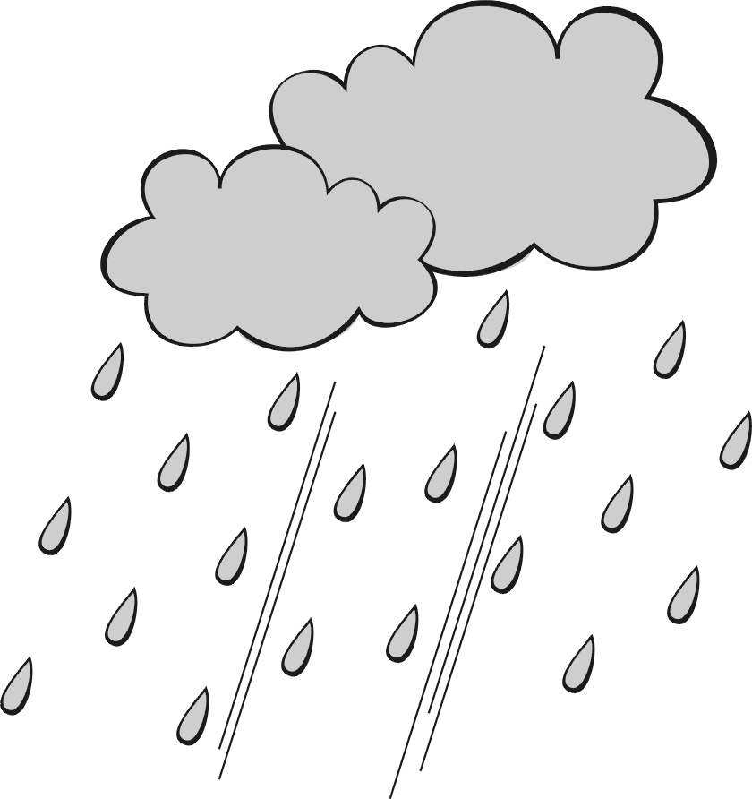
( D ) 8. (A) (B) (C) (D)

( C ) 9. (A) She has a bad cold. (B) She doesn’t like David.
(C) She has to clean the house. (D) She doesn’t like to go out on rainy days.
( D )10. (A) It is always rainy this month every year.
(B) It has rained heavily for a week.
(C) It won’t become fine until tomorrow.
(D) It is not raining when David calls Emily.

三.文意字彙選擇：根據句意，選出最適當之答案。每題2分共30分
11.Could you please _____ your question? I wasn’t listening. (A) talk (B)repeat (C) make (D) took
12.I don’t like seeing animals in _____. They look so poor. (A)cages (B) drawer (C) shopkeeper (D) proud
13.Lily’s driving test is this afternoon. She is very _______and worries that she may not pass it. (A)lonely (B) proud (C)healthy (D)nervous
14.Jay Chou is famous, both at home and ______. (A)abroad (B)road (C) country (D)closet
15.Kent has been ____ strangely since his wife died. (A)acts (B)acted (C)acting (D)think
16.Jack is _______because he has been sick for a week, and he can’t even move a finger. (A)strong (B)weak (C)polite (D)pretty
17.Jemery spent two ________ dollars on buying a sports car. (A)million (B) thousands (C)hundreds (D)many
18.My mother has a beautiful ______ with pearl on it. (A)person (B)children (C)towels (D)pin pearl珍珠
19.My brother _________ to the phone and picked it up when it rang. (A)raced (B)run (C)comes (D)carry
20.Everyone went hiking on Sunday _______ Eric because he caught a bad cold. (A)except (B)for (C)next (D)beside
21. What are you planning to do after you _______ from jonior hogh school next June? (A)go through (B)graduate (C)race (D)explain
22._______ speak louder than words,so just do it now. (A)Dots (B)Air (C)Actions (D)Mud
23.If you drive, it’s not easy to find a parking ______ in Taipei. (A)space (B)tourist (C)glue (D)lady
24.Many students always ______ about too much homework and too many tests to their teachers. (A)serious (B)complain (C)explains (D)counts
25.Getting up late is not a good ______ for being late. (A)examples (B)cases (C)excuse (D)space
四、對話測驗：根據句意，選出最適當之答案。每題2分共20分
26.Jimmy:
Tom: OK. It’s 32 miles from here.
(A) Tell me how far the gym is.. (B) Tell me how tall it is.
(C) Tell me how often it is. (D) Can you tell me how old your brother is?
- Jenny: Peter has to wear glasses to read this, ______?
Eric:
(A) has Peter；No, he hasn’t. (B) does he；Yes, he has.
(C) doesn’t he；Yes, he does. (D) isn’t Peter；No, he isn’t.
- Ben: This diamond ring is the birthday gift for you!
Alice: Oh,__________! Thank you.
(A) how a nice day (B) what wonderful (C)how wonderful (D)what a bad idea
- Sue: You’ve spelled my name wrong!
Mark: Oh, sorry.
(A) How strange you are! (B) Could you explain what you did last night? (C) I am too easy to remember.
(D) What a stupid mistake I made!
- Kevin：My darling, ________ happens,I will always be with you.
Jenny:Oh, you are so sweet.
  - No matter how (B)Now matter it (C)No matter what (D)No matter when
- Mother：What is the matter? Son :__________.
(A)I do not know what can I say. (B)I want to make sure whether to do. (C)Nothing. Do not worry. (D)Tell me if make a plan.
32.Lily:Your mother has gone to Taipei, _________? Tom:Well, I am not so sure.
(A) hasn’t she (B)has she (C)does he (D)is she
33.Cathy: Alex will never tell the truth, _________? Tim:I think so.
(A) will she (B) won’t he (C) will he (D) don’t she
34.Mom: Can you tell Sam ____________? Dad:Sure, no problem.
(A) when can he do it. (B)what time is it (C)if can he make (D) how to fix it.
35. Sam: The movie was ____ boring ____ I fell asleep in the movie theater. Kitty:Really?
(A) too , to (B)so, it (C) so , that (D)enough .to
五.克漏字測驗 18％
A. My son is getting bad grades at school, so I called his teacher. I’m not sure 36. I should have
done that. I was angry at first. But his teacher was so nice—I just didn’t know 37. to think or say.
His teacher said 38. my son is very smart, but he doesn’t try hard enough in class. She said she
didn’t know 39. to make him try harder. I told her not to worry: I’ll make him try harder.
36.(A) what (B) whether (C) when (D) how
37.(A) where (B) when (C) what (D) who
38.(A) that (B) when (C) then (D) where
39.(A) what (B) if (C) how (D) who
B. Jenny:You’ve seen your grades, 40 ?
Brian:They aren’t the final ones, are they?
Jenny:I’m afraid they are. I told you to stop 41 computer games and start studying, but you 42 , did you?
Brian: I need to talk to Mrs. Thomas. I’ll ask her to give me a second chance.
Jenny:I don’t think she will listen to you.
Brian:You will talk to her about my grades, 43 ?
Jenny:Well, I will. But I don’t think she will give you 44 chance.
40.(A) have you (B) haven’t you (C)wouldn’t you (D)did you
41.(A)to play (B)to playing (C)in paying (D)playing
42.(A)didn’t listen (B)hasn’t started (C)didn’t started (D)couldn’t stoping
43.(A)will you (B)isn’t you (C)will she (D)won’t you
44.(A)more (B)another (C)else (D)other
六、閱讀測驗：閱讀文章後,根據題意,選出最適當之答案；每題二分。
Mark: You love me, don’t you?
Stacy: Of course.
Mark: You’d do anything for me, right?
Stacy: Yes, my dear.
Mark: You’d even die for me, is that true?
Stacy: If I had to, I would.
Mark: You’d do anything for me. Great! Now go
make me a sandwich!
Stacy: Make your own sandwich, lazy bones!
45. “Lazy bones” probably means .
(A) Mark is helpful (B) Mark is a lazy person
(C) Mark is not lazy at all (D) Stacy wants Mark to take a rest
46.Which is true about Stacy?
(A) She makes herself a sandwich. (B) She tells Mark to make her a sandwich.
(C) She has never made a sandwich. (D) She doesn’t make a sandwich for Mark.
B.
How smart are you ? Do you know how high your I.Q.is ? I.Q. stands for “intelligence quotient”. To most people, it is a number that shows how smart a person is. Before there were I.Q. tests, a person was as smart as the things he or she did. But as we all know, sometimes “smart” people can do some very “ stupid ” things, and some people who don’t seem very smart are successful or important people. So how do we know for sure whether a person is smart or not ? In 1904, the French psychologist Alfred Binet found a way to tell how smart a person was. Binet designed a test. The test asked children to follow simple orders, copy pictures, name different things. People started calling the score on Binet’s test “intelligence quotient” or “ I.Q. ”
intelligence quotient 智力商數 design 設計 psychologist 心理學家 score 分數
47.How many years has the intelligence quotient test been used?
(A)one year (B)more than one hundred years (C) tens of thousands of years (D)ten thousand years

C. Chatbook

 Cathy Hsu
Hey, you know what? Ang-Lee, who is a famous director（導演）, has had a new work. Has anybody seen it? If not, may I invite somebody to go to the movie this weekend? And maybe some of you can tell me something about the movie.

Like Message
67
Lisa: I think the movie”Life if Pi” is very great. And I am wondering how he could make such a wonderful movie.
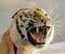Anna: Actually, the story of “Life of Pi”was a novel,which was written by Yann Martel. The protagonist, Piscine Molitor “Pi”, an Indian boy from Pondicherry, explores things of spirituality（精神） and practicality（現實）from an early age. He survies 227 days after a ship accident while floating on a boat in the Pacific Ocean with a Bengal tiger named Richard Parker.
Susan: I think all of you should go to the movie “Life of Pi” because Ang-Lee is very good at telling a long story in a simple way. Most of all, the scenery in the movie is so beautiful that I want to know where it is.
Jimmy: I heard that most of the scenes（場景）in the movie were in Taichung, and Kenting. No wonder Taiwan was called “Beautiful Island” before.

48.According to（根據）the reading,which one is true?
(A)Parker was the best actress in the song. (B)Taiwan was the important scenery of the movie ‘Life of Pi”. (C)Susan asked Jimmy to go to the movie with her. (D) Lisa is a famous director, and she made the movie “Life of Pi.”
49.What does The protagonist mean in the reading? It means ________.
(A)the first man in the world. (B)the most important role（角色）in the story. (C)the actor that acted like an animal. (D)the person who did not know what to do.
D.
Dear Diana, Jan.16,2013
I came to your wedding yesterday, and I made up my mind to write to you for the last time. You are so beautiful that I can’t stop loving you. Although you were married, I still can’t forget you. In 2000, we met and fell in love. We have gone through good times and bad times. You loved me more than I did. I still remembered that you had told me not to smoke, not to make friends with the bad guys, but I just rufused to do anything. No matter what you told me, no matter how hard you tried to asked me, I didn’t want to change my mind. I didn’t know how much you loved me until you left me behind, and what a fool I have been! What I did to you used to make you cry sadly. Now smoking and playing online games too much makes me weaker and weaker. I also understand that I am not good enough for you to love. In the end, I wish you live a happy life ever after, and it’s never too late for me to give up my bad habits, is it? Thank you for your love.

Yours truly,
Ada

50.Which is true about this reading?
(A)Diana and Ada have known each other for more than ten years.
(B)Ada’s love for Diana was a story of unrequited love.
(C)The writer will get married to Diana soon.
(D)Ada wasn’t in the habit of smoking.

三年級 英文 科 第 三 次段考答案欄（年級、科目請標示清楚，謝謝！）
1-10 DDCABCBDCD 31-40 CACDCBCACB
11-20 BADACBADAA 41-50 DADBBDBBBA
21-30 BCABCACCDC

