高雄市立林園高級中學 國中部 101學年度 第 二 學期 一 年級 英文 科 第 一 次 段考考卷
【將答案填寫在答案卷內】 班級： 姓名： 座號：
壹、聽力測驗：30％
一、聽CD，配合圖片選出最適當的答案。 (5％)
1. 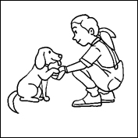 2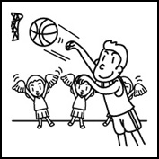 3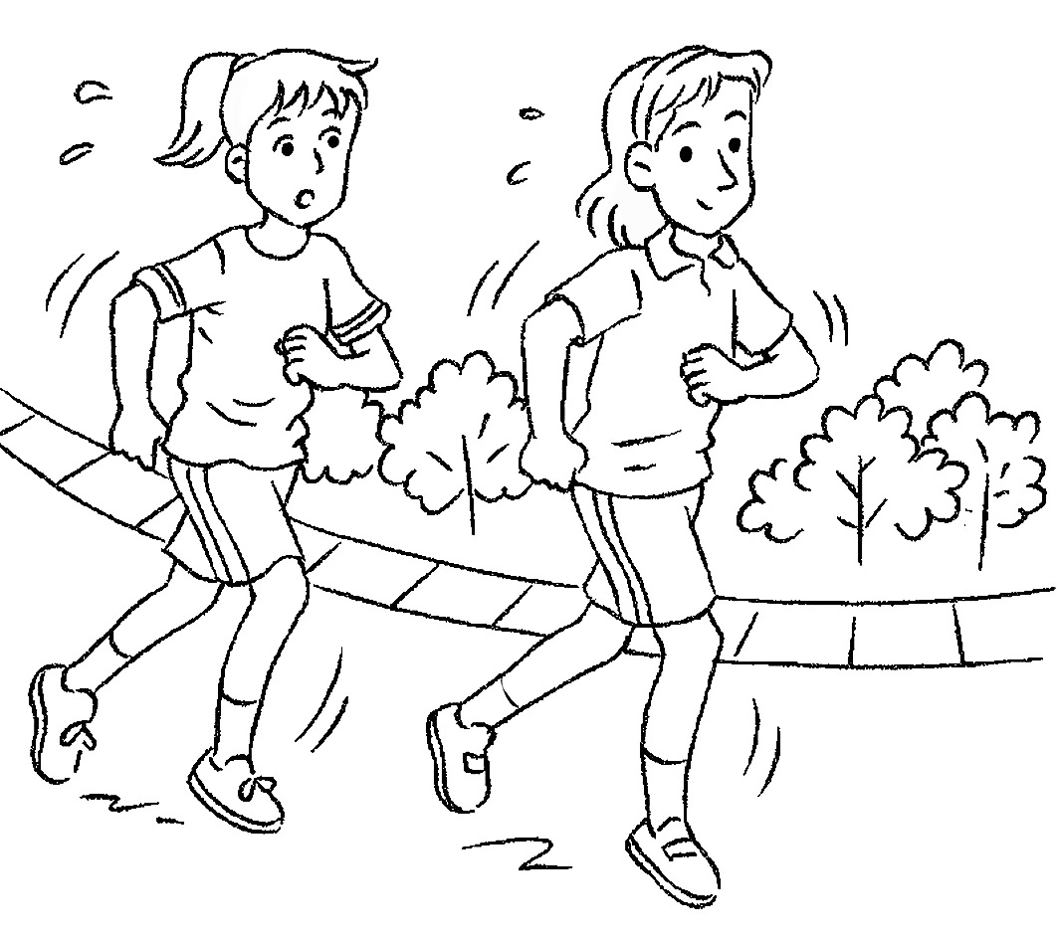 4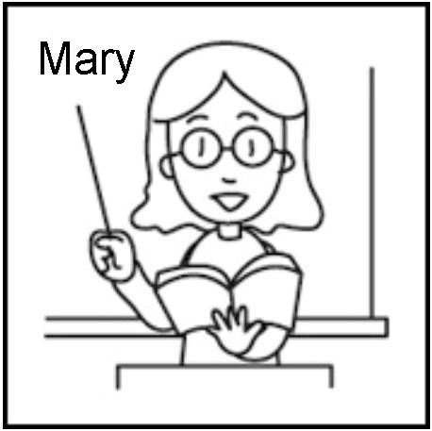 5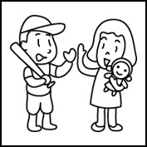
二、聽CD，選出適當的回應句。 (10％)
1. (A) I don’t have a sister. | (B) My mother is not at home. | (C) Yes, I am her cousin.
2. (A) I like badminton. | (B) Wow! He’s good. | (C) I don’t play soccer.
3. (A) Yes, they do. | (B) They play tennis only on weekends. | (C) No, they play tennis every day.
4. (A) It’s very difficult. | (B) I can get a good grade | (C) Math. I am good at numbers.
5. (A) Let’s go together. | (B) Not bad. | (C) She can help you.
三、聽CD中的題組，選出正確的答案。 (15％)
1. (1) (A) He can dance. | (B) He can jump. | (C) He can catch a ball.
(2) (A) Jacky can nod. | (B) Jacky can shake hands. | (C) Jacky can play baseball.
2. (1) (A) Baseball. | (B) Basketball. | (C) Badminton.
(2) (A) No, they don’t. | (B) No, they don’t. | (C) Yes, they do.
(3) (A) No, he isn’t. | (B) Yes, he is. Many girls like him | (C) No, he isn’t at school.
貳、讀寫測驗
一、文法選擇（20％）
1. I like puppies, and Tom , .
(A) is；too | (B) does；too | (C) likes；too | (D) can’t；either
2. your mom busy(忙碌的) housework(家事) every day？
(A) Is；with | (B) Does；doing | (C) Are；to do | (D) Can；in
3. A： every student in your school like table tennis？
(A) Can | (B) Are | (C) Do | (D) Does
4. Peter has a big nose, but his brothers .
(A) doesn’t have | (B) have | (C) doesn’t | (D) don’t
5. I’m a teacher, and
(A) Lisa also is a teacher. | (B) Lisa is also a teacher. | (C) Lisa is too a teacher. | (D) Lisa too is a teacher.
6. I don’t sing. I don’t dance, . I’m not good music.
(A) either; at | (B) too; at | (C) either; in | (D) too; in
7. Bill English with his sister every evening.
(A) study | (B) studies | (C) is studying | (D) are studying
8. Everything at the party ______ fun.We ______ fun.
(A) have ; are | (B) has ; are | (C) is ; has | (D) is ; have
9. I like to swim ________.
(A) in the weekend | (B) every weekends | (C) on weekends | (D) on every weekend
10. 請選出書寫體改為印刷體的正確答案。(習作p1)

(A) Hay with a fall an television. | (B) Play with a fall on television.
(C) Hay with a ball on television. | (D) Play with a ball on television. 背面有試題請繼續作答
二、閱讀測驗：10％
1. There are forty students in Class A. And this chart (圖表)is about their favorite subjects.
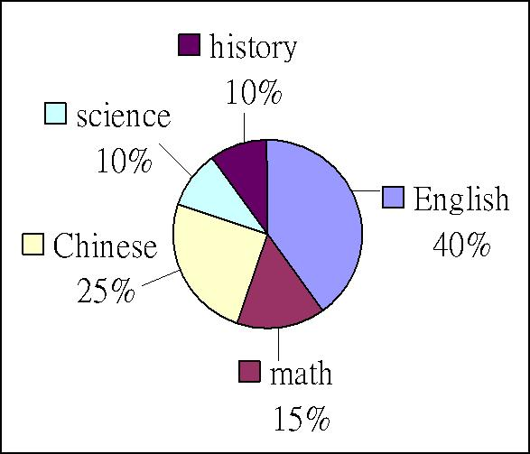
(1). What is most students’ favorite subject?  most 大多數
(A) Chinese. | (B) English. | (C) Math. | (D) History.
(2). students’ favorite subject is math.
(A) Sixteen | (B) Four | (C) Six | (D) Ten
(3). Which is true?（何者為真？）
(A) Twelve students like Chinese. | (B) Ten students like history.
(C) No students like English. | (D) Only four students like science.
2. Chien-Ming Wang vs. Hong-Chih Kuo
Can you catch a baseball? Can you throw a baseball? Do you like baseball?
Do you play baseball? Watch the game today. Chien-Ming Wang is against Hong-Chih Kuo today.
It is their first time! Let’s shout for Chien-Ming Wang and Hong-Chih Kuo.
Let’s watch the game on TV today.  throw 丟擲 against 對抗 first time 第一次
(1). What is “It”? (A) The watch. (B) A baseball. (C) Today. (D) The baseball game.
(2). What can we do for Chien-Ming Wang?
(A) We can buy some baseballs for him. | (B) We can throw baseballs for him.
(C) We can watch the game on TV. | (D) We can buy things for him.
三、文意字彙：（20％）(每題2分。)
1 Cindy：Are they doctors? David：No, they are b n. It is their store.
2. A t Mary is my father’s sister.
3.My cousin is in my c s , too.
4.A: The food is t e here. B: Let’s go to Amy’s.
5. A: Do you have rackets(羽球拍)? B:Yes. A: Let’s play b n.
6. A: I can’t play baseball. B: Don’t w y .
7. My brother and I walk to school t er every morning. (習作p14)
8.Tina isn’t very happy. She doesn’t get good g es this time.
9. Students don’t like too much(太多) h k .
10. Math is d t for me .
四、翻譯（10％）(每格1分)
1. 我們有優秀的網球教練。 We have (1 ) tennis (2) (習作p12)
2. A:我的貓會坐和跳。B:酷! 他還會做什麼？A: My cat can sit and jump rope.B: Cool!__(3)_ (4) can he do? (習作p4)
3. Bill 每天晚上都協助他堂弟讀歷史。Bill (5) his cousin with ( 6 ) every evening. (習作p17)
4.看這兩個袋子。它們幾乎是相同的。 (7) ( 8 ) these two bags. They’re (9 ) the (10). (習作p17)
五、依提示作答：（10％）(每題2分, 分段給分。)
1. The game is exciting. (用what改寫成感嘆句)
2. Anna can play baseball. (改為否定句)(習作p7)
3. My baby is crying and playing now. (把劃線部份now用every night 代替並改寫句子)
4. You teach music well.（You 改為 Ms. Carson） (習作p17)
5. Can Mr. Li speak English well? (先肯定簡答再詳答 ) (習作p7)

試題結束，請將答案填寫在答案卷內。

高雄市立林園高級中學 國中部 101學年度 第 二 學期 一 年級 英文 科 第 一 次 段考答案卷
- 聽力測驗：30％ 班級： 姓名： 座號：
一、聽CD，配合圖片選出最適當的答案。 (5％)
1. |  | 2. |  | 3. |  | 4. |  | 5.

二、聽CD，選出適當的回應句。 (10％)
1. |  | 2. |  | 3. |  | 4. |  | 5.

三、聽CD中的題組，選出正確的答案。 (15％)
1.(1) |  | (2) |  | 2.(1) |  | (2) |  | (3)

- 讀寫測驗
- 文法選擇（20％）(每題2分。)
1. |  | 2. |  | 3. |  | 4. |  | 5. |  | 6. |  | 7. |  | 8. |  | 9. |  | 10.

- 閱讀測驗：10％(每題2分。)
1. (1) |  | (2) |  | (3) |  | 2.(1) |  | (2)

- 文意字彙：（20％）(每題2分。)
1. |  | 2. |  | 3. |  | 4. |  | 5.
6. |  | 7. |  | 8. |  | 9. |  | 10.

- 翻譯（10％）(每格1分)
(1). |  | (2). |  | (3). |  | (4). |  | (5).
(6). |  | (7). |  | (8). |  | (9). |  | (10).

- 依提示作答：（10％）(每題2分, 分段給分。)
1
2
3
4
5

高雄市立林園高級中學 國中部 101學年度 第 二 學期 一 年級 英文 科 第 一 次 段考答案欄
壹、聽力測驗：
一、聽CD，配合圖片選出最適當的答案(每題1分。)Q1-5 ACAAC
二、聽CD，選出適當的回應句。(每題2分。) Q1-5 CBACB
三、聽CD中的題組，選出正確的答案。(每題3分。)Q1.(1)B(2)A Q2.(1)B(2)C(3)B
讀寫測驗
一、文法選擇 (每題2分。) Q1-5 BADDB Q6-10 ABDCD
二、閱讀測驗 (每題2分。) Q1.(1)B(2)C(3)D Q2. (1)D(2)C
三、文意字彙 (每題2分。)
1. | businessmen | 2. | Aunt | 3. | class | 4. | terrible | 5. | badminton
6 | worry | 7. | together | 8. | grades | 9. | homework | 10. | difficult

四、翻譯(每格1分)
(1). | excellent | (2). | coaches | (3). | What | (4). | else | (5). | helps
(6). | history | (7). | Look | (8). | at | (9). | almost | (10). | same

五、依提示作答： (每題2分, 分段給分。)
1. What an exciting game!
2. Anna can’t play baseball.
3. My baby cries and plays every night.
4. Ms. Carson teaches music well.
5. Yes, he can. He can speak English well.

高雄市立林園高級中學國中部 101學年度 第 二 學期 一 年級 英文科 第 一 次段考聽力測驗
壹、聽力測驗：30％
一、聽CD，配合圖片選出最適當的答案。 (5％)

- A02L1096, 中
CD: (A) The girl is shaking hands with the dog.
(B) The girl is painting the dog.
(C) The girl can’t play with the dog.
答案：A
2.A02L2096, 中
CD: (A) Peter is a baseball player.
(B) Peter is playing dodge ball.
(C) Peter is an excellent basketball player.
答案：C
3.A02L2097, 易
CD: (A) Lucy and her friend jog every day.
(B) Lucy and her friend play soccer every day.
(C) Lucy and her friend play frisbee every day.
0
答案：A

4. A02L3093, 易
CD: (A) Mary is a teacher. She teaches English well.
(B) Mary is a reporter. You can see her on TV.
(C) Mary is a soccer player. She can play it well.
答案：A
5.A02L3094, 中
CD: (A) The boy likes baseball, and the girl likes art.
(B) The boy likes basketball, and the girl likes baseball.
(C) The boy likes baseball, and the girl likes dolls.
答案：C
二、聽CD，選出適當的回應句。 (10％)
- A02L1072, 易
CD: Are you Marie’s cousin?
(A) I don’t have a sister.
(B) My mother is not at home.
(C) Yes, I am her cousin.
答案：C

2.A02L2073, 中
CD: Look! David is playing soccer over there.
(A) I like badminton.
(B) Wow! He’s good.
(C) I don’t play soccer.
答案：B
3.A02L2076, 易
CD: Do people in Taiwan play tennis?
(A) Yes, they do.
(B) They play tennis only on weekends.
(C) No, they play tennis every day.
答案：A

4. A02L3073, 中
CD: What’s your favorite subject at school?
(A) It’s very difficult.
(B) I can get a good grade.
(C) Math. I am good at numbers.
答案：C
5.A02L3075, 中
CD: How’s it going, Andy?
(A) Let’s go together.
(B) Not bad.
(C) She can help you.
答案：B

三、聽CD中的題組，選出正確的答案。 (15％)
- A02L1090, 難
CD: Judy has two dogs, Happy and Jacky. Happy can do a lot of things. Happy can stand, jump, nod, and shake hands with Judy. Jacky can’t do a lot of things. Jacky just can nod.

(1)A02L1091, 難
CD: What can Happy do?
(A) He can dance.
(B) He can jump.
(C) He can catch a ball.
答案：B
(2)A02L1092, 難
CD: What can Jacky do?
(A) Jacky can nod.
(B) Jacky can shake hands.
(C) Jacky can play baseball.
答案：A

2.A02L2086, 中
CD: Daniel is not tall, but he can play basketball well. He is a famous basketball player at his school. Many girls like him. Daniel and his friends play basketball at the school gym every day. They love basketball a lot.
(1)A02L2087, 中
CD: What can Daniel play?
(A) Baseball.
(B) Basketball.
(C) Badminton.
答案：B
(2)A02L2088, 中
CD: Do Daniel and his friends play basketball every day?
(A) No, they don’t.
(B) No, they don’t. They play tennis every day.
(C) Yes, they do.
答案：C
(3)A02L2089, 中
CD: Is Daniel popular at school?
(A) No, he isn’t.
(B) Yes, he is. Many girls like him.
(C) No, he isn’t at school.
答案：B

