高雄市立林園高級中學 國中部 101學年度 第 二 學期 一 年級 英語 科 第 二 次 段考考卷
班級： 姓名： 座號：
Part A. Listening Comprehension (30%，每題2分)
一、聽CD，配合圖片選出最適當的答案。
( )1. 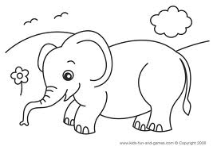 ( )2. 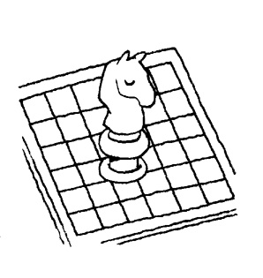
( )3. (A)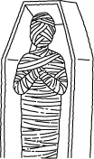 (B)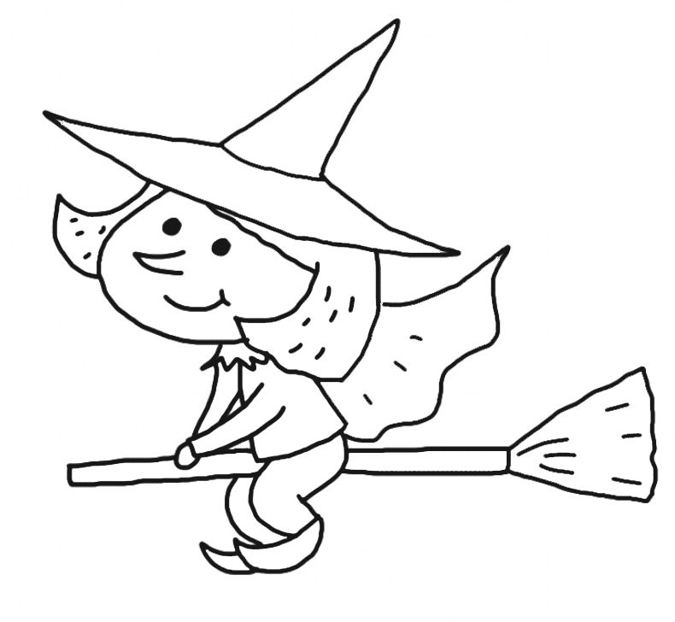 (C)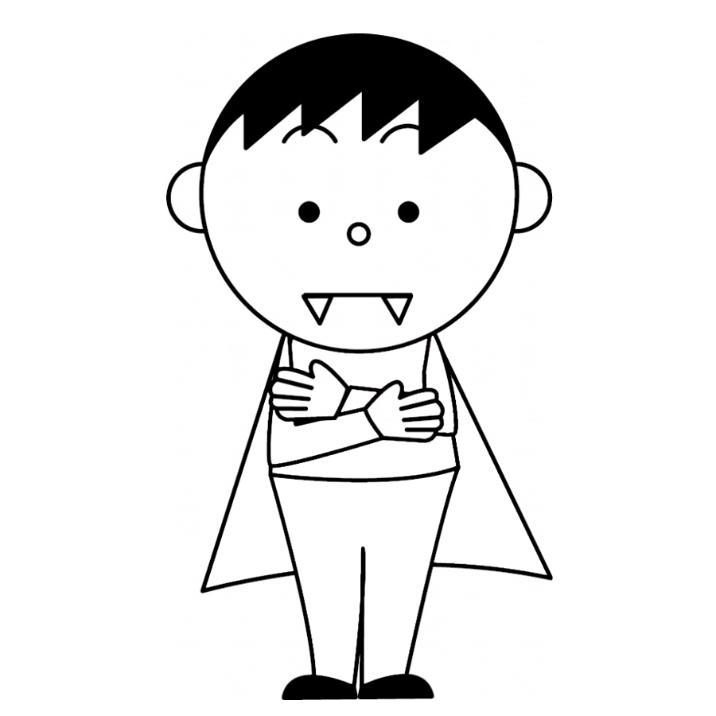
( )4. (A)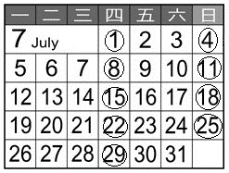 (B)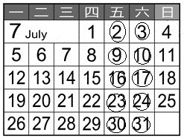 (C)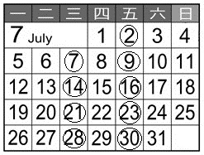
( ) 5. (A) (B)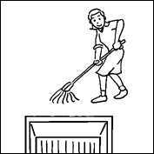 (C)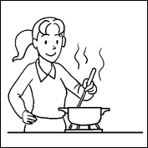
二、聽CD，選出符合句意的選項。
( )1. (A) Eric’s dad has no hair. (B) Eric’s dad has a lot of hair. (C) Eric’s dad has black hair.
( )2. (A) David doesn’t like his job. (B) David likes his job. (C) David doesn’t have a job.
( )3. (A) They practice with the band on Saturdays and Sundays. (B) They practice with the band every day.
(C) They practice with the band after school.
三、聽CD中的對話，選出適當的答案。
( )1. (A) They feed the dog. (B) They jog in the park. (C) They hunt animals.
( )2. (A) Jason. (B) Jason’s classmate, Sean. (C) Jason’s brother, Sean.
( )3. (A) On Fridays. (B) On Wednesdays. (C) On Thursdays.
四、聽CD，選出適當的回應句。
( )1. (A) Great! Mom loves chocolate cake. (B) I do! (C) Dad has to work hard.
( )2. (A) What time do you go to school? (B) Yes, I do. (C) Where’s my watch?
( )3. (A) She is a player. (B) She plays the drums from six to seven. (C) She doesn’t play the drums every day.
( )4. (A) No, he is studying English. (B) Yes, he is from the UK. (C) No, he loves Chinese.

Part B. Reading & Writing Comprehensions (70%)
一、字彙、片語、文法及對話選擇(20%，每題2分)
( )1. Students, hello to you new classmate. (A) speak (B) tell (C) talk (D) say
( )2. A：Who’s good music? B：Linda is. She can play the drums. (A) for (B) at (C) on (D) with
( )3. Wayne is very hungry. He eats . (A) a lot of (B) a lot (C) lot (D) lots of
( )4. Do you have ideas for the show? (A) any (B) some (C) every (D) only 【習作p.29】
( )5. We are going to swim（游泳） the afternoon. (A) × (B) at (C) on (D) in
( )6. There is a party Tuesday evening this week. (A) at (B) in (C) with (D) on
( )7. A：Who can practice tennis with me today? B：Lisa . (A) is (B) do (C) does (D) can
( )8. Tiffany doesn’t play the guitar, but her parents . (A) does (B) doesn’t (C) do (D) don’t
( )9. Frank: What day is today? David:
(A) It is Saturday. (B) It is on the weekend. (C) It is the day after tomorrow. (D) It is on Monday.
( )10. Collin： Jessica：I sell（販賣）books here.
(A) What do you do? (B) What is the book about? (C) Do you like reading books? (D) What do you have?

二、克漏字選擇(5%，每題1分)
I am Monica, a music teacher. １. Monday １. Friday, I get up at 6:00 a.m. And then I make sandwiches ２. breakfast. The school is not far away, so I ３. to school. There are many smart and cute students in my class. I have a good time teaching them. After work, I play tennis at the gym. At ４. 6:00 p.m., I have dinner with friends. After dinner, I watch TV, listen to music and ５. novels. I go to bed at 10:30 p.m. every night.
sandwich三明治 far away距離遙遠 novel小說
( ) 1. (A) From; to (B) Between; and (C) At; or (D) In; but
( ) 2.(A) with (B) on (C) near (D)for
( ) 3. (A) count (B) speak (C) sign (D)walk
( ) 4. (A) for (B) about (C) with (D) in
( ) 5. (A) read (B) watch (C) see (D) look

三、閱讀測驗(10%，每題2分)
【A】
Helen is going to take her daughter, Olivia, to see a dentist, but Olivia has school in the morning from Monday to Friday and piano classes on Tuesday and Saturday afternoon.
Here are the dentist’s office hours.
take帶 dentist牙醫 office hour營業時間
( )1. How many（多少…）days a week does the dentist work in the morning?
(Ａ) Three days. (B) Four days. (C) Five days. (D) Six days.
( ) 2. When is the best（最好的）time for Helen to take Olivia to see the dentist?
(Ａ) Monday morning. (B) Tuesday afternoon. (C) Friday afternoon. (D) Sunday morning.
【B】
Paul: Mrs. Huang, I want to join the English speech contest.
Mrs. Huang: Really? I’m happy to hear that. Ann from the next class joins the contest, too. When is the contest?
Paul: It’s next Friday. I don’t have much time to prepare for it. Can you give me some tips?
Mrs. Huang: Sure! First, choose a topic and write a draft. Then, remember all the lines and practice speaking it loud. When you talk, wear a smile on your face and look at the judges’ eyes.
Paul: Can’t I move my body?
Mrs. Huang: Yes. But don’t do that too often.
Paul: I see. Thank you for your help.
speech contest演講比賽 tip提示 topic主題 draft草稿 line句子 wear a smile on one’s face 面帶微笑 judge評審
( )1. Which is TRUE about the speech contest?
(A) Students can’t choose the topic. (B) Ann and Paul’ are in the same class.
(C) It’s on Friday. (Ｄ) Paul and Ann don’t prepare for it.
( )2. Which is NOT the tip for an English speech contest?
(A) Writing a draft. (B) Looking at Ann’s eyes.
(C) Wearing a smile on the face. (D) Remembering all the lines.
( ) 3. What does “that” refer to（指稱）?
(A) Moving the body. (B) Smiling. (C) Practicing speaking English. (Ｄ) Remembering the lines.

四、文意字彙(5%，每題1分)
1. Lucky is a cute w e dog. 【習作p.29】
2. You can ask your t or the new words this evening. He can help you.
3. Jerry：I am tired（疲累的）now. Rita：Just take a r t.
4. The movie star is h e. He is very popular with young girls. 【習作p.29】
5. Vivian likes f t, and apples are her favorite.

五、填入適當的動詞形態(每格不限1字；12%，每格2分，全對才給分)
1.Listen! Amanda (sing) my favorite song. 【習作p.26】
2.A: What (1.) (do) Brian’s son study every day? B: He (2.) (study) Chinese. 【習作p.26】
3. My father can (fix) the computer. He is an engineer.
4. A: Halloween is (come). B: Yeah! We have a Halloween party this Saturday.
5. Everyone in the class (speak) English well.

六、依提示作答(8%，每題2分)
1.We start the English class at 10:00. (依畫線部分造原問句) 【習作p.26】
2. Nick goes to school at 7：30 a.m.（加上 have to 改寫）
3. Tina plays a witch. (依畫線部分造原問句)
4. Peter and I play basketball in the park every day. (依畫線部分造原問句)

七、中翻英(10%)
1. 我們班經營鬼屋。(2分)【課本p.75】Our class (1) a (2) house.
2. 一個沒有牙齒的吸血鬼如何？(3分)【課本p.71】What about a (1) (2) (3) ?
3. 學生們可以選擇自己的社團。(2分) 【習作p.26】
4. 有些動物在入夜後找食物。(3分) 【習作p.22】

高雄市立林園高級中學 國中部 101學年度 第 二 學期 一 年級 英語 科 第 二 次 段考(答案卷)
班級： 姓名： 座號：
Part A. Listening Comprehension(聽力測驗):30%(每題2分)
一、1. | 2. | 3. | 4. | 5.
二、1. | 2. | 3.
三、1. | 2. | 3.
四、1. | 2. | 3. | 4.

Part B. Reading & Writing Comprehensions (70%)
一、字彙、片語、文法及對話選擇(20%，每題2分)
1. | 2. | 3. | 4. | 5. | 6. | 7. | 8. | 9. | 10.

二、克漏字選擇(5%，每題1分)
1. | 2. | 3. | 4. | 5.

三、閱讀測驗(10%，每題2分)
【A】1. | 2. | 【B】1. | 2. | 3.

四、文意字彙(5%，每題1分)
1. | 2. | 3. | 4. | 5.

五、填入適當的動詞形態(每格不限1字；12%，每格2分，全對才給分)
1. | 2(1) | (2) | 3. | 4. | 5.

六、依提示作答(8%，每題2分)
1.
2.
3.
4.

七、中翻英(10%)
1(1) | (2)
2(1) | (2) | (3)
3.
4.

高雄市立林園高級中學 國中部 101學年度 第 二 學期 一 年級 英語 科 第 二 次 段考(答案卷)
班級： 姓名： 座號：
Part A. Listening Comprehension(聽力測驗):30%(每題2分)
一、1. D | 2. C | 3. C | 4. C | 5. C
二、1. A | 2. B | 3. A
三、1. B | 2. B | 3. A
四、1. A | 2. B | 3. B | 4. C

Part B. Reading & Writing Comprehensions (70%)
一、字彙、片語、文法及對話選擇(20%，每題2分)
1. D | 2. B | 3. B | 4. A | 5. D | 6. D | 7. D | 8. C | 9. A | 10. A

二、克漏字選擇(5%，每題1分)
1. A | 2. D | 3. D | 4. B | 5. A

三、閱讀測驗(10%，每題2分)
【A】1. C | 2. D | 【B】1. C | 2. B | 3. A

四、文意字彙(5%，每題1分)
1. white | 2. tutor | 3. rest | 4. handsome | 5. fruit

五、填入適當的動詞形態(每格不限1字；12%，每格2分，全對才給分)
1. is singing | 2(1) does | (2) studies | 3. fix | 4. coming | 5. speaks

六、依提示作答(8%，每題2分，分段給分)
1.What time do you start the English class?
(1分) (1分)
2. Nick has to go to school at 7:30a.m.
(1分) (1分)
3. What does Tina play?
(1分) (1分)
4. Who plays basketball in the park every day?
(1分) (1分)

七、中翻英(10%，1、2題每格1分，3、4題分段給分)
1(1) runs | (2) spooky
2(1) vampire | (2) without | (3) teeth
3. The students can choose their own clubs.
(1分) (1分)
4. Some animals look for food after dark.
(1分) (1分) (1分)

