高雄市立林園高級中學 國中部 101學年度 第 二 學期 一 年級 英語 科 第 三 次 段考考卷
班級： 姓名： 座號：
Part . A Listening Comprehension (30％)
請依「題號」在答案卡上作答。
一、聽CD，若符合圖意或表格內容的選 A，否則選 B。 (每題1分，共5分)

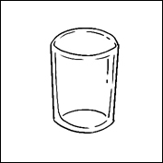
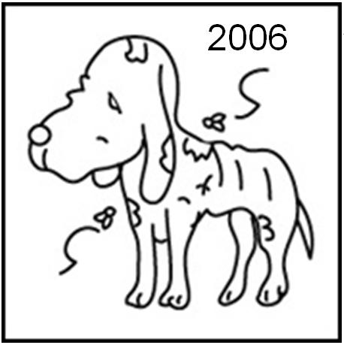
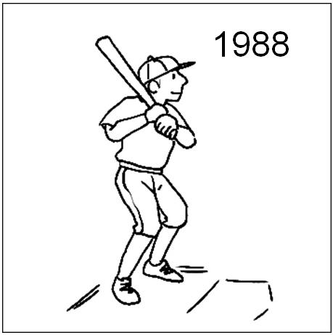
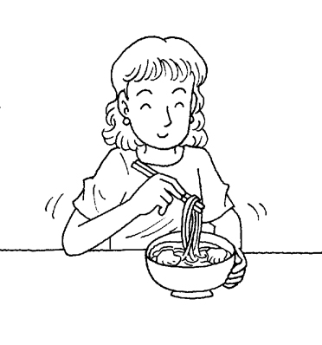
- 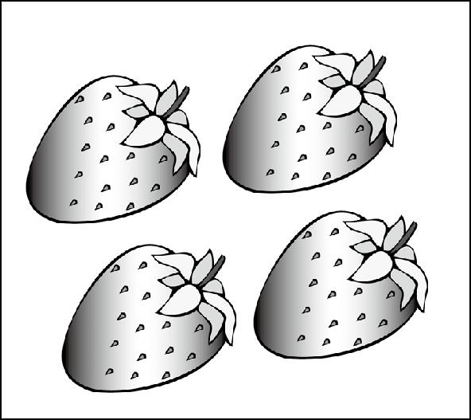 2. 3. 4. 5.
(A) True (B) False (A) True (B) False (A) True (B) False (A) True (B) False (A) True (B) False

二、聽CD，選出適當的回應句。(每題2分，共10分)
- (A) Yes, I was there. (B) No, there isn’t anything in the river. (C) Yes, there was a junior high school.
- (A) All right. Let’s buy a new one. (B) Sorry, I can’t go with you. (C) Sure. I can do that for you.
- (A) He was at the school library. (B) He has to work. (C) He eats a lot.
- (A) Yes, I want a giant hamburger. (B) Yes, that’s too much for me. (C) Yes, I drink a lot of water every day.
- (A) Yes. I can help people. (B) Yes, two bags of rice, please. (C) Where is the food store?

三、聽CD，配合圖片選出最適當的答案。(每題1分，共5分)
- (A) (B)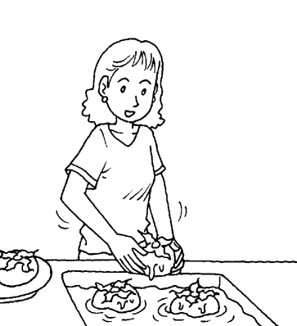 (C)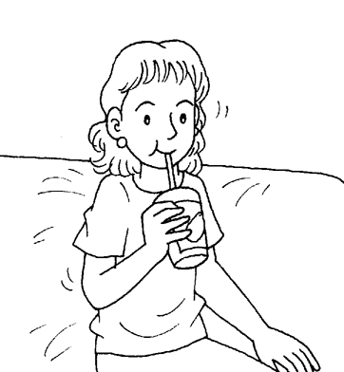

- (A)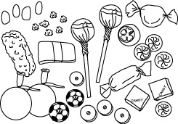 (B)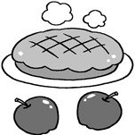 (C)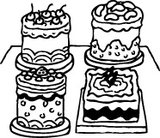

- (A)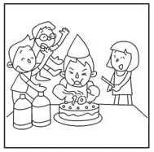 (B)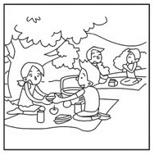 (C)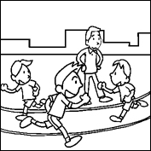

- (A)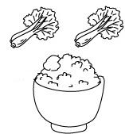 (B)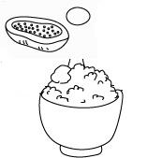 (C)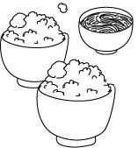
- (A)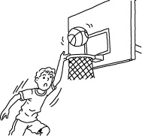 (B)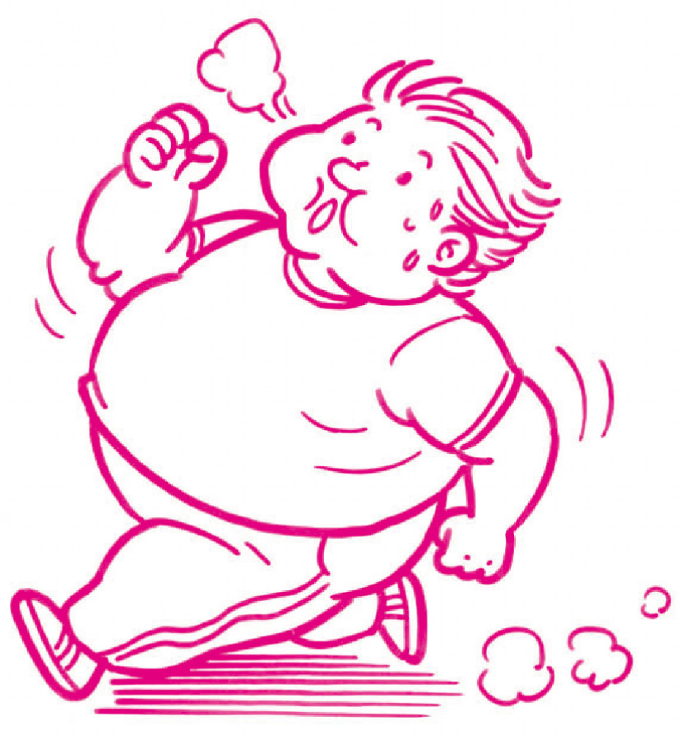
四、聽CD中的題組，選出正確的答案。(每題2分，共10分)
(一) 16. (A) She takes good care of Edward. (B) She is Edward’s mother. (C) She is beautiful.
17. (A) He has long teeth. (B) He has long nails. (C) He doesn’t have long nails.
(二) 18. (A) True (B) False
19. (A) True (B) False
20. (A) True (B) False
Part . B Reading Comprehensions (70％)
一、字彙選擇。(每題1分，共10分)
( )21. Please the cake and share (分享) it with everyone. [習作p.39]
(A) put (B) build (C) leave (D) cut
( )22. Maggie and I like to listen to music in our free (空閒) time. We have the hobby(嗜好).
(A) same (B) different (C) nervous (D) yummy
( )23. The river is . There is a lot of trash in it. [習作p.44]
(A) handsome (B) dirty (C) clean (D) chubby
( )24. A：Can I go to the ? I have to wash my hands. B：Sure, go ahead. (去吧)
(A) gym (B) sports field (C) gate (D) restroom
( )25. The little girl is smart. She can a lot of words. [習作p.44]
(A) remember (B) forget (C) count (D) worry
( )26. There are too many people here. We don’t have chairs for everyone. [習作p.34]
(A) large (B) sweet (C) medium (D) enough
( )27. My hands are . Can you open the door for me? [習作p.34]
(A) giant (B) full (C) more (D) medium
( )28. I eat too much . My teeth are aching. [習作p.34]
(A) candy (B) rice (C) pies (D) tea
( )29. Don’t eat junk food. You need a . [習作p.37]
(A) health diet (B) healthy diet (C) fresh fruit (D) fresh food
( )30. Our need fresh vegetables every day. [習作p.39]
(A) ears (B) bodies (C) hands (D) heads

二、文法與對話選擇。(每題2分，共24分)
( )31. Mark ten years old . [習作p.47]
(A) was / then (B) was / ago (C) were / then (D) were / ago
( )32. How tomatoes there in the box?
(A) many / is (B) many / are (C) much / is (D) much / are
( )33. Let’s the computer. (Ａ) buy (B) buys (C) buying (D)to buy
( )34. A：Does Tina need apple juice? B：Yes, she needs three bottles of apple juice.
(A) a (B) many (C) a lot (D) any
( )35. A：How much pork do you want the dumplings? B：Two kilos.
(A) in (B) with (C) for (D) on
( )36. Emily a student before, but she a businesswoman now. [課本p.115]
(A) is / was (B) was / is (C) are / were (D) were / are
( )37. This food guide (食物攝取指南) is for you. Follow it, and you can healthy. [習作p.38]
(A) do (B) does (C) be (D) are
( )38. A：? B：I have two puppies. [習作p.42]
(A)How much puppy do you have? (B) How much puppies do you have?
(C)How many puppy do you have? (D) How many puppies do you have?
( )39. Bob：Can’t Joe play baseball? Ricky：. He just watches it on TV. [習作p.35]
(A) Yes, he can. (B) Yes, he can’t. (C) No, he can. (D) No, he can’t.

( )40. Lilian：Do you want some candy? Sean：. It is not healthy for me.
(A) Why not ? (B) Yes, I want some. (C) No, thanks. (D) Yes, please.
( )41. Charlene：Do you play basketball? Sam：Yes, I do. In fact, I am the captain my school team.
(A) of (B) under (C) over (D) from
( )42. A：We can make an apple pie for Mom. B：Great.
A：Two apples, some sugar (糖), and a bag of flour (麵粉).
(A) What can we make it? (B) What do we need for it? (C) What else can we do? (D) Which do you like?

三、克漏字選擇。(每題2分，共20分)
I.
A: (43) I help you?
B: Yes, two (44) , please.
A: Sure. (45)
B: We also need two cups of coffee(咖啡).
A: Hot (46) cold?
B: Hot, please.
( )43. (A) Can (B) Who (C) Do (D)What
( )44. (A) rice (B) hot dog
(C) banana (D) banana cakes
( )45. (A) What do we need? (B) What time is it?
(C) What else? (D) Who are you?
( )46. (A) and (B) or (C)but (D) so

II. My grandfather lives in Green Field. It is a small town near the mountains. Twenty years ago, it (47) quiet and
there (48) a few stores there. The river was clean. The trees were tall and green. There were farms (49) .
Now, everything (50) different in Green Field. There is a new train station in town. Many people come and live there.
The streets are wide, and the (51) are tall. However, the (52) is heavy and the river is dirty. My grandfather
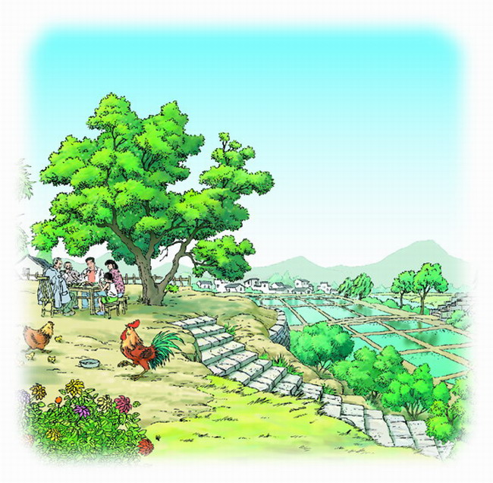
doesn’t like it. [課本p.114]
( )47. (A) is (B) was (C) are (D) were
( )48. (A) is (B) was (C) are (D) were
( )49. (A) here (B) now (C) where (D) everywhere
( )50. (A) is (B) was (C) are (D) were
( )51. (A) buildings (B) boxes (C) badmintons (D) dreams
( )52. (A) idea (B) example (C) traffic (D) meeting

四、閱讀測驗。(每題2分，共16分)

I. Here is the game “Crossword Puzzles.” Some letters are missing. Please answer the questions.
 | ¹ |  |  |  |  | ⁵
² |  |  | ³
 |  |  | e
⁴ | o
p
c

s

crossword puzzle 縱橫字謎遊戲
letter 字母
miss遺失
DOWN  1. Children love to play on it.  3. People can buy things in it  5. People play balls on it. | ACROSS  2. Students study and learn in it.  4. There are a lot of animals in it.

( )53. What is the word in “ 1 ” ? (A) playgronue (B) playgroune (C) playground (D) playgronud
( )54. What is the word in “ 5 ” ? (A) count (B) court (C) clean (D) chess
II.
Food around the World
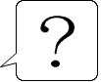

Riddle 1
I am a small cake of rice.
People eat me with chopsticks
and they bath me in a brown sauce.
They also put something green on me.
I have a piece of fresh shasimi on top.
Riddle 2
I am from India.
People eat me with meat, vegetables, rice and bread.
Be careful when you eat me,
Because I can make your clothes yellow.
riddle謎語
chopsticks筷子
bath 泡澡
sauce 醬汁
piece片
shasimi生魚片
top頂端
India 印度
bread麵包
careful小心
because因為
clothes衣服


Riddle 3
I am a kind of healthy food.
I have many vegetables in me.
People can eat me with different dressings.
The fridge is my home.
I am cold all the time.

kind種類
dressing沙拉醬
fridge冰箱

( )55. The food in riddle 1 is from .
(A) China (B) Japan (C) Canada (D) America
( )56. Read riddle 2. What am “I” ?
(A) pizza (披薩) (B) sushi (壽司) (C) curry (咖哩) (D) coffee (咖啡)
( )57. Read riddle 3. What am “I” ?
(A) ice cream (B) sushi (C) lettuce (D) salad

III.
In today’s world, many people have a lot of stress (壓力) in their lives (生活). Parents get stress from their busy work and
problems (問題) from their children. Students also have a lot of problems they have to face (面對) at school. It may(或許)
seem (似乎) that there is nothing we can do about all that stress. In fact, there is something we can do－learn to manage (管理)
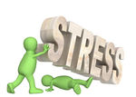
stress.The following are a few (一些) stress management (管理) skills(技巧)：

(1) Smile (微笑) more.
(2) Learn to say “no.”
(3) Manage your time better.
(4) Do things that would(會) make you happy.
(5) Share your feelings (感覺) with someone in the family or a close friend.

Stress can also be seen as (被視為) a good thing because it sometimes (有時) helps us perform (表現) better (更好). For
example, sports players play better under stress because they all want to win (贏). The most (最) important thing is to
face stress and don’t run away from (逃避) it.

( )58. What is the reading about?
(A) How to smile. (B) How to manage stress. (C) How to run away from stress. (D) How to win a game.
( )59. What can we do when we face stress?
(A) We can learn to manage stress. (B) We can do more work.
(C) There is nothing we can do. (D) We can run away from stress.
( )60. Which of the following stress management skills is NOT true?
(A) We should (應該) do things we don’t like. (B) We should talk to our family.
(C) We should manage our time better. (D) We should smile more.

