高雄市立林園高級中學 國中部 101學年度 第 二 學期 二年級英文科 第 三 次 段考考卷
班級： 姓名： 座號：
壹. Listening Comprehension
一. 根據聽到的內容，選出聽到的單字。
（ ）(１)(Ａ) care (Ｂ) notes (Ｃ) forget
（ ）(２)(Ａ) voice (Ｂ) quiz (Ｃ) grade
（ ）(３)(Ａ) least (Ｂ) tips (Ｃ) soccer
（ ）(４)(Ａ) passed (Ｂ) failed (Ｃ) point
（ ）(５)(Ａ) main (Ｂ) title (Ｃ) several

二. 根據聽到的內容，將相符的敘述寫(Ａ)，不符的寫(Ｂ)。
（ ）(6) Amanda is crying.
（ ）(7) The old man is a kind person.
（ ）(8) We followed the waiter and got to our table.
（ ）(9) His mother died because he attacked her.
（ ）(10) Music is very important to Janet.

三. 根據聽到的內容，選出最適當的答案。

(11 )  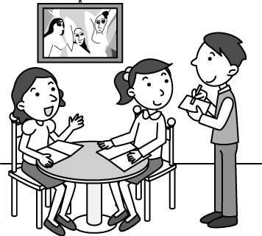 | (12) 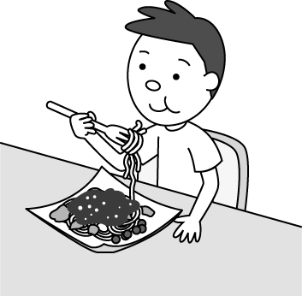 | (13)  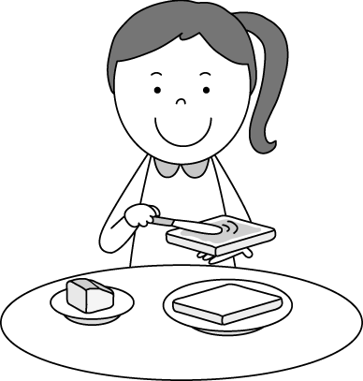 | (14)  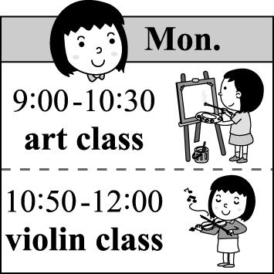 | (15)  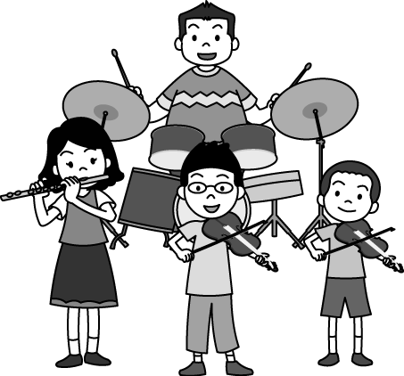
貳. Reading Comprehension
16. If you don’t know a word, you can . (textbook p.106)
(A) correct mistakes (B) look it up in the dictionary (C) do exercises (D) mark important points
17. Joining a ______ is very interesting. You may know more people and learn a lot in it.
(A) quiz (B) castle (C) part (D) club
18. Gina worked late and was worried she might not be able to catch the bus. ______, she saw a bus come just after she arrived at the bus station.
(A) Truly (B) Quickly (C) Safely (D) Luckily
19. Please speak louder, or we can’t hear your ______.(workbook p.37)
(A) noise (B) notes (C) voice (D) sound
20. Don’t get too close to the lions. They may ______ you. (workbook p.41)
(A) attack (B) fail (C) forget (D) shoot
21. James didn’t like vegetables, so he took ______ out of the hamburger.(workbook p.41)
(A) cheese (B) lettuce (C) beef (D) pork
22. For children, using a ______ is easier than using chopsticks when they eat.
(A) knife (B) fork (C) drum (D) arrow
23. Mrs. Murphy: ______ you tired of ______ steak? John: I _____. (textbook p.80)
(A) Do / eating / do (B) Are / eat / am (C) Aren’t / eating / am (D)Did / eat / did
24. _____ the end of the party, the band teacher asked a waiter ______ a picture for them. (textbook p.85)
(A) By / take (B) To / taking (C) In / to take (D) At / to take
25. Each of the princesses _____ holding a candle. (textbook p.114)
(A) is (B) are (C) can (D) will
26. The little boy jumped up and down happily when he saw a bee _______ into the house.
(A) flew (B) to fly (C) flying (D) flies
27. I can't find my history book, ______ I know it's somewhere in the living room.
(A) because (B) until (C) since (D) but
28. ______ of my grandpa’s hair is gray. (workbook p.29)
(A) Many (B) Most
29. If there ______ a science test next week, David _______ at the library.(workbook p.38)
(A) will / will study (B) is / studies (C) will be / will study (D) is / will study
30. Choose(選出) the correct sentence.
(A) Though Andy worked hard he made little money.
(B) He made little money though Andy worked hard.
(C) Andy worked hard, but he made little money.
(D) Although Andy worked hard, but he made little money.
31. Doing exercises may _______ you much time, but you will get better grades by doing so.
(A) take (B) cost (C) spend (D) run
32. Alison has good study habits. ______ she plays the computer games, she always finishes all her homework.
(A) After (B) When (C) Before (D) Because

33~35 從(A)到(D)選項中選出適合的答案
(A) look up (B) take notes (C) go over (D) at least
(workbook p.37)
33. They always _______ of the important points, so they can review them after class.
34. Before you interview the soccer team, remember to _______ your questions again.
35. Mom asks me to clean my bedroom ________ once a month.

(36~40)
Can you move 36 one place to another quickly? A group of French teenagers develop(發展) modern parkour(「跑酷運動」). The kind of sport doesn’t need any exercise machine. It can exercise your whole body and focuses(注重) on skills(技巧) like running, jumping, and climbing.
Some people are 37 parkour. They can jump over a wall and 38 the ground safely. They can also jump from one roof(屋頂) to another without injury(受傷). 39 you are interested in exciting sports and don’t have much money, you can try parkour. It can both save your money and do exercise at the same time. 40 a pair of sports shoes and make the world your playground.
36. (A) from (B) for (C) in (D) with
37. (A) afraid of (B) surprised at (C) tired of (D) good at
38. (A) jump on (B) run through (C) fly over (D) land on
39. (A) If (B) Though (C) So (D) Before
40. (A) To put on (B) Putting on (C) Put on (D) Puts on

(41~42)
Little Secretary(秘書)

When I do my math homework,
David likes to watch me.
Sometimes when I don’t know what to do,
He will count out loud.
Though my brother only knows 1, 2, 3,
He still tries to help me.

When I do my English homework,
David likes to watch me.
Sometimes when I don’t know what to write,
He will spell out loud.
Though my brother only knows A, B, C,
He still tries to help me.
Now I see it is his love
That makes him do all these for me.
John N.
（歷屆基測試題）
41. What can we learn about the little secretary?
(A) He is a junior high school student. (B) He does not like to be with his brother.
(C) He knows more about English than about math. (D) He cannot do his brother’s homework very well.
42. Which is true about the “I”?
(A) His name is David. (B) He is smart enough to make his brother work for him.
(C) He taught his brother a lot of math and English. (D) He feels his brother’s love for him.

(43~44)
Below is Stan’s report. It shows the number of students in each club at his school in 2009 and 2010.（歷屆基測試題）
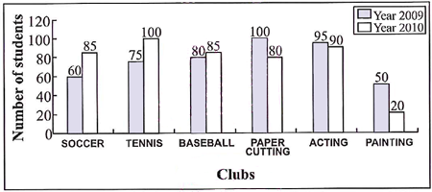
43. Which club has the fewest students in both 2009 and 2010?
(A) The painting club (B) The soccer club (C) The baseball club (D) The acting club
44. Which is NOT true?
(A)The art clubs have fewer students in 2010 than in 2009.
(B) The sports clubs have more students in 2010 than in 2009.
(C) The acting club is the most popular club both in 2009 and in 2010.
(D) In 2009, the painting club has half the number of students of the paper-cutting club.

(45~46)
Read the play and answer the questions.
Place: A child’s room with white walls, a white door, and a white bed. On the bed, there are some clothes.
Character(角色): An old and dirty doll is sitting on the bed and speaking.
----------------------------------------------------------------------------------------------------------------------
The doll: She should be here soon. We will play some games today.
【Three hours pass. NO ONE knocks(敲) on the door.】
The doll: Just a few more seconds. We might play “try-on-new-clothes” today.
【Five hours go by. There is still no sound.】
The doll: Maybe the school bus is late. Soon she’ll be here, and we will sing and dance together.
【One day has passed away. The doll is still sitting on the bed, waiting.】
The doll: Maybe tomorrow.... I’m sure she’ll come tomorrow, and then we will play.
【There in the room, the doll repeats(重覆) the same story every day …】
（歷屆基測試題）
45. What happens in the play?
(A) A doll is changing clothes.
(B) A doll is talking to herself.
(C) A doll is singing and dancing.
(D) A doll is waiting for the bus to school.
46. What can we learn about the doll?
(A) She likes to play by herself.
(B) She is good at telling stories.
(C) She lives in a room full of colors.
(D) Her owner forgets her for some time.

47~48
Bill Gates(比爾.蓋茲), the Pope(教宗), and a Boy Scout(童子軍) were in a plane that was going to crash(墜毀). They realized(意識到) that there were only two parachutes(降落傘).
“I’m the smartest man in the world,” said Bill Gates. “The world needs smart men.” He grabbed(抓起) a parachute and jumped out.
“You are young,” said the Pope to the Boy Scout. “You should take the last parachute.”
“Don’t worry,” said the Boy Scout. “The world’s smartest man just jumped out with my backpack.”
47. Why did the Boy Scout tell the Pope not to worry?
(A) All of them could survive(生存). (B) The plane will not crash.
(C) There are still two parachutes for both of them. (D) Worrying would not do any good for them.
48. Which is NOT true?
(A) Bill Gates is the first one to get out of the plane. (B) The Pope is a kind man.
(C) The backpack Bill Gates took with him is the boy’s. (D) Only one of them could survive in the crash.

(49~50)
Test Instructions(指示)
______________________________________________________________
The test takes about 8-10 minutes to complete(完成). There are three parts. In each part, there are 5 to 7 questions.
Part 1 : There are five sentences. You will hear each sentence twice, and you have to repeat(重覆) it out loud once.
Part 2 : You have to read out loud five sentences and one article in one minute. You have to read them clearly and correctly.
Part 3 : Answer seven questions. You will hear each question twice. You have 15 seconds to answer each question. Speak to the point; you don’t need to answer in complete(完整的) sentences.
(textbook p.112)
49. How many questions are probably(可能) there in the test?
(A) About 14. (B) About 30. (C) About 25. (D) About 20.
50. What test are the instructions for?
(A) A speaking test. (B) A listening test. (C) A reading test. (D) A writing test.

