高雄市立林園高級中學 國中部 102學年度 第 ㄧ 學期 一年級 英語科 第二次 段考考卷
班級： 姓名： 座號： 本試卷共（3）頁
【請將答案寫在答案欄內，交卷時只須繳交答案卷】
- 聽力測驗30%
一、看圖選擇 (根據聽到的內容，寫下符合的圖片代號) 10%
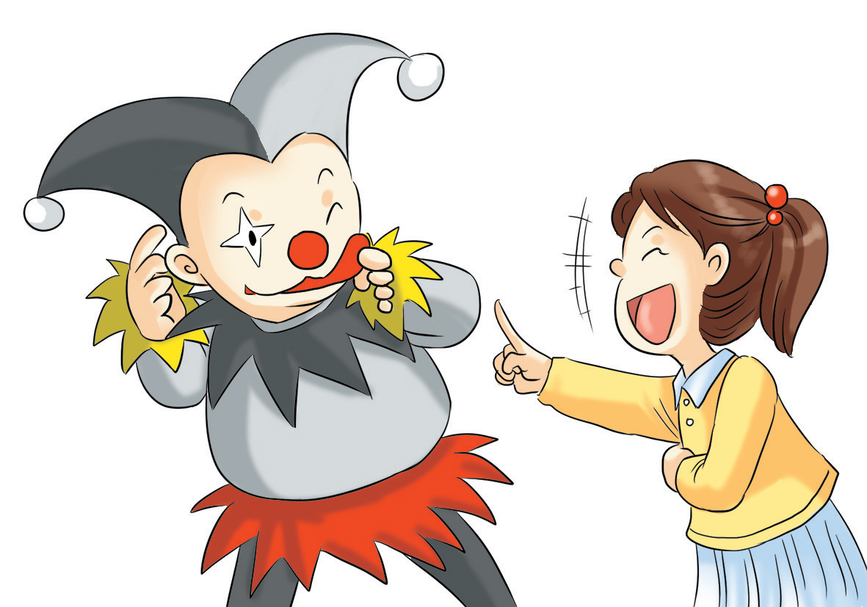  A. | B. | C.
D.  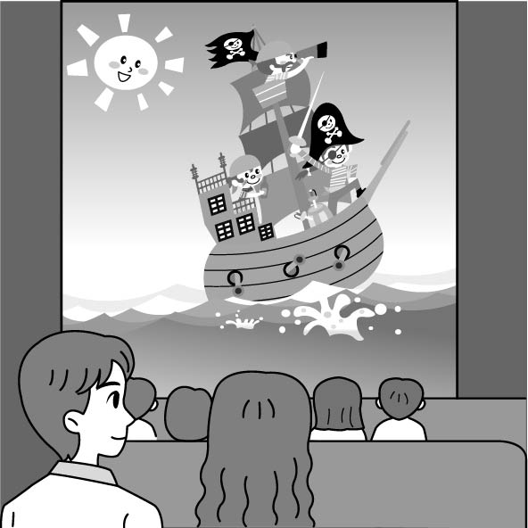 | E.  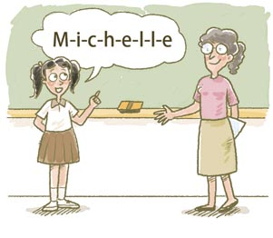 | 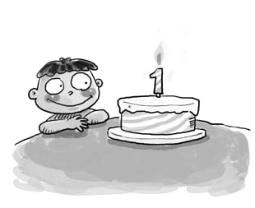  F.

二、對話選擇 (根據聽到的對話內容，選出正確的敘述) 10%
1. (A) Kevin is shy. (B) Kevin is strong. (C) Kevin is smart.
2. (A) The man’s nose is black. (B) The man’s nose is blue. (C) The man’s nose is red.
3. (A) The baseball is for Uncle Tom. (B) The toy car is for David. (C) The candies are from Grandpa.
4. (A) The boy and the girl are in the living room.
(B) The boy and the girl are in the film room.
(C) The boy and the girl are in the museum.
5. (A) The girl is in the film room.
(B) The film is about rats.
(C) The girl is waiting in line.

三、短文理解 (根據聽到的內容，在方框內寫下每個學生的名字) 10%
Adam Denny Emma Stacy Ken Billy

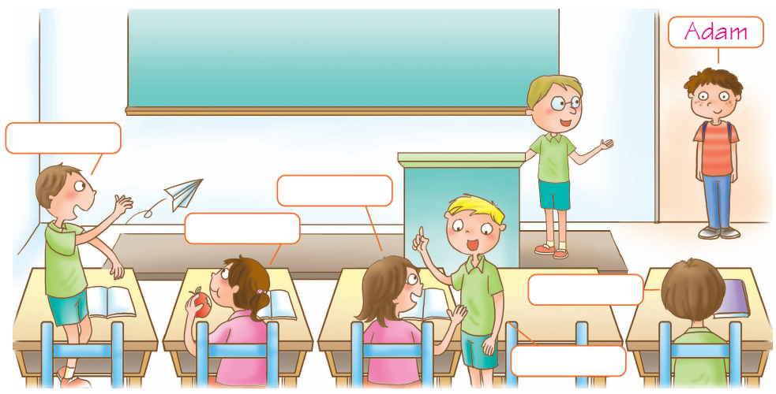
1.
3.
2.
4.
5.
- 紙筆測驗70%
四、文意字彙 10%
1. T y is my birthday. Welcome to my party.
2. Amy’s husband is an actor. He is tall and h e.
3. Lily is smart and b l. Many(很多) boys like(喜歡) her.
4. Don’t take p res with(用) your camera or cellphone in the museum.
5. Ms. Lin: Look at the s n and read it. Students: “Don’t touch anything.”

五、語法選擇 28%
1. A: Are these your books? B: ________
(A) Yes, these are. (B) Yes, they are. (C) No, those aren’t. (D) No, it’s not.
2. My father is a writer, ________ my mother isn’t.
(A) and (B) but (C) or (D) so
3. A: Is Amy ________? B: No. She is tall.
(A) shy (B) smart (C) short (D) funny
4. The ________ is for Emma. And the ________ are for Jason.
(A) flowers ; toys (B) camera ; glass (C) baseball ; puppy (D) cake ; candies
5. A: Are you a doctor ________ a nurse?
B: I’m a nurse.
(A) and (B) but (C) or (D) so
6. ________ the TV, Bob. It’s bed time now.(該睡覺了。)
(A) Wait for (B) Look at (C) Turn off (D) Listen to
7. Ben: Who’s that short guy? ________ nose is big.
Tim: ________ my classmate.
(A) He’s ; He’s (B) He’s ; His (C) His ; He’s (D) His ; His
8. ________, sit down, ________. It’s game time now.
(A) Please ; students (B) Don’t ; students (C) Don’t ; please (D) Students ; please
9. The film about butterflies ________ on. ________ sit down.
(A) is ; Let’s (B) are ; Please (C) is ; No (D) are ; Don’t
10. ________ quiet! ________ a good dog!
(A) Be ; Be (B) Please ; Don’t (C) No ; Let’s (D) Don’t ; Please
11. ________ are in the film room.
(A) I and my friends (B) My cousin and I (C) My brother, Frank, (D) My classmate
12. A: ________ B: It’s a cartoon.(卡通)
(A) Is the man a pirate? (B) Are you sure?
(C) Who’s that short guy? (D) What’s on TV now?
13. Mom: Gina, this is my friend, Aunt Judy. ________
Gina: Hi, Aunt Judy.
(A) Listen to me. (B) Have fun. (C) Say hello to her. (D) Nice to meet you.
14. A: Let’s see the movie. B: ________
(A) What is it about? (B) How are you?
(C) Where are they from? (D) Who’s in the room?

六、克漏字選擇與閱讀測驗20%
（一）
Ms. Wu: Selina, please 1. up. Look at the blackboard. What are 2. ?
Selina: They are cards.
Ms. Wu: Good. Now look at your book. What is 3. in the living room?
Selina: It’s a cat.
Ms. Wu: 4. Now, 5. the sentence on page 32.
blackboard 黑板 page頁
1. (A) touch (B) call (C) ring (D) stand
2. (A) it (B) this (C) that (D) these
3. (A) that (B) they (C) these (D) those
4. (A) Great! (B) Shhh… (C) Sorry! (D) Wrong again!
5. (A) look (B) read (C) spell (D) listen
（二）
Stacy has（有）a happy family. Her father is tall and smart. His hair is short. Her mother is short and kind. Her nose is small. Stacy is a cute girl. Her nose is big. Her brother is short but strong. His hair is long.
6. Who has a big nose? (A) Stacy’s father. (B) Stacy’s mother. (C) Stacy. (D) Stacy’s brother.
7. Who is short and kind? (A) Stacy’s father. (B) Stacy’s mother. (C) Stacy. (D) Stacy’s brother.
8. Which（哪一個）is Stacy’s family?
(A) 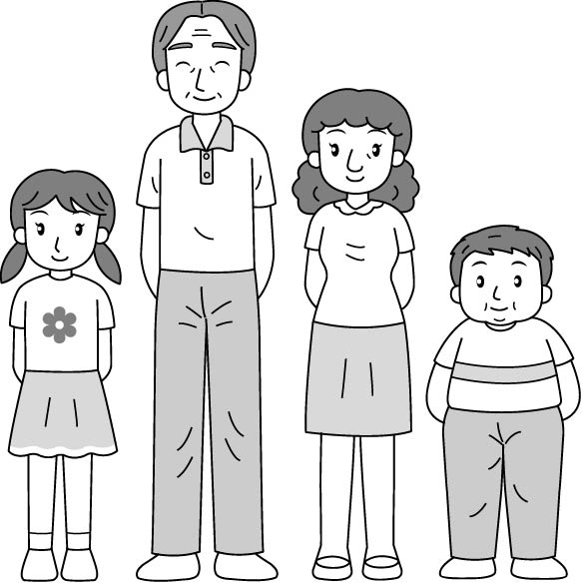 (B) 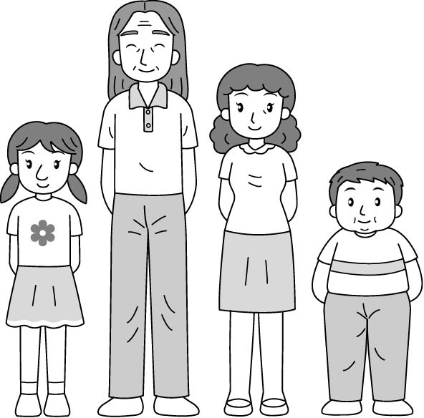 (C) 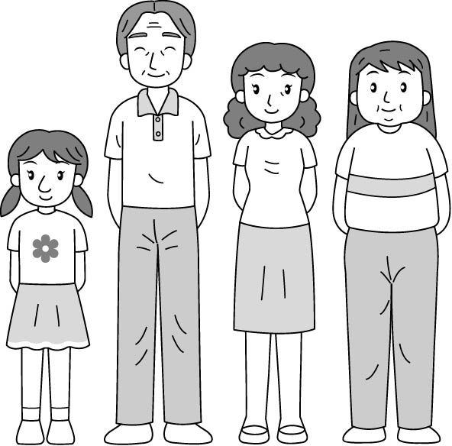 (D) 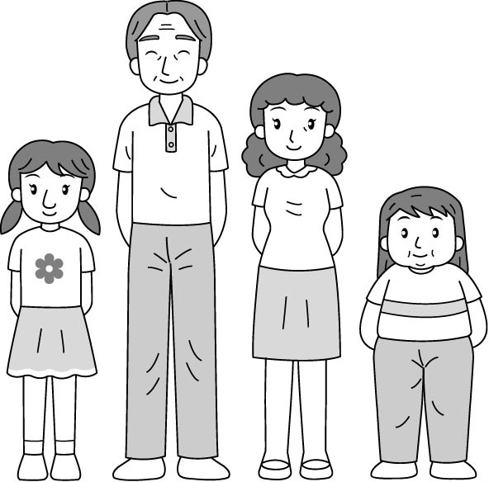

（三）
(In the living room)
Andy: What’s on Channel 5?
Tony: Well, it’s Pirates.
Andy: What’s on the next channel?
Tony: A baseball game.
Andy: Hey, look! Who’s that strong man?
Tony: Well, he’s Dai-Kang Yang. He’s a player from Taiwan.
player 球員
Andy: And the next?
Tony: It’s a funny movie.
9. What’s on Channel 7?
(A) A funny movie. (B) Pirates. (C) A baseball game. (D) A basketball game.
10. What is Dai-Kang Yang’s job(工作)?
(A) An actor. (B) A pirate. (C) A baseball player. (D) A basketball player.

七、依提示作答與翻譯 (分段給分) 12%
1. They are old boxes. (改為單數句)
2. This is a candy. (改為複數句)
3. 這本字典是Denny送的。
4. 那些人們既親切又樂於助人。
5. 這些是我的手錶。
6. 你最喜歡的電視節目是什麼?

高雄市立林園高級中學 國中部 102學年度 第 ㄧ 學期 一年級 英語科 第二次 段考答案
範圍：Lesson 3~Review 2 班級： 姓名： 座號：
【請將答案寫在答案欄內，交卷時只須繳交答案卷】
壹、聽力測驗30%
一、看圖選擇 (根據聽到的內容，寫下符合的圖片代號) 10%
1.  E | 2.  C | 3.  A | 4.  F | 5.  D

二、對話選擇 (根據聽到的對話內容，選出正確的敘述) 10%
1.  C | 2.  C | 3.  B | 4.  C | 5.  A

三、短文理解 (根據聽到的內容，在方框內寫下每個學生的名字) 10%
1.  Billy | 2.  Emma | 3.  Stacy | 4.  Ken | 5.  Denny

貳、紙筆測驗70%
四、文意字彙 10%
1.  Today | 2.  handsome | 3.  beautiful | 4.  pictures | 5.  sign

五、語法選擇 28%
1.  B | 2.  B | 3.  C | 4.  D | 5.  C
6.  C | 7.  C | 8.  D | 9.  A | 10.  A
11.  B | 12.  D | 13.  C | 14.  A

六、克漏字選擇＆閱讀測驗20%
1.  D | 2.  D | 3.  A | 4.  A | 5.  B
6.  C | 7.  B | 8.  D | 9.  A | 10.  C
七、依提示作答與翻譯 (分段給分) 12%

1. 【It is】【an old box.】

2. 【These are】【candies.】

3. 【This/ The dictionary is】【from Denny.】

4. 【Those people are】【sweet/kind/nice and helpful.】

5. 【These are】【my watches.】

6. 【What’s your】【favorite TV program?】

