高雄市立林園高級中學 國中部 102學年度 第ㄧ學期 一 年級 英語 科 第 三 次段考試卷
班級： 姓名： 座號：
本試卷共（ 4 ）頁

壹、聽力測驗 30%
一、看圖選擇（根據聽到的內容，選出與圖片相符合的句子）10%
1. | 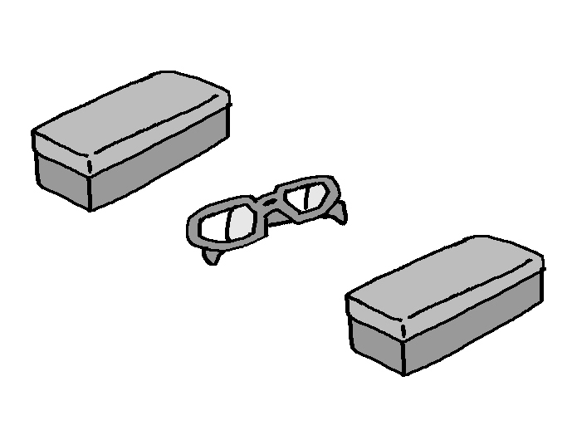  2. | 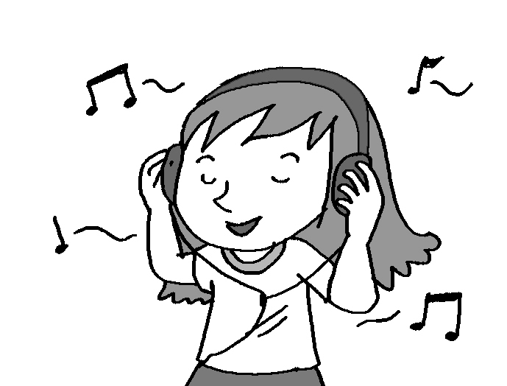  3. | 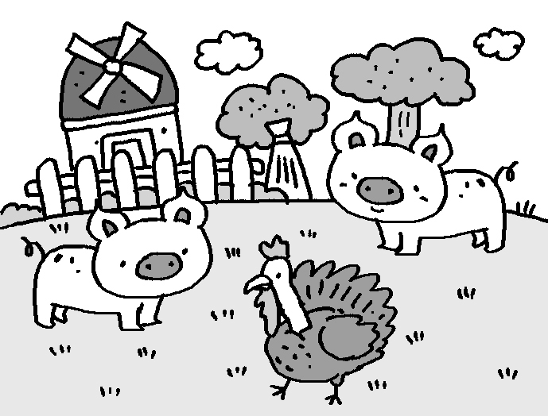  4. | 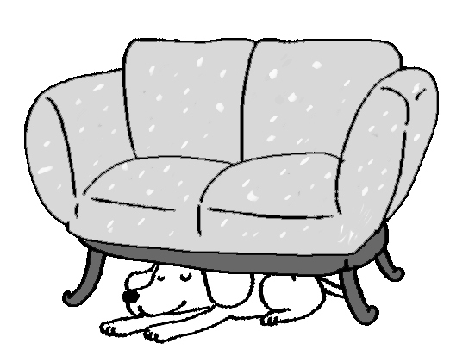  5.

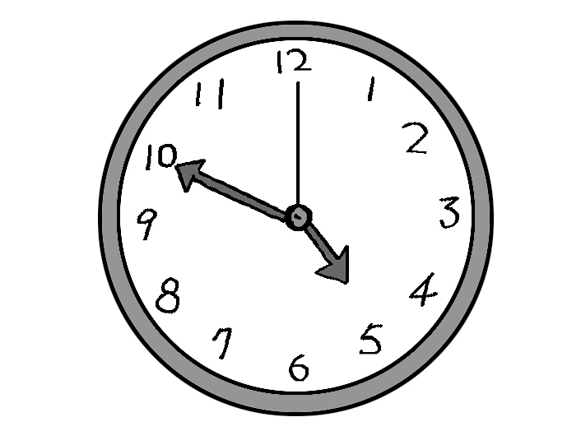

二、看圖回答（根據海報，聽完問題後選出正確的答案）10%
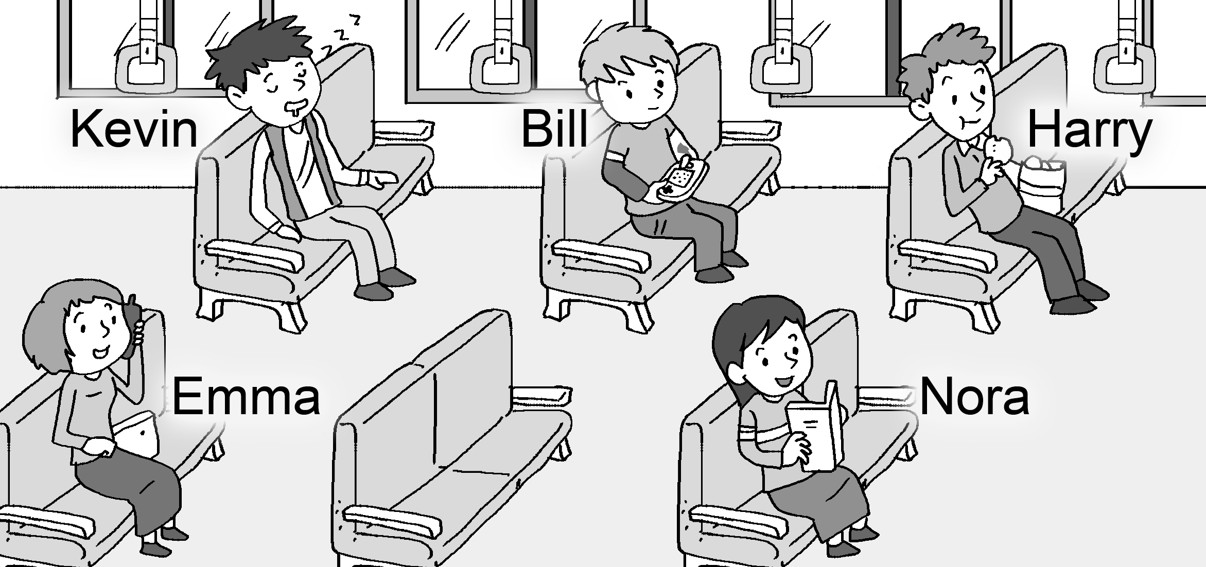
( ) 6. (A) Five
(B) Four
(C) Seven
( ) 7. (A) Yes, she’s reading a book.
(B) No. She’s eating cookies.
(C) No. She’s talking on the cellphone.
( ) 8. (A) Kevin is.
(B) Harry is.
(C) Bill is.
( ) 9. (A) He’s sleeping.
(B) He’s talking on the cellphone.
(C) He’s eating cookies.
( )10.(A) He’s behind Emma.
(B) He’s behind Harry.
(C) He’s behind Kevin.

三、簡短對話（根據聽到的對話內容，選出正確的答案）10%
( )11.(A) They are at the Monkey House.
(B) They are at the Penguin House.
(C) They are on the farm.
( )12.(A) Dad
(B) Gina
(C) Nora
( )13.(A) It’s in his desk.
(B) It’s on his desk.
(C) It’s under his desk.
( )14.(A) Yes, he is reading the newspaper in the dining room.
(B) No, he isn’t reading the newspaper in the living room.
(C) Yes, he is reading the newspaper in the living room.
( )15.(A) They are on the table.
(B) It is on the table.
(C) They are on the sofa.

貳、讀寫測驗 70%
一、字彙選擇 20%
( ) 16. I am . Let’s eat something.
(A) cute (B) hungry (C) quiet (D) shy
( ) 17. Mr. Wang is English in the classroom now.
(A) teaching (B) jumping (C) kicking (D) looking
( ) 18. The dog is big but very .
(A) right (B) little (C) friendly (D) strong
( ) 19. Look! The are eating bananas in the tree.
(A) penguins (B) turkeys (C) monkeys (D) frogs
( ) 20. Mary: What are you doing here? Tony: I’m a book about penguins.
(A) looking for (B) turning off (C) playing with (D) hiding from
( ) 21. Tina: There are many snakes around here. Eric: What? Let’s of here.
(A) get out (B) stand up (C) wait for (D) look at
( ) 22. A: Is Peter in his bedroom? B: Yes. He’s his e-mail.
(A) clapping (B) checking (C) calling (D) coming
( ) 23. Grandma is not in her room. she’s in the garden.
(A) Perhaps (B) Next (C) Also (D) So
( ) 24. There are three in my home, one cat and two dogs.
(A) insects (B) bees (C) pets (D) hens
( ) 25. Mom: Tom, turn off the TV and study. Tom: , Mom.
(A) Come on in (B) Just a minute (C) Have fun (D) Wait in line

二、語法選擇 24%
( ) 26. Two ________ are sleeping over there.
(A) wolf (B) penguin (C) sheep (D) monkey
( ) 27. Johnny has (有) a rabbit and a turtle. They are ________ cute.
(A) only (B) every (C) all (D) both
( ) 28. My sister is studying English the desk.
(A) under (B) at (C) in (D) between
( ) 29. The boys by the pond.
(A) is dancing (B) is fighting (C) are claping (D) are running
( ) 30. Tom is reading, not ________.
(A) write (B) writting (C) writing (D) writeing
( ) 31. Look! There is a man a book on the balcony.
(A) read (B) to read (C) reading (D) reads
( ) 32. Jack: Are Jason and his friends throwing a ball in the park? Alice: No, .
(A) he’s not (B) we’re not (C) they aren’t (D) they are
( ) 33. Denial: Peter, don’t ________ the monkeys. Peter: OK.
(A) feed (B) fed (C) feeding (D) feding
( ) 34. Leo: Are there any wolves in the zoo?
Ivy: Yes, are.
(A) there (B) they (C) these (D) those
( ) 35. Teresa: There is a bee on your head. Andy: Ahhh! I am afraid bees.
(A) at (B) of (C) on (D) to
( ) 36. Mom: _______ is your dad doing?
Emily: He is singing in the bathroom.
(A) Who (B) What (C) Where (D) How
( ) 37. Steve: How many girls by the door? Ruby: There is one.
(A) is there (B) there is (C) are there (D) there are

三、對話選擇 6%
( ) 38. Peter: Is John playing video games in the living room?
Susan: .
(A) I’m watching TV in the living room.
(B) They’re playing basketball in the park.
(C) No. He is studying English in his room.
(D) Yes. He is playing video games in his room.
( ) 39. Mom: .
John: It’s today’s newspaper.
- Is there today’s newspaper?
- What’s he doing there?
- What’s under the table?
- Where’s today’s newspaper?
( ) 40. Leo: What’s on your grandparents’ farm?
Peggy: .
- Yes. There are two turtles.
- They’re eating around the tree.
- There are turkeys and sheep.
- No. But there are some books on the table.

四、閱讀測驗 10%
The Red Riding Hood（小紅帽）is a story between a girl and a bad hungry wolf. It’s six o’clock in the morning. The Red Riding Hood is going to her grandma’s home. It is ten. A wolf is looking for food. Now it is twelve. The Red Riding Hood is hiding from it. She is behind the door.
( ) 41. Where is the Red Riding Hood?
(A)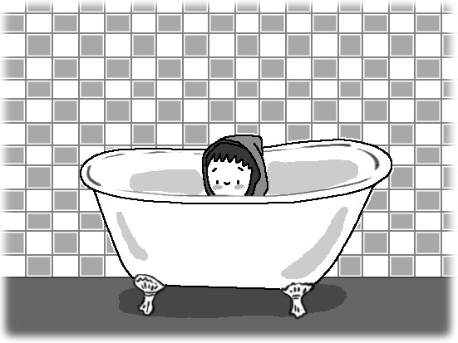 (B)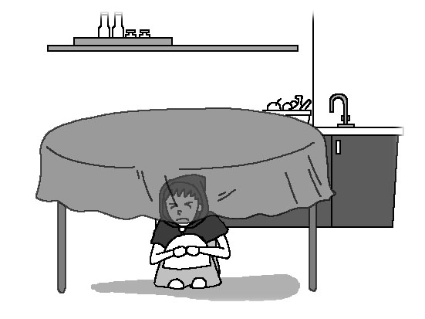 (C)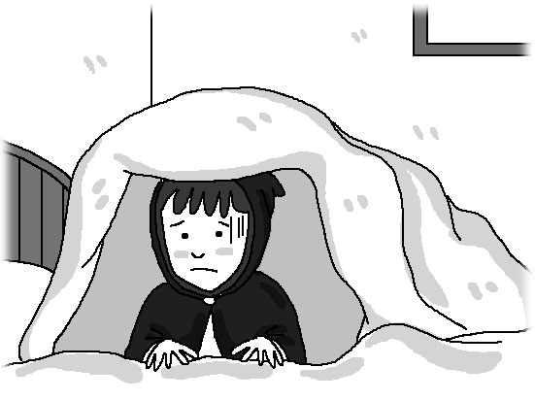 (D)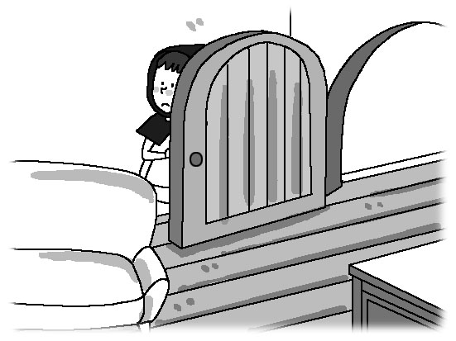
( ) 42. What time is it now?
(A) It is twelve. (B) It is ten. (C) It is six. (D) It is eleven.
( ) 43. What is the Red Riding Hood hiding from?
(A) The food. (B) The door. (C) The wolf. (D) The sheep.
( ) 44. What is the Red Riding Hood doing at six o’clock?
(A) She is hiding from her grandma. (B) She is looking for food.
(C) She is going to school. (D) She is going to her grandma’s house.
( ) 45. Which is true（真的）?
(A) The Red Riding Hood is a story between a girl and a wolf.
(B) The Red Riding Hood and the wolf are good friends.
(C) The Red Riding Hood is looking for food.
(D) The Red Riding Hood is hiding in the bathtub.
五、克漏字選擇 10%
What is in Sarah’s room? 46 there any basketballs and baseballs? No. 47 are in her brother’s room. In Sarah’s room, there 48 dolls, books, and beautiful pictures. 49 there a pet, too? Yes. And 50 a cellphone on the desk. It is a birthday gift from her aunt.

( )46. (A) Is (B) Are (C) Am (D) Be
( )47. (A) It (B) We (C) They (D) You
( )48. (A) is (B) are (C) am (D) be
( )49. (A) Are (B) Be (C) Am (D) Is
( )50. (A) it is (B) there is (C) there are (D) they are

一年級 英語科 第三次段考答案欄（年級、科目請標示清楚，謝謝！）
BACBB
ACCAB
BCBCA
BACCA
ABACB
CDBDC
CCAAB
BCCCC
DACDA
BCBDB

