高雄市立林園高級中學 國中部 102學年度 第 ㄧ 學期 二 年級 英文 科 第 一 次段考考卷
壹、聽力測驗 班級： 姓名： 座號
一、聽CD，配合圖片選出最適當的答案，每題二分。：
1.
(A)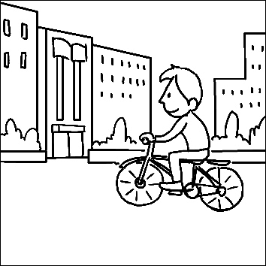 (B)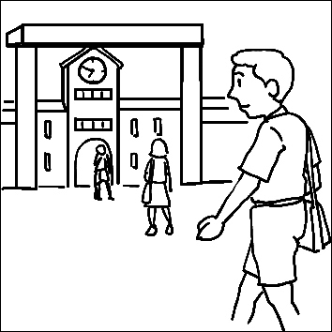
2.
(A)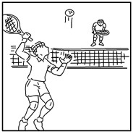 (B)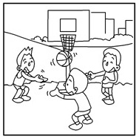(C)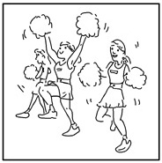
3.
(A)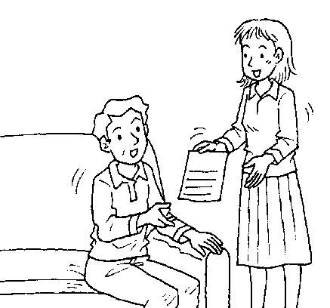 (B)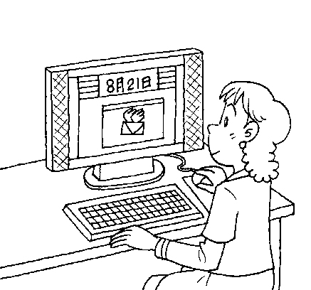(C)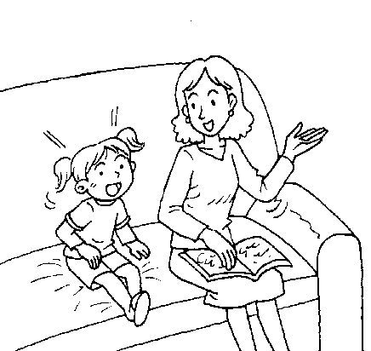
4.
(A)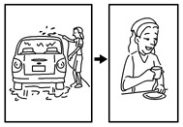 (B)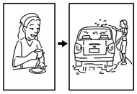
5.
(A)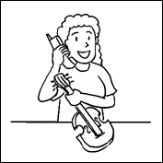 (B)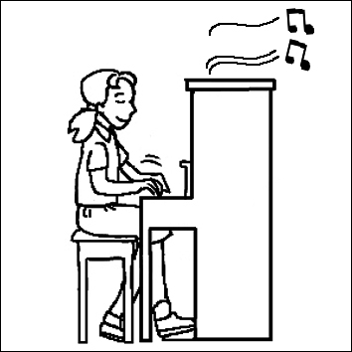 (C)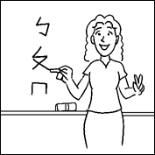
二、聽CD，選出適當的回應句，每題二分。
6.
(A) It’s OK. Study hard, and you can do well next time.
(B) How about you? Are you OK?
(C) You really helped me a lot.
7.
(A) You bet! You need to take a rest.
(B) Aren’t you tired?
(C) I asked for it. I didn’t do my work this morning.
8.
(A) What’s wrong?
(B) I had to take care of my child.
(C) Because she doesn’t have time.
9.
(A) He must have a talent for music.
(B) Why don’t you help the poor?
(C) I really admire him.

10.
(A) My mom doesn’t like pets.
(B) I also want to have a pet.
(C) He must be sad. Let’s cheer him up.

三、聽CD中的對話，選出適當的答案，每題二分。：
11.
(A) Watch TV.
(B) Do homework.
(C) Clean the room.
12.
(A) She mixed the apples and oranges together before she cut them.
(B) She put some salt and yogurt in a bowl before she cut the fruit.
(C) She cut the fruit, and then she mixed some milk, salt, and yogurt with the fruit.
13.
(A) At home.
(B) At the gate.
(C) In the hospital.
(D) In the living room.
14.
(A) His parents were sick.
(B) His parents went out of town.
(C) His parents had to work.
(D) His parents prepared a big dinner.
15.
(A) The bike isn’t red now.
(B) The girl is poor at painting.
(C) The girl washed her bike last weekend.

貳、讀寫題
四、文意字彙：根據句意，填入適當的單字；每題二分，共20分
- After I went to the doctor, I had to take the m_________ three times a day to get well. .
- Grandfather told us many i______________ stories,so we laughed a lot .
- Your hat is beautiful. Can I b_________ it (from you)? I give it back this afternoon.(L3w)
- Don’t eat too many s__________. They are not good for you.
- Sorry, I have a s________________, so I can’t talk loudly.
- Yumi lives next door. She is my n_______________.
- My brother and I played v_________ games together last night.
- My son goes to c m school every night because he can’t study very well on her own.
- I couldn’t find my glasses. I l＿＿＿＿＿＿ them when I was in the library..
- Peter is ten years old. He is an e______________ school student.

五、對話與完成句子：每題二分，共10分
- Bob：What is the book about?
Jack：
(A)Thanks for your help and I joined a summer camp.
(B) Nobody liked him because he was nice to them.
(C) He was a great writer in history.
(D) It is about Thomas Edison’s early life.
- Sam：
Mom：You can watch movies after you finish your homework.
Sam：OK.
(A) How are you doing?
(B) When can I finish the homework?
(C) Where are you going?
(D) When can I watch movies on TV, Mom?

3.. Ivy：Why didn’t you come to school yesterday? ______________
Coco：I caught a bad cold and had to take a rest at home.
(A) What was wrong?
(B) That was very nice of Jack.
(C) Did you love me very much?
(D) I really admire Mike’s father.
4. Nina：
Hank：They visited a toy museum.
(A) What did they do to me?
(B) What did the students do last summer vacation?
(C) Where does your grandfather live?
(D) Where are they going?
5. Kevin：Hey, son. How was your day?.
Henry：
(A) That’s is nice of him.! (B)What happened?. (C) I admire him. (D)Terrible! My teacher was angry with me.
.
六、克漏字選擇：每題一分，共10分
A. Ten years 1 , Nancy joined a tennis club at school. She__2_____tennis every Wednesday and Friday evening. She also played tennis wirth her friends on weekend. Tennis was not an easy sport, but she liked it. Andre Agassi ___3____ her favorite tennis player. She watched almost all his games.
Now, Nancy is an engineer. She has to __4_____ all day and even all night. Every day, she is busy and tired after work. She doesn’t like sports, and she _5____ play tennis any more. She only plays computer games in her free tme.
1.(A)before (B)after (C)ago (D)when.
2.(A)practice (B)practiced (C)practices (D)is practicing
3.(A)was (B)are (C)be (D)were
4.(A)is working (B)works (C)worked (D)work
5.(A)isn’t (B)didn’t (C)doesn’t (D)wasn’t

B. When A-mei was a little girl, she 6 almost every day. It was her favorite thing. She loved to sing with the birds in the tree after school. In 1992, she 7 her hometown, Taitung, and worked in restaurants in Taipei. But she didn’t forget her dream. One day, she joined in a singing contest. She failed 8 she forgot the lyrics. In 1994, she joined in the singing contest again, and this time she 9 the contest. Now A-mei is a famous singer, but she never 10. her experience of contests. When she is tired and sad, she thinks of the past and becomes happy again.
 hometown 家鄉 contest 比賽 again 再次 lyrics 歌詞 experience 經驗 past 過去
6. (A) sing (B) sang (C) is singing (D) sings
7. (A) leaves (B)is leaving for (C) is leaving (D) left
8. (A)but (B) so (C) before (D) because
9. (A)win (B)is winning (C)won (D)wins
10. (A)forget (B) forgets (C)was forgetting (D)is forgetting

七、閱讀測驗：每題二分，共10分。
A. Bill：How many times did Jeremy Lin fail before he became a famous basketball player in America?
Hank：Well, five years ago, he was still a student in a famous college. At that time, he did not do well in a lot of basketball games because he was too busy to practice it.
Bill：Did he go to America at that time?
Hank：No. In fact, he was born (出生) in 1989 in the US. His father taught him how to play basketball when he was little. But he was not an excellent basketball player when he studied in college in the US. Maybe he didn’t have many chances of playing in the games and he lost some basketball games then.
Bill：Was Jeremy Lin sad then?
Hank：Of course. But he still practiced hard day and night. In 2012, he did well and helped his team win many games.
Bill： No wonder he is a world-famous basketball player now.
（ ）1. Why DIDN’T Jeremy Lin play well when he was a student in college?
(A) He was only an old student.
(B) He was a smart player.
(C) He didn’t practice hard at that time.
(D) He was too sad at that time.
（ ）2. Which is NOT true about Jeremy Lin?  true 正確的
(A) He went to America in 2012.
(B) He played basketball well in 2012..
(C) His father was Jeremy’s first basketball coach.
(D) He practiced hard after he failed.

B Smart Juice
* Do you want to be excellent? Just drink our excellent drink!
* Four flavors to choose: Chocolate, Papaya,Lemon, and Orange.
* Low-fat and low-calorie.
* Drink smart juice three times a day.
* You can lose 5 kilos in a week and have good looks: pretty eyes, teeth, face, and hair.
* What are you waiting for? Buy Smart Juice here now!
 low 低 fat 脂肪 calorie 卡路里 lose 失去；減掉 juice果汁 flavor口味
（ ）3. What does “good looks” mean?
(A) Someone is beautiful. (B) Someone is heavy. (C) Someone is smart. (D) Someone is hungry.

C. Do you know who Jason Wu is? He liked to play with Barbie Dolls, and he also loved to change clothes for them when he was little. This made some of his classmates and friends laugh at him a lot. He felt so sad at school while he was in Taiwan, so his mother decided to take him to Canada. There were many kinds of peoples there, and most of them didn’t think he was different because they thought that everyone was special. Jason liked Barbie Dolls,and he enjoyed designing the clothes for them,too. Then he becomes a famous fashion clothing designer, and he even does that for some of the very famous women.
( )4. Why did Jason Wu study in Canada?
(A) Because his parents lived there. (B)Because some of his classmates in Taiwan teased him. (C)Because his mother asked his classmates to do so. (D)Because many people in Taiwan helped him.
( )5.Which is true about the reading?
(A)Jason designed many Barbie dolls. (B) Jason’s mother enjoyed designing clothes. (C) That everyone is special means everyone is the same. (D) A lot of women love the clothes that Jason Wu designs.
decide 決定 special特別的 design設計 tease嘲諷 fashion現代的

八、依提示回答問題：每題二分，共十分；錯一字扣一分。
- Harvey meets his girlfriend on his trip to the big city.（加入「上星期六」並改寫句子）
- She made a toy car at home last night.（依畫線部分造原問句）
- Did he go to school on foot this morning ?（先否定簡答再用「騎腳踏車」回答）
- The boy was sad.
The boy couldn’t find his money.（以 because 合併句子）
- Kitty caught a bad cold.
She couldn’t go to school.(以so合併句子)
_______________________________

九、整句式翻譯：每題二分，共十分；依段落給分，錯一字扣一分。
1. 在Edison成為偉大的發明家之前，他失敗了很多次。
1分 1分
2. 為了那筆錢，她去年夏天做了四份不同的工作。
1分 1分
3. Jenny 昨天離開教室前， 她有把燈關掉。
1分 1分
4. 你們曾經 問過她這個問題嗎？
1分 1分
5. 他們上週日去超市 買一些食物為園遊會做準備。
1分 1分

高雄市立林園高級中學 國中部 102學年度 第 ㄧ 學期 二 年級 英文 科 第 一 次段考答案卷
班級： 姓名： 座號： 得分：
一、看圖 10％
1 | 2 | 3 | 4 | 5
二、對答10％
6 | 7 | 8 | 9 | 10
三、對話 10％
11 | 12 | 13 | 14 | 15
四、文意字彙 20％
1 | 2 | 3 | 4 | 5
6 | 7 | 8 | 9 | 10
五、對話測驗 10％
1 | 2 | 3 | 4 | 5
六克漏字測驗 10％
1 | 2 | 3 | 4 | 5
6 | 7 | 8 | 9 | 10
七、閱讀測驗 10％
1 | 2 | 3 | 4 | 5
八、依提示作答 10％每句二分，錯一字扣一分。
1.

2.

3.

4.

5.

九、整句翻譯 10％，每句二分、按段落，錯一字扣一分。
1

2

3

4

5

