高雄市立林園高級中學 國中部 102學年度 第 ㄧ 學期 二 年級 英文 科 第 二 次段考試卷
一、聽CD，配合圖片選出最適當的答案 (10%) 本試卷共（4）頁
1. 2. 3. 4. 5.
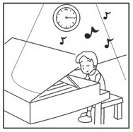 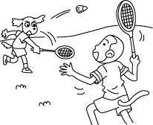 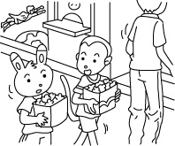 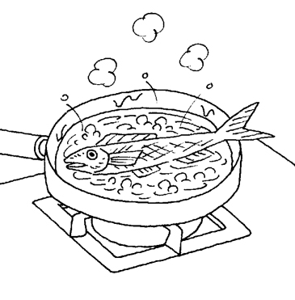 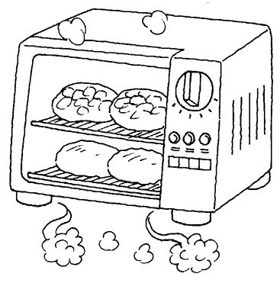

- 聽CD，選出符合句意的選項 (10%)
1.
(A) It’s important to have good manners.
(B) It’s important to have a lot of money.
(C) It’s important to have many friends.
- (A) It’s good for the elderly to swim in the morning.
(B) Elderly people like to swim in the morning.
(C) Elderly people need to swim in the morning.
3.
(A) Mrs. Liu was cooking in the kitchen when Andy called her.
(B) Mrs. Liu answered Andy’s call in the kitchen.
(C) Mrs. Liu called Andy in the kitchen.
4.
(A) Ben likes to buy new clothes.
(B) Ben gives clothes to the children’s home every year.
(C) Ben likes to wear children’s clothes.
- (A) I am writing a letter now.
(B) I was writing a letter at 4 p.m.
(C) I am reading a letter now.

三、聽CD中的對話，選出適當的答案 (10%)
1.
(A) He had a love problem.
(B) He had a bad dream.
(C) He had a fight with a ghost.
- (A) It’s not nice to practice hard.
(B) It’s not nice to make noise at night.
(C) It’s nice to play the drums at night.
- (A) Beef noodles.
(B) Bread.
(C) Steak.
- 4.
(A) To get up early.
(B) To wait for others.
(C) To be on time.
- (A) She is a young lady.
(B) She has a beautiful hat.
(C) She comes from the UK.
四、文意字彙 (10%)
- The new semester b n last Friday. (習作P.16)
- Mother b ls water to make tea every morning. (習作P.26)
- Rick helps clean up the n d in his free time. (習作P.22)
- That man was s ge. He asked everyone the same question. (習作P.16)
- It is not p te to laugh at people. (習作P.26)
- The accident (意外) happened s ly, so no one remembered much about it.
- Alex is reading an interesting story on the I t. (習作P.21)
- Where are the c cks ? I need them to eat noodles. (習作P.26)
- The little boy th w the ball, and the dog caught it. (習作P.16)
- A: Try the sandwiches！ They are my s y. B: They are really yummy.

- 文法選擇 (10%)
- She _____, so she couldn’t buy the house.
- didn’t have enough money (B) wasn’t having money enough (C) has enough money
- isn’t having money enough
- A: What was Fanny at seven yesterday morning? B: Wasn’t she basketball with Dad?
(A) do; play (B) does; plays (C) doing; played (D) doing; playing
- Mr. Wang wasn’t listening to music, but the children .
(A) are (B) wasn’t (C) were (D) was
- A: Who talking and laughing then? B: Gina and Tammy .
(A) was; were (B) were; were (C) were; was (D) was; was
- The volleyball game at ten this morning.
(A) ends (B) is ending (C) ended (D) was ending
- Walter want badminton with us?
(A) Do; playing (B) Does; to play (C) Is; playing (D) Is; to play
- Jones enjoys the Chinese songs when he is free.
(A) to sing (B) sing (C) sang (D) singing
- To learn English well, Lisa keeps English every day.
(A) to practice speaking (B) practicing speaking (C) practicing to speak (D) practice speaking
9. Betty ______ TV when her brother ______ off the chair.
(A) watched; is falling (B)watches; was falling (C) watched; falls (D) was watching; fell
10. Surfing the Net difficult for my grandparents.
(A) is (B) are (C) to be (D) being

六、對話與完成句子 (10%)
1. A: What do you want to be in the future (未來)? B:
(A) I don’t plan to be a teacher.
(B) I want to be an engineer.
(C) I hate to study.
(D) I love dancing. How about you?
2. A: Wasn’t York mopping the floor in the living room? B:
(A) No, he was mopping the floor.
(B) No, he isn’t.
(C) No, he was in the living room.
(D) Yes, he was.
3. A: What are they talking about? B:
(A) Some news about the soldier.
(B) They are talking to Amos.
(C) What about you?
(D) For about four hours.
- A: B: I practice it every day.
(A) What do you plan to do tomorrow (明天)?
(B) Do you want to be a writer?
(C) How can you play the guitar so well?
(D) How many hours do you practice dodge ball a day?
5. A: Where was your sister at five yesterday? B: ______
(A) That was a big problem.
(B) She is doing her homework.
(C) No wonder no one answered the phone.
(D) She was cooking dinner at home.

七、閱讀測驗 (16%)

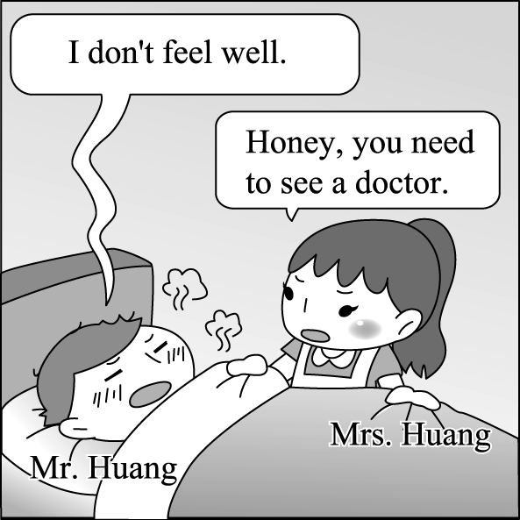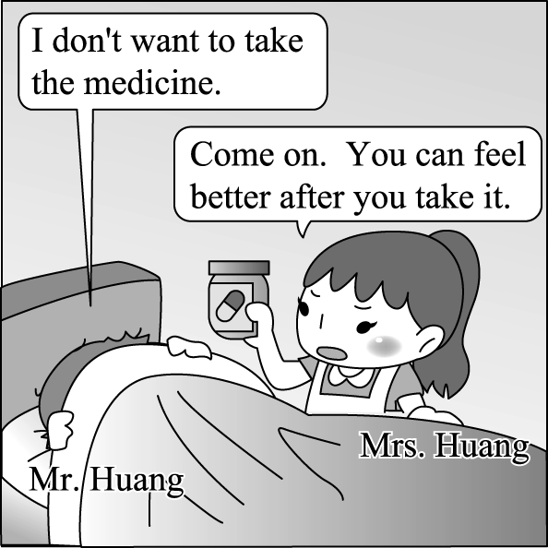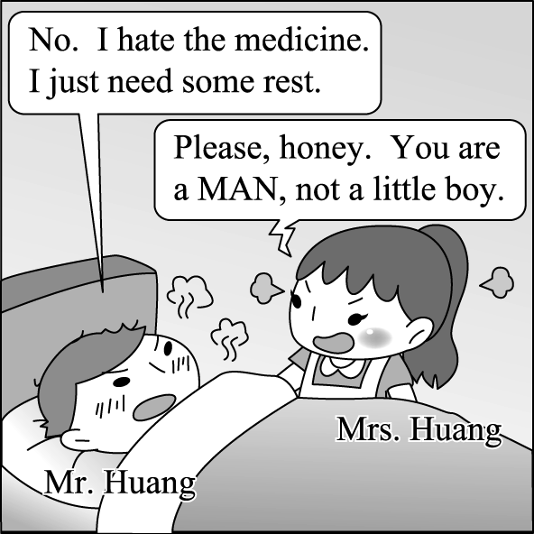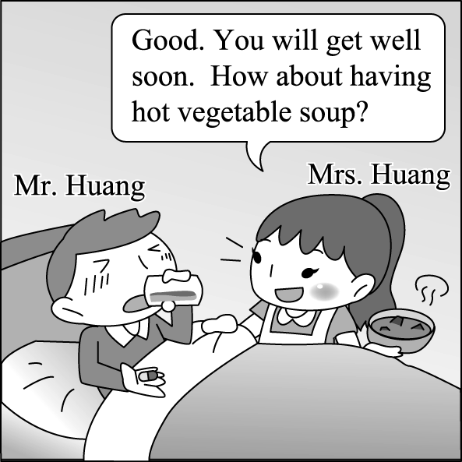
(１) What’s wrong with Mr. Huang?
(A) He needed to work late.
(B) He was mad at his wife.
(C) He had a fever.
(D) He couldn’t find his medicine.
(２) What did Mrs. Huang want her husband to do?
(A) Stay in the office.
(B) Work until eleven o’clock.
(C) Go to bed early.
(D) Take the medicine.
2.
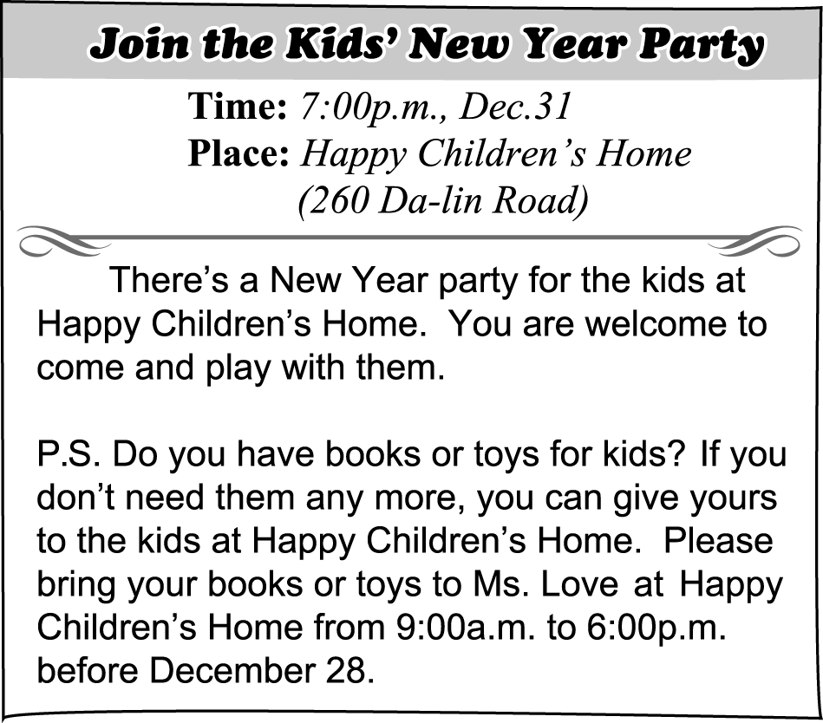
& P.S. 附註 if 如果 yours 你(們)的物品
(１) Jessica has some children’s books. What time CAN’T she take them to Happy Children’s Home on December 25?
(A) 8:00 a.m.
(B) 10:00 a.m.
(C) 12:00 p.m.
(D) 4:00 p.m.
(２) It’s 8:30 p.m. on December 31. Amy and David are at Happy Children’s Home. What are they doing?
(A) Donating toys.
(B) Giving books to the kids.
(C) Chatting with Ms. Love.
(D) Playing with the kids.
(３) What do the kids at Happy Children’s Home like to have?
(A) Vests and coats.
(B) Shoes and belts.
(C) Books and toys.
(D) Delicious snacks.
3.
Eric: Dad, who’s the little girl over there? Why is she shaking her head like that on the street? She looks so interesting.
Dad: Brad! Don’t say anything like that again. She is just sick.
Eric: Oops, I’m sorry. I won’t do it again. But who is she? I never saw her before.
Dad: Sara just moved into the house next to our house. Ms. Lin took her home last month. She wants to take care of children
in need of special help. Sara is one of them.
Eric: Can I help, too?
Dad: Sure. But remember: people may look different, but we are all the same. We all need love and care in difficult times.
Eric: I see, Dad. Let’s visit Ms. Lin and Sara some other time.
Dad: OK. How about this weekend?
Eric: I can’t wait!
(１) Who may be sick in the story?
(A) Eric.
(B) Sara.
(C) Ms. Lin.
(D) Eric’s dad.
(２) What won’t Eric do again?
(A) He won’t get sick.
(B) He won’t talk about other children.
(C) He won’t shake his head on the street.
(D) He won’t be rude（粗魯的）in talking about other people.
(３) What does Eric’s dad mean by saying “we are the same?”
(A) People need love and care from other people in difficult times.
(B) People need to say and do the same thing.
(C) People need to be happy every day.
(D) People need to live in the same place every day.

八、依提示回答問題 (15%)
1. was / at 10:20 / a bike / Ted / yesterday morning / riding（重組句子並做適當變化）
2. help / for / thanks / science homework / me / with / my （重組句子並做適當變化）(習作P.29)
3. I have to study hard. My parents hope me to do that.（用不定詞合併句子）
4. To get good grades in math is easy for James.（用動名詞當主詞改寫句子）
5. Wayne wrote an e-mail last night.（加入 plan 改寫句子）

九、整句式翻譯 ( 9%)
1. 在空中揮舞刀叉是不對的。(習作P.29)
2. 我跟著他鑽進了個兔子洞，進入了奇幻仙境。(課本P.46)
3. 當日本人喝湯時，他們以碗就口。(習作P.29)
高雄市立林園高級中學 國中部 102學年度 第 ㄧ 學期 二 年級 英文 科 第 二 次段考作答卷
班級： 姓名： 座號：
一、聽CD，配合圖片選出最適當的答案 (10%)
1. | 2. | 3. | 4. | 5.
二、聽CD，選出符合句意的選項 (10%)
1. | 2. | 3. | 4. | 5.
三、聽CD中的對話，選出適當的答案 (10%)
1. | 2 . | 3. | 4 . | 5 .
四、文意字彙 (10％)
1. | 2. | 3. | 4. | 5.
6. | 7. | 8. | 9. | 10.
五、文法選擇 10％
1 . | 2. | 3. | 4. | 5.
6. | 7. | 8. | 9. | 10.
六、對話與完成句子 10％
1. | 2. | 3. | 4. | 5.
七、閱讀測驗 16％
1. ( 1 ) | ( 2 )
2.( 1 ) | ( 2 ) | ( 3 )
3.( 1 ) | ( 2 ) | ( 3 )
八、依提示作答 15％ (採分段給分,請同學努力作答)
1.

2.

3.

4.

5.

九、整句式翻譯 9％ (採分段給分,請同學努力作答)
1

2

3

高雄市立林園高級中學 國中部 102學年度 第 ㄧ 學期 二 年級 英文 科 第 二 次段考解答卷
一、聽CD，配合圖片選出最適當的答案 (10%)
1. A | 2. B | 3. A | 4. C | 5. C

二、聽CD，選出符合句意的選項 (10%)
1. A | 2. A | 3. A | 4. B | 5. B

三、聽CD中的對話，選出適當的答案 (10%)
1. B | 2 . B | 3. C | 4 . C | 5 . A

四、文意字彙 (10％)
1. began | 2. boils | 3. neighborhood | 4. strange | 5. polite
6. suddenly | 7. Internet | 8. chopsticks | 9. threw | 10. specialty

五、文法選擇 10％
1 . A | 2. D | 3. C | 4. A | 5. C
6. B | 7. D | 8. B | 9. D | 10. A

六、對話與完成句子 10％
1. B | 2. D | 3. A | 4. C | 5. D

七、閱讀測驗 16％
1. (1) C | (2) D
2. (1) A | (2) D | (3) C
3. (1) B | (2) D | (3) A

八、依提示作答 15％ (採分段給分,請同學努力作答)
1. Ted was riding a bike at 10:20 yesterday morning.
2. Thanks for helping me with my science homework.
3. My parents hope me to study hard.
4. Getting good grades in math is easy for James.
5. Wayne planned to write an e-mail last night.

九、整句式翻譯 9％ (採分段給分,請同學努力作答)
- Waving knives and forks in the air is not right./
It’s not right to wave knives and forks in the air.
2. I followed him into a rabbit hole and entered a wonderland.
3. When Japanese people have/eat soup, they hold the bowls to their mouths.

