高雄市立林園高級中學 國中部 102學年度 第 ㄧ 學期 二 年級 英語 科 第 三 次 段考考卷
本試卷共（4）頁 班級： 姓名： 座號：
一. 聽力測驗：每題 2 分，共15題，總分30分。
(一) 聽CD，若符合圖意或表格內容的選 A，否則選 B。
( ) 1.  (A) True (B) False  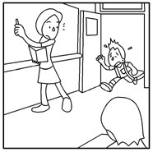 | ( ) 2.  (A) True (B) False  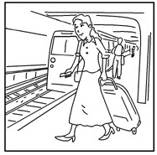 | ( ) 3.  (A) True (B) False  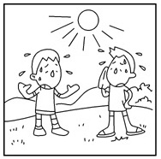 | ( ) 4.  (A) True (B) False  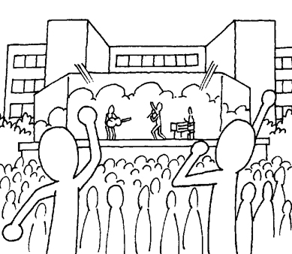 | ( ) 5.  (A) True (B) False  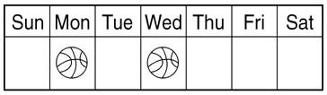

(二) 聽CD，配合圖片選出最適當的答案。
( ) 6.
(A)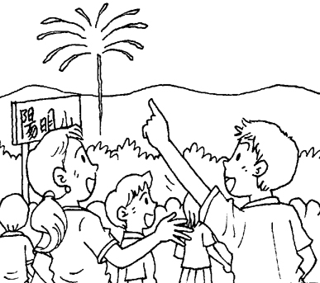 (B)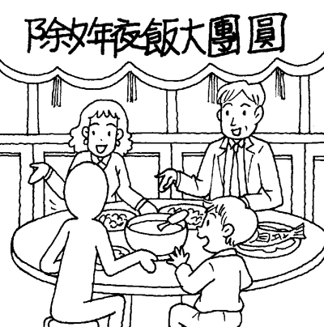 (C)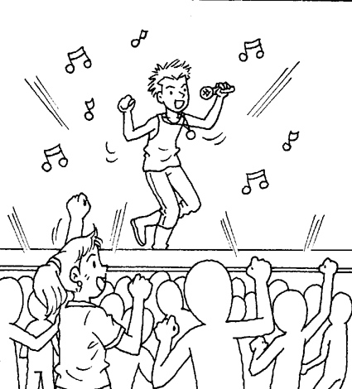
( ) 7.
(A)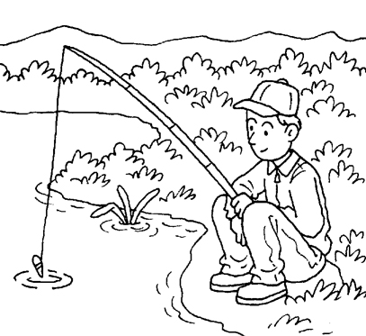 (B)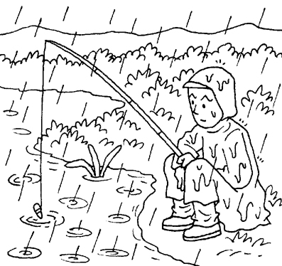(C)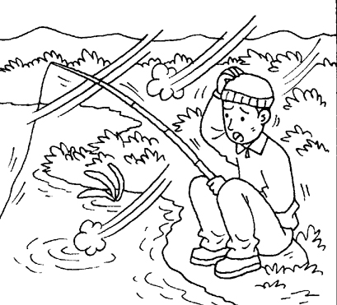
( ) 8.
(A)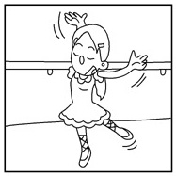 (B)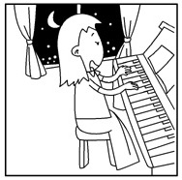(C)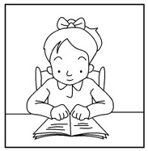
( ) 9.
(A)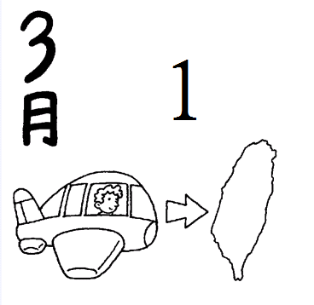 (B)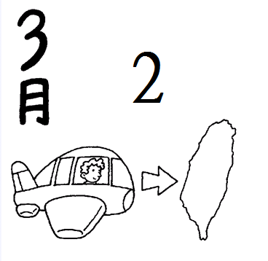 (C)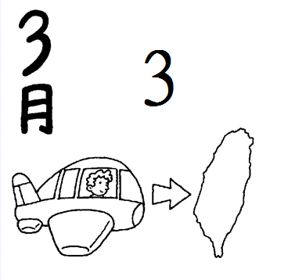

( ) 10.
(A)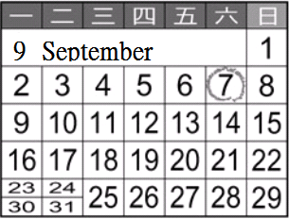 (B)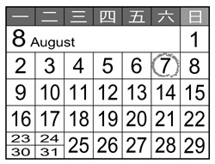(C)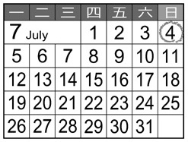
(三) 聽CD，選出適當的回應句。
( ) 11. (A) It’s very hot. (B) I like to go swimming in August. (C) Summer is the season to go swimming.
( ) 12. (A) I will join in the national contest. (B) It’s on October tenth. (C) He will fly to Taiwan today.
( ) 13. (A) Because he has a lot of homework to do.
(B) Because she has a serious toothache.
(C) Because she has serious problems with her mom.
( ) 14. (A) Great! It’s the season to see the beauty of snow.
(B) Great! We seldom have snow here.
(C) Great! I plan to take a trip there this weekend.
( ) 15. (A) No, he goes fishing once a month.
(B) He goes fishing once a month.
(C) He always goes fishing with his friends.
二. 紙筆測驗：每題 2 分，共35題，總分70分。
(一)字彙選擇
( ) 16. Bill had ______ problems with math. He always failed it.
(A) honest (B) afraid (C) serious (D) happy
( ) 17. Ted seldom washes his face, so he gets a lot of ____________ on his face.
- pimples (B) flowers (C) rain (D) snow
( ) 18. A: How are we going to ______ Jacob’s birthday? B: We can take him to a nice restaurant.
(A) pick (B) celebrate (C) wear (D) chat
( ) 19. ______ is a special month because it usually has only twenty-eight days.
- August (B) September (C) October (D) February
( ) 20. He played the guitar all night on the ______.
(A) prize (B) balcony (C) career (D) fan
( ) 21. My father is a good cook. _____________, he’s also a coach of the school team.
- To be honest (B) Besides (C) So (D) At least
( ) 22. The weather is too ______ for this season. There is even no rain.
(A) hot (B) cold (C) wet (D) dry
( ) 23. The contest is just around the ___________. I have _____________ in my stomach.
- corner ; butterfly (B) world ; butterflies (C) corner ; butterflies (D) world ; butterfly
( ) 24. A ______ can help you when you have a toothache.
(A) dentist (B) engineer (C) master (D) police officer
( ) 25. John wants to be ______ in the future, so he studies very hard now.
(A) serious (B) national (C) successful (D) fair

(二)文法選擇
( ) 26. Mrs. Lin makes her children ______ a lot of fruit and vegetables every day.
(A) to eat (B) eat (C) eats (D) eating
( ) 27. A: What ______ for lunch? B: Let’s have some dumplings.
(A) are we going to eat (B) were we going to eat (C) did we eat (D) do we eat
( ) 28. A: How is ______ today? B: It’s cloudy and rainy.
(A)weather (B) weather like (C) the weather like (D) the weather
( ) 29. A: How often do you go to a museum? B:______.
(A) About every three months (B) Once or twice (C) In fact, they never do (D) At least eight hours
( ) 30. Today is English teacher’s ______ birthday. We’re going to have a big party for her.
(A) Twenty-five (B) twenty-fifth (C) twenty-five’s (D) twentieth-five
( ) 31. Kitty sometimes eats sushi, but her sisters never ______.
(A) is (B) am (C) do (D) does
( ) 32. When it’s not so hot, I usually go ______ .
(A) roller-skate (B) roller-sakted (C) roller-skates (D) roller-skating
( ) 33. There were two typhoons last year, and a lot of rain.
(A) we had (B) there were (C) it rains (D) it’s raining
( ) 34. A: Tammy eats a lot before she goes to bed. B: She ______ fat soon.
(A) becomes (B) became (C) will become (D) will not become
( ) 35. Anne is hard-working, and she ______ busy at work.
(A) always (B) always is (C) always to be (D) is always

(三). 克漏字選擇
Jay：Spot, why don’t you come to my house after lunch? My brother let me 36. his video game. We can have fun
together.
Spot：I want to, but I have to be at home to take care of my little sister.
Jay：Why? Won’t your parents 37. at home?
Spot：No, they 38. . They will 39. my grandmother later.
Jay：I see. Umm… Maybe I can go to your house and help you take care of your sister. After she sleeps, we can play the
video game.
Spot：That’s great. Thank you.
Jay：You’re welcome.
Spot：Oh, by the way, my mom 40. me to clean the house, too. You’ll also help me with that, right?
Jay：All right!

( ) 36. (A) play (B) plays (C) playing (D) to play
( ) 37. (A) are (B) is (C) X (D) be
( ) 38. (A) aren’t (B) will (C) won’t (D) are
( ) 39. (A) visit (B) visits (C) to visit (D) visited
( ) 40. (A) made (B) wanted (C) had (D) let

(四). 閱讀測驗
Ａ.
Maria: Hi, Emma. What are you going to do on New Year’s Eve?
Emma: My family and I are going to celebrate it in the USA with my grandparents.
Maria: Great! You are going to have a white New Year because the weather report said it’s snowing over there.
Are you going to stay at your grandparents’ house?
Emma: No, we’re going to stay at a hotel in the amusement park.
Maria: Wow! Are you going to ride the roller coaster on New Year’s Eve?
Emma: No, it’s too scary. I tried it once and decided not to do it ever again. What are you going to do on New Year’s Eve?
Maria: I’m going to a free concert at Taipei 101 on New Year’s Eve. Many famous singers will sing at that concert. I’ll see all my favorite singers there.
Emma: Who is going with you?
Maria: My sister, Susan, her boyfriend, Tommy and their friends. After the concert, we will join the final countdown.
Emma: Sounds exciting!
Maria: Yeah. I will have an excellent New Year’s Eve. When will you come back?
Emma: I’ll be back next weekend.
Maria: Don’t forget to bring me some snow.
Emma: What?
Maria: I’m just kidding. I would like to see your beautiful pictures.
Emma: No problem.
 Eve前夕；amusement park 遊樂園；roller coaster雲霄飛車；countdown倒數
( ) 41. How’s the weather in the USA now?
(A) It’s cool. (B) It’s warm. (C) It’s cold. (D) It’s hot.
( ) 42. Is Emma going to ride the roller coaster on New Year’s Eve?
(A) Yes, she is. (B) No, she isn’t. (C) She’s isn’t sure. (D) We don’t know.
( ) 43. Who isn’t going to the concert with Maria?
(A) Susan. (B) Susan’s boy friend. (C) Maria’s friends. (D) Tommy’s friend.
( ) 44. Which is TRUE?
(A) Maria will have a white New Year in the USA.
(B) Emma doesn’t like to see the snow in America.
(C) Emma won’t visit her grandparents on New Year’s Eve.
(D) Emma and Maria are talking about their New Year’s plans.

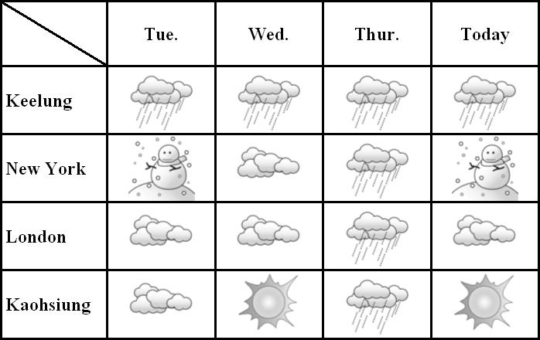
B.

( ) 45. What day is “Today”?
(A) Friday. (B) Saturday. (C) Sundy. (D) Monday.
( ) 46.When did people in the four cities all have rain?
(A) Monday. (B) Wednesday. (C) Tuesday. (D) Thursday.
( ) 47. Peter got sunburn(曬傷) this Wednesday. Where was he?
(A) Keelung. (B) Kaohsiung. (C) New York. (D) London.
C.
Secret Number
Long time ago, before people could write, they found ways to tell the news. They built a fire to tell others what had happened. The smoke was a message, so others from far away places could see it and understand what had happened. Then, people learned to write. Still some things needed to be kept secrets. So they used numbers to mean letters or words. 1 means A, 2 means B, and 26 means Z.
1 | 2 | 3 | 4 | 5 | 6 | 7 | 8 | 9 | 10 | 11 | 12 | 13
A | B | C | D | E | F | G | H | I | J | K | L | M
14 | 15 | 16 | 17 | 18 | 19 | 20 | 21 | 22 | 23 | 24 | 25 | 26
N | O | P | Q | R | S | T | U | V | W | X | Y | Z
Jimmy has written a message for Amy. Someone might read it, so he writes his way:
13-5-5-20 13-5 1-20 19-3-8-15-15-12.
The message is, MEET ME AT SCHOOL.
Now, we have a message for you. Can you read it?
2-5 1 7-15-15-4 19-20-21-4-5-14-20  build建造；secret秘密；mean意指；message訊息

( ) 48. What did people NOT use to tell news in this reading?
(A) Fire. (B) Smoke. (C) Letters. (D) Speaking.
( ) 49. What’s the final(最後的) message?
(A) BE A GOOD FRIEND (B) BE A GOOD STUDENT
(C) BE MY GOOD FRIEND (D) BE A GOOD DAUGHTER
( ) 50. Which one is “HAPPY CHINESE NEW YEAR?”
(A) 8-1-16-16-25 3-8-9-14-5-19-5 14-5-23 25-5-1-18
(B) 8-1-16-16-25 3-8-9-13-5-19-5 14-5-23 25-5-1-18
(C) 8-1-16-16-25 3-8-9-13-5-18-5 15-5-23 25-5-1-18
(D) 8-1-16-16-25 3-8-9-14-5-12-5 13-5-23 25-5-1-18

高雄市立林園高級中學 國中部 102學年度第 ㄧ 學期 二 年級 英語 科 第 三 次 段考答案卷

一、聽力測驗
1. B | 2. B | 3. B | 4. A | 5. A
6. C | 7. B | 8. A | 9. C | 10. C
11. A | 12. B | 13. A | 14. C | 15. B
二、紙筆測驗
(一) 字彙選擇
16. C | 17. A | 18. B | 19. D | 20. B
21. B | 22. D | 23. C | 24 A | 25. C
(二) 文法選擇
26. B | 27. A | 28. D | 29. A | 30. B
31. C | 32. D | 33. A | 34. C | 35. D
(三)克漏字選擇
36. A | 37. D | 38. C | 39. A | 40. B
(四)閱讀測驗
41. C | 42. B | 43. C | 44. D | 45. A
46. D | 47. B | 48. D | 49. B | 50. A

