高雄市立林園高級中學 國中部 102學年度第一學期 三年級英語科 第一次 段考考卷
班級： 姓名： 座號：
一、聽力測驗
(一)根據聽到的內容，選出最適當的答案。10%
(１) | (２) | (３) | (４) | (５)
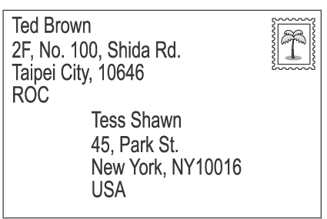 | 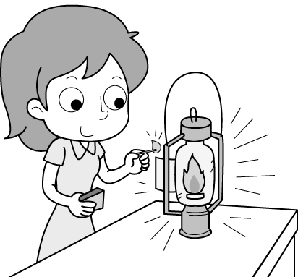 | 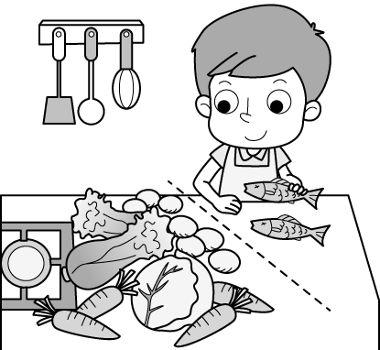 | 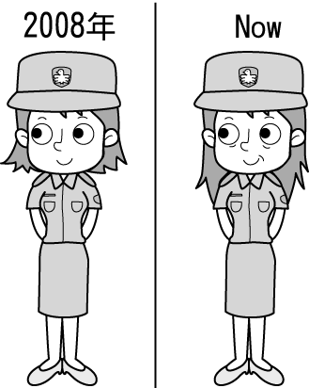 | 
（ ） | （ ） | （ ） | （ ） | （ ）
(二)根據聽到的內容，選出適當的答句。10%
（ ）(１)(Ａ) So far so good. (Ｂ) Hope you enjoy it. (Ｃ) Thanks for asking.
（ ）(２)(Ａ) Yes, I think so. (Ｂ) Yes, she’s quite happy. (Ｃ) Yes, she looks like an artist.
（ ）(３)(Ａ) No, I don’t believe it. (Ｂ) Yes, it’s very possible. (Ｃ) No, we won’t be there in time.
（ ）(４)(Ａ) Not yet. (Ｂ) I no longer like it. (Ｃ) I look at it from a different angle.
（ ）(５)(Ａ) Good topic. (Ｂ) It’s small in size. (Ｃ) That’s really something.
(三)根據聽到的短文內容，正確的敘述寫(Ａ)，錯誤的寫(Ｂ)。10%
（ ）(１) Going trick-or-treating is a fun activity for children on Halloween.
（ ）(２) Kids dress up before they go trick-or-treating.
（ ）(３) Adults may share some ghost stories when the kids come to their doors.
（ ）(４) Adults ask “Trick or treat?” when kids ring the doorbell.
（ ）(５) Kids play tricks on the adults if the adults don’t treat them.

二、紙筆測驗
(一)文意字彙10%
1. Frank put the letter in the e pe and then went to the post office.
2. They have been m ied for many years, but they haven't had any children yet.
3. Annie has kites in many different sh pes, but the round one is her favorite.
4. Jessica can speak three l ges: Chinese, English, and Japanese.
5. Tony turned off the TV after he watched his favorite p m.
6. The blue wh le is a very large sea animal. In fact, it is the largest animal on Earth.
7. Heidi swims much faster now. It's p le for her to win the swimming race.
8. Angela is a d of the dark. She always sleeps with the light on.
9. A: Would you like a r cup of coffee? B: Sure. Thanks.
10. Mr. Chen is p d. He thinks he's right about everything.

(二)文法選擇(請依題意選出一個最適當的答案)30%
( )1.My mom Taipei. She'll get back in a few days.
(A) have been to (B) has been to (C) have gone to (D) has gone to
( )2.There's no student in the gym, ?
(A) is it (B) is there (C) isn't there (D) isn't it
( )3.The girl looked because the ghost story.
(A) scary ; × (B) scared ; × (C) scared ; of (D) scary ; of
( )4.I guess will rain soon.
(A) that (B) it (C) × (D) there
( )5.My mother her basket with fruits while she went shopping in the supermarket.
(A) filled with (B) dress up (C) filled up (D) got to

( )6.You shouldn't use my car without me first.
(A) asks (B) asking (C) asked (D) to ask
( )7.He said he was with trick-or-treating.
(A) that；interested (B) ×；surprised (C) that；excited (D) ×；bored
( )8.She's never seen this movie, she?
(A) has (B) hasn't (C) is (D) isn't
( )9.My parents and I in Kaohsiung I was a little girl.
(A) has lived；for (B) have lived；for (C) have lived；since (D) has lived；since
( )10.We had to go to school last Saturday, we?
(A) didn't (B) had (C) hadn't (D) did
( )11.Students are about playing online games.
(A) excited ; excited (B) exciting ; exciting (C) exciting ; excited (D) excited ; exciting
( )12.A: have you learned Hakka ? B: For about three months.
(A) When (B) How long (C) How often (D) What time
( )13.We are all hear the big news about three typhoons.
(A) surprised at (B) proud of (C) surprising to (D) surprised to
( )14.A: What else should I bring for the trip to Taipei ?
B: , you should take an umbrella with you. It rains most of the time there in winter.
(A) Just to play it safe (B) Just for fun (C) Just to think of me (D) Just between you and me
( )15.A:Are you going to make jack -o'-lanterns with us? B:No, thanks. .
(A) Stop showing off your works. (B) I can't help it.
(C) That's not my cup of tea. (D) I haven't heard of it.

(三)克漏字選擇10%
Ms. Wu: Summer vacation is 1. the corner. 2. you decided on anything special to do yet?
Josh: No, I 2. . I really have no idea what I can do besides studying. I’ll be a busy ninth-grader in junior high
school, you know.
Ms. Wu: I guess 3. you are so right. But you have 4. playing tennis since you entered junior high school,
5. you? It’ll be OK for you to spend a little time practicing it.
Josh: Thanks, Ms. Wu. I’ll talk it with my tennis coach(教練).
( )1. (A) on (B) in (C) around (D) at
( )2. (A) Have; haven’t (B) Did ; didn’t (C) Will; won’t (D) Are; am not
( )3. (A) it (B) that (C) this (D) what
( )4. (A) bored with (B) been worried (C) been interested in (D)afraid of
( )5. (A) didn’t (B) did (C) have (D) haven’t

(四)閱讀測驗10%
Halloween is coming. Jack is looking at the poster about the party in Lin Yuan Senior High School. Look at it and
answer the questions.
Dress Up For Fun
Must Show Off the scariest Costumes to Join Us!
Date: October 31 Place: Gym
Time: 19:00~23:00
Activities: 1.make jack-o'-lanterns
2.go trick-or-treating
3.enjoy ghost storytime
4.join the parade
Entrance Fee: NT$100(each person)
Food & Drinks are FREE!! entrance fee 入場費用
( )1. What won't Jack do at the party?
(A) Make a pumpkin pie. (B) Make a lantern with a pumpkin.
(C) Wear a ghost mask. (D)Ask for candy from door to door.
( )2. Which is not true about the party?
(A) The party will last(持續) for four hours.
(B) There will be four activities at the party.
(C) The party will be held(被舉辦) on Halloween.
(D) Everyone can join the party and it will be free!

Have you ever been to Pingxi(平溪) and release a sky lantern before? The sky lanterns in Pingxi have been around for more than two hundred years. In the past, the Han people in the mountain areas like Pingxi used sky lanterns to let others know of their safety during dangerous times. Today, people release sky lanterns for another purpose: they use sky lanterns to make a wish or pray for good luck. People believe that the higher the lanterns go, the luckier they will be. Today's sky lanterns also come in different colors, and each color has its own meaning. For example, if you wish for good grades, you can release a yellow lantern. And if you hope to make a lot of money, try to light a red one. It's interesting, isn't it?
 release 施放 Han people 漢人 area 地區 safety 安全 dangerous 危險的
purpose 目的 pray 祈求
( )3.Why did people release sky lanterns in the past?
(A) Just for fun. (B) To tell other people that they are safe. (C) To make a wish. (D) To ask others for help.
( )4.What kind of lantern do you need if you hope to make a lot of money?
(A) A yellow one. (B) A round one. (C) A red one.(D) We don't know.
( )5.Which is true?
(A) Sky lanterns has been around for two thousand years.
(B) People today release sky lanterns to wish for good luck.
(C) People can wish for good grades by releasing a red sky lantern.
(D) In the past, the Han people in Pingxi released sky lanterns for fun.

(五)翻譯10%
1.你已經住在高雄多久了？(3分)
2.我認為「不給糖就搗蛋」活動很無聊( …that…)。(3分)
3.你可以將他的任何一個作品還原成一張平坦的紙。(4分)

高雄市立林園高級中學 國中部 102學年度第一學期 三年級英語科 第一次 段考答案卷
班級： 姓名： 座號：
一、聽力測驗
(一)根據聽到的內容，選出最適當的答案。10%
1. |  | 2. |  | 3. |  | 4. |  | 5.
(二)根據聽到的內容，選出適當的答句。10%
1. |  | 2. |  | 3. |  | 4. |  | 5.
(三)根據聽到的短文內容，正確的敘述寫(Ａ)，錯誤的寫(Ｂ)。10%
1. |  | 2. |  | 3. |  | 4. |  | 5.

二、紙筆測驗
(一)文意字彙10%
1. |  | 2. |  | 3. |  | 4. |  | 5.
6. |  | 7. |  | 8. |  | 9. |  | 10.
(二)文法選擇(請依題意選出一個最適當的答案)30%
1. |  | 2. |  | 3. |  | 4. |  | 5.
6. |  | 7. |  | 8. |  | 9. |  | 10.
11. |  | 12. |  | 13. |  | 14. |  | 15.
(三)克漏字選擇10%
1. |  | 2. |  | 3. |  | 4. |  | 5.
(四)閱讀測驗10%
1. |  | 2. |  | 3. |  | 4. |  | 5.
(五)翻譯10%
1. | (3分)
2. | (3分)
3. | (4分)

高雄市立林園高級中學 國中部 102學年度第一學期 三年級英語科 第一次 段考解答
班級： 姓名： 座號：
一、聽力測驗
(一)根據聽到的內容，選出最適當的答案。10%
1. | A | 2. | C | 3. | C | 4. | B | 5. | C
(二)根據聽到的內容，選出適當的答句。10%
1. | A | 2. | A | 3. | B | 4. | A | 5. | C
(三)根據聽到的短文內容，正確的敘述寫(Ａ)，錯誤的寫(Ｂ)。10%
1. | A | 2. | A | 3. | B | 4. | B | 5. | A
二、紙筆測驗
(一)文意字彙10%
1. | envelope | 2. | married | 3. | shapes | 4. | languages | 5. | program
6. | whale | 7. | possible | 8. | afraid | 9. | another | 10. | proud
(二)文法選擇(請依題意選出一個最適當的答案)30%
1. | D | 2. | B | 3. | C | 4. | B | 5. | C
6. | B | 7. | D | 8. | A | 9. | C | 10. | A
11. | D | 12. | B | 13. | D | 14. | A | 15. | C
(三)克漏字選擇10%
1. | C | 2. | A | 3. | B | 4. | C | 5. | D
(四)閱讀測驗10%
1. | A | 2. | D | 3. | B | 4. | C | 5. | B
(五)翻譯10%
1. | How long have you lived in Kaohsiung?(3分)
2. | I think that trick-or-treating is boring .(3分)
3. | You can turn any of his works back into a flat piece of paper.(4分)
- 錄音稿
(一)：(１)(Ａ) Ted wrote the letter. (Ｂ) Tess Shawn lives in Taipei. (Ｃ) The letter is going to Taiwan.
(２)(Ａ) The woman lit up a candle. (Ｂ) The woman cooked with oil. (Ｃ) The woman used an oil lamp.
(３)(Ａ) Mr. Wang is setting the table for dinner. (Ｂ) Mr. Wang is wrapping the food with paper.
(Ｃ) Mr. Wang separated the fish from the vegetables.
(４)(Ａ) The woman wasn’t a police officer in 2008. (Ｂ) The woman has been a police officer since 2008.
(Ｃ) The woman has been a police officer for two years.
(５)(Ａ) It’s Sue’s birthday. (Ｂ) Sue wishes Chuck good luck. (Ｃ) Chuck wishes Sue a Happy New Year.
(二)：(１) How’s everything going?
(２) She seems tired, doesn’t she?
(３) Will we be able to win the game?
(４) You have seen the program, haven’t you?
(５) I finished the painting in thirty minutes.
(三)：Going trick-or-treating on Halloween is a fun activity for many children. They wear masks or costumes and go door to door to do this activity. Most adults will prepare some candy or cookies for these kids. When the kids come and ask “Trick or treat?”, the adults will fill up their bags with snacks. Sometimes they give out money. If the adults give no treat to the kids, the kids will play a trick on them.

