高雄市立林園高級中學 國中部 102學年度 第 ㄧ 學期 三 年級 英語 科 第 二 次 段考考卷
班級： 姓名： 座號： 本試卷共（4）頁
一. 聽力測驗
(一) 根據聽到的內容，選出符合句子描述的圖片。10%
（ ）(１)
(Ａ) | (Ｂ) | (Ｃ)
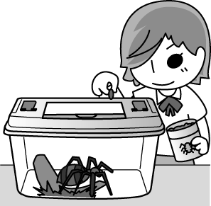 | 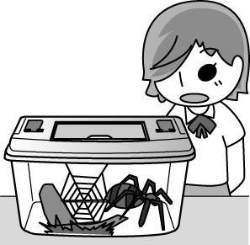 | 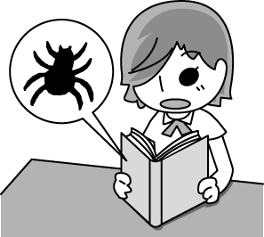
（ ）(２)
(Ａ) | (Ｂ) | (Ｃ)
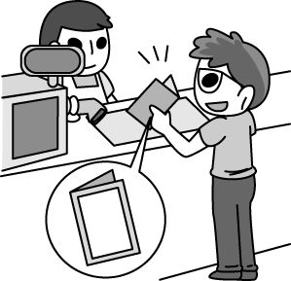 | 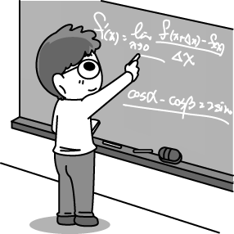 | 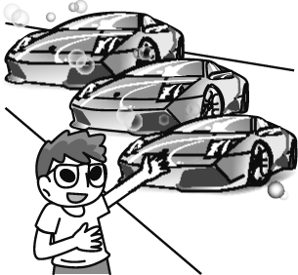
（ ）(３)
(Ａ) | (Ｂ) | (Ｃ)
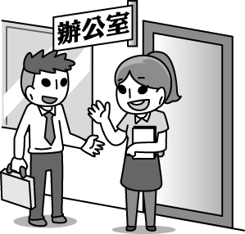 | 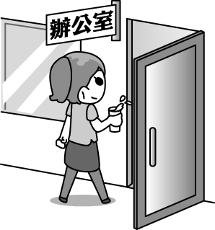 | 
（ ）(４)
(Ａ) | (Ｂ) | (Ｃ)
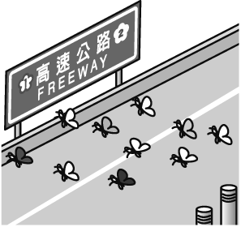 | 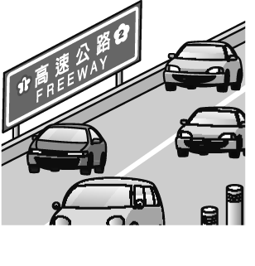 | 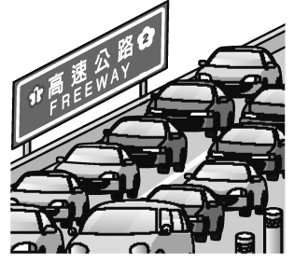
（ ）(５)
(Ａ) | (Ｂ) | (Ｃ)
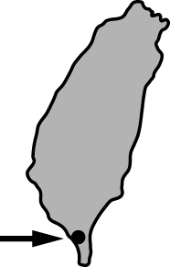 | 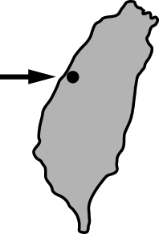 | 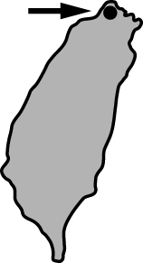

(二) 根據聽到的內容，選出適當的答句。10%
（ ）(１)(Ａ) Perhaps you’re right.
(Ｂ) We can work it out together.
(Ｃ) I don’t know how to communicate with you.
（ ）(２)(Ａ) Sorry. We don’t have a restroom here.
(Ｂ) Go straight for two blocks. It’s on the left.
(Ｃ) This restaurant has a long interesting history.
（ ）(３)(Ａ) Perhaps not.
(Ｂ) He appears to be sad.
(Ｃ) I won’t do that any more.
（ ）(４)(Ａ) Every day except Sundays.
(Ｂ) I don’t know what day it is.
(Ｃ) Nothing special happened during the band practice.
（ ）(５)(Ａ) This appears to be true.
(Ｂ) Don’t worry. You’re on time.
(Ｃ) First, find out what you’re good at.

(三) 根據聽到的對話內容，將正確的敘述寫(Ａ)，錯誤的寫(Ｂ)。10%
（ ）(１) The man and the woman are going west.
（ ）(２) The man and the woman want to know if it will rain tomorrow.
（ ）(３) To the man and the woman, the fish in this restaurant is not so delicious.
（ ）(４) The man wants to get close to nature.
（ ）(５) The woman has been to the Flying Fish Festival on Lanyu before.

二. 紙筆測驗
(一)文意字彙10%
1. Sue wore new glasses today, but no one n ced them. She felt quite sad about it.
2. Tim loves t ling. He has visited twenty countries.
3. Some t rs don’t ask their parents for help when they have problems at school.
4. Miss Lin is our new n r. She just moved in next to us last weekend.
5. You shouldn’t laugh at Jane. She is s s and she means what she says.
6. Everybody likes Tim because he always wears a big s e on his face.
7. Jack is a f y person. He is nice to everyone.
8. The book is written in very s e English, so many young children can read it.
9. Mike was very excited at his daughter ‘s wedding. In fact, it was one of the greatest m ts of his life.
10. Jason didn’t pass the test. He will ask his teacher to give him another c e.

(二)文法選擇30%
1. When I entered the house, I found _____ was a big TV in the living room.
(A) this (B) there (C) that (D) it
2. Tom had some problems at school. He really don’t know _________.
(A) what to do it (B) how to do (C) what he should do (D) what can he do
3. I want to go swimming on the weekend, but I am not sure _____ my mom will ask me to help her do housework.
(A) whether (B) how (C) what (D) that
4. I think _____ is more interesting to go to the night market with my friends than with my family.
(A) that (B) there (C) if (D) it
5. A: Can you tell me _____ John and Sandy know each other so well?
B: Of course. They have been friends for 30 years.
(A) why (B) how long (C) how often (D) when
6. I want to know if you _____ time to go to the movies with us tomorrow.
(A) have (B) have had (C) will have (D) had
7. Do you know __________?
(A) who is she (B) who is in the kitchen (C) what is your name (D) where does he live
8. The dirty coat need to ________.
(A) be washed (B) wash (C) washed (D) be washing
9. The museum will ______ by the students next week.
(A) visited (B) visit (C) be visited (D) have visited
10. The movie ________ by me many times because it is quite great.
(A) have seen (B) has been seen (C) has seen (D) have been seen
11. _________ people went to see the baseball game last night. It was really exciting.
(A) Thousand of (B) Two thousands (C) Three thousand of (D) Thousands of
12. ______ the news __________ lots of people when they knew butterflies could fly across the ocean?
(A) Were; surprised (B) Did; surprise to (C) Was; surprising to (D) Do; surprise
13. Michelle was ______ surprised to say a word because she met a long lost friend in New York.
(A) quite (B) very (C) so (D) too
14. She has ________ cooking since she joined the cooking club.
(A) been interested in (B) been interesting to (C) interested in (D) interesting to
15.The museum was _____ large _____ it took years to build.
(A) very; that (B) too; to (C) enough; that (D) so; that

(三). 克漏字選擇10%
One day, Tom’s brother took him to a movie. When they were standing in line, the family in front of them caught their eye. The four children were so ______ that they couldn’t stop talking. From their chat, Tom knew this was their first time to go to a movie theater. The father and mother were looking at them happily.
Then it was their turn to buy tickets, and the father asked the price. When the clerk told him _________, he was embarrassed.(尷尬的) He only had the money for four tickets. He bought the tickets and told the children he and their mom weren’t going into the theater with them. The children looked sad. After seeing this, Tom’s brother bought two tickets and walked to the family. He told the man that he got a phone call and couldn’t see the movie. He asked if he_________. The man looked at Tom’s brother gratefully.(感激地)
Although Tom didn’t see the movie that night, he saw something more wonderful.
1.(A)interesting (B)excited (C)surprising (D)bored
2.(A)how much he should pay (B)the tickets were all sold out
(C)he should stand in line (D)when the movie would start
3.(A)wanted to buy the tickets (B)was going home with his brother
(C)had seen the movie before (D)would like to use the tickets

Lucy is close to her grandmother. She ______ with her grandmother since she was little. Every night before she goes to bed, her grandmother tells her some bedtime stories. The stories her grandmother tells are full of imagination.(想像)
Lucy learns a lot from her grandmother. When she has problems, she always asks her for advice.(建議) Her grandmother always listens to her and shares her life experience with her. Without her grandmother, Lucy will never find her own way of life.
Time with her grandmother is the most wonderful moment in Lucy’s life. Though her grandmother _______ older, she is still young, happy, and wise in her eyes. Lucy is glad that she has such a good grandmother.
4.(A)lives (B)lived (C)was living (D)has lived
5.(A)is getting (B)was getting (C)got (D)will get

(四). 閱讀測驗10%
Jenny got married to Bill three years ago. She is a housewife, and her husband is a salesperson. Jenny does much housework every day. After getting up, she prepares (準備) breakfast for Bill. Then she starts to wash clothes, mop the floor, water the flowers and walk her dog.
On the morning of September 5, Jenny woke up and she found Bill wasn’t in bed. She got up in a hurry and walked to living room. She was surprised to see there was so much delicious food on the table. At this moment, Bill was standing in front of the door with roses in his hand. It was their wedding anniversary (紀念日) that day. Bill did all the housework and invited Jenny to a big dinner at a great Japanese restaurant. Jenny had never been to a Japanese restaurant. One of Japanese food, “sashimi”, was Bill’s favorite, so he ordered one dish. But Jenny was afraid to have something uncooked. Bill knew about this, so he said if she dared (敢) to have one piece of it, he would do all the housework for one month. After hearing that, Jenny started to eat a piece of it. After a while, Jenny started to love this kind of food. She had a piece after another. Poor Bill! He had to pay a lot of money for the big dinner and do the housework for a long time because she had twelve pieces of sashimi at last.

1.Why did Bill volunteer (自願) to do the housework on September 5 ?
(A) It was Jenny’s birthday.
(B) It was Bill and Jenny’s wedding anniversary.
(C) Jenny was sick.
(D) It’s Mother’s Day.
2. What did Bill and Jenny do on their wedding anniversary?
(A) They went to a Japanese restaurant to have a big dinner.
(B) They stayed at home and had a big dinner.
(C) They went to a big department store to shop.
(D) They went to Japan on vacation.
3. How long will Bill do the housework for Jenny?
(A) One month. (B) Four months. (C) Twelve years. (D) Twelve months.

In England(英國) , nurses have to be very good at their jobs. So before becoming a nurse, each student nurse needs to work in hospitals for a long time.
Cathy, a young student nurse, was sent to a small hospital in a small town. One day, it was time for the patients(病人) to have a bath. After giving nine patients a bath, she felt tired. But there was still an old man sitting on the last bed. She went to him and said with a smile “How are you doing today? Now it is time for your bath.” The old man answered slowly, “No, thank you. I have had one this afternoon.” She thought in her mind, “Oh, the poor old man. He is a little crazy.” Then, she took him to the bathroom, took off all his clothes, and gave him a hot bath. After thirty minutes, they finished the bath and returned to the room together. When she entered the room, she felt so surprised. She said, “Oh, look! There is another man in your bed.” The old man told her slowly, “ That is my twin brother. I come to visit him today.”
4. Where did the interesting story happen?
(A)In America. (B) In Europe. (C) In Taiwan. (D) In Japan.
5. Did Cathy give a bath to the right patient? Why or why not?
(A) Yes, she was too tired to give a bath to one more person.
(B) No, the twin old men looked like each other.
(C) Yes, it was easy for her to tell (辨別) the twin old man from the other one.
(D) No, she loved giving people a bath.

(五). 翻譯10%
1. 有自信比長得高更有吸引力。3%
2. 每年，上百萬隻紫斑蝶會飛越國道三號。3%
3. 現在，為了阻止牠們進入車流中，設置四公尺高的網子。4%

高雄市立林園高級中學 國中部 102學年度 第 ㄧ 學期 三 年級 英語 科 第 二 次 段考答案卷
班級： 姓名： 座號：
一. 聽力測驗
(一) 根據聽到的內容，選出符合句子描述的圖片。10%
1 | 2 | 3 | 4 | 5
(二) 根據聽到的內容，選出適當的答句。10%
1 | 2 | 3 | 4 | 5
(三) 根據聽到的對話內容，將正確的敘述寫(Ａ)，錯誤的寫(Ｂ)。10%
1 | 2 | 3 | 4 | 5

二. 紙筆測驗
(一)文意字彙10%
1________________ | 2________________ | 3________________ | 4________________ | 5________________
6________________ | 7________________ | 8________________ | 9________________ | 10________________
(二)文法選擇30%
1 | 2 | 3 | 4 | 5
6 | 7 | 8 | 9 | 10
11 | 12 | 13 | 14 | 15

(三). 克漏字選擇10%
1 | 2 | 3 | 4 | 5

(四). 閱讀測驗10%
1 | 2 | 3 | 4 | 5

(五). 翻譯10%
1.________________________________________________________________________________ 3%

2. ________________________________________________________________________________3%

3. _________________________________________________________________________________4%

