高雄市立林園高級中學 國中部 102學年度 第ㄧ學期 三年級 英語 科 第 三 次段考試卷
班級： 姓名： 座號：
本試卷共（ 4 ）頁
第一部分：聽力測驗 30%
- 根據聽到的短文內容，正確的敘述寫(Ａ)，錯誤的寫(Ｂ)。
（ ）１. John is the person that Claire chatted online.
（ ）２. Claire asked John out because she wanted to have Japanese food.
（ ）３. Jessie and Claire have a lot in common.
（ ）４. Claire is nervous about meeting a Net friend.
（ ）５. Claire plans to meet John alone.
- 根據聽到的內容，將正確的圖片寫(Ａ)，不正確的寫(Ｂ)。
6. | 7. |  | 8.
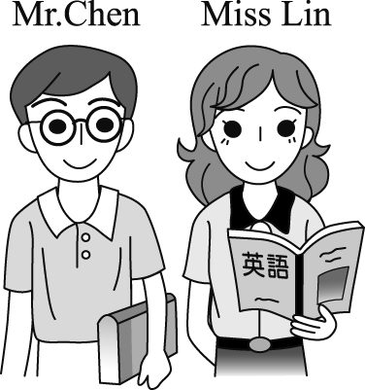 | 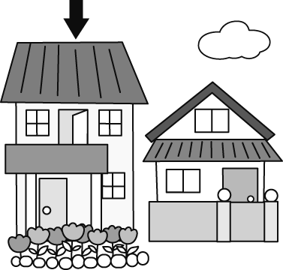 |  | 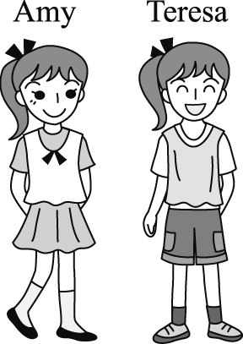
（ ） | （ ） |  | （ ）
9. |  | 10.
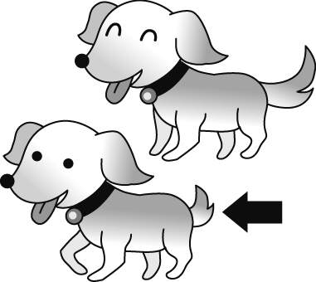 |  | 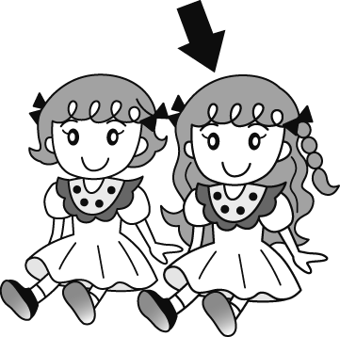
（ ） |  | （ ）

- 根據圖表與聽到的內容，正確的敘述寫(Ａ)，不正確的寫(Ｂ)。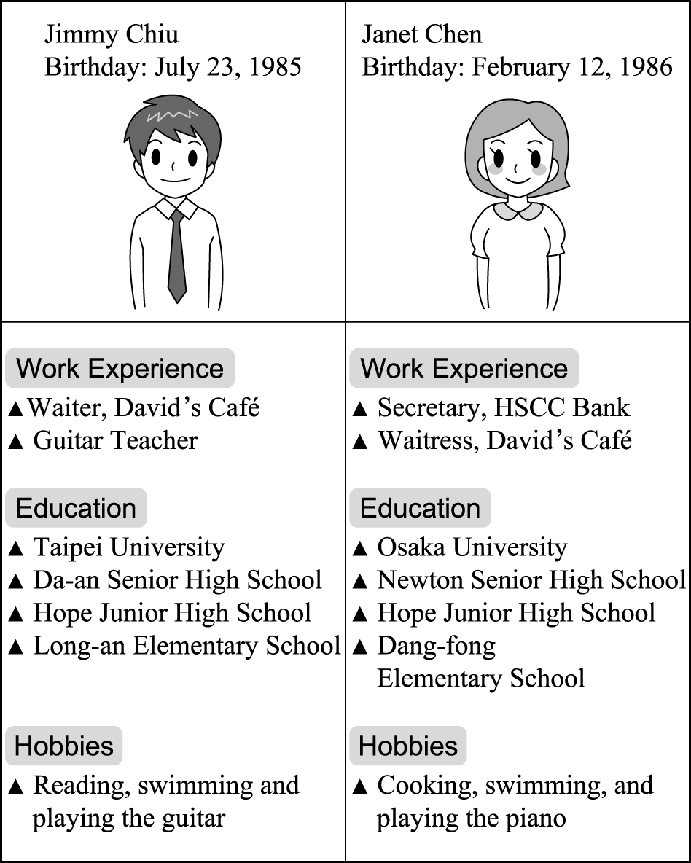
11.（ ）12.（ ）13.（ ）14.（ ）15.（ ）

第二部份：下列各題（題號1-20）請依題意選出一個正確或最佳的答案。
16. Joshua feels nervous when talking to __________ .
（A）hobby （B）prize （C）strangers （D）badminton
17. Don’t play ball in the street. It’s very __________.
（A）rich （B）alone （C）dangerous （D）unhappy
18. Kate didn’t sleep well last night. She had bad ________ all night.
（A）career （B）dreams （C） apartment（D）shell
19. Mr. Lai is a _______ businessman. He owns thirty supermarkets.
（A）public （B）successful（C） sharp（D）mad
20. Can you speak any ________ languages?
（A）foreign （B）above（C）indoor （D）polite
21. Jane is doing her homework,and ______Jack.
（A）neither does （B）so does（C）neither is（D）so is
22. Mrs.Lee’s never been to America,and ______his husband.
（A）neither has（B）so has（C）neither is（D）so is
23. The books _______are more expensive.
（A）write about music（B）with CDs（C）in black box（D）sell in his store
24. I’m going to leave for Taipei next weekend,and ________.
（A）so will he（B）so is him（C）he will,too（D）he is,too
25. The man _______has just left the bakery ________in the supermaket.
（A）who;work（B）that;working（C）that;works（D）who;is work
26. There are some _________.
（A）sweaters she really love ( B）toys your daughter will be interested（C）books that develop your mind（D）roses are beautiful
27. I noticed the girl _______he talked _______yesterday.
（A）who;to（B）which;with（C）who;for（D）which;about
28. The chair _______she sits is very comfortable.
（A）which（B）on which（C）on that（D）that on
29. Alice is the only person ______hard in the office.
（A）who work（B）is working（C）that works（D）which worked
30. The woman _______a black hat is my aunt.
（A）is wearing（B）that wearing（C）who in（D）in
31. He used to _____ a living by growing rice in the country.
（A） making （B）to make （C）made （D）make
32. Jane is the most hard-working student ______ I have ever met.
（A） that （B） why （C） which （D）what
33. You had better _______ yourself ______ playing.
（A） set；up（B） keep；from（C） take；up（D）cheer；up
34. Tell me who ____________________.
（A） is the little boy in the blue vest （B）the little boy is in the blue vest
（C） the little boy in the blue vest is （D）is in the blue vest the little boy
35. A：I’m sorry, ma’am. Your name is not on the waiting list.
B：_________ I signed my name on the list in person. Could you check it again? Thanks.
（A） No way!
（B） Don’t get mad.
（C） Why did you ask?
（D） Please bring it back.

第三部份：下列五個題組（題號36-50），共有15題，請依據選文或所附圖表資料，選出一個正確或最佳的答案。

【36-39】
I agree to follow these rules when I surf the Net.
Name：Emma Chang
- I promise that I will do things ___36___ my parents and I have agreed on.
- I won’t provide anyone online with my personal ___37_____ like my home address and phone number.
- I will always be ____38____ when chatting online and I will never say bad things about others.
- I will talk to my parents before I meet anyone ____39_____ I’ve just made friends with online.

（ ）36. （A） which （B） whose（C） who （D）what
（ ）37. （A） network （B） posts （C） information （D）thoughts
（ ）38. （A） alone （B） polite （C）unhappy （D）born
（ ）39. （A） they （B） which （C） where （D）that

【40-42】
Fried chicken, fried fish and fried vegetables all need to be cooked with oil.
However, is the oil ___40___ we use all safe enough? In the middle of October last year, an oil company ___41___ is one of the largest edible oil producers in Taiwan, has added chemicals and other poor quality oil to olive oil which was labeled “pure”.
Almost all the oil products of that company were found mixed with cottonseed oil ___42___ could be harmful to human health.

【edible 食用的 / producer 製造者 / chemical 化學物質 /quality 品質 / olive 橄欖 / label 貼上標籤為
product 產品 / mix 混合 / cottonseed 棉籽 / harmful 有害的】
（ ）40. （A） who （B） X （C） whose （D）where
（ ）41. （A） which （B） who （C） what （D）when
（ ）42. （A） that （B） this （C） who （D）what

【43-44】
The giant yellow rubber duck created by Dutch artist Florentijn Hofman caused a sensation in Hong Kong last summer as it turned busy Victoria Harbor into one huge bathtub.
The big toy attracted the attention of seven million visitors from all over the world. “The yellow duck represents welfare, happiness,and peace,” Hofman says.
The display not only shows the path of its world travels and the background of the creater, but also makes people pay attention to the need to protect the environment.
The rubber duck was until October 20 in Kaohsiung. Then it was moved to Taoyuan from October 26 to November 10 and appeared in Keelung from December 21, 2013 to January, 2014.

【giant 巨大的 / rubber 橡皮 /cause引起 / sensation 轟動的人或事物 / represent 象徵 / welfare財富/ path 路徑
display展覽 / creater 創作者 / background 背景】

（ ）43. Where was the rubber duck displayed in the summer of 2013 ?
（A）In Kaohsiung.（B） In Taipei.（C） In Hong Kong.（D）In Taoyuan.
（ ）44. What does the yellow rubber duck make people notice?
- Toys.（B） Harbors.（C） Trips.（D）Environmental protection.

【45-47】
Kevin is looking for his ideal woman who has many talents on the Net.
Here are four women that Kevin may like.
Name：Alice  Age：28  Career：artist  Looks：long hair, long legs  Interests：painting, singing, dancing  and playing the flute | Name：Lisa  Age：29  Career：baker  Looks：short hair, a sharp nose  Interests：singing, cooking
Name：Jane  Age：30  Career：teacher  Looks：short hair, with glasses  Interests：watching movies, reading | Name：Wendy  Age：28  Career：police officer  Looks：short hair, big eyes  Interests：jogging, singing

（ ）45. Which is true about the four women?
（A）Jane is the woman who likes singing.
（B）Alice is the woman who works in the school.
（C）Wendy and Lisa wear glasses.
（D）Both Lisa and Jane have short hair.
（ ）46. Who may have a chance to date with Kevin?
- Wendy.（B） Lisa.（C） Jane.（D）Alice.
（ ）47. What isn’t Alice interested in ?
（A） Music.（B） Concerts.（C） Baking a cake.（D） Drawing pictures.
【49-50】
There are three text messages for Ivy.
Look at them and answer the questions.
Dear Ivy,
I’m in Tokyo now. It’s snowing here. The temperature is about -8~2℃. I come here to visit the Disneyland. It is a ground in which all kinds of wonderful shows are given and there are lots of amuzement facilities. They are really interesting.
Love
Jack
Dear Mom,  I’m going hiking with my classmates in the mountains. Today is a sunny day. It’s suitable for hiking. I also take sun cream with me. I don’t want to get tanned.  Your daughter  Winnie | Dear Ivy,  I make a pumkin pie for you. Come to my house and take it. It’s windy and cold here. Don’t forget to put on your coat and wear more clothes if you come here.  Take care!  Mom  Jane
【text message簡訊 / temperature溫度 /amusement facilities 遊樂設施 / suitable合適的 / tan曬黑】
（ ）48. Where is Jack?
（A）In Taiwan.（B）In China.（C）In America.（D）In Japan.
（ ）49. What is Winnie going to do with her classmates?
（A） Go shopping. （B） Chat online.
（C） Go mountain climbing.（D）Go bike riding.
（ ）50. What is the weather like in Tokyo now?
- It’s very cold.（B） It’s cool.（C） It’s hot.（D）It’s warm.
三年級 英語 科 第 三 次段考答案欄
第一部分：1-15題
1.ABBAB
6.AABAB
11.BABBA
第二部份：16-35題
16. CCBBA
21. DABDC
26.CABCD
31.DABCA
第三部份：36-50題
36.ACBDB
41.AACDD
46.DCDCA

