高雄市立林園高級中學 國中部 102學年度 第二學期 一 年級 英語 科 第 三 次段考試卷
班級： 姓名： 座號：
本試卷共（ 4 ）頁
- 聽力測驗 30%
- 聽字選圖
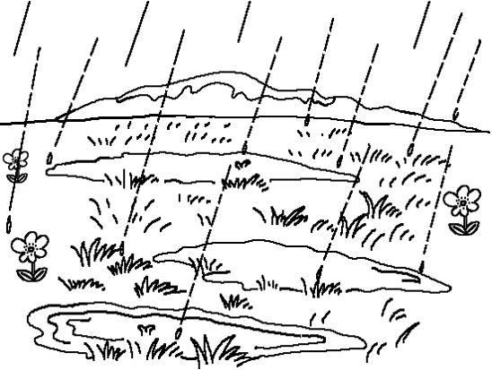
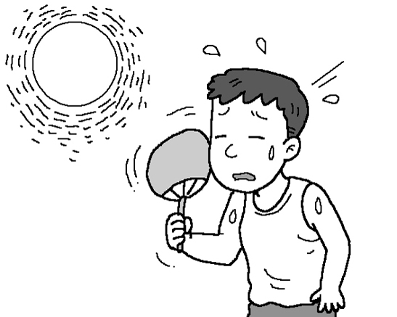
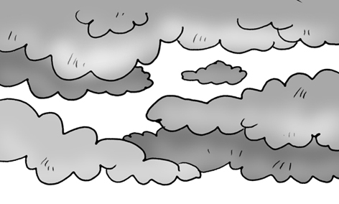
( ) 1.(A) (B) (C) (C)
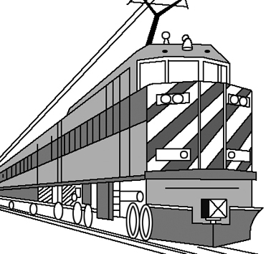
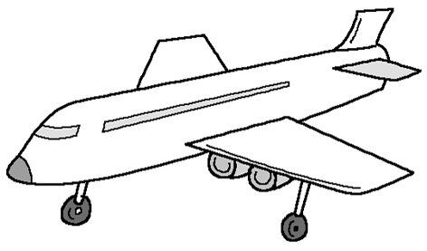
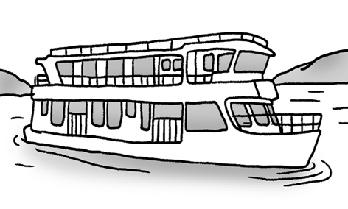
( ) 2 (A). (B) (C)
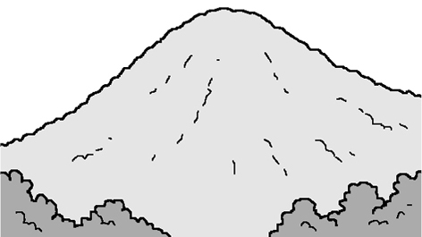

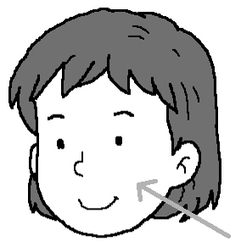
( ) 3.(A) (B) (C)
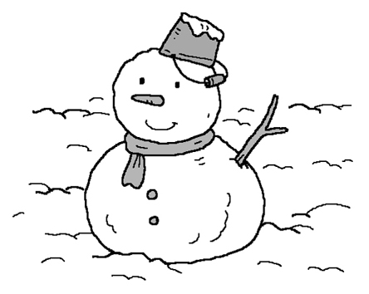
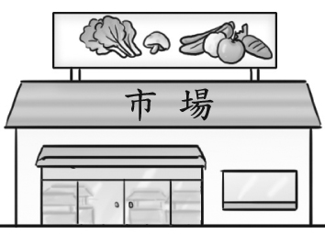

( ) 4.(A) (B) (C)
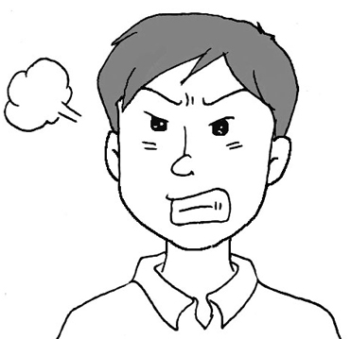
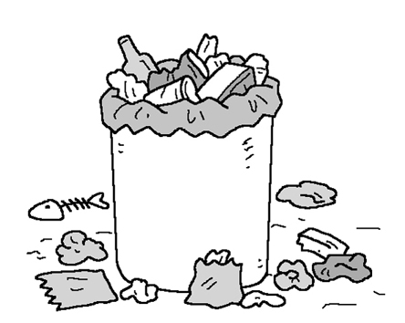
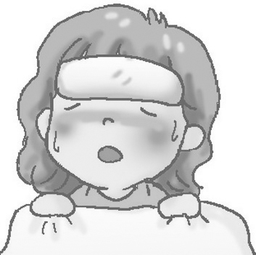
( ) 5 . (A) (B) (C)

- 看圖選擇（看圖選出正確的句子）
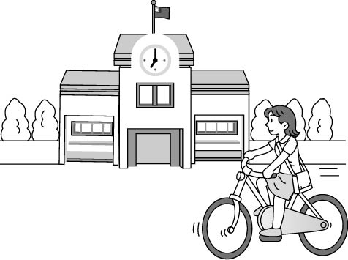
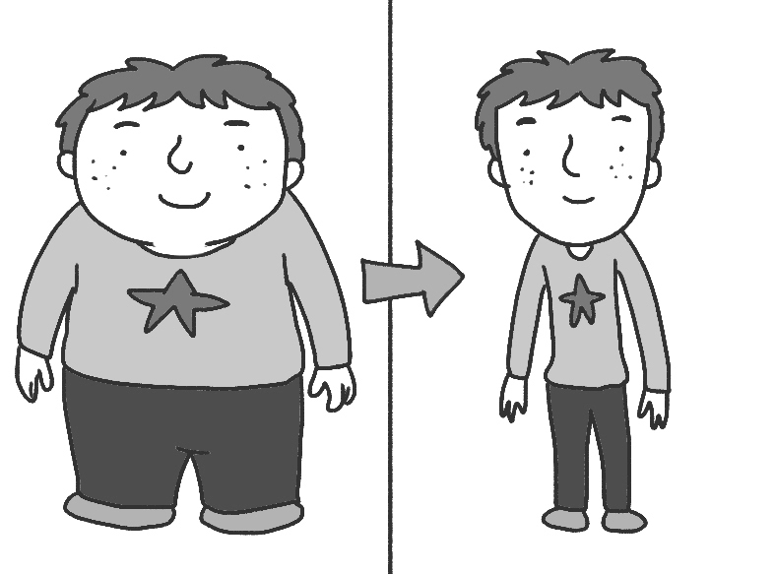

6. 7. 8.

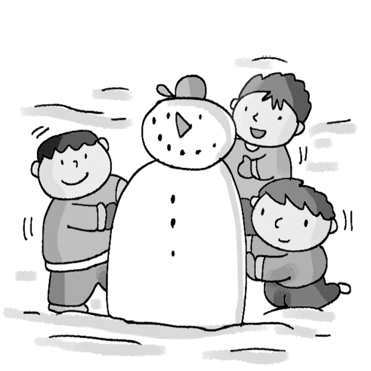
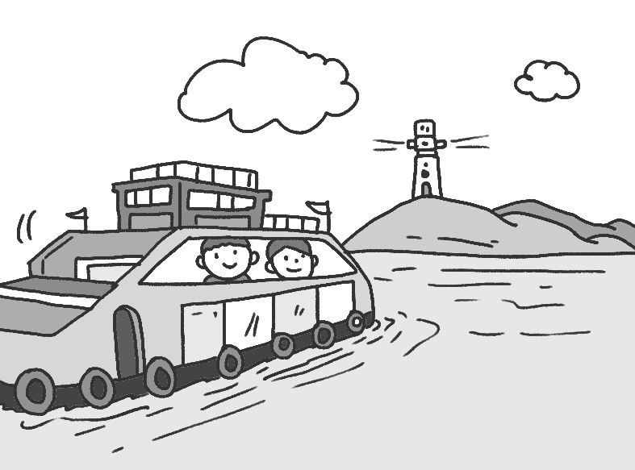
9. 10.

三、對話選擇（根據聽到的對話內容與問題，選出正確的答案）
( ) 11. (A) At home. (B) In the USA. (C) In Canada.
( ) 12. (A) It’s cold. (B) It’s hot. (C) It’s cloudy.
( ) 13. (A) One. (B) Three. (C) Two.
( ) 14. (A) Lucas. (B) Emma. (C) Erica.
( ) 15. (A) They’re going to do their English reports together.
(B) They’re going to look at Gina’s photos together.
(C) They’re going to a movie together.

貳、讀寫測驗 70%
- 字彙選擇 28%
- It’s a ________ day today. We can’t see the sun today.
(A) cloudy (B) hot (C) sunny (D) warm
- Hokkaido is a wonderful ________ of snow in winter.
(A) hill (B) weather (C) world (D) season
- It’s ________ in summer.
(A) cold (B) dry (C) cool (D) hot
- A: What ________ is your new bag? B: It’s red.
(A) season (B) rain (C) color (D) change
- It’s cool and ________ today. Please put on（穿上）your coat（外套）first and then go out.
(A) hot (B) windy (C) warm (D) dry
- There are too many _______and cars on the street
(A) summer (B) seafood (C) seasons (D) scooters
- Hokkaido is a beautiful ________ in summer. Many people visit there every year.
(A) place (B) island (C) shop (D) lighthouse
- The ________ in the mountains（山）is very beautiful, and it always makes me comfortable（舒適的）.
(A) seafood (B) view (C) place (D) ferry
- A: I can’t find my toy robot.
B: But it was on the table ________.
(A) one day (B) in time (C) not anymore (D) just now
- Tom was ________ yesterday. He didn’t come to school.
(A) windy (B) fine (C) sick (D) shy
- Leon is __________. He can’t see anything.
(A) bee (B) blind (C) smart (D) wolf
- Iris: Where’s the sandwich? It was on the dining table just now.
Tina: It’s in my _______ now.
(A) stomach (B) eyes (C) ears (D) nose
- Jacob: I’m going to the top of the_________ in Cijin. Are you going with me?
Lynn: Of course.
(A) view (B) sea (C) kitchen (D) lighthouse
- __________ food makes you strong. You have to eat more.
(A) Turkeys (B) Person (C) Healthy (D) Ferry

- 閱讀測驗 10%
The following（以下）is Andy’s weekend’s schedule（行程）
.
Staurday | Sunday
7:00~12:00 take a train from Kaohsinug to Taipei | 9:00~12:00 take a bus to Yangmingshan( 陽明山 ) to watch birds
12:00~14:00 go to Hank’s steak( 牛排 ) house by taxi and have lunch with my friends, Bella and Adam | 12:00~1400 have a picnic in the mountains
18:00~21:00 take the MRT to Shilin Night Market | 14:00~15:00 go to Taipei Station by bus
21:00 walk to Adam’s home | 15:30 go back home by Taiwan High Speed Rail( 高鐵 )
( )30. Where does Andy live?
(A) Taipei. (B) Kaohsiung. (C) Yangmingshan. (D) Shilin Night Market.
( )31. Where does Andy stay during Saturday night?
(A) Shilin Night Market. (B) Yangmingshan. (C) His house. (D) His friend’s house.
( )32. How does Andy go to Yangmingshan?
(A) On foot. (B) By MRT. (C) By bus. (D) By train.
( )33.What doesn’t Andy take on the weekend?
(A) A car. (B) A train. (C) A bus. (D) An MRT.
( )34.Which（哪一個） is true（正確的）?
(A) Hank is Andy’s friend in Taipei. (B) Adam’s house is near Shilin Night Market.
(C) Andy eats lunch at Shilin Night Market on Sunday. (D) Andy eats lunch at Yangmingshan on Saturday.

三、對話選擇 8%
( )35. Amy:
Billy: You can take bus 202.
Amy: Thank you.
(A) How can I get to the museum? (B) How often do you take a bus? (C) Where can I take bus 202?
( )36.Emily:
Kevin: No. You can only take a taxi there.
(A) Can I go to the department store by bus? (B) Do you usually take a taxi to school?
(C) Can we play basketball together this afternoon?
( )37.Bob:
Liam: We can go there by boat.
(A) Where can we go by boat? (B) How can we go to that island? (C) Who can go there with us?
( )38.Amber: How do you usually go to school?
Steven:
(A) I usually go by MRT (B) You can go there with me. (C) I can’t ride a bicycle.

四、根據圖表，選出正確的答案
 | Taipei | Taichung | Hualien | Kaohsiung
Friday | 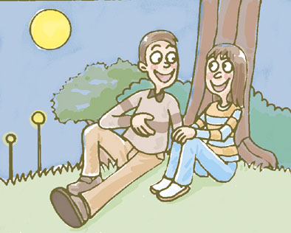  24℃ | 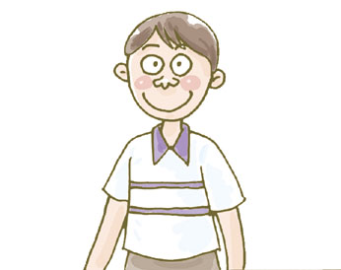  25℃  20℃ | 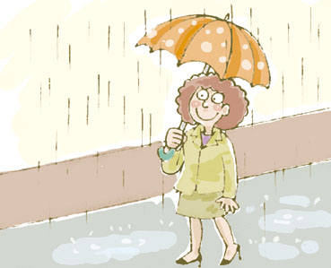  21℃ | 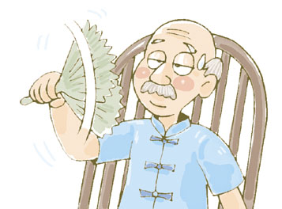  27℃  29℃
Saturday | 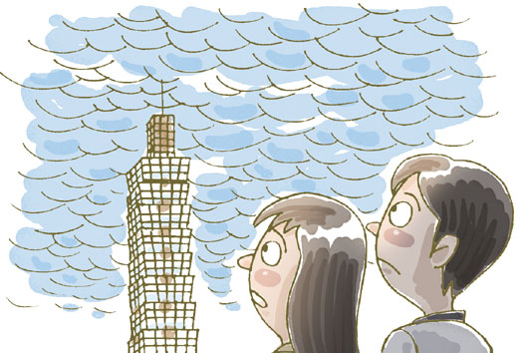  22℃ | 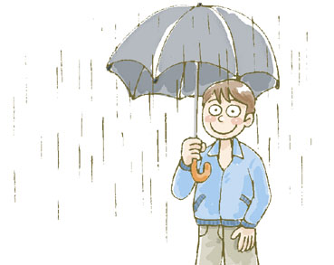 | 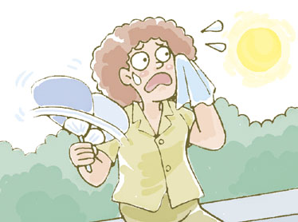  26℃
Sunday | 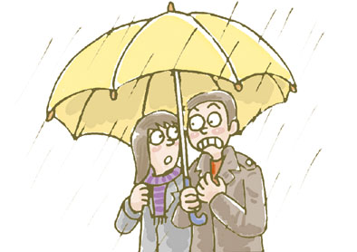  17℃ | 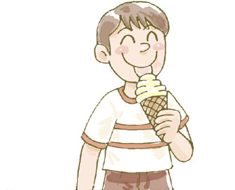  28℃ | 28℃ | 30℃

( )39. Nina lives in Taipei. She doesn’t like rainy days. Where can she go for the weekend?
(A) Taipei or Taichung.
(B) Taichung or Hualien.
(C) Hualien or Kaohsiung.
( )40.It’s rainy, and David can’t play basketball after school on Saturday. Where does David live?
(A) Taipei.
(B) Taichung.
(C) Kaohsiung.
( )41.It’s rainy on Sunday. Where is Bill?
(A) Hualien
(B). Taipei.
(C) Kaohsiung.

五、語法選擇 18%
( )42.Rupert and Lavender were classmates twenty years .
(A) before (B) old (C) then (D) ago
( )43.There a lot of milk in the bottle this morning.
(A) have (B) has (C) was (D) were
( )44. you late for class the day before yesterday?
(A) Do (B) Are (C) Was (D) Were
( )45. ________ subject（科目）is her favorite, English, math, or history?
(A) How often (B) Which (C) Where (D) How much
( )46. People can go to many places in the big city by ________ MRT.
(A) a (B) the (C) an (D) ×
( )47. My mom walks to work（工作）________.
(A) every day (B) last week (C) yesterday (D) this morning
( )48. I hungry. Anything to eat?
(A) is (B) am (C) was (D) were
( )49.Steven: your brother Joe very busy this time last year?
Oscar: Not really.
(A) Are (B) Is (C) Were (D) Was
( )50.Carol: Where the children?
Susan: I don’t know. They in the yard just now.
(A) were; are (B) are; were (C) were; were (D) are; are

一年級 英語 科 第三次段考答案欄
1-5. A C B B C
6-10. B C C A B
11-15. B A C A B
16-20. A C D C B
21-25. D A B D C
26-30. B A D C B
31-35. D C A B A
36-40. A B A C B
41-45. B D C D B
46-50. D A B D B

