高雄市立林園高級中學 國中部103學年度 第1學期 1年級 英文科 第1次段考 試卷
班級： 姓名： 座號：
本試卷共（ 3 ）頁
壹：聽力測驗(30%)
- 辨識句意：根據聽到的內容，選出符合描述的圖片或符合圖片的描述。將答案寫在答案紙上. 每題2分,共10%

- （ ）(Ａ) 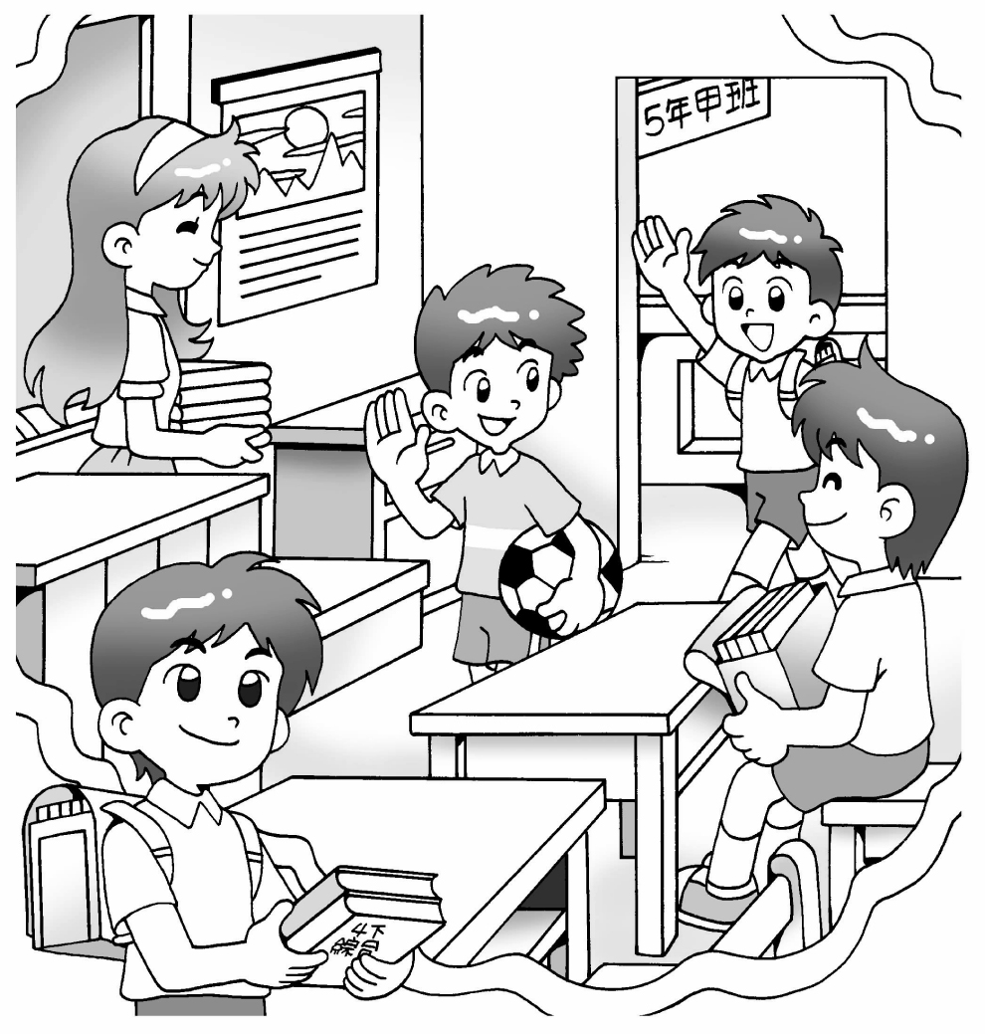 (Ｂ) 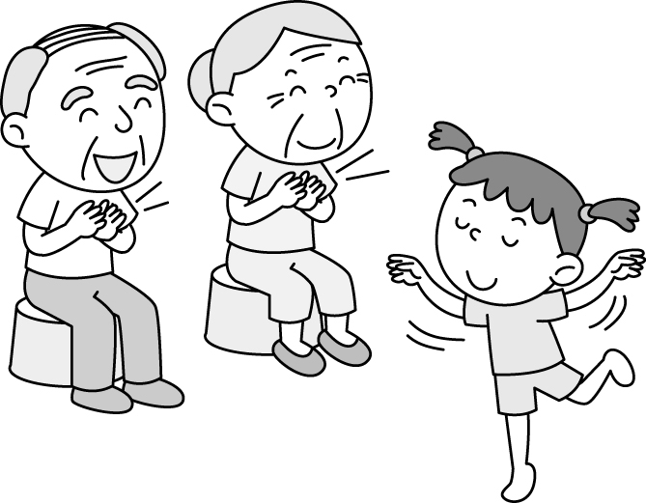 (Ｃ) 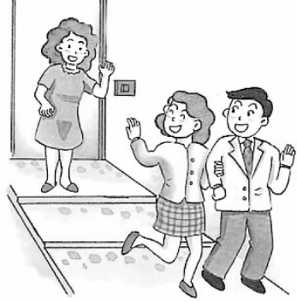
- （ ）(Ａ) 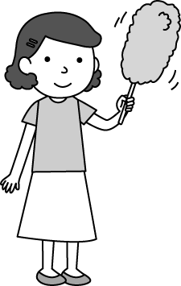 (Ｂ)  (Ｃ) 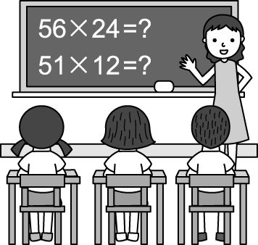

- （ ）(Ａ) 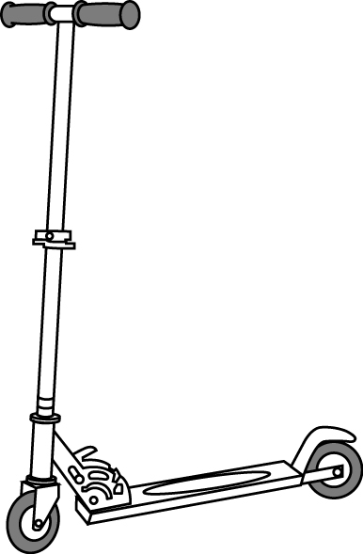 (Ｂ) 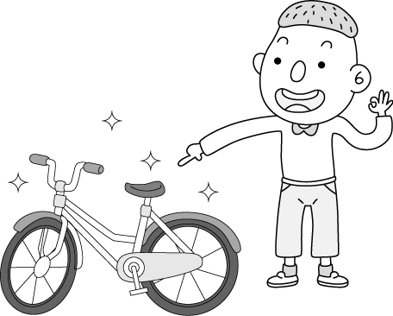 (Ｃ) 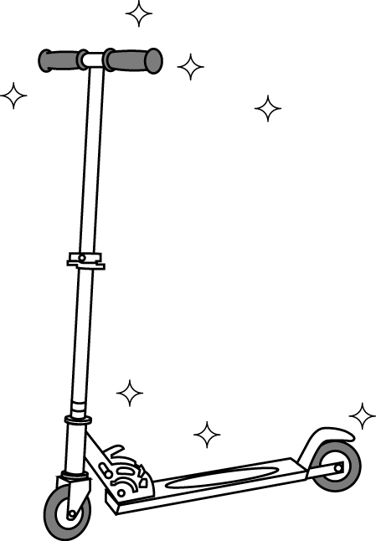

- （ ）(Ａ) 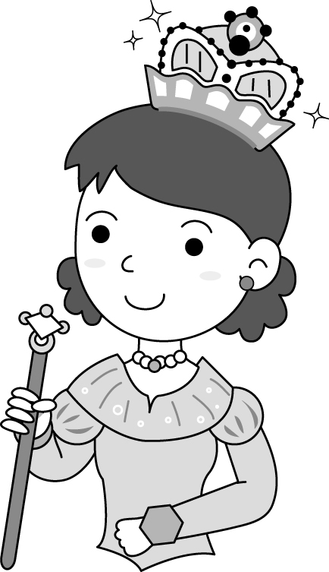 (Ｂ) 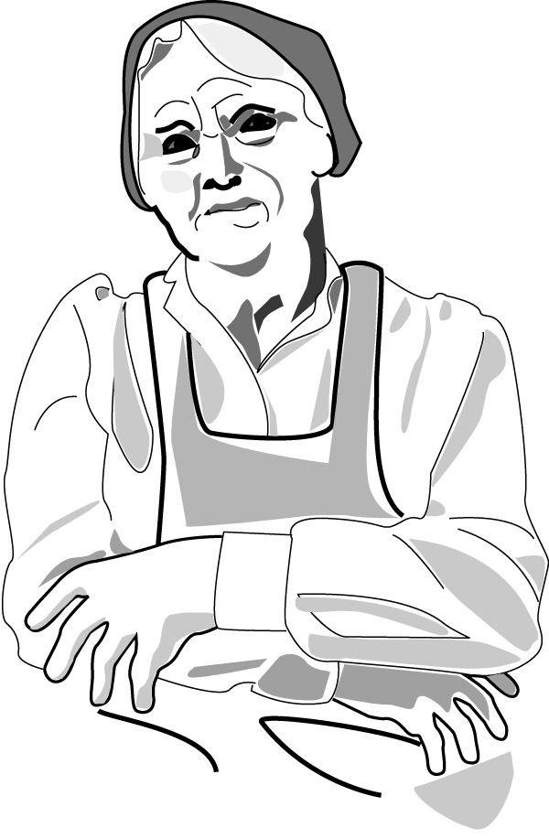 (Ｃ) 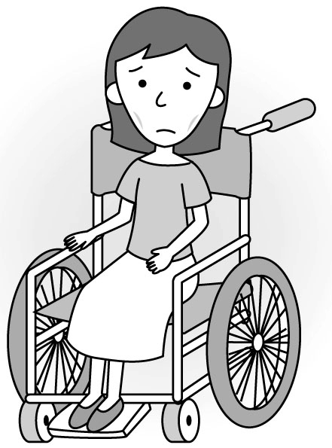

- （ ）(Ａ) 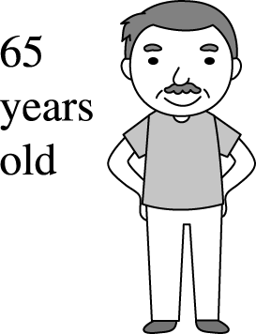 (Ｂ) 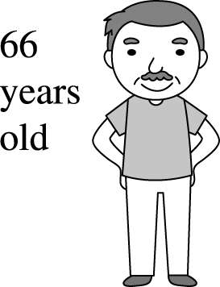 (Ｃ) 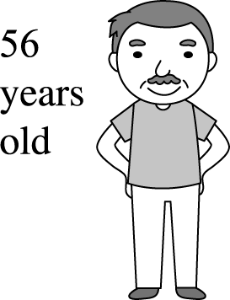

- 基本問答：根據聽到的內容，選出一個最適合的回應或最適合的問句。將答案寫在答案紙上。每題2分,共10%

- （ ）(Ａ) Betty Wang. (Ｂ) Yes, I’m Patty. (Ｃ) I’m OK. Thank you.
- （ ）(Ａ) It’s my cat. (Ｂ) No, it’s not your cat. (Ｃ) Yes, it is. Its name is Mimi.
- （ ）(Ａ) I’m pretty. (Ｂ) Yes, I’m fine. (Ｃ) Not bad. Thank you.
- （ ）(Ａ) It’s blue. (Ｂ) It is a new bike. (Ｃ) No. It’s a scooter.
- （ ）(Ａ) He’s old. (Ｂ) He’s a young man. (Ｃ) He’s nineteen years old.

- 言談理解：根據聽到的內容，選出一個最適合的答案。將答案寫在答案紙上。每題2分,共10%

- （ ）(Ａ) Judy. (Ｂ) Jane. (Ｃ) Jennifer.
- （ ）(Ａ) the girl. (Ｂ) the girl’s mother. (Ｃ) The girl’s grandma.
- （ ）(Ａ) A nurse. (Ｂ) A ductor. (Ｃ) A cook.
- （ ）(Ａ) Yes, she’s a cute girl. (Ｂ) Yes, he’s kind and smart. (Ｃ) Yes, he’s a handsome tall boy.
- （ ）(Ａ) One. (Ｂ) Four. (Ｃ) Five.

貮：筆試評量: 70分

四、將下列的單字大小寫互換(一字l分共5分 5%) 。將答案寫在答案紙上

例如: GIRL→ girl
1. around →_____
2. HAMBURGER →_____
3. really →_____
4.NEWSPAPER→_____
5.acrobat→_____

五、將下列的數字翻成芵文(一字l分共5分 5%) 。將答案寫在答案紙上
1, 10→ ______
2, 12 →______
3, 17 →______
4, 19 →______
5, 90 →______

六、文意字彙 (每題2分,共10%) 。將答案寫在答案紙上
1 . ______My mother’s sister is my a_____t.
2. ______ My p _____ e number is 6412059.
3. ______ Their teacher is in the c_____m.
4. ______ Her n_____e is Betty Lin ,not Lisa Lin.
5. ______ She is Leo’s mother. She is a h _____e , not a nurse.

七、選擇題(每題2分,共20%) 。將答案寫在答案紙上
1. ( ) 選出正確的句子 .(A) Good morning。 (B) how is your father？ (C) My name is william. (D) She is fine.
2,.( ) A: Is Eric’s sister a writer？
B: ______ .
(A) No. She is a writer. (B) Yes, he is. He is a writer. (C) Yes, she is .She is a writer.(D) Yes, it is.
3. ( ) A: Are you a baseball coach？
B: ______ .
(A) Yes, I am a cook. (B) Yes, I am Bill Johnson. (C) No, I am not . I am a doctor.(D) Yes, he is a coach.
4. ( ) A: Who is Tom？
B: ______ .
(A) His name is Tom. (B) He is my grandpa. (C) He is not a teacher. (D) Yes, he is Tom.
5. ( ) 選出正確的句子
(A) Her new desk is small.(B) She is not singer. (C) Our teacher are nice. (D) She is tall ugly.
6. ( ) A: Are you Adam？
B: ______ .
(A)Yes, he is my cousin.(B) Yes, I am Adam Blake. (C) No, I am not Uncle Adam Blake.
(D) I am Adam Blake.
7. ( ) Tom’s mother is a doctor.相當於下列何句
(A) He is a doctor .(B) You are a doctor. (C) I am a doctor. (D) She is a doctor.
8. ( ) A: Is your teacher young？
B: ______ .
(A) No.She is very well.(B)Yes. She is weak. (C) She is very young. (D) Yes, she is young and beautiful.
9. ( ) A: ______ their cats cute？
B: Yes, they are.
(A) Are not (B) Isn’t (C) Aren’t (D) Is

10. ( ) Tom: Mr. Lin, ______.
Mr. Lin: Nice to meet you, John.
John: Nice to meet you, too.
(A) he is John ’s cousin. (B) this is my friend, John . (C) John’s cousin is very happy.
(D) John is a teacher.

八、重組句子(每題3分,共15分 15%) 。分段給分。將答案寫在答案紙上

1 singer / My / Ben Oliver / is / favorite / .
_____________________________________________.
2 not / is / Annie / full / .
______________________________________________.
3 .is /My / black and white / scooter / .
______________________________________________.
4 smart / a / He / boy / is / .
______________________________________________.
5 coach / Ted and Alex’s / is / . / The man
______________________________________________.

九、依提示作答(每題3分, 共15分 15%) 分段給分。將答案寫在答案紙上

1 Is this picture beautiful ? (用ugly詳答)
________________________________________________

2 Her phone number is 752-8520 (改為疑問句)
_______________________________________________
3 She is Jim’s classmate, Cathy. (依劃線部份造原問句)
________________________________________________
4 How old is your aunt ？(用44歲回答;須拚寫出數字)
________________________________________________
5 我們的表弟是一個強壯的男孩 。(翻成英文)。
________________________________________________

1年級 英文科 第 1次段考答案欄（年級、科目請標示清楚，謝謝！）
I聽力測驗30%
一、辨識句意：根據聽到的內容，選出符合描述的圖片或符合圖片的描述。將答案寫在答案紙上. 每題2分,共10%

1. A | 2. A | 3. C | 4. A | 5. C
二、基本問答：根據聽到的內容，選出一個最適合的回應或最適合的問句。將答案寫在答案紙上。每題2分,共10%

1. A | 2. C | 3. C | 4. A | 5. C
三言談理解：根據聽到的內容，選出一個最適合的答案。將答案寫在答案紙上。每題2分,共10%

1. C | 2. C | 3. A | 4. C | 5. A

II. 筆試70%
四、將下列的單字大小寫互換(一字l分共5分 5%)
1. AROUND | 2. hamburger | 3. REALLY | 4.newspaper | 5. ACROBAT
五、將下列的數字翻成芵文(一字l分共5分 5%)
1. ten | 2. twelve | 3. seventeen | 4. nineteen | 5. ninety
六、文意字彙 (每題2分,共10%)
1. aunt | 2. phone | 3. classroom | 4. name | 5. housewife
七、選擇題(每題2分,共20%)
1. D | 2. C | 3. C | 4. B | 5. A
6. B | 7. D | 8. D | 9. C | 10. B

八、重組句子(每題3分,共15分 15%) 分段給分
1. | My favorite/ singer is/ Ben Oliver..
2. | Annie/ is not/ full.
3. | My scooter / is black/ and white.
4. | He/ is a/ smart boy.
5. | The man is/ Ted and Alex’s/ coach.

九、依提示作答(每題3分, 共15分 15%) 分段給分
1. | Not , / it’s / ugly or No. / It is / ugly.
2. | Is / her phone number / 752-8520 ？
3. | Who / is / she ？
4. | My aunt / / She is / forty – four. （years old）
5. | Our cousin / is / a strong boy.

