高雄市立林園高級中學 國中部 103學年度 第1學期 一年級英文科 第3次段考 試題卷
班級： 姓名： 座號：
◎本試卷共（ 4 ）頁

第一部分 聽力理解 (共30分)
- 選出與聽到單字同母音的選項。（每題1分）
1.（ ）(A) hang (B) wave (C) week (D) lucky
2.（ ）(A) shout (B) fight (C) eve (D) great
3.（ ）(A) my (B) gift (C) card (D) shop
4.（ ）(A) bell (B) touch (C)wait (D) with
5.（ ）(A) go (B) put (C) study (D) talk

聽單字或句子，選出聽到的單字。（每題1分）
6.（ ）(A) clean (B) cry (C) card (D) Christmas
7.（ ）(A) wave (B) with (C) wrong (D) great
8.（ ）(A) Friday (B) Thursday (C) Wednesday (D) Sunday
9.（ ）(A)weekend (B) together (C) dinosaur (D)snack
10.（ ）(A) Thank goodness. (B) Blow kisses. (C) Follow the rules.

C. 根據圖片與聽到的問題及選項，選出正確的答案。10%（每題2分）
11. ( )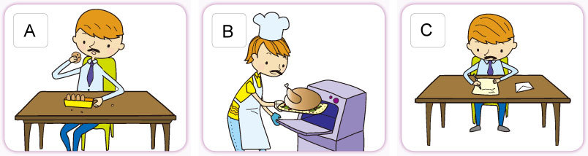
12. ( )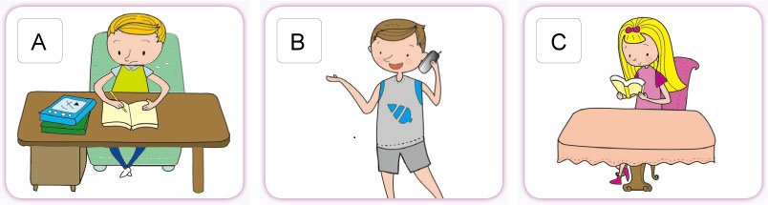
13. ( )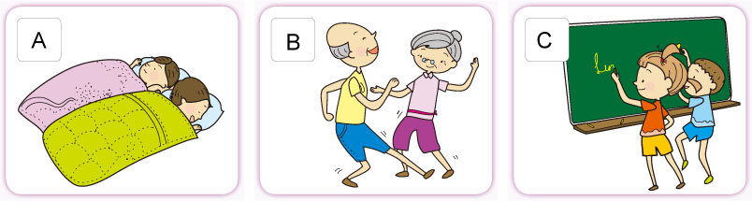
14. ( )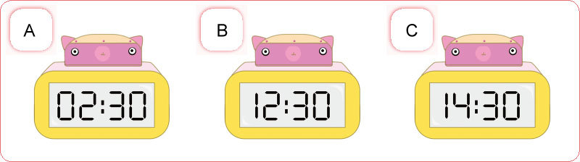
15. ( )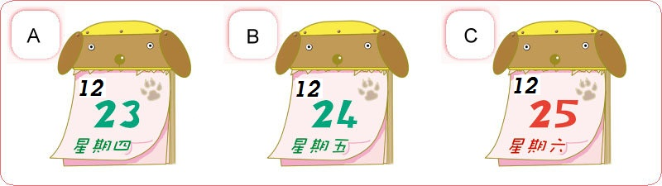

D. 根據聽到的內容，選出正確的答案。10％（每題2分）
16.（ ）(A) She is talking with a girl.
(B) She is reading with her cousin.
(C) She is writing to her cousin.
17.（ ）(A) She is sleeping in her bedroom.
(B) She is eating at home.
(C) She is helping her mom in the kitchen.
18（ ）(A) Yes, there are.
(B) No. There are four.
(C) No. There are three.
19.（ ）(A) Friday. (B) Saturday. (C) Sunday.
20.（ ）(A) At five thirty. (B) At six o'clock. (C) At six thirty.

第二部分 單字與文法概念 依照題意，選出最適當的答案。

21.( ) Are there any cakes at the snack bar? I am very now.
(Ａ) nice (Ｂ) lucky (Ｃ) yummy (Ｄ) hungry
22.( ) It is not allowed(被允許的) to talk on the in class.
(Ａ)rules (Ｂ) driver (Ｃ) cellphone (Ｄ) week
23.( ) There is a good exhibition(展覽) in National Science And Technology (科工館). Are you going with me?
(Ａ) Concert (Ｂ) Museum (Ｃ) House (Ｄ) Class
24. ( ) is the fourth（第四的）day of the week.
(Ａ) Monday (Ｂ)Tuesday (Ｃ) Wednesday (Ｄ) Sunday
25. ( ) Justin Bieber is good at Chinese. He is not about the Chinese test.(國文考試)
(Ａ) nervous (Ｂ) quiet (Ｃ) full (Ｄ) smart
26. ( ) There are seven days in a .
(Ａ) week (Ｂ) farmer (Ｃ) time (Ｄ) class
27. ( ) Clean the bag. It is so .
(Ａ) great (Ｂ) wrong (Ｃ) dirty (Ｄ) nice
28. ( ) the rules, and you will(將) touch the goal.(目標)
(Ａ) Blow (Ｂ) Have (Ｃ)Play (Ｄ) Follow
29. ( ) You I am a good basketball player.
(Ａ) and (Ｂ) or (Ｃ) but (Ｄ) to
30. ( ) Zoe: Are you free tonight? Let’s go to Jay’s concert. Kelly: No, I am busy my homework.
(Ａ) on (Ｂ) over (Ｃ) around (Ｄ) with
31. ( ) Christmas Eve, everyone in the Wang family happy.
(Ａ) On; is (Ｂ) In; is (Ｃ) In; are (Ｄ) On; are
32. ( ) David: Is it five to five? Ben: Yes, it’s .
(Ａ) five five (Ｂ) four fifty-five (Ｃ) five fifty-five (Ｄ) four five
33. ( ) Meg: What is in your ? John: It is an eraser.
(Ａ) hand (Ｂ) kiss (Ｃ) time (Ｄ) day
34. ( ) Anna: Do you have time? Elsa: Yes, it’s 4:20 p.m.
(Ａ) a (Ｂ) × (Ｃ) the (Ｄ) any
35. ( ) Annie: Is Jay’s concert 7:00 p.m.? Ken: That’s right. It’s 6:30 p.m. now. Let’s go.
(Ａ) at; × (Ｂ) at; at (Ｃ) ×; at (Ｄ) ×; ×
36. ( ) Tonight is Christmas Eve. My mom is in the kitchen.
(Ａ) studying (Ｂ) make a Christmas card (Ｃ) roasting a turkey (Ｄ) do her homework
37. ( ) Is there a park here? I can play basketball.
(Ａ) behind (Ｂ) between (Ｃ) at (Ｄ) around
38. ( ) Merry Christmas, everyone. a good time at the party.
(Ａ) Play (Ｂ) Playing (Ｃ) Having (Ｄ) Have
39. ( ) Hey. Look, there is a bird on the bike.
(Ａ) sing (Ｂ) singing (Ｃ) is singing (Ｄ) to sing
40. ( ) Mom: Wow. The Christmas card is beautiful. Who is it ? Paul: Mrs. Lee, my favorit teacher.
(Ａ) on (Ｂ) for (Ｃ) about (Ｄ) at
41. ( ) Please my pencil. There are many pencils in your pencil case.
(Ａ) not use (Ｂ) not to write (Ｃ) not write (Ｄ) don’t use
42. ( ) Let’s be good students and the school rules.
(A) not break (B) not breaking (C) not to break (D) don’t break
43. ( ) Some girls are blowing kisses Justin Beiber, and some are shouting his name.
(Ａ) for; × (Ｂ) for; at (Ｃ) to; at (Ｄ) to; ×
44. ( ) Look! There is a park over there.
(A) Please don't touch my pencil case. (B) Let's go there and play on the slide.
(C) Listen to your mom and be a good boy. (D) Do not talk and play over there.
45. ( ) Hebe: What’s Selina doing now? Ella:
(Ａ) Yes, she is doing her homework. (Ｂ) No, she is not doing it.
(Ｃ) She is watching TV. (Ｄ) She’s not eating dinner.
46. ( ) Rose: Is Grandpa hanging the bells on the Christmas tree with Jack? Sue:
(Ａ) No, she is not. (Ｂ) No, they are.
(Ｃ) Yes, they are putting the bells on it. (Ｄ) Yes, the bells are on the Christmas tree.
47. ( ) Willy: I see. You are not studying. You’re writing a letter. Tina: I’m making a birthday card.
(Ａ) Thank goodness! (Ｂ) Wrong again. (Ｃ) No, you are not. (Ｄ) Yes, you are right.
第三部分 閱讀理解
48-50
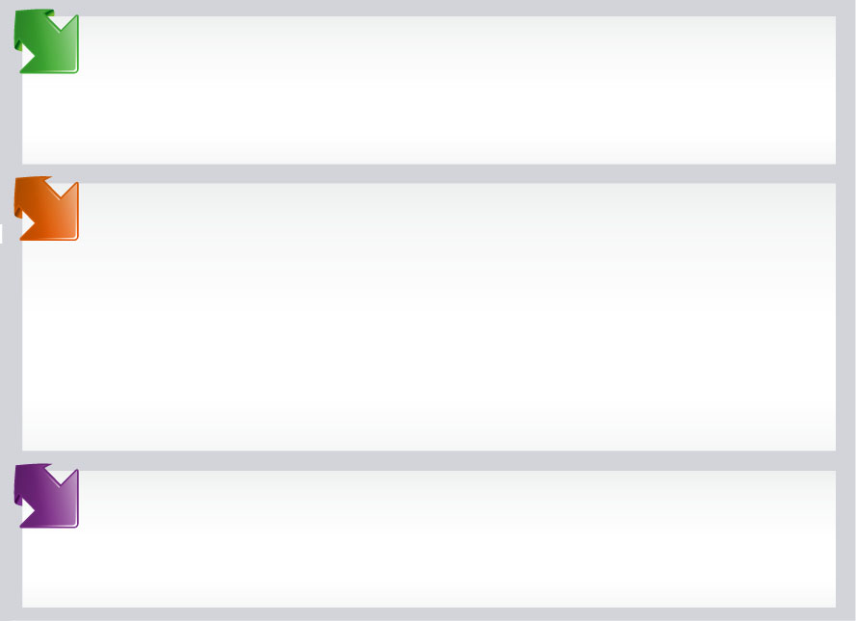
It is morning now. Harry White is at the park. He is playing with toys with his friend, Ron Brown. Harry's sister, Mary, is singing and dancing with her grandpa.

It is afternoon. Harry and his family are on a farm. There are many pretty farm animals. Mary is playing with some rabbits behind the big rocks,(岩石) and Harry is riding a horse with his borhter on the grass.(草地) Their parents are sitting and talking to a farmer at the tea bable, and their grandparents are feeding the monkeys near the tree.

It is evening now. The White family is at home. They are having a party under the tree behind their house. They are very happy.
with 和… feed 餵
48.（ ）Who is Harry playing with toys with in the morning?
(A) His friend.
(B) His sister.
(C) His parents
(D) His grandpa.
49.（ ）Where is Harry riding a horse?
(A) In the zoo.
(B) On the grass.
(C) At a tea table.
(D) Behind the big rocks.
50.（ ）What is Harry's grandpa doing on the farm?
(A) He is having a party with his family.
(B) He is singing and dancing with Mary.
(C) He is feeding the animals near the tree.
(D) He is sitting under a tree and talking to a farmer.

51-52
Classroom Tules for Class 703
- Don’t’t litter.
- Don’t eat in class.
- Be nice to classmates.
- Don’t be late for school.
- Turn in your homework on time.
- Don’t use your cellphone in class.
✓ Don't eat in class.

late 遲到的
turn in 交上
homework 功課
on time 準時
✓ Be nice to classmates.
✓ Don't be late for school.
✓ Turn in your homework on time.
✓ Don't use your cellphone in class.

51.( ) There are rules in Class 703.
(A) four (B) five
(C) six (D) seven
52.( ) Which is NOT a rule in Class 703?
(A) Don't eat in Class 703.
(B) Don't be late for school.
(C) Don't talk on a cellphone.
(D) Don't do your homework. which 哪一個

53-55 根據歌手Sophie的記事本， 選出正確的答案。
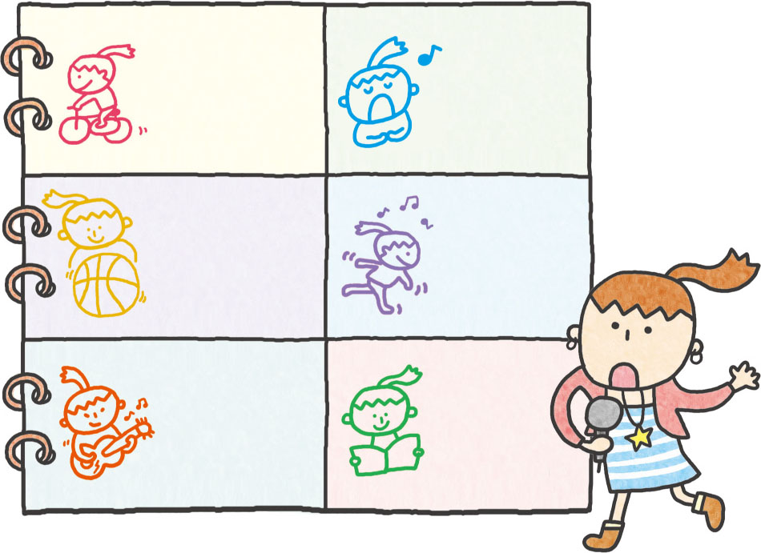
Tue. and Fri.  3–5 p.m. | Mon.  9–11 a.m.  Wed.  1–2 p.m.
Wed.  8–10 a.m.  Sun.  3–5 p.m. | Tue.  9–11 a.m.  Sat.  2–4 p.m.
Mon.  8–9 p.m.  Tue. and Fri.  10–11 a.m. | Weekend  8–10 a.m.

53.( )It is eight fifteen on Monday night. What is Sophie doing?
(A) Riding a bike.
(B) Playing the guitar.
(C) Singing songs.
(D) Reading a book.
54. ( )It is 15:50. Sophie is playing basketball. What day is it?
(A) Wednesday.
(B) Monday.
(C) Saturday.
(D) Sunday.
55.( ) What day is a free day for Sophie to take a trip?(旅遊)
(A) Thursday.
(B) Monday.
(C) Saturday.
(D) Sunday.

. 1年級-英文 科 第 3 次段考--答案欄
1 - 5 | CBBCA
6 -10 | BCDCA
11-15 | CABAC
16-20 | CBBCC
21-25 | DCBCA
26-30 | ACABD
31-35 | ABACA
36-40 | CDDBB
41-45 | DADBC
46-50 | CBABC
51-55 | CDBDA

