高雄市立林園高級中學 國中部 103學年度 第 1 學期 2 年級 英語 科 第 1 次 段考試題卷
班級： 姓名： 座號：
本次測驗，試題共有4頁。第一～三大題為聽力測驗，第四～十大題為紙筆測驗。請將答案用印刷體寫在答案卷上，測驗結束時將答案卷交回。
一、看圖選擇（根據聽到的內容，選出與圖片相符合的句子）：每題2分，共10分
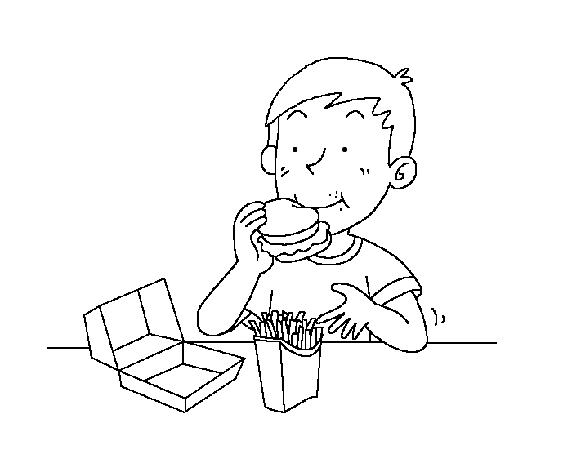
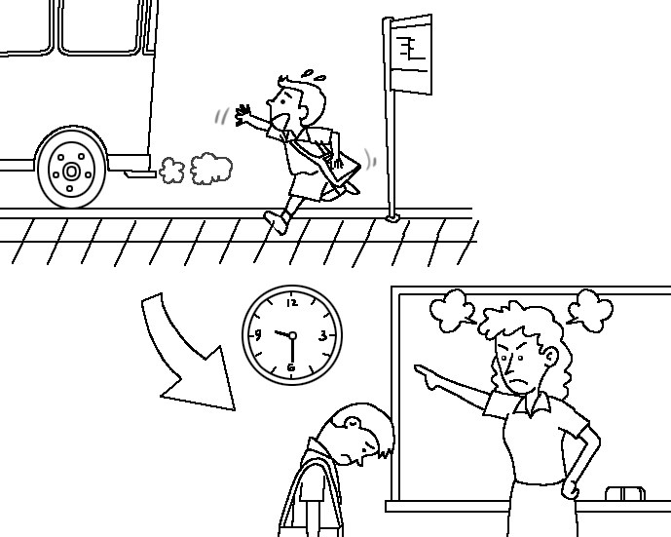
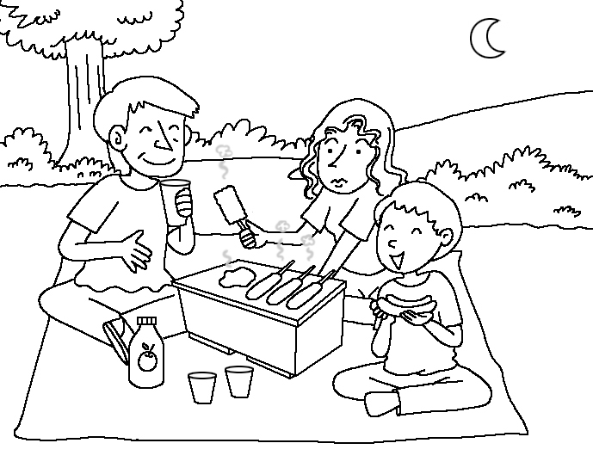
1. 2. 3.

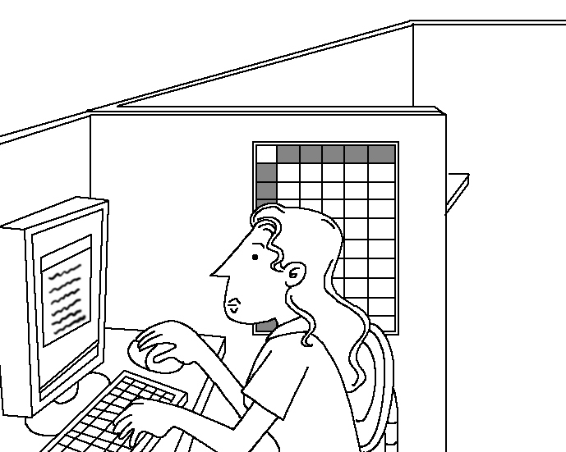
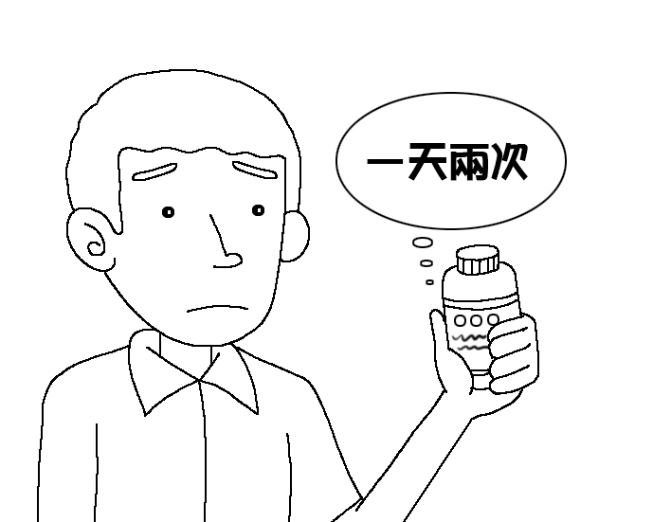
4. 5.

答：1. ( ) 2. ( ) 3. ( ) 4. ( ) 5. ( )

二、辨識句意（根據聽到的內容，選出正確的圖片代碼）：每題2分，共10分
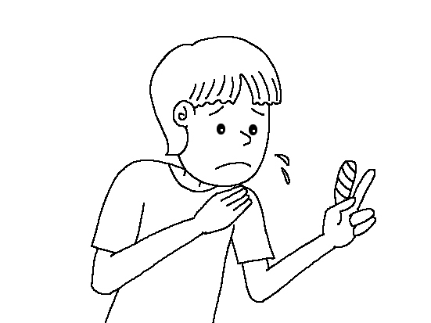
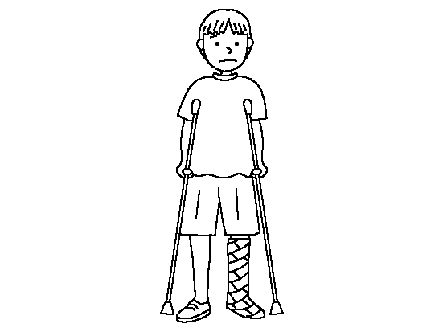
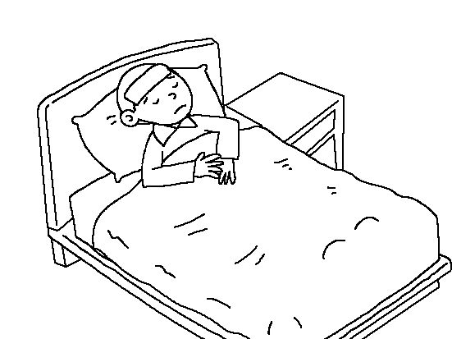
( ) 1. (A) (B) (C)
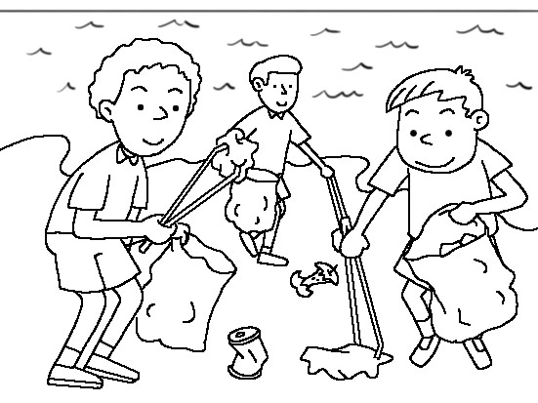
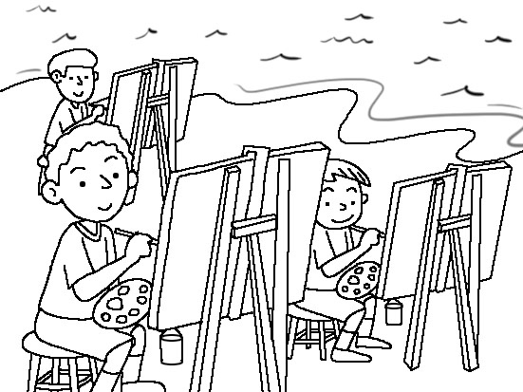
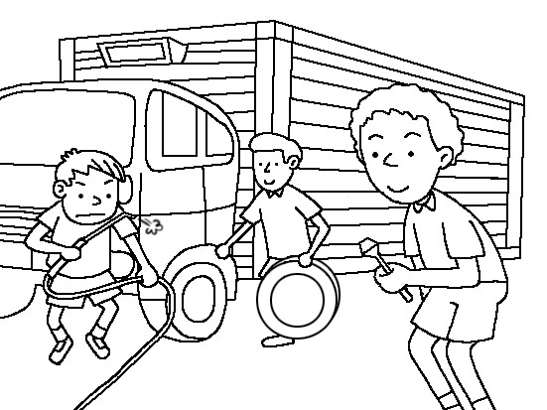
( ) 2. (A) (B) (C)
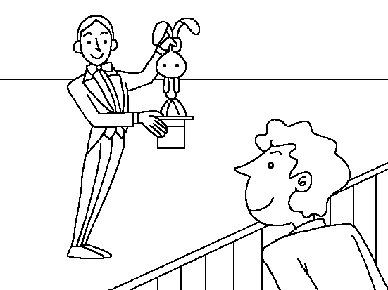
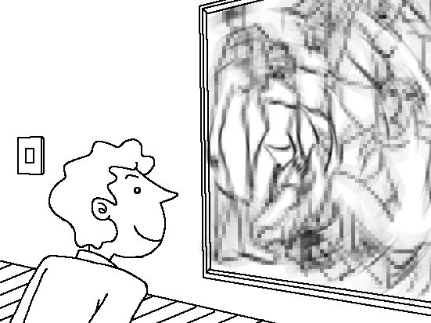
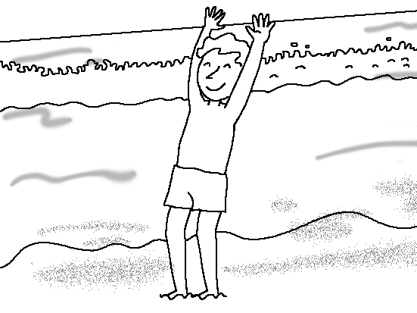
( ) 3. (A) (B) (C)
P.1/4

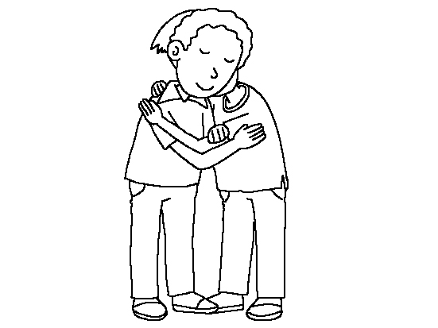
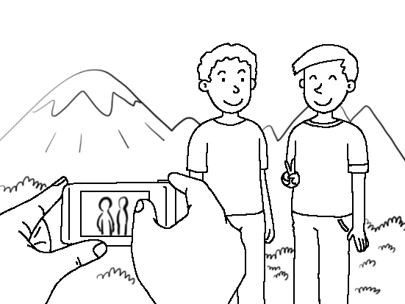

( ) 4. (A) (B) (C)
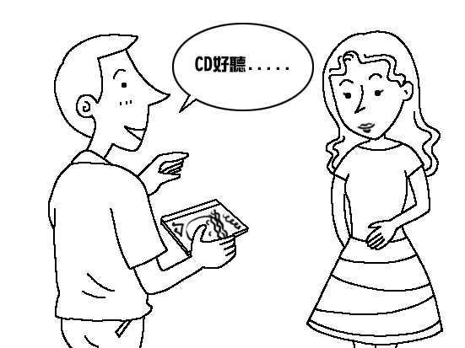
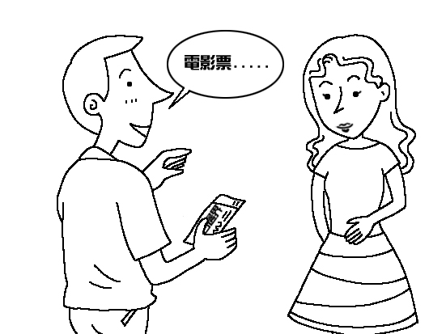
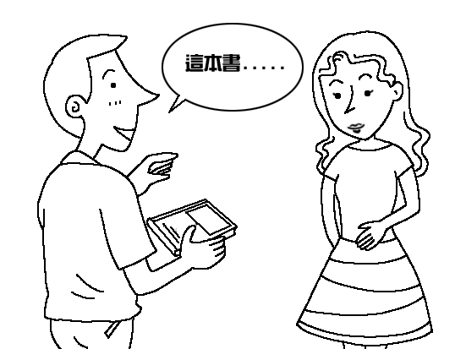
( ) 5. (A) (B) (C)

三、看圖回答（根據圖片，聽完問題後選出正確的答案）：每題2分，共10分

Things they did after school yesterday
Things | Mandy | Kevin | Tina | Billy
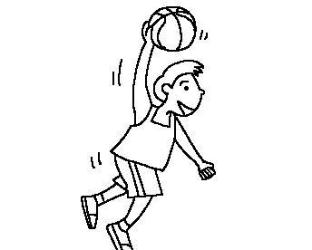 | × | ○ | ○ | ×
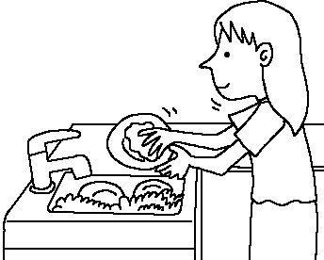 | ○ | × | ○ | ×
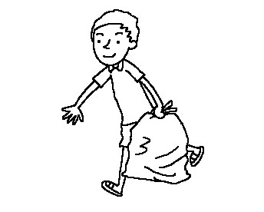 | × | × | × | ×
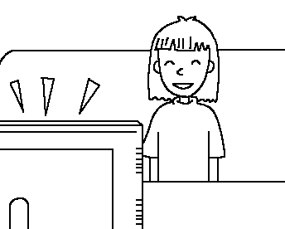 | ○ | ○ | ○ | ○
 | ○ | ○ | ○ | ×
( ) 1. (A) Tina.
(B) Mandy.
(C) Billy.
P.2/4
( ) 2. (A) They all studied yesterday.
(B) They all watched TV yesterday.
(C) They all took out the trash yesterday.
( ) 3. (A) Yes, he did. (B) No, he didn’t. (C) We don’t know.
( ) 4. (A) She didn’t play basketball.
(B) She didn’t do the dishes.
(C) She didn’t study.
( ) 5. (A) Kevin didn’t do the dishes yesterday.
(B) Billy only did one thing after school yesterday.
(C) Tina did all the things after school yesterday.

四、字彙選擇：每題2分，共10分
( ) 1. We ____ Jim’s birthday with our friends.
(A) invited (B) pasted (C) celebrated
( ) 2. Jam is a ____ singer. A lot of people love his songs.
(A) become (B) popular (C) elephant
( ) 3. Mr. Li lives near my house. He’s my ____.
(A) neighbor (B) classmate (C) worker
( ) 4. Jean was sick, she needed some ____.
(A) pumpkin (B) medicine (C) hamburger
( ) 5. The story is ____. Students all like it.
(A) handsome (B) interesting (C) careful

五、寫出下列動詞的過去式：每題2分，共10分
1. carry: _____ 2. jog: _____ 3. put: _____ 4.enjoy: _____ 5.bring: _____

六、文法選擇：每題2分，共10分
( ) 1. Today is my birthday. My mother bought some food at the supermarket ___ my birthday party yesterday.
(A) at (B) for (C) on
( ) 2. I liked toy cars when I ___ a little boy.
(A) am (B) were (C) was
( ) 3. Mary helped me ___ my homework.
(A) with (B) to (C) doing
( ) 4. The students studied Lesson One ___.
(A) every day (B) now (C) yesterday morning
( ) 5. Andy: Jane has a new cellphone. Who ___?
Joe: I did. What’s up?
(A) bought it for her (B) bought her it (C) bought it her

P.3/4
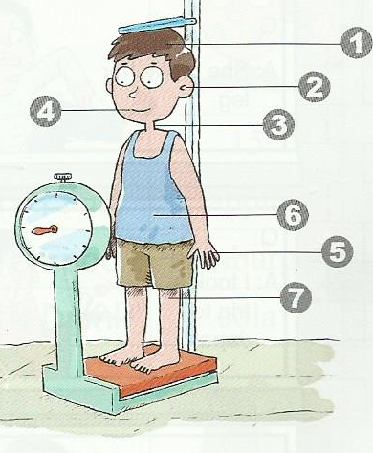七、看圖寫出身體部位的名稱：每題2分，共10分
1. → head
2. → (1) _________
3. → (2) _________
4. → (3) _________
5. → (4) _________
6. → (5) _________
7. → leg

八、選出適當的回應句：每題2分，共10分
(A) David. And he really enjoyed my mom’s brown sugar cake.
(B) Its pumpkin rice noodles are delicious.
(C) We worked at a summer camp in Kenting.
(D) In the supermarket near your school.
(E) Several volunteers. We cleaned the park together.
( ) 1. What did you do during the summer vacation?
( ) 2. Who did you work with?
( ) 3. Why do you often go to that restaurant?
( ) 4. Where did you buy the sandwiches?
( ) 5. Who did you invite for dinner last night?

九、克漏字填充：每個空格2分，共10分
You may know many things about Jam Hsiao, 1 you may not know one thing about him. Jam Hsiao has a reading 2 , and school work was not easy 3 him. However, it didn’t 4 him. His teacher gave him some advice about his gift 5 music, and it brought him a new life.

十、句型：(分段給分，請盡量作答) 每題2分，共10分
1. 我們談笑著有趣的事。 (把這句翻成英文)

2. Jam gave me a birthday gift. (加入介系詞改寫)

3. We didn’t take the trip to Penghu. (用…, so …合併句子)
The weather was bad.

4. I often listen to music. (用When…合併句子)
I read the newspaper.

5. The little boy can’t answer the math question. (用Because …合併句子)
The math question is too hard.
P.4/4
高雄市立林園高級中學 國中部 103學年度 第 1 學期 2 年級 英語 科 第 1 次 段考答案卷
班級： 座號： 姓名：
- 看圖選擇（根據聽到的內容，選出與圖片相符合的句子）：每題2分，共10分
1. | 2. | 3. | 4. | 5.
二、辨識句意（根據聽到的內容，選出正確的圖片代碼）：每題2分，共10分
1. | 2. | 3. | 4. | 5.
三、看圖回答（根據圖片，聽完問題後選出正確的答案）：每題2分，共10分
1. | 2. | 3. | 4. | 5.
四、字彙選擇：每題2分，共10分
1. | 2. | 3. | 4. | 5.
五、寫出下列動詞的過去式：每題2分，共10分
1. | 2. | 3. | 4. | 5.
六、文法選擇：每題2分，共10分
1. | 2. | 3. | 4. | 5.
七、看圖寫出身體部位的名稱：每題2分，共10分
(1). | (2). | (3). | (4). | (5).
八、選出適當的回應句：每題2分，共10分
1. | 2. | 3. | 4. | 5.
九、克漏字填充：每個空格2分，共10分
1. | 2. | 3. | 4. | 5.
十、句型：(分段給分，請盡量作答) 每題2分，共10分
1.
2.
3.
4.
5.
高雄市立林園高級中學 國中部 103學年度 第 1 學期 2 年級 英語 科 第 1 次 段考解答
班級： 座號： 姓名：
一、看圖選擇（根據聽到的內容，選出與圖片相符合的句子）：每題2分，共10分
1. A | 2. C | 3. B | 4. B | 5. C
二、辨識句意（根據聽到的內容，選出正確的圖片代碼）：每題2分，共10分
1. B | 2. A | 3. A | 4. C | 5. B
三、看圖回答（根據圖片，聽完問題後選出正確的答案）：每題2分，共10分
1. C | 2. B | 3. A | 4. A | 5. C
四、字彙選擇：每題2分，共10分
1. C | 2. B | 3. A | 4. B | 5. B
五、寫出下列動詞的過去式：每題2分，共10分
1. carried | 2. jogged | 3. put | 4. enjoyed | 5. brought
六、文法選擇：每題2分，共10分
1. B | 2. C | 3. A | 4. C | 5. A
七、看圖寫出身體部位的名稱：每題2分，共10分
(1). ear | (2). neck | (3). mouth | (4). finger | (5). stomach
八、選出適當的回應句：每題2分，共10分
1. C | 2. E | 3. B | 4. D | 5. A
九、克漏字填充：每個空格2分，共10分
1. but | 2. problem | 3. for | 4. stop | 5. for
十、句型：(分段給分，請盡量作答) 每題2分，共10分
1. We talked and laughed / about fun (interesting) things.
2. Jam gave a birthday gift / to me.
3. The weather was bad, / so we didn’t take the trip to Penghu.
4. When I read the newspaper, / I often listen to music.
5. Because the math question is too hard, / the little boy can’t answer it.
一、看圖選擇（根據聽到的內容，選出與圖片相符合的句子）：每題2分，共10分
聽力內容：
1. (A) Jason had a hamburger and French fries for lunch.
(B) Jason had a pizza and fried chicken for lunch.
(C) Jason had fried chicken and French fries for lunch.
2. (A) Peter was late for school because he woke up too late.
(B) Peter had a fever, so he didn’t go to school.
(C) Because Peter didn’t catch the bus, he was late for school.
3. (A) The Wang family celebrated the holiday with a party.
(B) The Wang family celebrated the holiday with a barbecue.
(C) The Wang family celebrated the holiday with a big dinner.
4. (A) Sherry was at a concert. (B) Sherry was in the office. (C) Sherry was at the beach.
5. (A) Jason went to a supermarket twice a day.
(B) Jason took out the trash twice a day.
(C) Jason took the medicine twice a day.

二、辨識句意（根據聽到的內容，選出正確的圖片代碼）：每題2分，共10分
聽力內容：
1. Eric broke his leg yesterday afternoon.
2. People picked up the trash on the beach.
3. Harry went to a magic show this Sunday.
4. Lucas shook hands with Peter.
5. Zack gave me a ticket to a movie this morning.

三、看圖回答（根據圖片，聽完問題後選出正確的答案）：每題2分，共10分
聽力內容：
1. Who didn’t do the dishes yesterday?
2. What did all the four people do yesterday?
3. Did Kevin play basketball after school yesterday?
4. What didn’t Mandy do after school yesterday?
5. Which is NOT true?

