高雄市立林園高級中學 國中部 103學年度 第1學期 2 年級 英語科 第2次段考 試題卷
班級： 姓名： 座號：
本次測驗，試題共有4頁。第一~三大題為聽力測驗，第四~九大題為紙筆測驗。請將答案寫在答案卷上，測驗結束時將答案卷交回。

一、字彙選擇（選出句子中出現的單字）：每題2分，共10分
( ) 1. (A) October (B) September (C) August (D) January
( ) 2. (A) homework (B) bookstore (C) keyboard (D) culture
( ) 3. (A) unlucky (B) present (C) convenient (D) blackboard
( ) 4. (A) shopping (B) shouting (C) using (D) hopping
( ) 5. (A) guess (B) text (C) start (D) respect

二、基本問答（根據聽到的內容，選出合適的回應）：每題2分，共10分
( ) 1. (A) Yes, beef noodles in this restaurant are very delicious.
(B) Oxen were helpers on my grandfather’s farm before.
(C) You should learn and respect the taboos of different cultures.
( ) 2. (A) He was sleeping.
(B) Yes, he was talking to me.
(C) He is watching TV now.
( ) 3. (A) I’m sorry. I didn’t know that.
(B) What a terrible dream!
(C) Thanks a lot.
( ) 4. (A) I broke my leg when I was playing baseball.
(B) Yes, I had a bad dream last night.
(C) No, I only care about online games.
( ) 5. (A) Let’s play online games now.
(B) Please turn off the power after you use it.
(C) I can use it to take notes and surf the Internet.

三、辨識句意（根據聽到的內容，選出正確的圖片代碼）：每題2分，共10分
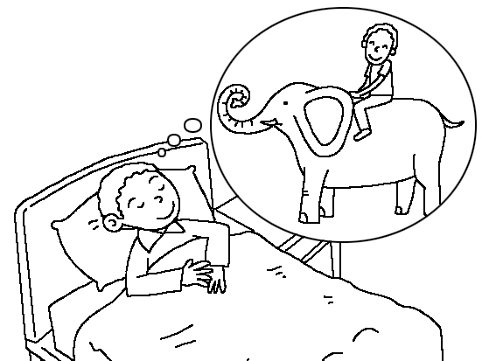
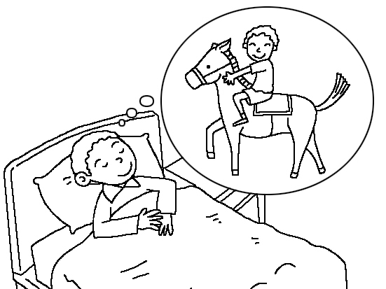
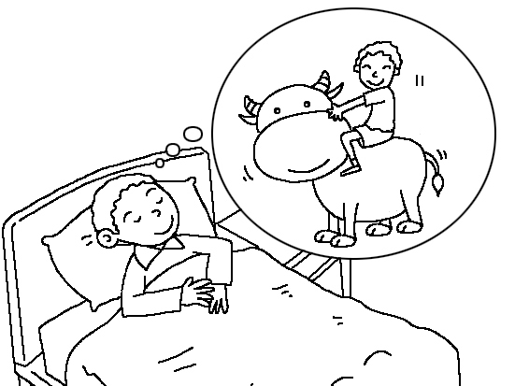
( ) 1. (A) (B) (C)
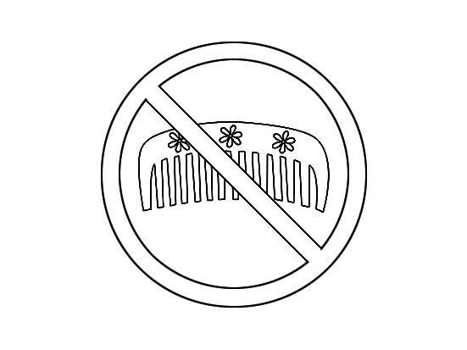
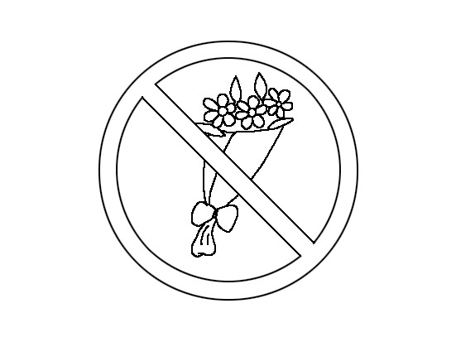
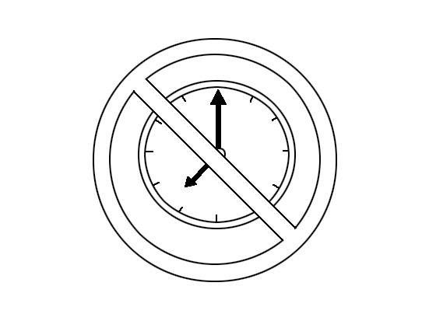
( ) 2. (A) (B) (C)
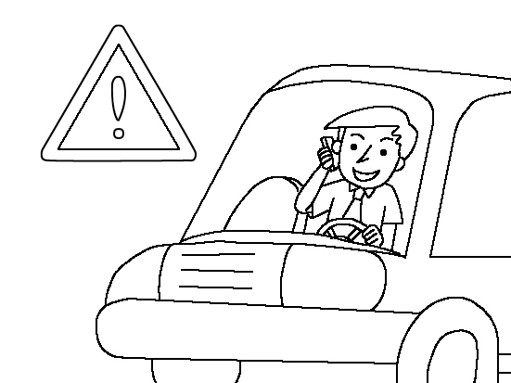
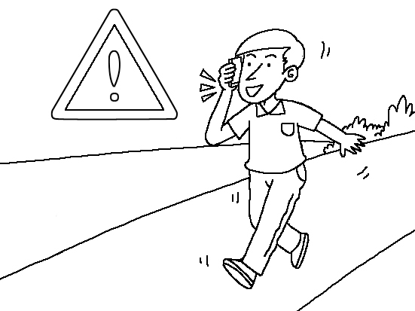
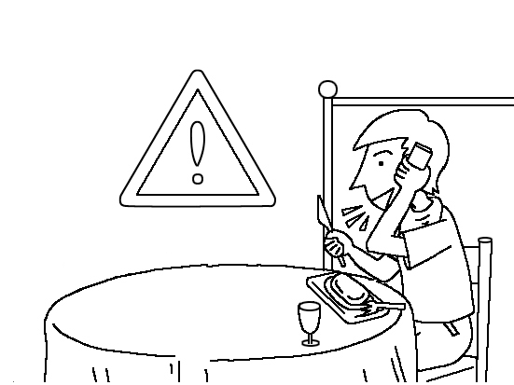
( ) 3. (A) (B) (C)

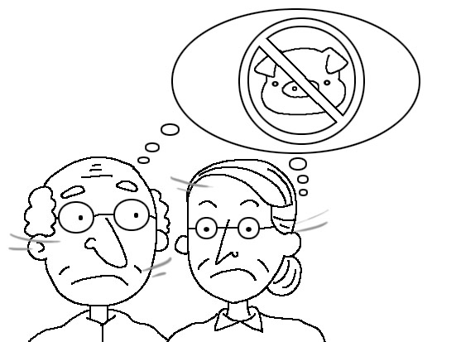
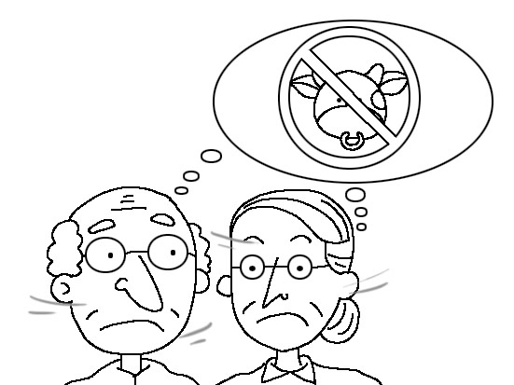
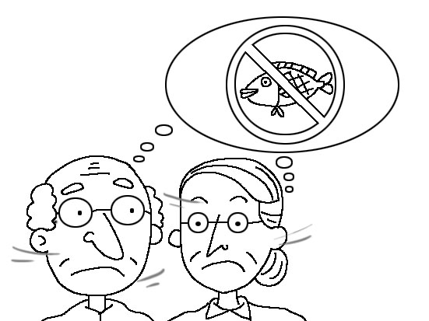
( ) 4. (A) (B) (C)
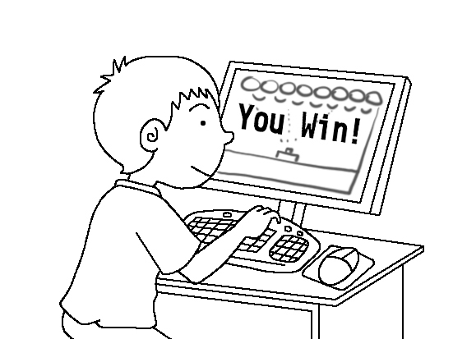
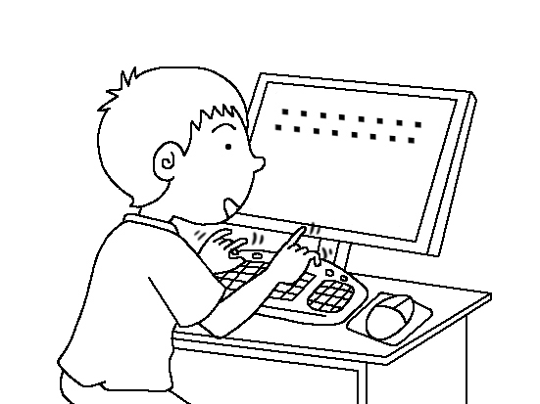
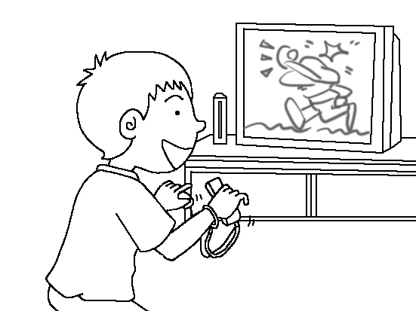
( ) 5. (A) (B) (C)

四、文意字彙：每題2分，共10分
1. Math is always d t for me because I’m not good at math.
2. I can’t b ve it! I got 100 on my English test.
3. My brother got a cold, so he went to the h l yesterday.
4. F y comes after January. It has 29 days every four years.
5. I just got a p d from my friend in Japan. There is a beautiful picture of the country on it.

五、填空（依提示填入正確的動詞形態，每格不限一字）：每題2分，共10分
1. I’m planning _________(invite) Tiffany, my neighbor from Canada, to my birthday party next weekend.
2. I even practiced _________(write) her an English invitation.
3. You should finish __________ (read) the book by Friday.
4. Mom asked me __________ (clean) the kitchen before she went out this morning.
5. Mom: What would you like to do this weekend?
Dad: I don’t mind just __________ (stay) home.

六、文法選擇：每題2分，共10分
- Jane was walking her dog when I _______ her in the park last night.
(A) meet (B) met (C) am meeting (D) was meeting
- While I ________ to my office, I ________ a police officer.
- drove ; saw (B) drove ; was seeing (C) was driving ; saw (D) was driving ; was seeing
- Uncle Tom gave toy robots ________ Jim ________ birthday presents.
- for ; to (B) for ; as (C) to ; with (D) to ; as
- Preparing for tests ________ not easy at all. You have to do a lot of exercises(習題).
- is (B) are (C) must (D) should
- ________ off the cellphone when you ________ dinner with your family.
- To turn ; eat (B) For turning ; eat (C) Turn ; are eating (D) Turning ; are eating

七、配合題（選出適當回應句）：每題2分，共20分
A.
(A) How convenient!
(B) What a small world!
(C) It’s on November 22.
(D) She fell off her bike and broke her leg.
(E) It’s a big shopping day because everything is on sale.
1. A: What happened to Jenny last week? B: ______
2. A: What’s special about Black Friday? B: ______
3. A: I met my English teacher while I was traveling in Canada. B: ______
4. A: What date is your father’s birthday? B: ______
5. A: Yesterday, I bought all these books and clothes on the Internet. B: _______

B.
(A) Why not? They are both my favorites.
(B) Of course not. I’m happy to do it for you.
(C) Of course. Chinese people may think of death.
(D) When I started playing basketball with my classmates.
(E) Most people like to choose six, seven, eight or nine for good luck.
6. When did you stop playing with toy robots? B: ________
7. Do you mind carrying the bag for me? B: ________
8. Should we avoid giving friends a clock as a present? B: ________
9. What numbers usually mean good luck in your culture? B: ________
10. Would you like to have some spaghetti and salad for lunch? B: ________

八、閱讀測驗：每題2分，共10分

The Story of Thanksgiving
In 1620, the Pilgrims went to America from England by ship. They cut down trees to build houses and churches. The Pilgrims had a hard time during the first winter. They didn’t have enough food and clothes, so many of them got sick and died. The next spring, the Indians visited them and showed them how to plant corn. They also taught the Pilgrims how to hunt for turkeys in the woods.
When fall came, the Pilgrims had enough food for the winter. They invited the Indians to enjoy a big turkey dinner with them. The Pilgrims were thankful for all the good things and food. That was the first Thanksgiving in the United States. Now, Americans celebrate Thanksgiving on the fourth Thursday of November every year.

Pilgrim 清教徒 build 建造 die 死亡 Indian 印第安人 hunt 獵捕 woods 森林

( ) 1. How did the Pilgrims go to the USA?
(A)  (B) 

(C) 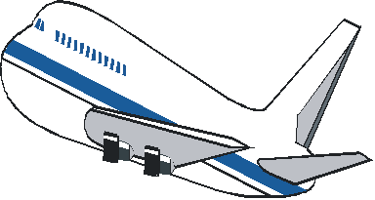 (D) 
( ) 2. When did the Indians come and help the Pilgrims?
(A) In the fall of 1620. (B) In the winter of 1620.
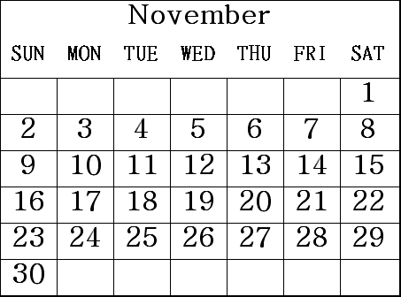
(C) In the spring of 1621. (D) In the fall of 1621.
( ) 3. According to the calendar, what date is Thanksgiving this year?
- On November nineteenth.
(B) On November twentieth.
(C) On November twenty-sixth.
(D) On November twenty-seventh.
( ) 4. Which DIDN’T happen before the Indians visited the Pilgrims?
(A) The Pilgrims hunted for turkeys in the woods.
(B) The Pilgrims had a hard time during the first winter.
(C) The Pilgrims cut down trees to build houses and churches.
(D) The Pilgrims didn’t have enough food and many of them died.
( ) 5. Which is NOT true?
(A) The first Thanksgiving was in 1621.
(B) The Indians taught the Pilgrims to plan corn.
(C). The Pilgrims had enough food for the first winter.
(D) The Pilgrims prepared a big turkey dinner for the Indians.

九、依提示作答(分段給分，請盡量作答)：每題2分，共10分
1. The phone rang. (以While…合併句子)
Ms. Wang was making breakfast.

2. We practiced baseball a lot last week. (以…although …合併句子)
We didn’t win the game today.

3. They watched TV last night. (加入at six o’clock改寫)

4. 你還能用你的手機做什麼？ (中翻英)

5. 上課做筆記對一個學生來說是很重要的。(It’s…) (中翻英)

高雄市立林園高級中學 國中部 103學年度 第1學期 2年級 英語科 第2次段考 解答
一、字彙選擇（選出句子中出現的單字）：每題2分，共10分
1. C | 2. A | 3. C | 4. D | 5. B
二、基本問答（根據聽到的內容，選出合適的回應）：每題2分，共10分
1. B | 2. A | 3. C | 4. A | 5. C
三、辨識句意（根據聽到的內容，選出正確的圖片代碼）：每題2分，共10分
1. C | 2. B | 3. B | 4. C | 5. A

四、文意字彙：每題2分，共10分
1. difficult | 2. believe | 3. hospital | 4. February | 5. postcard
五、填空（依提示填入正確的動詞形態，每格不限一字）：每題2分，共10分
1. to invite | 2. writing | 3. reading | 4. to clean | 5. staying

六、文法選擇：每題2分，共10分
1. B | 2. C | 3. D | 4. A | 5. C
七、配合題（選出適當回應句）：每題2分，共20分
1. D | 2. E | 3. B | 4. C | 5. A
6. D | 7. B | 8. C | 9. E | 10. A
八、閱讀測驗：每題2分，共10分
1. D | 2. C | 3. D | 4. A | 5. C

九、依提示作答(分段給分，請盡量作答)：每題2分，共10分
1. While Ms. Wang was making breakfast, / the phone rang.
2. We didn’t win the game today / although we practiced baseball a lot last week.
3. They were watching TV/ at six o’clock last night.
4. What else can you do / with your cellphone?
5. It’s very important for a student / to take notes in class.

