高雄市立林園高級中學 國中部 103學年度 第1學期 二 年級 英文科 第3次段考 試題卷
班級： 姓名： 座號：
◎本試卷共（ 4 ）頁

- 聽力測驗 30%

一、辨識句意（根據聽到的內容，選出正確的圖片代碼）：
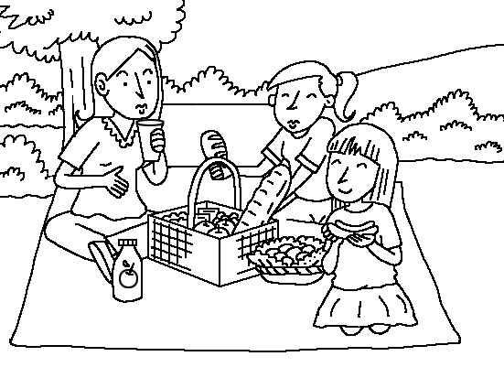
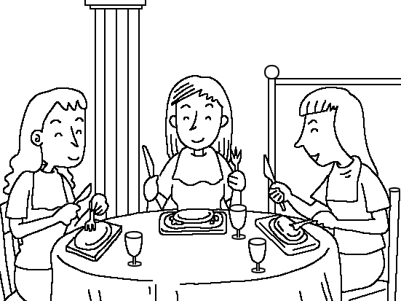
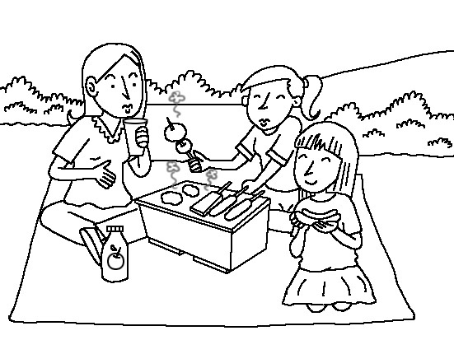
( ) 1. (A) (B) (C)
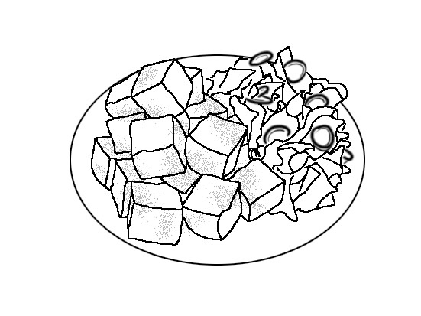
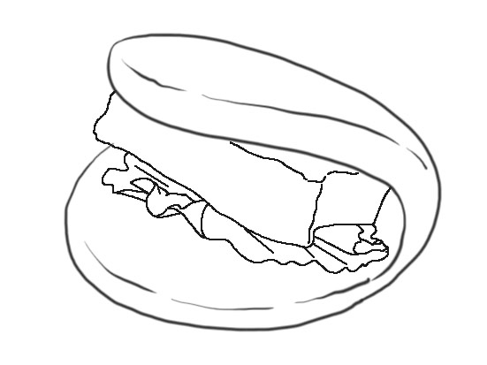

( ) 2. (A) (B) (C)
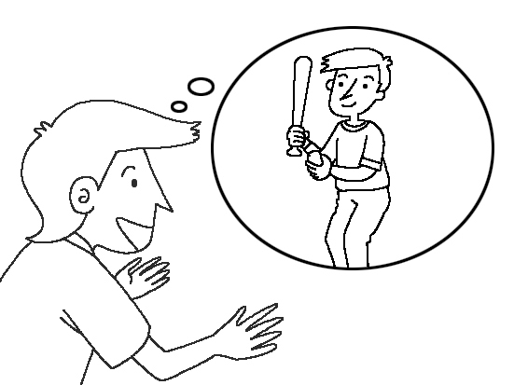
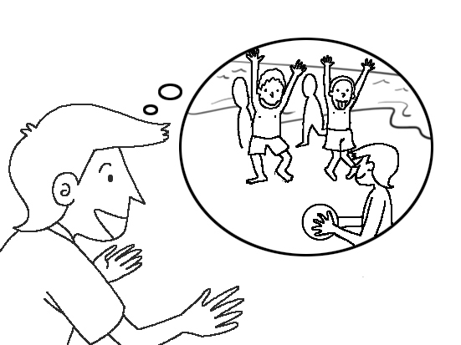
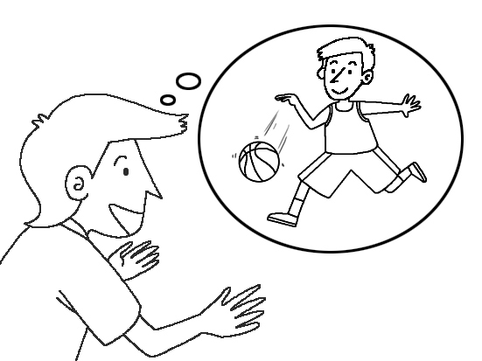
( ) 3. (A) (B) (C)
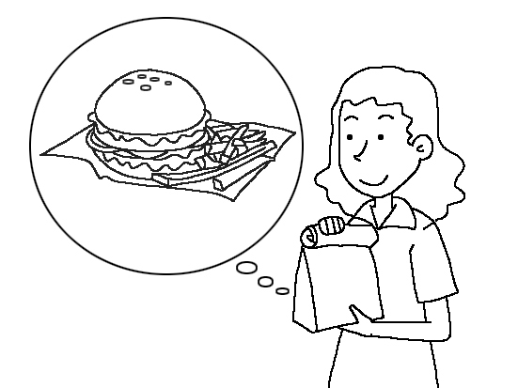
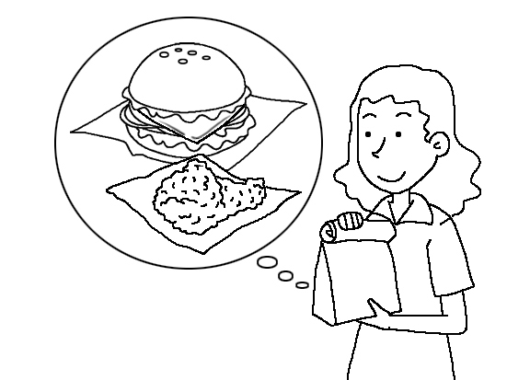
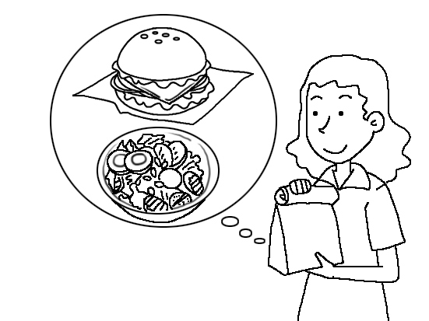
( ) 4. (A) (B) (C)
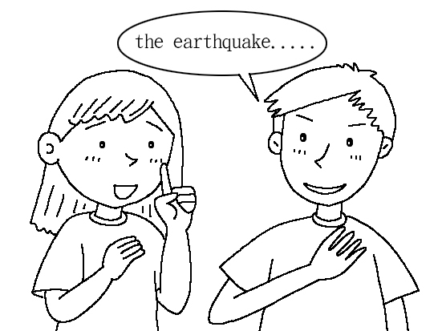
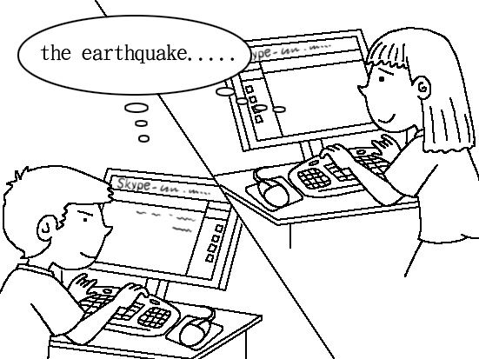
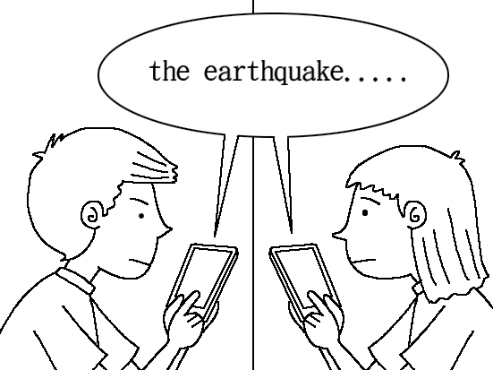
( ) 5. (A) (B) (C)

二、字彙選擇（選出句子中出現的單字）：
( ) 6. (A) celebrate (B) respect (C) follow (D) experience
( ) 7. (A) trip (B) trick (C) truck (D) trash
( ) 8. (A) postcard (B) problem (C) pumpkin (D) power
( ) 9. (A) careful (B) difficult
(C) crazy (D) interesting
( ) 10. (A) spaghetti (B) butter
(C) noodles (D) beef

三、基本問答（根據聽到的內容，選出合適的回應）：
( ) 11. (A) Lucky you! (B) I’m not sure! (C) Never mind.
( ) 12. (A) Yes, I was reading then.
(B) I was doing my homework.
(C) Well, I don’t enjoy studying at all.
( ) 13. (A) No, thanks. I don’t like the smell.
(B) Yes, everything is on sale now.
(C) I made the cheese cake by myself.
( ) 14. (A) He had a high fever yesterday morning.
(B) Yes, he enjoyed his time very much there.
(C) He was shopping with his lover then.
( ) 15. (A) It was awesome. I visited a lot of places and enjoyed some local food.
(B) Yes, I will go there next time.
(C) I’m going to take a trip to Taitung next month.
.
貳、 讀寫測驗 70%
- 字彙選擇
- The ________ led the tourists（觀光客）around the city.
(A) race (B) power (C) garbage (D) guide
- The bag is very heavy. You should it with two hands.
(A) filled (B) sailed (C) hold (D) sent
- A big ________ hit Taiwan many years ago. A lot of people died then.
(A) earthquake (B) wind (C) decision (D) motorcycle
- Don’t look at the ________ sun. It’s bad for your eyes.
(A) sailing (B) picnicking (C) leaving (D) shining
( )20. After the picnic, many people left their ________ on the beach.
(A) fire (B) garbage (C) camp (D) dragon
( )21. Look! The rock is in the shape of a ________.
(A) guide (B) power (C) dragon (D) picnic
( )22. There are some people having a picnic on the ________.
(A) stair (B) grass (C) area (D) message
( )23. Many people don’t use their names on the Internet.
(A) online (B) same (C) third (D) real
( )24. A: Thanks for helping me. B: It’s my ________.
(A) pleasure (B) experience (C) sentence (D) sock
( )25. There’s a fruit ________ there. Let’s have some orange juice.
(A) stand (B) school (C) museum (D) library

二、 文法選擇
( )26. I want a big meal ________ the restaurant over there.
(A) with (B) to (C) at (D) on
( )27. I don’t like the smell. May I have ________?
(A) other something (B) something else (C) something other (D) else something
( )28 The banana cake ________ delicious.
(A) eats (B) tastes (C) eats like (D) tastes like
( )29. My parents had their vacation in Canada last week. They ________ happy.
(A) felt (B) smelled (C) felt like (D) sounded like
( )30. I have a special party ________ you! Are you happy?
(A) in (B) at (C) with (D) for

( )31 Suan: How is the weather there?
Debbie: It looks like_________.
(A) rainy (B) raining (C) rain (D) rains
( )32. I ________ to the party with my good friends, Betty and Sue, tonight. How about you, Jill?
(A) go (B) will going (C) went (D) am going
( )33. Shh…be quiet. Here ________ Miss Lin.
(A) is coming (B) came (C) comes (D) will come
( )34. A: Where did you buy the cookies?
B: I made them ________.
(A) myself (B) itself (C) themselves (D) herself
( )35. You do your report, and I do ________.
(A) me (B) my (C) mine (D) you
( )36. My brother is good at swimming, and he enjoys on the sea very much.
(A) skating (B) starting (C) surfing (D) shopping
( )37. The cloud（雲）________ a rabbit.
(A) like (B) looks (C) looks like (D) looking like
( )38 My mom is busy ________ dinner in the kitchen now.
(A) cooking (B) to cook (C) cook (D) cooks.
( )39. Emily: I’d like Jay’s CD.
Hank: ________
(A) Here the CD is. (B) Here is the CD. (C) Here they are. (D) Here is it.
( )40. Sam and Ted are going to play music for us during dinnertime ________.
(A) every day (B) last night (C) an hour ago (D) next Monday

三、對話選擇:
.( )41. A:What are you going to do tonight?
B:_____________________________
(A) He’ll see a doctor. (B) My mom is going hiking. (C) I’m going to study English.
( )42 A:.When will we go to Penghu, Dad?
B:_____________________________
(A) Maybe next summer. (B) I’ll take a picture of you. (C) Let me check your stomach.
( )43 Sophia: The stinky tofu smells terrible, but it’s really delicious. Try it.
Roger:
(A) Well, your friend looked funny. (B) Yuck! It smells like dirty socks.
(C) Come on. That’s my favorite horse. (D) When is he going to arrive next time?
( )44. A:Who will you have a picnic with tomorrow?
B:_____________________________________
(A) Tom is having a picnic. (B) My best friends, Amber and Lily. (C) My parents will have a great time.
( )45. Harry: When you get your food, may I have a bite?
Vivian:
(A) Sure. I don’t mind. (B) In fact, I had great fun. (C) Never mind. You are right.
(D) Of course. Let me show you.

四、閱讀測驗

Winter vacation is coming, and Nora is making plans. In the first week, she is going to practice riding a bicycle. Then she will go biking around Taipei with her friends, Lisa and Eric. In the second week, she will visit her grandparents in Cijin and celebrate Chinese New Year. In the third week, she will do her science report with Amber. She will also prepare for a test. How about you? Do you have any plans?

( )46. What will Nora do in the first week of this winter vacation?
(A) Prepare for the coming test.
(B) Celebrate Chinese New Year.
(C) Go biking with her friends.

( )47.Where will Nora be in the second week of this winter vacation?
(A) In Cijin.
(B) In Taipei.
(C) At home.
( )48.When will Nora prepare for the test?
(A) In the first week of this winter vacation.
(B) In the third week of this winter vacation.
(C) In the second week of this winter vacation.

Fun in Driving
Hi, friends. Welcome to Kenting. We’re here to invite you to experience the great fun in driving a go-kart.
We give two lessons before you go driving it.
1. Learn the safety rules.
2. Practice driving a go-kart for twenty minutes.
We will have a race. You can join it when you are ready. Children above（以上）6 can join us. Let’s drive a go-kart and have fun!
Call Sam at 0988345531 for more information（資訊）.

( )49. Where can we experience the driving fun of go-kart?
(A) At home. (B) On the sports field（運動場）. (C) In Kenting. (D) On the computer.
( )50. Who can’t join the go-kart race?
(A) Jenny’s father. (B) A five-year-old boy. (C) Miss Chen, a junior high school teacher. (D) A kung fu actor.

二 年級 英文 科 第 3 次段考--答案欄
1-5 C A B B B
6-10 C B D C A
11-15 C B A A A
16-20 D C A D B
21-25 C B D A A
26-30 C B B A D
31-35 C D C A C
36-40 C C A B D
41-45 C A B B A
46-50 C A B C B

