高雄市立林園高級中學 國中部 103學年度 第 ㄧ 學期 三 年級 英語 科 第 一 次 段考試卷
班級： 姓名： 座號： 本試卷共（4）頁
I、聽力測驗：30％
一、聽CD，配合圖片選出最適當的答案 10%
( ) 1.
(A)  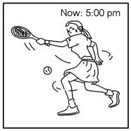 | (B)  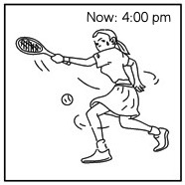 | (C)  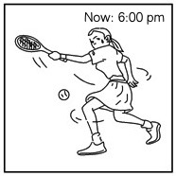
( ) 2.
(A)  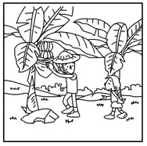 | (B)  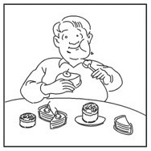 | (C)  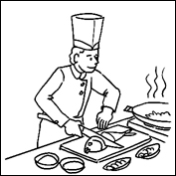
( ) 3.
(A)  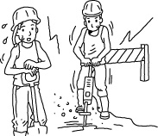 | (B)  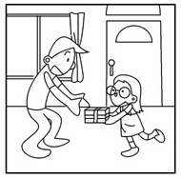 | (C)  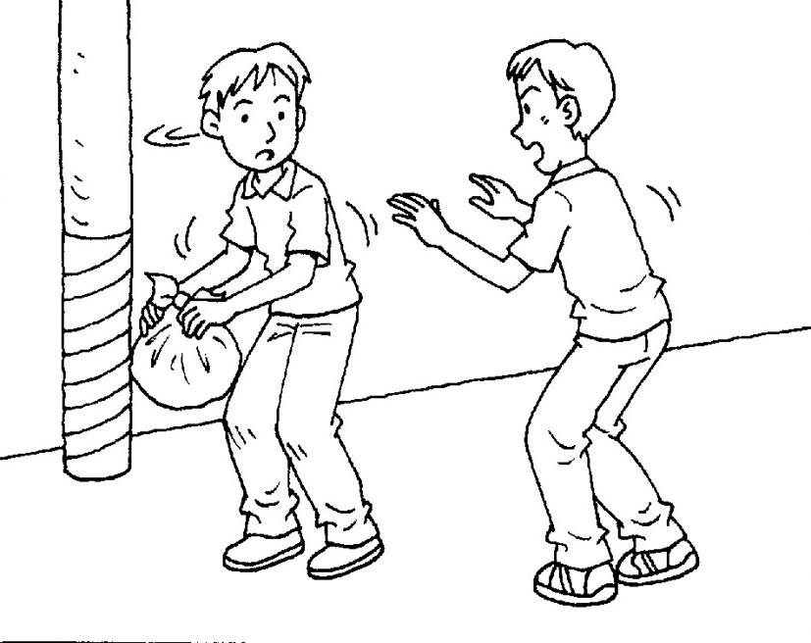
( ) 4.
(A)  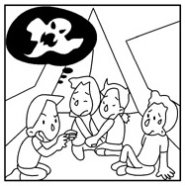 | (B)  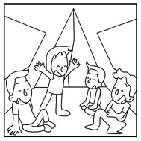 | (C)  
( ) 5.
(A)  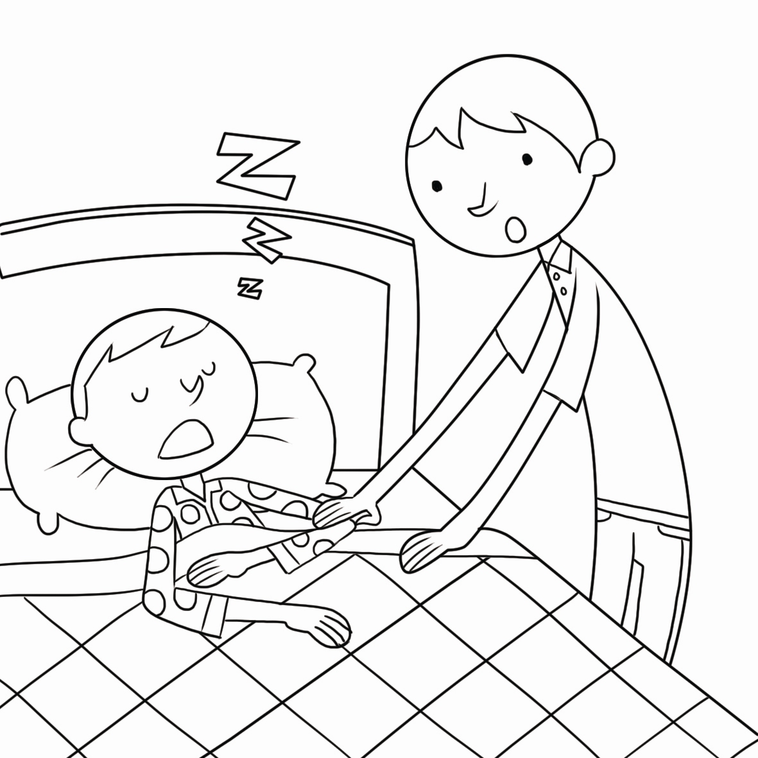 | (B)  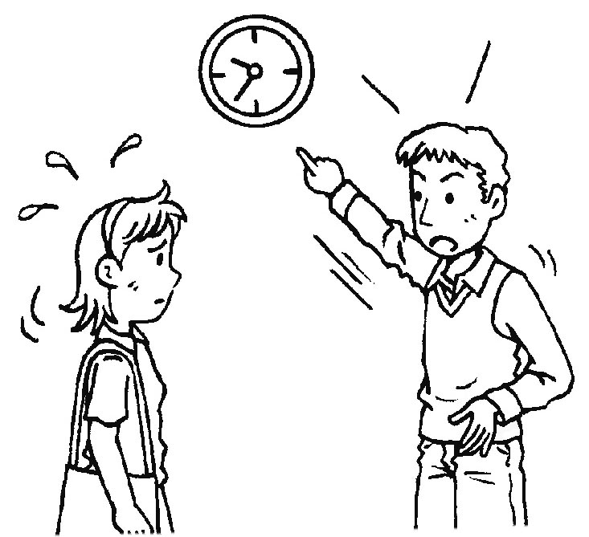 | (C)  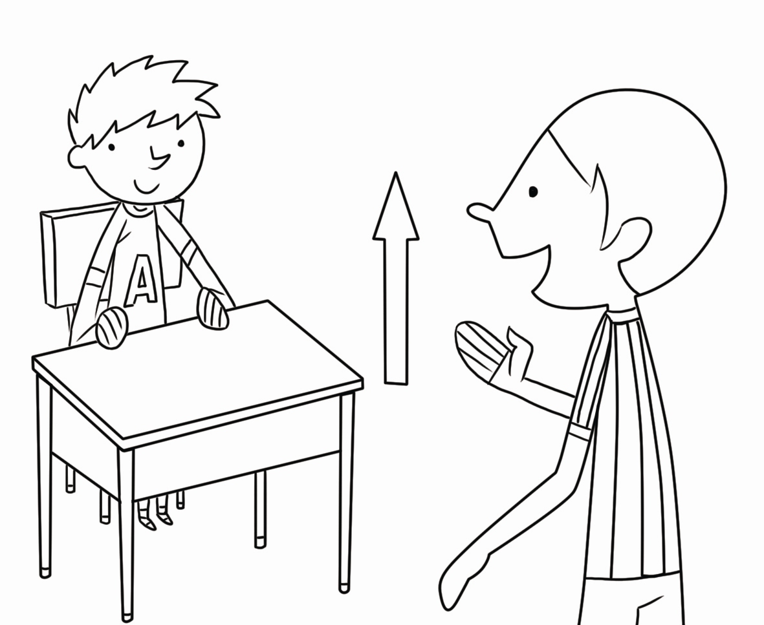

二、聽CD，選出適當的回應句 10%
( ) 1. (A) He’s bored with the trip tomorrow.
(B) He’s surprised at the trip tomorrow.
(C) He’s excited about the trip tomorrow.
( ) 2. (A) Yes, English and Chinese.
(B) Sure. In fact, I can speak four languages.
(C) Of course. I sometimes speak loudly.

( ) 3. (A) He has watched TV many times.
(B) He has watched TV already.
(C) He has watched TV since two.
( ) 4. (A) Help yourself to the fortune cookies.
(B) That’s your “fortune.” Go on! Read it.
(C) The fortune cookie has a strange taste.
( ) 5. (A) Yes, it’s a common snack food here.
(B) No, I haven’t touched it since yesterday.
(C) No, I’ve gone through the worst part of my life.

三、聽CD中的對話，選出適當的答案 10%
( ) 1. (A) Because of overfishing. (B) Because of oil spills. (C) Because of bad weather.
( ) 2. (A) She visited there last year. (B) She has never been there before. (C) She visited there with the man ten years ago.
( ) 3. (A) She’s interested in it. (B) She’s scared of its smell. (C) She doesn’t like the taste.
( ) 4. (A) Their new neighbor is helpful. (B) Their new neighbor is unhappy. (C) Their new neighbor is noisy.
( ) 5. (A) It tastes best when you eat it alone. (B) It goes well with tea. (C) It isn’t popular at all.

II、紙筆測驗：70％
- 文意字彙：10%
__________ 1. Philip has read many books about sea animals. He has gotten lots of kn ge of sea animals.
__________ 2. According to the news, eight p ts move around the Sun.
__________ 3. When Amy saw the snake, she felt very s red and cried out.
__________ 4. My pet dog is l ly. Everyone likes to play with him.
__________ 5. Vivian is interested in c ting teddy bears from different countries.
__________ 6. You can often see a r ow in the sky after the rain stops.
__________ 7. I have al y finished my homework. I can take a break now.
__________ 8. Ivy: Eric is always too p d of himself. Joe: No wonder he doesn’t have any friends.
__________ 9. Farmers work on the farm every day. They are h ng people.
__________ 10. Though Thomas Edison has been d d for many years, people still remember him.

- 文法選擇與對話：20% (選出最適當的答案)
( ) 1. Many of my classmates have had the experience of taking an airplane, but I _____.
(A) don’t (B) wasn’t (C) won’t (D) haven’t
( ) 2. Many Taiwanese love pig’s blood cake, but some are scared of _____ this snack.
(A) eat (B) ate (C) eating (D) eaten
( ) 3. A: have you learned Japanese ? B: For about three months.
(A) When (B) How long (C) How often (D) What time
( ) 4. The tall man over there is our new English teacher, _____ ?
(A) is he (B) is there (C) isn’t he (D) isn’t there
( ) 5. I am _____ at the _____ news, a gun shooting(槍擊) event in the USA.
(A) surprised; surprising (B) surprised; surprised (C) surprising; surprising (D) surprising; surprised
( ) 6. Alice really likes having noodles for breakfast, _____?
(A) doesn’t she (B) is she (C) hasn’t she (D) did she
( ) 7. Lily _____ to Japan. She will fly back to Taiwan next Tuesday.
(A) has been (B) has gone (C) is going (D) was going
( ) 8. The new house _____ Ms. Li. She bought it last year.
(A) puts up with (B) eats up (C) leads to (D) belongs to
( ) 9. Ryan: Would you like to play tennis with me?
Dara: No, thanks. _______ it for three hours already. I’m tired now.
- I play (B) I’m playing (C) I’ve played (D) I’ll play
( ) 10. Alice: Have you ever been to a baseball game?
Jamie: No, never. ________
(A) Do you? (B) Have you? (C) Don’t you? (D) Haven’t you?

- 依句意填入適當的答案完成句子：6% (每格不限一字，全對才給分)
1. Terry likes sea animals. He is _____ (interest) the book about sharks.
2. You won’t leave us, _____?
3. Mr. White has stayed in this hotel _____ five days.
4. The trip to Taipei Zoo is _____ (surprise) to me.
5. Judy hasn’t seen her grandmother _____ last June.
6. The twins can sing and dance well, _____?

- 克漏字選擇：10% (選出最適當的答案)
Have you ever ( 1 ) any special dishes before? In Korea, there is a very special dish, Sannakji. The cook ( 2 ) the live octopus and serves it to the customers right away. Although the octopus is just dead, its body pieces are still moving. People usually feel ( 3) at first. But after they taste it, they love the dish very much. So, are you
( 4 ) Sannakji now? Next time you go to Korea, you can ( 5 ) .
( ) 1. (A) tried (B) tring (C) try (D) tries
( ) 2. (A) has cut (B) have cut (C) cuts (D) cut
( ) 3. (A) scary (B) scared (C) scary to (D) scared of
( ) 4. (A) interesting (B) interested (C) interesting to (D) interested in
( ) 5. (A) show it to people (B) cut it in half (C) give it a try (D) hold it close to your nose

- 閱讀測驗：12% (選出最適當的答案)
(I)
Small Rice, Big Dream
Central Taiwan News May 13, 2008
Two years ago, a small town in Changhua started to grow healthy rice. The healthy rice was not grown by farmers but by students from a small elementary school of only about fifty people.
The idea of growing rice came from the school teachers. When making teaching plans, the teachers decided to teach students how to grow healthy rice on school land. They wanted the students to get closer to the land and learn to help each other when doing the rice farming outside the classroom.
What’s better, the school made money from selling the rice and giving farming classes to the public. With the money, the school could help students who wished to go to foreign countries some day. Today the dream is becoming real — the students are flying to Japan to share their special farming experiences, and have fun over there, of course! “We all feel very proud that even students from a small town can make themselves seen in the world,” said one of the teachers.
( ) 1. What is the reading about?
(A) A successful teaching plan. (B) A new way of cooking rice.
(C) A language class for farmers. (D) A famous teacher from a small town.
( ) 2. Which is said in the reading?
(A) Farming makes students healthy. (B) Farming helps the school make money.
(C) The school bought the land for the farming classes. (D) It is important for farmers to make good use of land.
( ) 3. What is the dream?
(A) Growing healthy rice. (B) Building more schools.
(C) Visiting a foreign country. (D) Learning outside the classroom.
(II)
Do you like colorful things? If you do, you will probably like rainbows a lot. Rainbows often appear after rain in the sky. It has the shape of half a circle. There are seven colors in a rainbow. The colors are red, orange, yellow, green, blue, indigo and violet. Some people like rainbows because they look pretty, and some people believe that rainbows can bring good luck. In our daily life, we sometimes have a hard time facing difficult things. However, we can always look at the bright side and wait for the rainbow of our life to come out. No matter what reason makes you like rainbows, it’s sure that rainbows bring good hope to people. Look up in the sky after rain next time. Maybe you will see a beautiful rainbow that makes you happy!
( ) 4. What may indigo be?
(A) A flower. (B) A color. (C) A language. (D) A shape.
( ) 5. What do some people believe that rainbows can bring?
(A) Food. (B) Difficult things to life. (C) Rain. (D) Good luck.
( ) 6. Which is true about the article?
(A) Rainbows are made of water. (B) Nobody likes to see rainbows
(C) It’s sure rainbows bring good hope to people. (D) We can’t see any bright side of our life.

- 依提示作答及翻譯：12% (每題3分，分段給分)
- Simon got hurt. （用Not only…but also…合併）
Gina got hurt, too.
2. My sister plays the piano beautifully. (用Frank said (that) 改寫句子)
3. 世界屬於勤勞耕耘者。
4. 如果我們不作改變，很多海洋生物不久後將會消失無蹤。

高雄市立林園高級中學國中部 103學年度第一學期 三年級英語科 第一次段考 作答卷 (解答)
班級： 座號： 姓名：
I、聽力測驗：30％ (選出最適當的答案)
一、聽CD，配合圖片選出最適當的答案 10%
1. | A | 2. | C | 3. | C | 4. | A | 5. | B
二、聽CD，選出適當的回應句 10%
1. | C | 2. | B | 3. | C | 4. | B | 5. | A
三、聽CD中的對話，選出適當的答案 10%
1. | A | 2. | A | 3. | B | 4. | C | 5. | B

II、紙筆測驗：70％
一、文意字彙10%
1. | knowledge | 2. | planets | 3. | scared | 4. | lovely | 5. | collecting
6. | rainbow | 7. | already | 8. | pround | 9. | hard-working | 10. | dead
二、文法選擇與對話20% (選出最適當的答案)
1. | D | 2. | C | 3. | B | 4. | C | 5. | A
6. | A | 7. | B | 8. | D | 9. | C | 10. | B
三、依句意填入適當的答案完成句子：6% (每格不限填一個字， 全對才給分)
1. | interested in | 2. | will you | 3. | for | 4. | surprising | 5. | since
6. | can’t they
四、克漏字選擇10%(選出最適當的答案)
1. | A | 2. | C | 3. | B | 4. | D | 5. | C
五、閱讀測驗12%(選出最適當的答案)
1. | A | 2. | B | 3. | C
4. | B | 5. | D | 6. | C
六、依提示作答及翻譯：12% (每題3分，分段給分)
1. | Not only Simon / but also Gina / got hurt.
2. | Frank said that / his sister / played the piano beautifully.
3. | The world / belongs to / hard-working people.
4. | If we don’t make a change, / a lot of sea life / will be gone soon.
高雄市立林園高級中學國中部 103學年度第一學期 三年級英語科 第一次段考聽力測驗錄音稿

- 聽CD，配合圖片選出最適當的答案10%
( A ) 1. Pam has played tennis since 3:00 p.m. She has played it for two hours already.
(A) | (B) | (C)
( C ) 2. Making foreign dishes is interesting to the man.
(A) | (B) | (C)
( C ) 3. Please take the garbage to somewhere else. It smells really bad.
(A) | (B) | (C)
( A ) 4. The students felt scared when listening to the story.
(A) | (B) | (C)
( B ) 5. Don’t be late again, will you?
(A) | (B) | (C)

二、聽CD，選出適當的回應句 10%
( C ) 1. Why does Tommy look so happy today?
(A) He’s bored with the trip tomorrow.
(B) He’s surprised at the trip tomorrow.
(C) He’s excited about the trip tomorrow.
( B ) 2. You can speak three languages, can’t you?
(A) Yes, English and Chinese.
(B) Sure. In fact, I can speak four languages.
(C) Of course. I sometimes speak loudly.

( C ) 3. How long has Jim watched TV?
(A) He has watched TV many times.
(B) He has watched TV already.
(C) He has watched TV since two.
( B ) 4. What’s this piece of paper inside the fortune cookie for?
(A) Help yourself to the fortune cookies.
(B) That’s your “fortune.” Go on! Read it.
(C) The fortune cookie has a strange taste.
( A ) 5. Have you ever eaten stinky tofu before?
(A) Yes, it’s a common snack food here.
(B) No, I haven’t touched it since yesterday.
(C) No, I’ve gone through the worst part of my life.

三、聽CD中的對話，選出適當的答案 10%
( A ) 1. Man: I feel sorry for the people in this town.
Woman: Why do you say so?
Man: The number of the fish in this lake has become lower and lower.
Woman: You’re right. Fishermen caught almost all the fish in the lake in the past five years.
Question: Why are there fewer fish in the lake than before?
(A) Because of overfishing. (B) Because of oil spills. (C) Because of bad weather.
( A ) 2. Woman: Rome is such a beautiful city!
Man: Have you been there before?
Woman: Yes, I went there last summer. And I want to go there again some day.
Man: I’ve never been to Rome before. Maybe we can visit there together.
Question: When did the woman visit Rome?
(A) She visited there last year. (B) She has never been there before. (C) She visited there with the man ten years ago.
( B ) 3. Man: The blue cheese tastes really good. Come on. Have some.
Woman: No, thanks. It smells like dead fish to me.
Question: How does the woman feel about the cheese?
(A) She’s interested in it. (B) She’s scared of its smell. (C) She doesn’t like the taste.
( C ) 4. Man: I really don’t like our new neighbor.
Woman: Me, either. He makes a lot of noise at night.
Man: He is not only noisy but also dirty.
Woman: Yeah. He always puts his garbage on the street.
Question: Why DON’T the man and the woman like their new neighbor?
(A) Their new neighbor is helpful. (B) Their new neighbor is unhappy. (C) Their new neighbor is noisy.
( B ) 5. Man: This cake isn’t delicious at all. Why is it so popular?
Woman: Well, you can’t eat it alone. Here, eat it with a cup of tea.
Man: Hmm…. Not bad. In fact, it tastes really good!
Woman: I’m happy you like it.
Question: What is true about the cake?
(A) It tastes best when you eat it alone. (B) It goes well with tea. (C) It isn’t popular at all.

