高雄市立林園高級中學 國中部 103學年度 第一學期 三 年級 英文 科 第 二 次段考試卷
班級： 姓名： 座號：
本試卷共（ 4 ）頁

壹、聽力測驗（每題2分，共30分）

一、聽CD，配合圖片選出最適當的答案。：
1.
(A)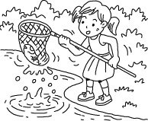 (B)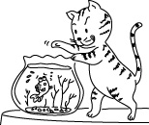 (C)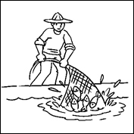
2.
(A)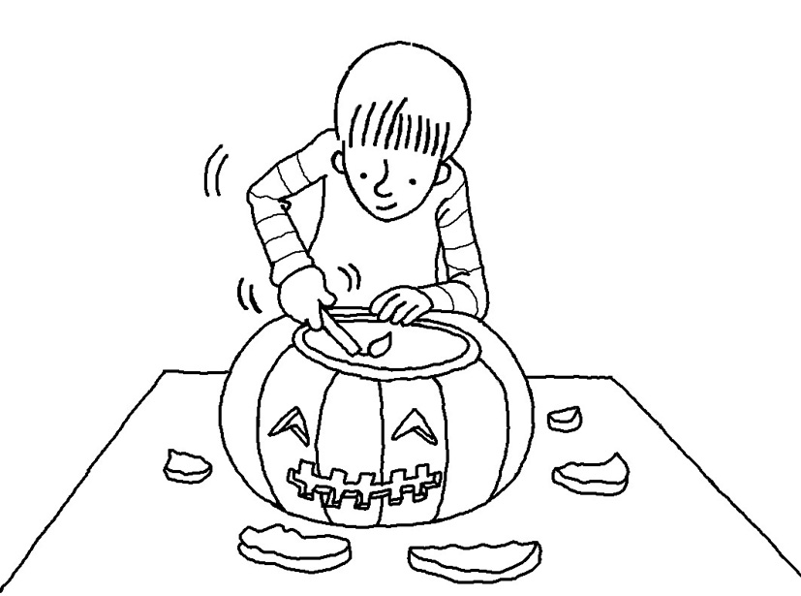 (B)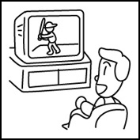 (C)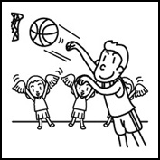
3.
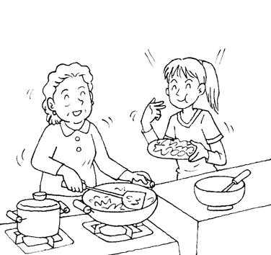
4.
(A)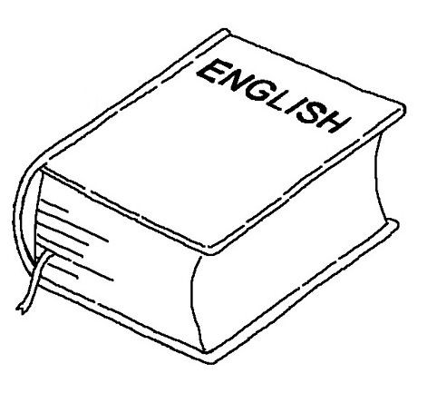 (B)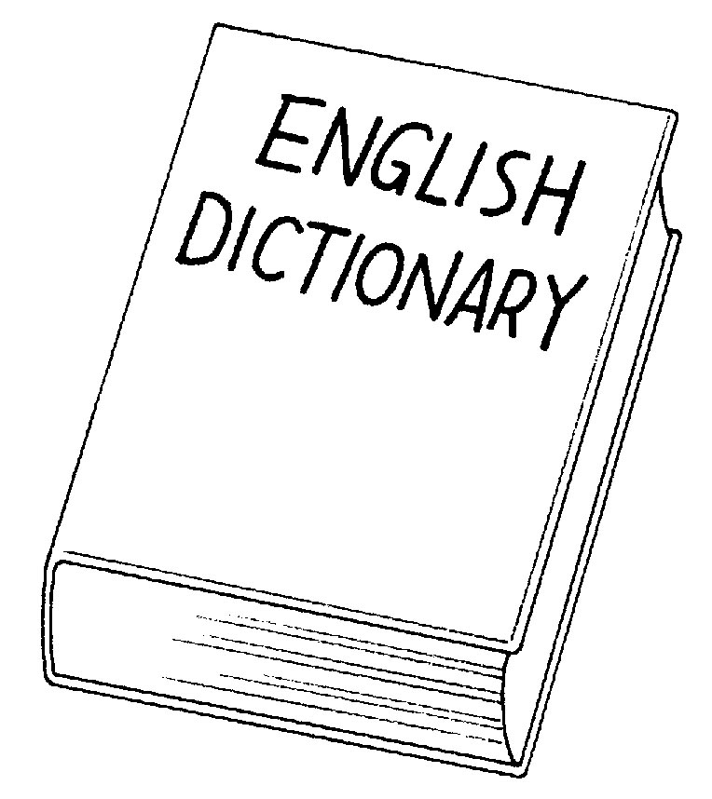 (C)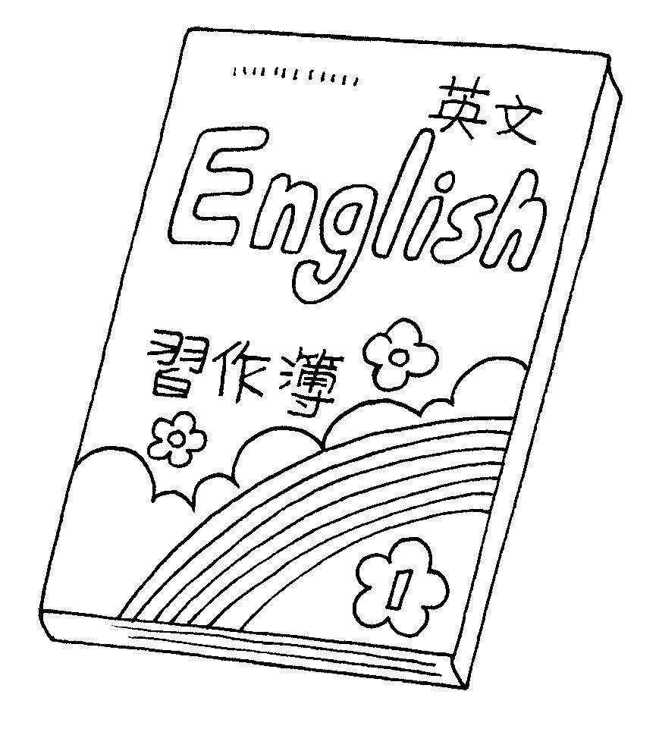
5.
(A)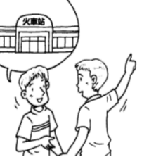 (B)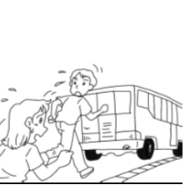 (C)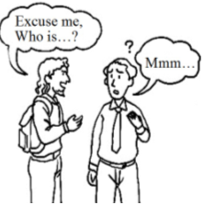

二、聽CD，選出適當的回應句。：
1.
(A) It is painted by a friend of mine.
(B) The picture was hung up on the wall.
(C) Painting pictures is interesting.
2.
(A) Would you tell me why I should do that?
(B) Yes, I am lying on the ground now.
(C) I didn’t hurt my knees yesterday.
3.
(A) I feel like smoking.
(B) Let’s tidy up our apartment.
(C) Let’s check out what’s happening.
【背面還有聽力試題】
4.
(A) No, he didn’t swing the bat.
(B) Yes, he is focusing his mind on the ball.
(C) I’m not sure if he will hit a home run or not.
5.
(A) Yes, they will leave at ten.
(B) No, I don’t have a better choice.
(C) Yes, they will go to the fashion show.

三、聽CD中的對話，選出適當的答案。：
1.
(A) She is good at music.
(B) She can dance well.
(C) She is the leader of Class 802.
2.
(A) The woman believes what the e-mail says.
(B) The woman got the same e-mail before.
(C) The woman thinks the world will end in two years.
3.
(A) The wood spirits.
(B) The man’s bad luck.
(C) The history about the temple.
4.
(A) The girl is so worried that she can’t focus on her study.
(B) The girl has to study math at a cram school every day.
(C) The girl’s father will run a cram school this summer.
5.
(A) John lied to her last time.
(B) John looks too weak to be true.
(C) John didn’t clean the classroom.

貳、紙筆測驗
四、字彙測驗（每題1分，共10分）
1. ＿＿＿＿＿＿ Because of HSR, going from Taipei to Kaohsiung has become more c t. (習作P16)
2. ＿＿＿＿＿＿ The tallest student in my class is 182 ce ers tall. (習作P21)
3. ＿＿＿＿＿＿ Alan: May I speak to Judy now?
Brian: Just a m t. She’s in a meeting now. (習作P26)
4. ＿＿＿＿＿＿ The little baseball player broke the window again! He is going to get himself into tr le. (習作P16)
5. ＿＿＿＿＿＿ Tom fell off his bike and hurt his kn es. He can’t walk now. (習作P21)
6. ＿＿＿＿＿＿ Remember to fasten your seat b t when you take a taxi. (習作P26)
7. ＿＿＿＿＿＿ The little boy is hiding b d the big tree. (習作P16)
8. ＿＿＿＿＿＿ During the Chinese New Year, parents give their children red e pes with lucky money in them.
(習作P21)
9. ＿＿＿＿＿＿ Before our teacher talked about the Earth, she drew a c le on the blackboard. (習作P27)
10.＿＿＿＿＿＿ Selena’s American friends tried every snack in the night market e t stinky tofu because they didn’t like
its smell. (習作P27)

五、依提示改寫或完成句子（每題1分，共6分）：（每題不限一字，全對才給分）
1. Samuel: Did you go to the party?
Emma: No, I ___________________ (invite). (習作P17)
2. The picture ___________________ (hang) on the wall for ten years. (習作P17)
【請翻到第三頁】
3. The problem is serious. Something must ___________________ (do) before it’s too late. (習作P17)
4. Can we talk about what we can eat for lunch? (用wh-不定詞重寫句子)
 Can we talk about ___________________________________? (習作P24)
5. Dad asked me ___________________ ( if 或what，請寫出正確答案) my future plans were. (習作P27)
6. Philip asked Cathy___________________ (what或whether，請寫出正確答案) she liked the yellow T-shirt or not. (習作P27)

六、文法測驗（每題2分，共20分）
1.（ ）A new road is going to ＿＿＿ in town because traffic is getting busier and busier. (習作P19)
(A) be built (B) building (C) build (D) have built
2.（ ）Most of Jeff’s best books ＿＿＿ when he was sick and poor. (習作P19)
(A) have written (B) were written (C) would write (D) wrote
3.（ ）Anita: I saw Nora in the teacher’s office this morning. Do you know ＿＿＿ she was there?
Brian: She cheated on tests. (習作P24)
(A) how (B) if (C) when (D) why
4.（ ）Teacher: Does anyone know ＿＿＿ the famous writer was born?
Mei-ling: I know! In Taitung, right?
Teacher: You got it! (習作P24)
(A) how (B) when (C) where (D) whether
5.（ ）I want to go camping in the mountains this afternoon, but a typhoon is coming. I’m not sure ＿＿＿ the road to the mountains will be closed. (習作P29)
(A) how (B) what (C) whether (D) why
6.（ ）A-wei: This typhoon is so terrible!
A-fen: Yes, I’m not sure we can still go fishing tomorrow. (習作P29)
(A) who (B) what (C) which (D) whether
7.（ ）The account ＿＿＿ up early tomorrow morning.
(A) is setting (B) are set (C) set (D) will be set
8.（ ）Please tell me ＿＿＿ get to the Children’s Art Museum.
(A) how can I (B) how to (C) where I can (D) where to
9.（ ）May I ask who ＿＿＿ you ＿＿＿ your hand to?
(A) will; lend (B) have; lent (C) ; will lend (D) did; lend
10.（ ）The man in red is ＿＿＿ to save the kitten high up in the tree.
(A) tall enough (B) too tall (C) so tall (D) enough tall

七、克漏字測驗（每題2分，共6分）
Yesterday, when Mrs. Kerr was sleeping, she was woken up 1. a loud noise. She got up and found that her windows 2. . She was very angry, but she didn’t know who did this. Now, she has to ask someone to help her 3. the window.

（ ）1. (A) with (B) for (C) at (D) by
（ ）2. (A) were broken (B) broke (C) were breaking (D) are broken
（ ）3. (A) fixes (B) fixing (C) fix (D) fixed

八、閱讀測驗（每題2分，共12分）
A. In Dan Brown’s college years, he spent most of his time learning music and writing. After he finished his studies in college, he made money by making CDs because he always dreamed of being a successful composer. In 1993, he moved back to his hometown and worked as an English teacher. In his free time, he enjoyed writing some special stories. Three years later, Dan Brown left the school for writing. In 2003, his most popular book, The Da Vinci Code, was published. In The Da Vinci Code, a teacher had to find codes in da Vinci’s designs to work on a strange case. Millions of book fans loved the book very much, and Dan Brown was thought to be a great writer then. In fact, almost each of his works shows his ideas about religion and science. By reading them, we may know the way he looks at the world.
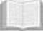 college 大學 composer 作曲家 code 密碼 publish 出版 religion 宗教

【請翻到第四頁】

（ ） 1. What did Dan Brown have interests in when he was a student in college?
(A) Teaching music.
(B) Reading strange stories.
(C) Learning music and writing stories.
(D) Being a good English teacher.
（ ） 2. What is true about Dan Brown before 1993?
(A) He became a popular writer.
(B) He had to work on strange cases about da Vinci.
(C) He wanted to write his own songs.
(D) Science was always boring to him.
（ ） 3. What are most of Dan Brown’s works about?
(A) Knowledge about da Vinci’s paintings.
(B) The way to be a successful writer.
(C) Stories about his book fans around the world.
(D) His thinking about science and religion.
B. Have you ever eaten sandwiches? Do you know where the name, “sandwich,” came from? It came from England a long time ago. In fact, “sandwich” at first was the last name of an earl. The Earl of Sandwich liked playing cards very much. He was often busy playing with his friends, so he didn’t want to get off the table. Every time he played cards, he forgot to eat meals. Of course, at last, he would feel hungry. So, he asked his servants to put some meat between two pieces of bread. In this way, he could continue playing cards and eat something at the same time. When his friends saw this, they also put meat between two pieces of bread. They all liked what sandwiches tasted like. The bread with meat became more and more popular, and later it was named after the Earl of Sandwich.
earl 伯爵 servant 僕人 continue 繼續

（ ）4. What does “this” mean?
(A) The earl’s servant.
(B) The card game.
(C) The bread with meat.
(D) The meal between two card games.
（ ）5. Where did the name “sandwich” come from?
(A) An interesting card game.
(B) An earl’s last name.
(C) A kind of meat.
(D) One of the earl’s friends.
（ ）6. What is the best title for the story?
(A) How the Sandwich Got Its Name
(B) How to Make a Sandwich
(C) Playing Cards Makes People Smarter
(D) Playing Cards Is Not Good for Your Health

九、翻譯﹙分段給分，共16分﹚
1. 我必須決定該去就讀高中或職業學校。（3分）(課本P64）
2. 我還是不想（feel…）使用它。（2分）(課本P41）
3. 終於，幾小時之後，Baby就被我的其中一位朋友找到了。﹙4分）(課本P41﹚
4. 或許你只是太過於煩惱而無法清楚地思考。﹙3分）(課本P71﹚
5. 他們想知道四樓是否已被打掃乾淨以防止嬰孩被燙傷。﹙4分﹚
【試題結束】

高雄市立林園高級中學 國中部 103學年度 第一學期 三年級 英文科 第 二 次段考 解 答
班級： 姓名： 座號：
一、聽CD，配合圖片選出最適當的答案（每題2分，共10分）：
1. C | 2. C | 3. A | 4. C | 5. A
二、聽CD，選出適當的回應句（每題2分，共10分）：

1. A | 2. A | 3. C | 4. A | 5. C
三、聽CD中的對話，選出適當的答案（每題2分，共10分）：

1. C | 2. B | 3. B | 4. A | 5. A
四、字彙測驗（每題1分，共10分）
1. convenient | 2. centimeters | 3. moment | 4. trouble | 5. knees
6. belt | 7. behind | 8. envelopes | 9. circle | 10. except
五、依提示改寫或完成句子（每題1分，共6分）：（每題不限一字，全對才給分）
1. wasn’t invited | 2. has been hung | 3. be done
4. what to eat for lunch | 5. what | 6. whether
六、文法測驗（每題2分，共20分）
1. A | 2. B | 3. D | 4. C | 5. C
6. D | 7. D | 8. B | 9. C | 10. A
七、克漏字測驗（每題2分，共6分）
1. D | 2. A | 3. C
八、閱讀測驗（每題2分，共12分）
1. C | 2. C | 3. D
4. C | 5. B | 6. A
九、翻譯﹙分段給分，共16分﹚
1.（3分）I have to decide whether / I should go to high school / or vocational school.
2.（2分）I still don’t / feel like using it.
3.（4分）Finally, / Baby was found / by a friend of mine / after a few hours.
4.（3分）Maybe you’re / simply too worried / to think clearly.
5.（4分）They wonder whether / the fourth floor has been tidied up / to stop babies / from being burned.

