高雄市立林園高級中學 國中部 103學年度 第1學期 3年級 英文科 第3次段考 試題卷
班級： 姓名： 座號：
◎本試卷共（ 4 ）頁
壹、聽力測驗 30%（每題2分）
一、聽CD，選出適當的回應句：
1.
(A) Your life has hit bottom.
(B) My school life is full of trouble.
(C) I can see you’re filled with hope.
2.
(A) Yes, she rose above all her problems.
(B) Yes, her life is always filled with pleasure.
(C) Yes, she had a lot of problems in her early life.
3.
(A) No. All of the trains run under the ground.
(B) Yes. That way, we can have more space above ground.
(C) Yes. That’s why you see the trains running between buildings.
4.
(A) I can’t do anything well.
(B) Yes, I asked my parents to do it for me.
(C) I wrote down everything I needed to do and finished it one by one.
5.
(A) I read alone at home.
(B) I ate pizza in the living room.
(C) I talked to my classmates until they came.

二、聽CD，配合圖片選出最適當的答案。：
6. 7. 8. 9. 10.
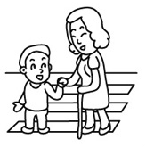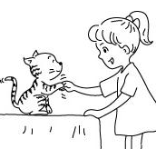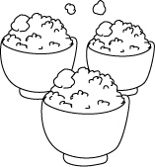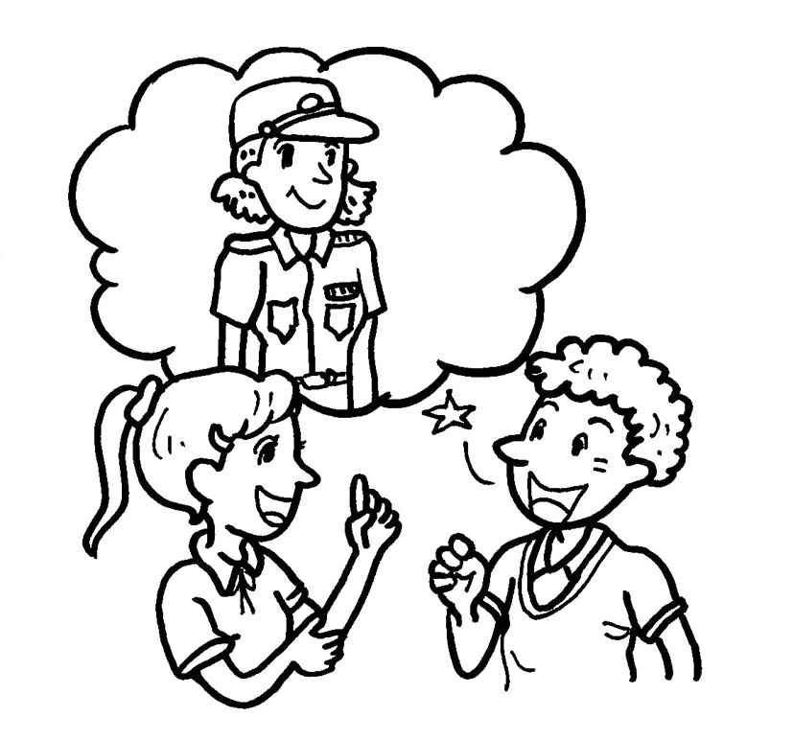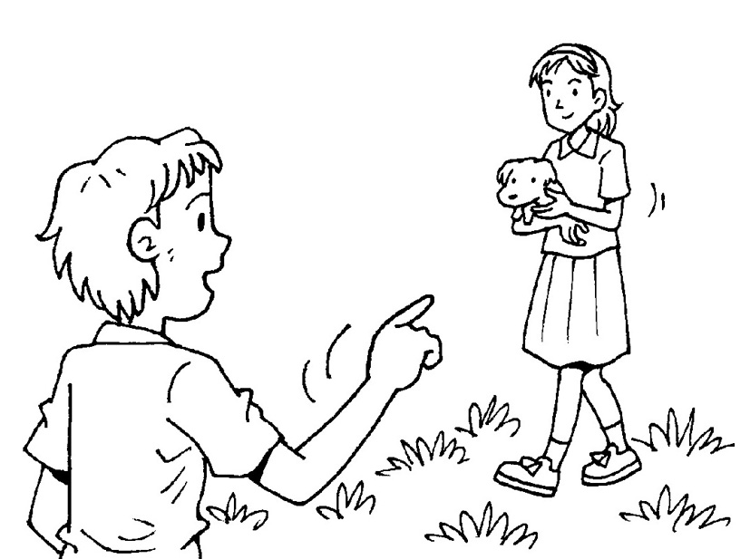

三、聽CD中的對話，選出適當的答案。：
11.
(A) The man is too full to eat any desserts.
(B) The man wants to have some desserts after the meal.
(C) The man doesn’t want the waitress to clean up the table.
12.
(A) A card from another country.
(B) A postcard from Green Island.
(C) A Christmas card from a friend.
13.
(A) Bob turned her down.
(B) Bob is every girl’s idol.
(C) Bob laughs at poor people.
【背面還有聽力試題】

14.
(A) The woman bought the pizza in a market.
(B) The woman is in the dining room.
(C) There is some cheese on the top of the pizza.
15.
(A) The man is buying plates.
(B) The man is washing the dishes.
(C) The man is making dinner.

貳、紙筆測驗 70%
四、字彙測驗 10% ( 每題1分 )
16. If someone makes you really angry, you may become like a “ ”. (課本 P109)
(A) pizza (B) barbecue (C) sofa (D) volcano
17. Mr. Chang’s courage（勇氣） is a good . We’re so lucky to follow him.
(A) waitress (B) actress (C) example (D) farmer
18. In Taiwan, rocks may a hill because of heavy rain. (習作 P41)
(A) stress out (B) slide down (C) go up (D) light up
19. Son：Mom, I want to exercise. Can you take the with me? Mom：No. I don’t want to do that.
(A) stairs (B) notebooks (C) habits (D) postcards
20. Sorry. Could you that question again？ I couldn’t hear you. (習作 P31)
(A) pleasure (B) repeat (C) mail (D) quarter
21. A：Your sister is studying , right? B：Yes, she’s in America now. She majors（主修） in music.
(A) aboard (B) below (C) already (D) abroad
22. Lisa keeps a of going jogging in the park every morning. (習作 P36)
(A) dictionary (B) garden (C) habit (D) sofa
23. It’s too hard to how I feel about the event. It made me mad. Now, do I really care about that ?
(A) pin down (B) get on (C) go away (D) take off
24. Everyone has different at different times. Sometimes we feel happy, and sometimes we feel sad. (習作 P42)
(A) hobbies (B) postcards (C) chalk (D) emotions
25. The Sun in the east and sets in the west . (習作 P31)
(A) above (B) rises (C) ahead (D) below
五、文法測驗 38% ( 每題2分 )
26. The movie is about a true story happened in Korea in 1945 . (習作 P39)
(A) it (B) that (C) what (D) when
27. The boy is my brother. The girl is Brenda. (習作 P34)
(A) with a smile； in a purple dress (B) lives there；with long hair (C) with green tie；in pink (D) next to me；in glasses
28. Mom： did you buy？ Kathy： . (習作 P31)
(A) How many glasses；Two dozens (B) How many eggs；A dozen (C) How many eggs；A dozen of eggs. (D) What；A dozen.
29. The book I read every night . (課本 P111)
(A) what ；was really interesting (B) × ；was really interested (C) that ；is really interested (D) × ；is really interesting
30. You may not agree the test says.（課本P109）
(A) with ；that (B) that ；what (C) with ； what (D) with ； which
31. 選出正確的句子：
(A) The pet cat and the old lady who are walking there looks cute.
(B) The house which the rich man lives in is very wonderful.
(C) Who is the foreigner who is talking to your mother？
(D) I know that a nobody likes me can get somewhere in life.
32. Now, over of Stockholm’s cars and buses run on biogas. (課本 P97)
(A) quarters of three (B) three - quarter (C) three of quarters (D) three-quarters
33. This is the man money . (課本 P100)
(A)whose ； was stolen (B) whose ； from his mother (C) his ；was stolen (D) whose his ；was burned
34. Nick Vujicic and I have nothing common. (習作 P34)
(A) at (B) on (C) in (D) with
35. You may not agree the test . Don’t worry. (課本 P109)
(A) to ；that ；say (B) with ；what ；says (C) with ；that ；speaks (D) on ；which ；tells
36. If is people are looking for, then Stockholm is surely a good living example. (課本 P97)
(A) go green ；that (B) going green ；which (C) go green ；what (D) going green ；what
37. Nick used to busy , but now he is lazy. Also, he is often scolded by his parents.
(A) be ；studying (B) be ；to study (C) being ；studying (D) being ； to study
38. Car drivers biogas can park first in the city. The gas waste water. （課本P96）
(A) that uses ；is made from (B) who use ；is made of (C) that use ；is made from (D) who use；is made by
39. I have to you the truth. My school life . I ‘m not popular at school.（課本P85）
(A) say；has hit bottom (B) tell；has hit bottom (C) told；has hit bottom (D) speak；has hit bottom
40. The medicine I you this morning should be taken three times a day.(習作 P44)
(A) to give (B) given (C) giving (D) gave
41. Don’t go to bed you finish your homework. (習作 P44)
(A) when (B) which (C) who (D) until
42. Take the following test to pin down . (課本 P108)
(A) who are you (B) who you are (C) who is it (D) what are you
43. Look closer. He’s a man arms and legs. Life must hard for him. (課本 P79)
(A) without ；be (B) without ；is (C) with ；to be (D) with ；been
44. You have to face and making friends in your life. (課本 P84)
(A) all types of the problems in learning (B) all types of the problems to learn
(C) all types of problems in learning (D) all types of problems to learn
六、克漏字選擇 10% ( 每題2分)
What will you do to pass the test for entering senior high school ? Many people will study hard, but some people will do
45. . For example, the test for entering college is also coming, and many people go to Wenchang temples to 46. good grades. Wenchangdijun is the god of examination in Chinese legend. Many students pray to him 47. good grades on tests for entering college or senior high school.
There are always some stands in front of Wenchang temples. The vendors there are always selling some goods to the students and their parents. The goods are believed to help students 48. smart and hard-working. Maybe it is good to pray to Wenchangdijun , but students had better 49. hard on their own.
▓ Wenchangdijun 文昌帝君 examination考試 legend 傳說 goods 商品
（ ）45. (A) nothing delicious (B) something special (C) different thing (D) funny everything
（ ）46. (A) deal with (B) run out of (C) pray with (D) pray for
（ ）47. (A) to get (B) getting (C) get (D) got
（ ）48. (A) are (B) were (C) be (D) been
（ ）49. (A) studying (B) study (C) to study (D) studied

七、閱讀測驗 12% ( 每題2分)
A. Have you ever been to Australia？ It is a wonderful country best known for many special things：the beaches, the outback, the wildlife, and so on. But do you know it is also best known for having the world’s worst greenhouse gas problem ?
On March 31, 2007, four million people in Sydney turned off all their lights for one hour from 7：30 p.m. to 8：30 p.m. to show their support for fighting global warming. Families even got together at parks and other public places to count down for the lights out.
Although this event was very successful, it was only the first step to make Australia a better place to live in. The Australian government hopes its people will think about what else they can do to fight global warming together in the future.
▓ global warming 全球暖化 the outback 澳洲內陸 wildlife 野生生物 greenhouse gas 溫室廢氣

( ) 50. What is NOT Australia best known for ?
(A) Its fruits. (B) Its wildlife. (C) Its beaches. (D) Its greenhouse gas problem.
( ) 51. Why did families in Sydney get together on the evening of March 31, 2007 ?
(A) To smell the greenhouse gas.
(B) To count down for the lights out together.
(C) To have a meeting about fighting global warming.
(D) To have a countdown party for their national holiday.
( ) 52. Which is true about the article?
(A) There are four million people in Australia.
(B) People in Australia don’t really care about global warming.
(C) The lights out started at 7：30 a.m. and ended at 8：30 p.m.
(D) Australia has the worst greenhouse gas problem.
B. Afternoon Sleep
Henry: Mom, can you talk to my teacher ?
Mom: Why ? Is there anything wrong ?
Henry: No, I just don’t want to waste time on sleeping after lunch.
Mom: But won’t you feel sleepy later if you don’t rest at that time ?
Henry: No, I don’t think so.
Mom: I see, but most of your classmates want to rest , don’t they ?
Henry: Yes, but I don’t make any troubles. I can read by myself.
Mom: The school must have some reasons for the policy. People usually do things better after they have taken a rest.
Henry: You know I always do well at school.
Mom: Well…I may try to talk to your teacher. But she has to think of other students. You know those who don’t sleep may make noise.
Henry: What if the teacher lets me help in the office ?
Mom: That may be a good idea. Oh, but the teachers may need to rest, too.
Henry: If they do, I’ll give up the idea. But, we don’t know yet. Would you please talk to Ms. Fu first ?
Mom: OK. Do you have her phone number?
Henry: Here you are. ▓ policy 政策
( ) 53. Who is Ms. Fu ?
(A) Henry’s sister.
(B) Henry’s class teacher.
(C) The secretary of Henry’s father.
(D) Henry’s classmate’s mother.
( ) 54. Why does Henry want his mother to talk to Ms. Fu ?
(A) He does not want to rest after lunch.
(B) He does not do very well at school.
(C) Some of his classmates make a lot of noise.
(D) He wants to help in the teachers’ office during lunch.
( ) 55. What can Henry finally do after lunch ?
(A) Take a rest.
(B) Read books.
(C) Help teachers.
(D) We do not know yet.
3年級 英文 科 第 3 次段考--答案欄（年級、科目請標示清楚，謝謝！）
1 ~ 5 C C B C C 6 ~ 10 C C A A B
11 ~ 15 B B C C B 16 ~ 20 D C B A B
21 ~ 25 D C A D B 26 ~ 30 B A B D C
31 ~ 35 B D A C B 36 ~ 40 D A C B D
41 ~ 45 D B A C B 46 ~ 50 D A C B A
51 ~ 55 B D B A D

