班級： 姓名： 座號：
第一部分 Listening Comprehension 聽力測驗 （30 %）
一.根據聽到的內容，圖片相符的寫(A)，不符的寫(B) 10%
1.( )  | 2.( )  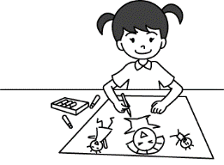 | 3.( ) 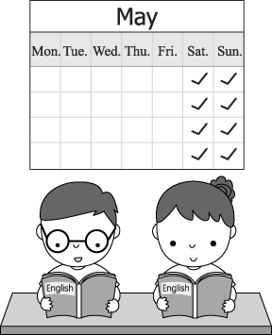 | 4.( )  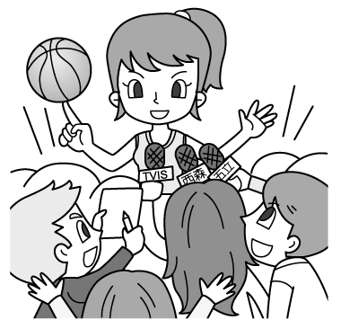 | 5.( )  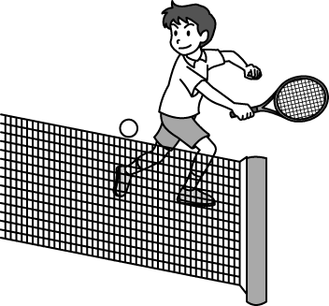

二. 基本問答：根據聽到的內容，選出一個最適合的回應或最適合的問句 10%
( ) 6. (A) Sorry, this is Vincent speaking. (B) Hold on, please. (C) No, I can’t.
( ) 7. (A) OK! Let’s watch TV now. (B) My mother watches TV for forty minutes. (C) I don’t watch TV. I
walk after dinner.
( ) 8. (A) At work. (B) At 7 p.m. (C) Before lunch.
( ) 9. (A) Don’t mind hard work. (B) I’m very tall. (C) I’m one hundred and sixty.
( ) 10. (A) He plays tennis. (B) Yes, he watches NBA. (C) He exercises with his wife.
( ) 11.(A) For thirty minutes a day. (B) I play baseball from seven to nine. (C) Yes, I love it. I play it from
Monday to Friday.
( ) 12. (A) He watches NBA games. (B) No, he doesn’t do that every day. (C) He does that with his coach.
( ) 13. (A) Sure, we have lots of time. (B) Come on! Don’t you like English class. (C) Yes, and that’s our
favorite class.
( ) 14. (A) Yes, I am reading love stories. (B) No, I am writing a story about animals. (C) Well, my family all
like my love stories.
( )15. (A) Who can catch a ball? (B) What can your cat do? (C) Where can your cat be?

三. 言談理解：根據聽到的內容，選出一個最適合的答案 10%
( ) 16. (A) Sally. (B) Kelly. (C) Polly.
( ) 17 (A) Watch TV. (B) Brush his teeth. (C) Study English.
( ) 18. (A) Five. (B) Nine. (C) Thirteen.
( ) 19 (A) A bus. (B) A chair shop. (C) A museum.
( ) 20. (A) They study. (B) They help the old people. (C) They love flowers.

第二部分 Reading & Writing Comprehension讀寫測驗 （70 %）
一.文意字彙 (全對才給分) 20%
21.____ My family and I eat b_____t at 7:30 every morning.
22._____There are twenty-four h_____s in a day.
23._____ There are twelve m____s in a year.
24._____ Nancy p_____es the piano for five hours every day.
25._____ Louis Liu can do a lot of magic t____s on TV.
26._____ My two-year-old sister can c____t from one to fifty .
27._____ Are you free now? How about playing c______r games with me.
28._____ The robots in the movie “Transformers” can c_____e into cool cars.
29._____ The elephant in the picture can dance and r______r things for a long time.
30._____Sue is studying. Please don’t listen to m______c.

二.選擇題(選出最適當的答案) 40%
( )31. Mom: Don’t get_______ trouble at school. Be a good student.
Son: OK, Mom. Don’t worry.
(A) on (B) to (C) up (D) into
( ) 32. Rose’s Mom: Put ____ your socks and shoes. It’s time for school.
Rose: Mom, I can’t find my socks. Where are they?
Rose’s Mom: On your bed.
(A) on (B) to (C) in front of (D) into find 找到
( ) 33. Frankie _______ a fat nose, but Nick_______ .
(A) has, does (B) have, has (C) has, doesn't (D) has, has
( ) 34. Jay can paint, he can't play tennis.
(A) but (B) or (C) and (D) ╳
( ) 35. Cindy: Don’t you read The Three Little Pigs every night? It’s my favorite story.
Ted and Rita:___________. We read it every night. It’s our favorite, too.
(A) No, we don’t. (B) Yes, we don’t. (C) No, we do. (D) Yes, we do.
( ) 36. A: Does Judy ______ long hair?
B: No. Her hair ________short.
(A) have, is (B) has, is (C) have, are (D) has, are
( ) 37. A: _______can Lydia play baseball on Sunday mornings ?
B: She can play baseball ______ 50 minutes on Sunday mornings.
(A) How tall, × (B) How old, about (C) How long, for (D) How big, at
( ) 38. A: _____ Jenny read comic books in her free time?
B: No, she _____.
(A) Does ; does (B) Do ; don't (C) Do ; do (D) Does ; doesn't
( ) 39. A: Does your sister see a movie on weekends?
B: No. She _____to a concert on weekends.
(A) can't go (B) go (C) going (D) goes
( ) 40. A: else can these elephants do?
B: They can carry things, too.
(A) Where (B) Who (C) How (D) What

41-43 What Do They Do on Weekends?
 | swim | play tennis | play dodge ball | roller-skate | go to English class
Nora | ○ | ○ |  | ○ | ○
Edward |  | ○
Sunny | ○ |  |  | ○ | ○
Paul | ○ |  | ○ |  | ○

（ ）41.What DON'T Edward and Nora do on weekends?
(A) Play dodge ball. (B) Roller-skate. (C) Play tennis. (D) Swim.
( ) 42.Which is true?
(A) Only Nora plays sports on weekends.
(B) Edward studies English on weekends.
(C) Paul roller-skates and Edward swims on weekends.
(D) Sunny and Paul can swim on weekends.

( ) 43. A: Can you go to the movies with me this Saturday?
B: Sorry, I can't. I have English class.
A: How about Sunday?
B: I can't, either. I have a dodge ball game.
Who can B be?
(A) Nora. (B) Edward. (C) Sunny. (D) Paul. either 也 which 哪一個 true 正確的
44-46

Find a Lost Dog
My dog, Lucy, was lost near Linyuan Senior High School .
She is three years old.
Her brown hair is short.
Her cute nose is black.
She has big ears, short legs and a long tail.
If you find her, please contact Miss Lin.
Phone: 02-2244-7799
Cellphone: 0911-775-663
E-mail: lucydog@find.com
Rewards for finding the dog: NT$3,000
Thank you for your help!

& was lost 走失了 tail 尾巴 if 如果 contact 聯絡 reward 報酬
（ ）44. Which is true about “Lucy”?
(A) She is twelve years old. (B) She has long hair. (C) She has a short tail. (D) She was lost near a school.
（ ）45. Oliver finds Lucy. What can he get?
(A) A dog. (B) A TV. (C) A cellphone. (D) NT$3,000.
（ ）46. Larry finds Lucy. How can he contact Miss Lin?
(A) Write an e-mail to lucydog@find.com.
(Ｂ) Write an e-mail to finddog@lucy.com.
(Ｃ) Call her at 0911-773-665.
(Ｄ) Call her at 02-2299-7744.
47-49
I’m Eliot, a twenty-year-old student. Leo is my classmate and roommate. We study English, play basketball , and swim at school during the day. We like our school life very much. After school, we study, write and read short stories. On Sunday, we fly a kite at the park . I’m a great writer, and Leo is a good singer. We help the kids in Opal Inn, too. They don’t have parents and need our help. The kids Ming-Ming and Ding-Ding, call Leo “Big Hero”. I like it! What do they call me? They call me “Handsome Egg”! “Handsome Egg” is my new short story. Ha!

& roommate室友 life生活 poor貧窮的
( ) 47. What is Opal Inn?
(A) The name of a story. (B) A place for poor kids. (C) Eliot and Leo’s school. (D) Eliot’s home.

( ) 48.Which is true about Eliot?
(A) He and Leo don’t have parents. (B) Ming-Ming and Ding-Ding are his students. (C) He and Leo help kids after school. (D) Eliot’s eggs are handsome.

( ) 49.What Don’t Eliot and Leo do at school duing the day?
(A) They play basketball. (B) They swim. (C) They study. (D) They raed short stories.

50
Wang- Lai is a very smart elephant. He is only two years old, but he can do a lot of things. He can swim, jump rope, and blow kisses. He is very strong, and he can carry heavy things. His brothers, Chin-Ho and Ming-Da, can swim, too, but they can’t blow kisses or carry heavy things. Their five-year-old sister Hua-Hua can dance and stand on a ball. She is beautiful,too. Her husband, A-ming, can shout, fight, and run! The elephant family can play baseball. Look! They’re playing baseball at the park now!

( )50. There is an elephant standing on a ball. What’s its name?
(A) Hua-Hua. (B) Ming-Da. (C) Wang-Lai. (D) Chin-Ho

三.依提示作答 (分段給分) 10%
51-55
51.  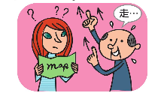 | 52.  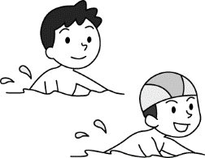 | 53.  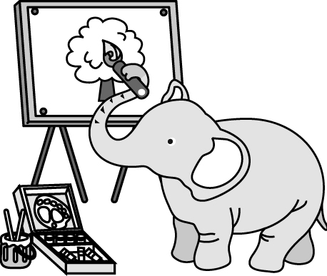 | 54.   | 55.  

51. Does Mr. Li speak English? (先簡答，再詳答)
52. Can the boys swim? (先簡答，再詳答)
53. What can the elephant do? (用-------brush.詳答)
54. What does Tom do on Sundays? (彈1小時來詳答)
55. Do you surf the Net every day? (依自己情況作答: 先簡答，再詳答)

高雄市立林園高級中學 國中部 103學年度 第2學期 1 年級 英語科 第1次段考 答案
◎ 本試卷有55題_共 4頁◎ 命題老師: 李慧真 (分機804)
第一部分 Listening Comprehension 聽力測驗 （30 % ）
1-5 BBAAB 10% (每題2分)
6-15 BCBCA CCCBB 10% (每題1分)
16-20 BACCB 10% (每題2分)
第二部分 Reading & Writing Comprehension讀寫測驗 （70 %）
一.文意字彙 (全對才給分) 20% (每題2分)
21-25 breakfast hours months practices tricks
26-30 count computer change remember music
二.選擇題 (選出最適當的答案) 40% (每題2分)
31-50 DACAD ACDDD ADDDD ABCDA
三.依提示作答(分段給分) 10% (每題2分)
51. No, he doesn’t. He doesn’t speak English./He speaks Chinese.
52. Yes, they can. They can swim.
53. He/She/It can paint with a brush.
54. He plays the guitar for one/an/1 hour on Suodays.
55.參考 Yes, I do. I surf the Net every day. (依自己情況作答)

聽力內容:
1. G: What can your cat do?
B: It can stand on the ball.
2. The girl is counting the markers.
3. We study English every weekend.
4. The woman is a famous basketball player.
5. G: Can you play tennis?
B: No, I can’t do that.
二. 基本問答：根據聽到的內容，選出一個最適合的回應或最適合的問句 10%
6. Hello, this is Ben. May I speak to Vincent?
7. I watch TV for thirty minutes after dinner. How about you?
8. What time can we have dinner, Mom?
9. How tall are you, Jason?
10. What sports does your teacher play?
11. Peter, you love baseball, right? What days do you play baseball?
12. Who does he practice basketball with every day?
13. Do you have music class on Mondays?
14. What are you doing, Jeff? Are you writing love stories?
15. My cat can’t do anything.
三. 言談理解：根據聽到的內容，選出一個最適合的答案 15%
16. M: Hello, this is Henry. May I speak to Sally, please?
W: Sorry. Sally and Polly are at the park. This is Kelly, Sally’s sister. Please call back later.
M: I see. Thank you.
Question: Who is talking to Henry on the phone?
17. M: I am very busy every day. I get up at 6:30 a.m. Then I brush my teeth, wash my face and eat my breakfast. At 9:00 a.m., I study English. At 11:00 a.m., I listen to music and use the computer. At 3:00 a.m., I play basketball at the park. At 7:00 p.m., I have dinner and watch TV with my family.
Question: What doesn’t the boy do in the morning?
18. M: Can I go to the concert with you, Tina? Fiona is my favorite singer.
W: Matt, you’re only five. Kids under ten can’t go to the concert.
M: Oh, I see. I’m very sad.
Question: How old may Tina be?
19. W: Welcome to FANTASY. You can look at the pictures on the wall, but don’t touch the pictures. You can sit on the chairs, but don’t run, drink, or eat here. You can be happy, but don’t be sad. Ha! Have a good time.
Question: What is FANTASY?
20. W: I’m Ruth. Jessica is my classmate. We surf the Net on Monday and Friday. We study together on Tuesday, Wednesday, and Thursday. On Saturday and Sunday, we change into Angel Baby and help the old people in Blue House.
Question: What do Ruth and Jessica do every weekend?

