高雄市立林園高級中學 國中部 103學年度 第2學期 1年級 英語科 第2次段考 試題卷
◎本試卷共（ ）頁 班級： 姓名： 座號：
※聽力測驗
一、辨識句意：根據聽到的內容，選出符合描述的圖片或符合圖片的描述。5%

- (Ａ) 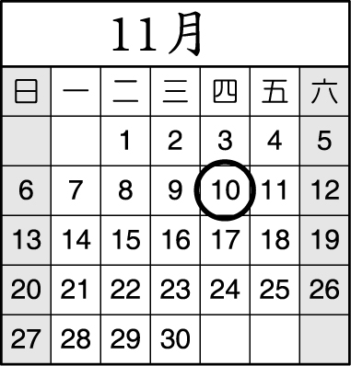(Ｂ) 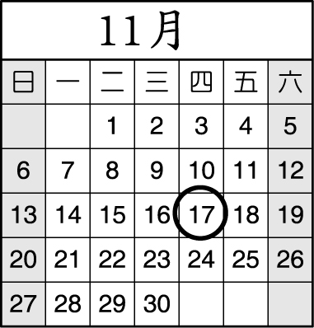(Ｃ) 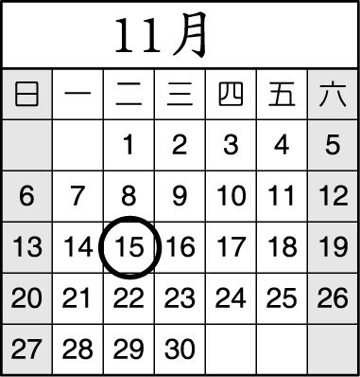

- (Ａ) (Ｂ) (Ｃ)

- (Ａ) 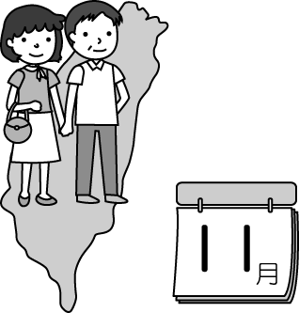(Ｂ) 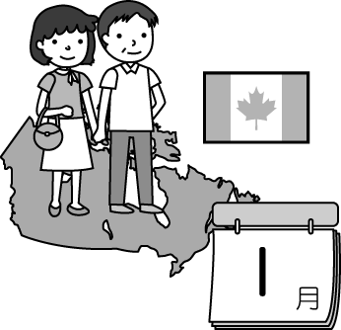(Ｃ) 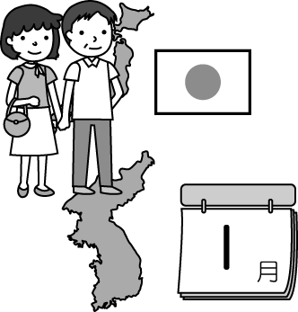

- (Ａ) 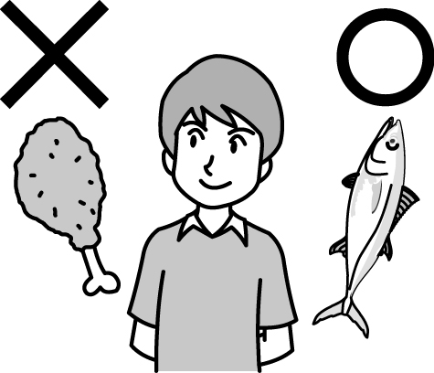(Ｂ) 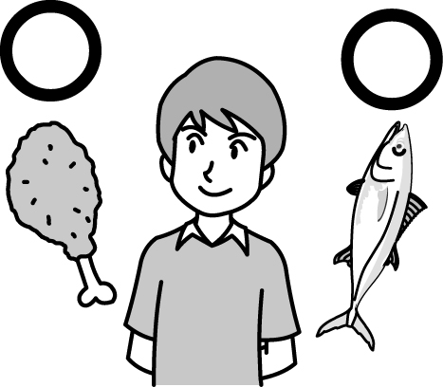(Ｃ) 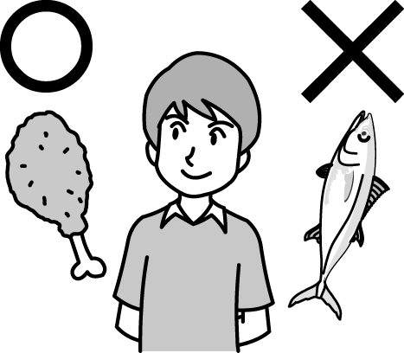

- (Ａ) (Ｂ) 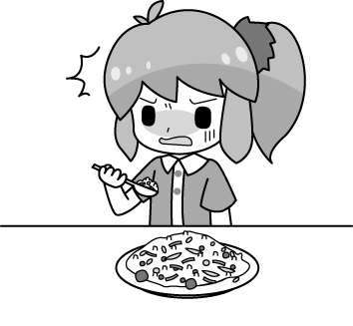(Ｃ) 
二、基本問答：根據聽到的內容，選出一個最適合的回應或最適合的問句。5%
- (Ａ) It's August. (Ｂ) It's October. (Ｃ) It’s a month.
- (Ａ) Yes, it’s on May 5.(Ｂ) No, it’s on March 15.(Ｃ) Yes, everyone likes the contest.
- (Ａ) Not bad. It’s very yummy.(Ｂ) It is three hundred and fifty.(Ｃ) I don’t like the music there.
- (Ａ) There are no pockets.(Ｂ) I can’t use the money.(Ｃ) About one hundred dollars.
- (Ａ) It sells Chinese food.(Ｂ) Everyone likes its fried rice.(Ｃ) I go to the food stand every day.
三、言談理解：根據聽到的內容，選出一個最適合的答案。20%
- (Ａ) Sep. 8.(Ｂ) Sep. 9.(Ｃ) Sep. 19.
- (Ａ) The girl.(Ｂ) The girl’s parents.(Ｃ) The boy’s parents.
- (Ａ) It’s for Karen.(Ｂ) It’s on March third.(Ｃ) It’s a birthday party.
- (Ａ) Fifty dollars.(Ｂ) One hundred dollars.(Ｃ) Two hundred dollars.
- (Ａ) They are talking about good concerts.(Ｂ) They are talking about people’s names.
(Ｃ) They are talking about their favorite singers.
- (１)(Ａ) Cookies.(Ｂ) Fruit salad.(Ｃ) Banana pie.
(２)(Ａ) Taiwan.(Ｂ) Germany.(Ｃ) The USA.
(３)(Ａ) Listen to music.(Ｂ) Make cookies.(Ｃ) Have tea.
(４)(Ａ) Work at the restaurant.(Ｂ) Go to the movies.(Ｃ) Clean the house.
(５)(Ａ) Eight hours.(Ｂ) Thirty hours.(Ｃ) Forty-eight hours.
※紙筆測驗
四、寫出下列連續書寫體單字的印刷體5%
1.cute 2.zebra 3.Japan 4.eight 5.Wednesday
五、文意字彙10%
1. A: May I sit here? B: Of c e.
2. J y is the first month of the year.
3. S r comes after August.
4. There are usually(通常) twenty-eight days in F y.
5. Mom takes c e of me every day. She is great!
6. She likes p a and fried chicken, but she doesn't like apple pie.
7. A: The coffee is really e e. B: That’s OK. I have 500 dollars with me.
8. Patty: Look at my gift for Mom. Gina: Wow! A pretty p e watch!
9. Denny's Breakfast Shop has good s es.
10. Don't w y about it. I can use my pocket money.
六、文法選擇20%
1. I'm hungry. Can I have hot dog and fried chicken?
(A) a ; some (B) some ; some (C) some ; a (D) a ; a
2. I have some and some . Let's make banana milk.
(A) banana ; milk (B) bananas ; milks (C) banana ; milks (D) bananas ; milk
3. These stories are great. I like . (A) it (B) them (C) they (D) their
4. Meg and I love our mom a lot. She is busy, but she roller-skates with before dinner every day.
(A) me (B) her (C) we (D) us
5. Some gas stations(加油站) in Taiwan are open .
(A) 24 hours a day (B) a day 24 hour (C) 24 hour a day (D) a day 24 hours
6. This Thursday is April 12, and it is Monday today. What date is it?
(A) It's on April 9. (B) It's April 9. (C) It's April 8. (D) It's on April 8.
7. Girl: How much the soy milk and the rice ball ? Man: Forty dollars. (A) is (B) do (C) does (D) are
8. Tina's birthday is December 12 .
(A) twelve;  (B) twelfth; on C) twelfth;  (D) twelve; on
9. A: do you have for lunch? B: Fried chicken, a hamburger and green tea. (A) Which (B) When (C) What (D) Where
10. A: Mom making , a cake or a pie? B: A fruit pie.
(A) What is (B) What does (C) Which does (D) Which is
七、閱讀測驗20%
(一)
Meg: It's 11:50 a.m. Let's 1. for lunch.
Lily: Where do you want to go?
Meg: How about Lulu's Kitchen? It 2. great Chinese food.
Lily: OK. Let's go now.
(Fifteen minutes later)
Meg: Which do you like, rice or noodles?
Lily: I like fried rice and vegetable soup.
Meg: OK. We can have our lunch 3. and then buy some coffee on our way to the office.
 vegetable 蔬菜
Lily: Great!
1.(A) go to (B) going to (C) go out (D) going out
2.(A) sell (B) sells (C) selling (D) to sell
3.(A) first (B) the first (C) to first (D) on first

(二)
Amy buys some food at Denny's Shop. Here is her receipt.
Denny's Shop ^{2015-4-19 13:30 No.356416}
Apples 5 NT$100
Eggs 10 NT$89
Fish 1 NT$119
Chicken 1 NT$85
Coffee 3 NT$75
 receipt 收據
Milk 1 NT$70
Orange juice 1 NT$70
 kind 種類
give 給
clerk 店員
change 零錢
thousand 千
Rice 1 NT$125
Bananas 5 NT$60

Total NT$793

4. How much are the drinks ? (A) 160. (B) 145. (C) 783. (D) 215.
5. How many kinds of fruit does Amy buy? (A) Two. (B) Three. (C) One. (D) Four.
6. Amy gives one thousand dollars to the clerk. How much change does she get?
(A) One hundreds and seven dollars. (B) One hundred and seven dollars.
(C) Two hundred and seven dollars. (D) Two hundreds and seven dollars.

(三)
To: pattylin@yahoo.com.tw
From: davidlin@yahoo.com.tw
Subject: The Gift for Mom
Date: Wednesday, August 10
Dear Patty,
I call you many times, but you don't call me back. Next Monday is Mom's birthday, and Dad can cook a big dinner for her on Sunday evening. So be sure to come home for dinner on Sunday. I plan to buy a smart phone for Mom. She often goes traveling with her friends. She can take many great pictures and send them to us with the smart phone. I think it's a cool gift for her. I check the price of the smart phone, and it's NT$10,000. I think you can share the money with me. I pay half of it, and you pay the other half. What do you think about it? Please call me back as soon as possible. See you on Sunday!
Love, David
 often時常 go traveling去旅行 send 寄;送 check查詢 price價格 pay付款 half一半
7.When is David's mother's birthday? (A) August fifteen. (B) August fourteen. (C) August fourteenth. (D) August fifteenth.
8.Which is Not true?
 mean 意指
(A) David can pay NT$5000 for the smart phone. (B) David's father can cook a big dinner this Sunday.
(C) The word "them" means David's mother's friends (D) Patty and David are brother and sister.
(四)
(In the living room)
Sarah: What are you doing?
Jasper: I 'm hanging some stockings on the tree. Can you help?
Sarah: Sure I can.
(Ten minutes later)
Sarah: Oh, I'm tired. Can we take a break?
Jasper: Come on! Tomorrow is Christmas!
Sarah: Wait! Tomorrow is December 24. It 's Christmas Eve tomorrow night.
Jasper: I see. Then we still have time. Let's do it tomorrow!

 tired 疲倦的take a break 休息一下tomorrow 明天still 仍然
9.What's the date today? (A) December 23. (B) December 24. (C) December 25. (D) December 26.
10.Which is true?
 true 真實的
(A) Sarah and Jasper are in the classroom. (B) Christmas Eve is the day after Christmas.
(C) Sarah can't hang Christmas stockings with Jasper. (D) Christmas Eve is on the night of December 24.

八、依提示作答6%
1. What date is the concert?(以7月31日詳答，數字用英文)
2. Which / they / have for breakfast / egg / milk tea(依所提示字的順序，加入適當的字詞及標點符號，造問句)
3. Every day is a nice day.(加入can改寫句子)

九、翻譯9%
1. 母親節在五月的第二個星期天。
2. 這魚湯多少錢？三百元。(數字用英文)
3. Gina去哪一家早餐店呢, Denny's還是Granny's？

高雄市立林園高級中學 國中部 103學年度 第2學期 1年級 英語科 第2次段考 作答卷
班級： 姓名： 座號：
※聽力測驗
一、辨識句意5% | 1. |  | 2. |  | 3. |  | 4. |  | 5.
二、基本問答5% | 6. |  | 7. |  | 8. |  | 9. |  | 10.
三、言談理解20% | 11. |  | 12. |  | 13. |  | 14. |  | 15.
三、言談理解20% | 16-(1) |  | 16-(2) |  | 16-(3) |  | 16-(4) |  | 16-(5)

※紙筆測驗

四、寫出下列連續書寫體單字的印刷體5%
1. |  | 2. |  | 3. |  | 4. |  | 5.

五、文意字彙10%
1. |  | 2. |  | 3. |  | 4. |  | 5.
6. |  | 7. |  | 8. |  | 9. |  | 10.

六、文法選擇20%
1. |  | 2. |  | 3. |  | 4. |  | 5.
6. |  | 7. |  | 8. |  | 9. |  | 10.

七、閱讀測驗20%
1. |  | 2. |  | 3. |  | 4. |  | 5.
6. |  | 7. |  | 8. |  | 9. |  | 10.

八、依提示作答6%(分段給分)
1.
2.
3.

九、翻譯9%(分段給分)
1.
2.
3.

高雄市立林園高級中學 國中部 103學年度 第2學期 1年級 英語科 第2次段考 解答
一、辨識句意5% | 1. | B | 2. | B | 3. | C | 4. | C | 5. | C
二、基本問答5% | 6. | B | 7. | B | 8. | A | 9. | C | 10. | A
三、言談理解20% | 11. | C | 12. | C | 13. | B | 14. | B | 15. | C
三、言談理解20% | 16-(1) | B | 16-(2) | B | 16-(3) | A | 16-(4) | A | 16-(5) | C
四、寫出下列連續書寫體單字的印刷體5% (每題1分)
1. | cute | 2. | zebra | 3. | Japan | 4. | eight | 5. | Wednesday
五、文意字彙10% (每題1分)
1. | course | 2. | January | 3. | September | 4. | February | 5. | care
6. | pizza | 7. | expensive | 8. | purple | 9. | sandwiches | 10. | worry
六、文法選擇20% (每題2分)
1. | A | 2. | D | 3. | B | 4. | D | 5. | A
6. | B | 7. | D | 8. | B | 9. | C | 10. | D
七、閱讀測驗20% (每題2分)
1. | C | 2. | B | 3. | A | 4. | D | 5. | A
6. | C | 7. | D | 8. | C | 9. | A | 10. | D
八、依提示作答6% (每題2分，分段給分)
1. | It's on / July thirty-first.
2. | Which do they have for breakfast, / eggs or milk tea?
3. | Every day can / be a nice day.
九、翻譯9% (每題3分，分段給分)
1. | Mother's Day is / on the second Sunday / of May.
2. | How much is / the fish soup? / Three hundred dollars.
3. | Which breakfast shop / does Gina go to, / Denny's or Granny's?
※錄音稿
1.My birthday party is on the third Thursday of November.
(第16題)
Question 1: Which food does Mike like?
Question 2: Where does Teresa come from?
Question 3: What do Teresa’s families do after dinner?
Question 4: Which doesn’t Teresa do on Monday?
Question 5: How many hours does Teresa work a week?

2.Please put the doll in the box first and then wrap it.
3.Mr. and Mrs. Smith are in Japan in the first month of the year.
4.W: Which do you like, fish or chicken? M: I like chicken.
5.Fiona doesn’t like rice balls, but she loves soy milk.
6.What month comes after September?
7.Is the talent contest on March 5?
8.How is the food at the Chinese restaurant?
9.How much pocket money do you get from your parents every week?
10.What does the food stand sell?
11.M: Happy birthday to you, Linda. W: Oh, thanks. But today is September ninth. My birthday is on September nineteenth.
M: Really? Isn’t today September eighth?
Question: What date is Linda’s birthday?
12.G: Do your parents take care of you? B: Yes, they take good care of me. They are nice.
Question: Who takes care of the boy?
13.B: There’s a birthday party for Karen. G: When is it? B: It’s on March third.
Question: When is the party?
14.M: I want fish soup. It’s yummy. W: It’s two hundred dollars. Too expensive! Chicken soup is only NT$50.
M: Well, today is Monday, so it is only one hundred.
Question: How much is the fish soup today?
15.M: Which one do you like, Judy or Joy? W: Well, they are not bad, but I like Cindy. Her songs are great and beautiful.
M: Let’s listen to her songs together.
Question: What are they talking about?
16.W: Hello, I’m Teresa, a cook from Germany. My family and I are working and studying in Taiwan now. I can make a lot of food, fried rice, cookies, cake, and pizza. I work for eight hours a day from Tuesday to Sunday. After work, I have yummy food and have a great family life with my family at home. My daughter, Phoebe, likes my banana pie very much, my son, Mike, likes the fruit salad very much, and my husband, a basketball coach from the USA, likes my cookies a lot. After dinner, my families listen to music, read, and play cards at night. On Monday, I go to the movies, clean the house, or have tea with my friends. I’m a happy mother.

