高雄市立林園高級中學 國中部 103學年度 第2學期 1年級第3次段考 (英語科) 試題卷
班級： 姓名： 座號：

辨識句意：根據聽到的內容，選出符合描述的圖片或符合圖片的描述。
1. (Ａ) 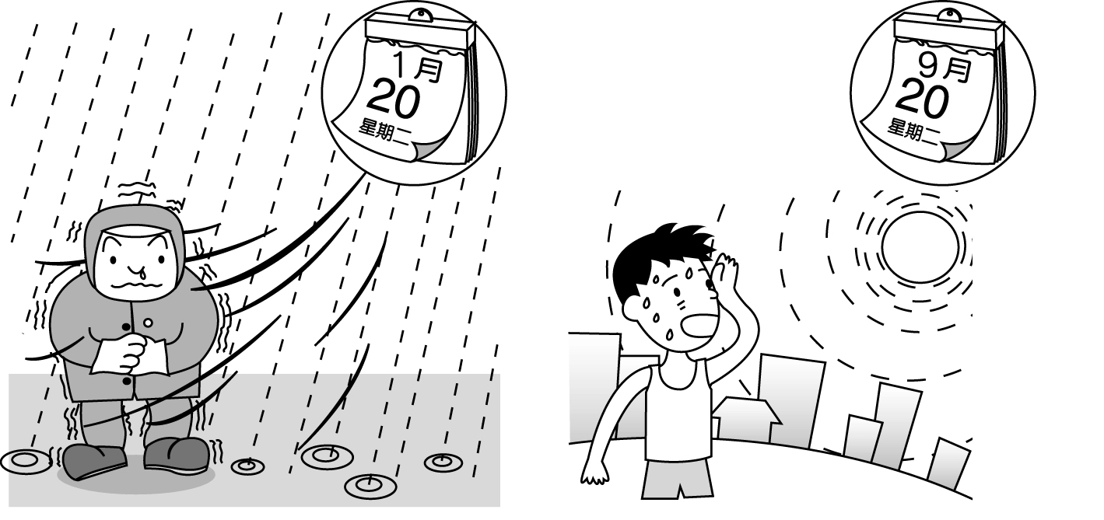
(Ｂ) 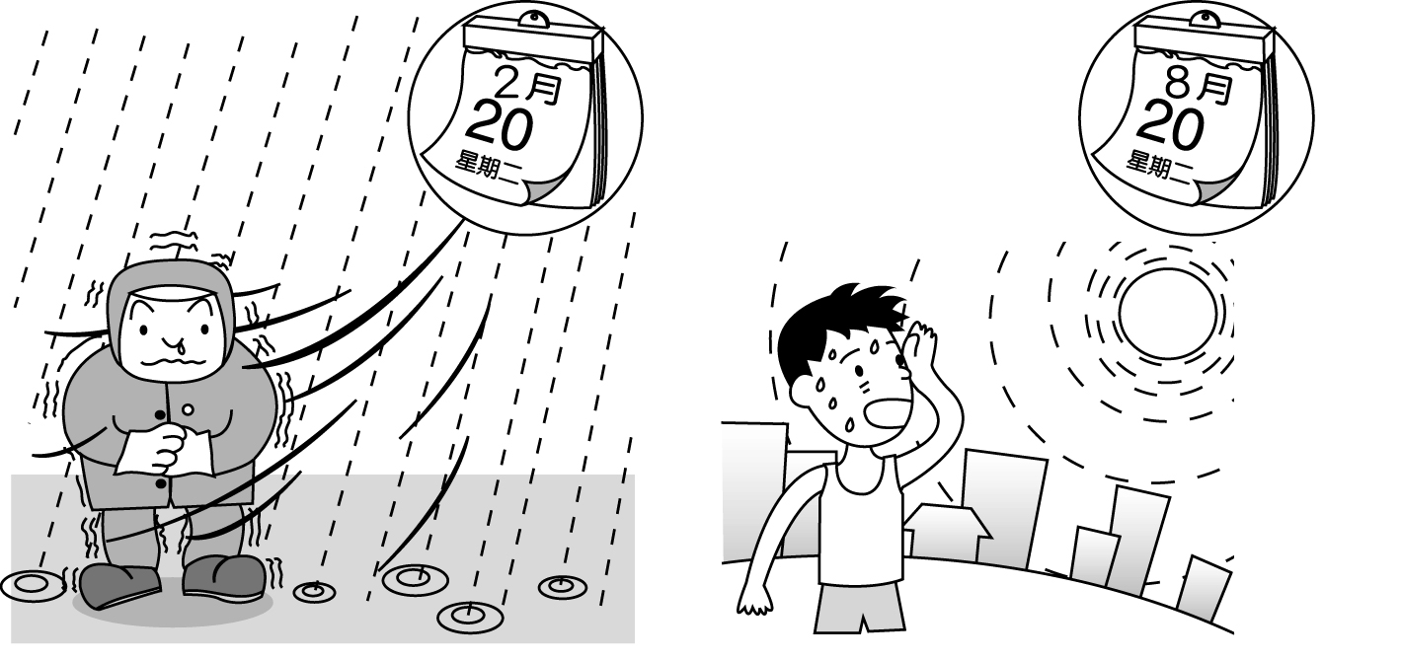
(Ｃ) 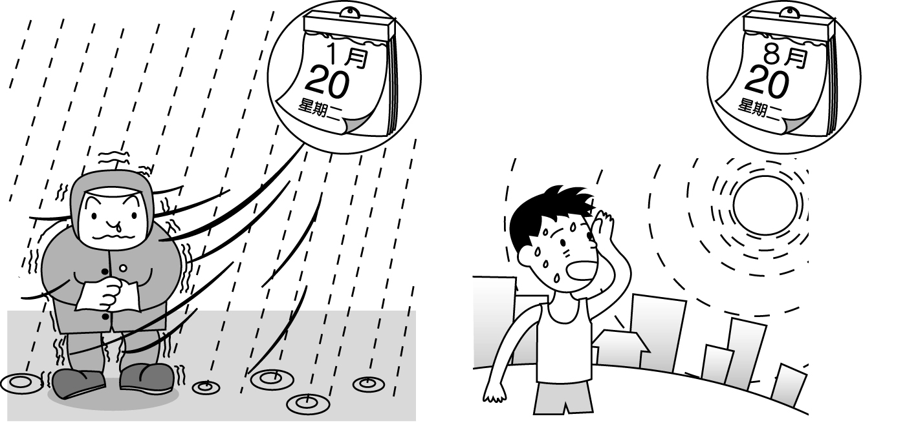

2. (Ａ) 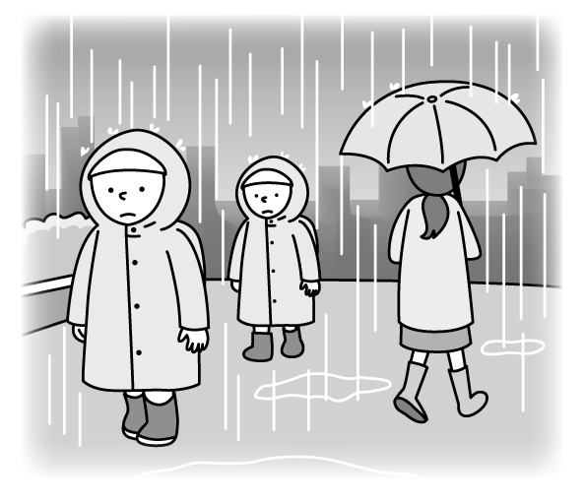
(Ｂ) 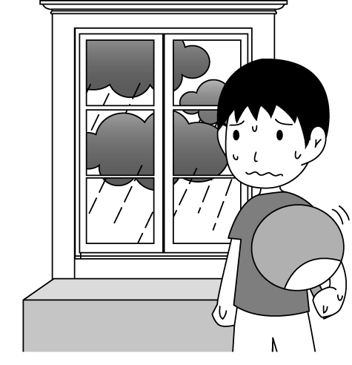
(Ｃ) 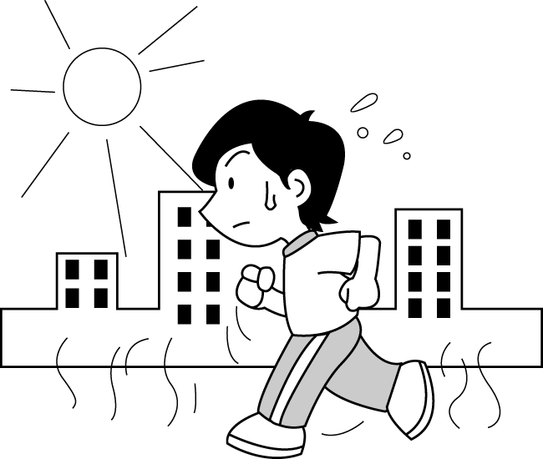

3. (Ａ) 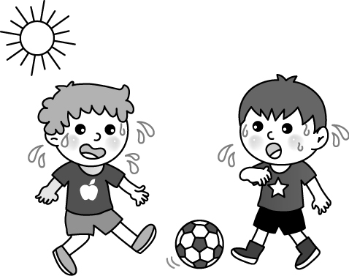
(Ｂ) 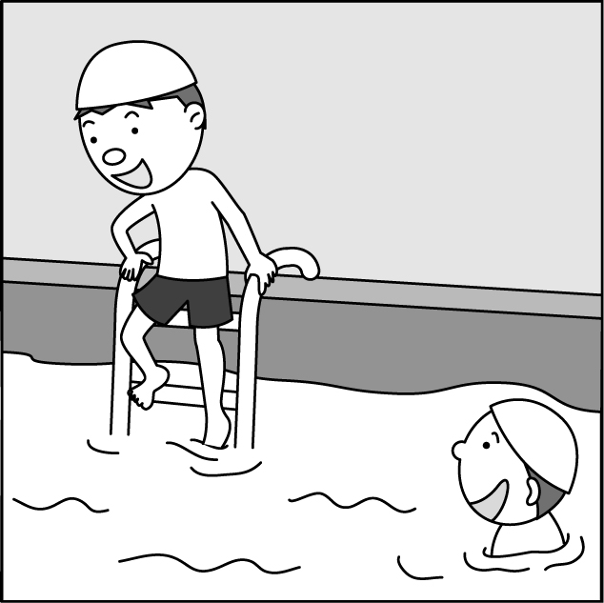
(Ｃ) 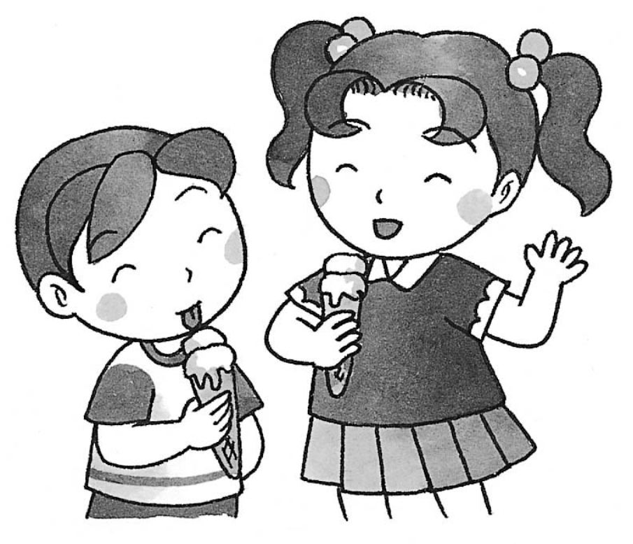
4.(Ａ)
(Ｂ)
(Ｃ)

5.(Ａ) 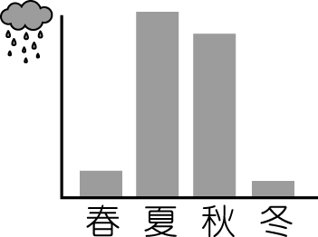
(Ｂ) 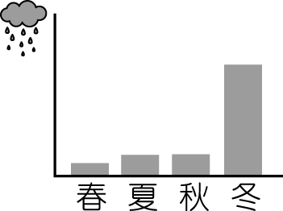
(Ｃ) 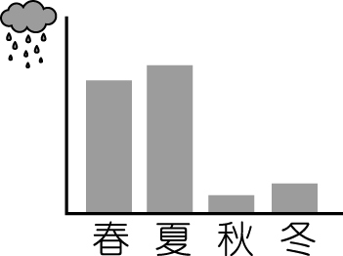
基本問答：根據聽到的內容，選出一個最適合的回應或最適合的問句。
6. (Ａ) Sorry, I don’t have a blender at home.
(Ｂ) One glass of chocolate milk shake, please.
(Ｃ) Please don’t touch the chocolate on the table.
7.(Ａ) Eight.
(Ｂ) Six bottles.
(Ｃ) That’s a lot.
8. (Ａ) No sugar, please.
(Ｂ) I want fifteen dumplings.
(Ｃ) There isn’t water on the table.
9.(Ａ) Don’t worry. Eggs are not expensive.
(Ｂ) How about pumpkins? Do you need them?
(Ｃ) I can go get some. How many eggs do you need?
- (Ａ) Don’t you have a blender?
(Ｂ) By the way, I need some tea.
(Ｃ) I can get a glass of orange juice.

言談理解：根據聽到的內容，選出一個最適合的答案。
11. (Ａ) One.
(Ｂ) Ten.
(Ｃ) Eleven.
12.(Ａ) She was not short, but she was beautiful.
(Ｂ) She was tall and beautiful.
(Ｃ) She was very short.
- (Ａ) Wednesday.
(Ｂ) Thursday.
(Ｃ) Friday.
14.(Ａ) A tadpole.
(Ｂ) A river fish.
(Ｃ) A Taipei tree frog.
- (Ａ) She was at home.
(Ｂ) She was at a toy store.
(Ｃ) She was at a museum.

字彙選擇
16.( ) We can see on a farm.
(Ａ) bears (Ｂ) cows (Ｃ) tigers (Ｄ) lions
17.( ) It’s in Taiwan in summer. (Ａ) warm and dry (Ｂ) hot and wet (Ｃ) cool and dry (Ｄ) cold and wet
18.( ) I don’t know if（是否）I can see him again in my .
(Ａ) lifetime (Ｂ) pocket (Ｃ) hand (Ｄ) story
19.( ) They were tadpoles three weeks ago, but now they are .
(Ａ) hippos (Ｂ) pandas (Ｃ) zebras (Ｄ) frogs
20. ( ) I’m making an apple pie. Please help me the eggs and the flour together first.
(Ａ) sell (Ｂ) buy (Ｃ) blend (Ｄ) cook

文法選擇
21. ( ) Leo: Do you often take your son to the park in the afternoon? Max: .
(Ａ) Yes, I always do (Ｂ) No, he seldom does (Ｃ) Yes, he usually does (Ｄ) No, he can never do it
- ( ) Amy: juice do they need at the party? Ben: They need juice.
(Ａ) How many; fifteen (Ｂ) How much; fifteen (Ｃ) How much; fifteen cans of (Ｄ) How many; fifteen cans of
- ( ) I usually have rice for lunch, but I have dumplings or noodles.
(Ａ) always (Ｂ) sometimes (Ｃ) never (Ｄ) seldom
- ( ) My sister is on a diet（節食）. She only has for lunch every day.
(Ａ) three bowls of rice (Ｂ) one bowl of fruit salad (Ｃ) five rice balls (Ｄ) thirty dumplings
- ( ) Tina: do you go to the supermarket? Jessie: Not very often.
(Ａ) How (Ｂ) When (Ｃ) How long (Ｄ) How often
- ( ) Jane: you early for school? Beth: Yes, I always .
(Ａ) Do; do (Ｂ) Are; am (Ｃ) Have; have (Ｄ) Can; can
- ( ) are there in your house? (Ａ) How many people (Ｂ) How much cola (Ｃ) What (Ｄ) How much
- ( ) A: ______ the weather like yesterday? B: ______ cloudy and windy.
(Ａ) How’s, It’s (Ｂ) What’s, It’s (Ｃ) How was, It was (Ｄ) What was, It was
29. ( ) A: Taiwan is so beautiful. B: _________ I like Taiwan, too.
(Ａ) I see. (Ｂ) Sure I do. (Ｃ) Come on. (Ｄ) You can say that again.
30. ( ) A: Do you have a lot of rain here in summer? B: Not really. _________.
(Ａ) It sometimes rains a lot (Ｂ) It’s always a wet season (Ｃ) It’s rainy here in summer (Ｄ) It’s usually sunny and dry

克漏字測驗
Good morning, everyone. Welcome to today’s (31) report. Today is a rainy day again in Taipei. Don’t forget your (32) . It’s very hot in Taichung and Kaohsiung. For Eastern Taiwan, it’s (33) and sunny in the morning but cool and (34) in the afternoon. This is Jeff Chen for today’s report. Have a nice day.
（ ）(31) (A) week (B) month (C) weather (D) season
（ ）(32) (A) umbrellas (B) towels (C) flowers (D) glasses
（ ）(33) (A) cold (B) hot (C) wet (D) cool
（ ）(34) (A) rain (B) snow (C) rainy (D) snowy

(At Mia’s house)
Mia: Welcome to my house. You come from Tainan. How do you like the weather in Taipei?
Joe: I (35) like the winter here. It is cold, and it often rains. It’s a little too wet for me.
Mia: Don’t you (36) in Tainan in winter?
Joe: No. (37) not much rain there in winter. By the way, you can come to Tainan during winter vacation, and let me show you around.
Mia: Really? I can’t wait!
（ ）(35)(Ａ) am (Ｂ) do (Ｃ) am not (Ｄ) do not
（ ）(36）(Ａ) rain (Ｂ) be rainy (Ｃ) have rain (Ｄ) be rain
（ ）(37)(Ａ) There’s (Ｂ) It’s (Ｃ) We have (Ｄ) It does

Jeff: Hi, Mom. I’m back home.
Mom: Today is your first day of school. How is everything?
Jeff: Not bad. We have a new PE teacher, Miss Wang. She is good at basketball.
Mom: Miss Wang? Is her name Sarah Wang?
Jeff: That’s right. (38) do you know her?
Mom: She and I (39) classmates fifteen years ago. She was the star basketball player at our school. Hey, let’s go to the park, and you can (40) me your basketball skills.
Jeff: OK. Let’s go!
（ ）(38) (Ａ) What (Ｂ) How (Ｃ) Which (Ｄ) When
（ ）(39) (Ａ) is (Ｂ) was (Ｃ) are (Ｄ) were
（ ）（40）(Ａ) sell (Ｂ) show (Ｃ) take (Ｄ) walk

閱讀測驗
Look at the chart and answer the questions.
（ ）(41) Who often listens to music and eat dinner at home?
(Ａ) Rita. (Ｂ) Hank. (Ｃ) Joe. (Ｄ) Ivy.
（ ）(42) Who always goes to bed before 10:00 and is seldom free on weekends?
(Ａ) Rita. (Ｂ) Hank. (Ｃ) Joe. (Ｄ) Ivy.
（ ）(43) Which is NOT true（正確的）?
(Ａ) Rita and Ivy sometimes play sports. (Ｂ) Hank usually eats dinner at home. (Ｃ) Ivy sometimes surfs the Net. (Ｄ) Joe is seldom free on weekends.

Look at the chart and answer the questions.
（ ）(44) Eric lives in City 3, and it rains a lot. What month is it now?
(Ａ) October. (Ｂ) April. (Ｃ) July. (Ｄ) January.
（ ）(45) How is the weather in City 2 in winter?
(Ａ) It is windy. (Ｂ) It is cold. (Ｃ) It is sunny. (Ｄ) It is rainy.

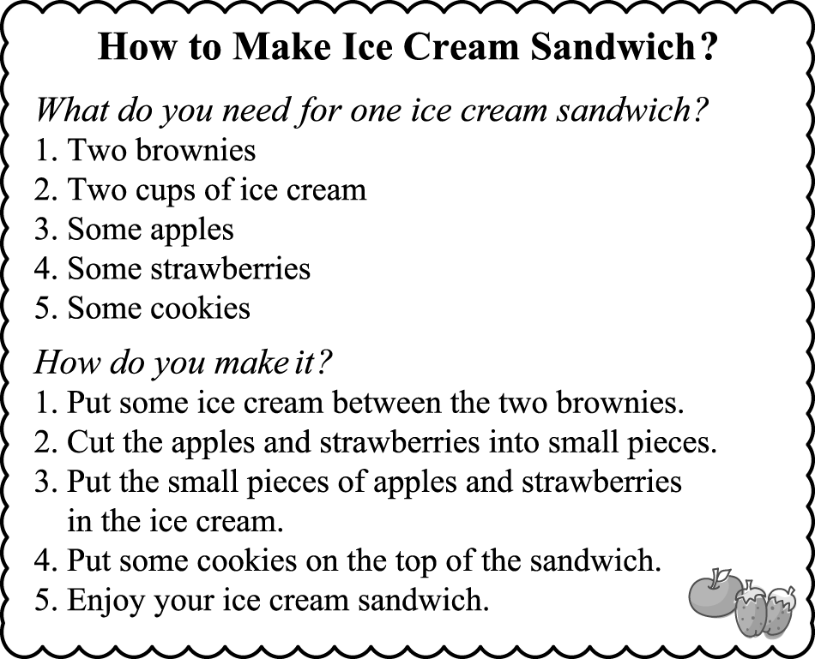
（ ）(46) Which one is the ice cream sandwich?
(Ａ) 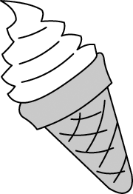 (Ｂ) 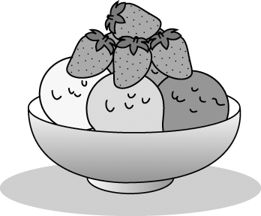 (Ｃ) 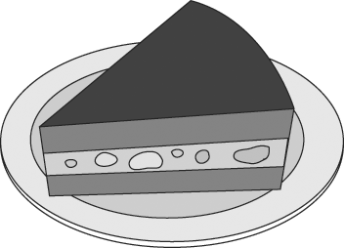
(Ｄ) 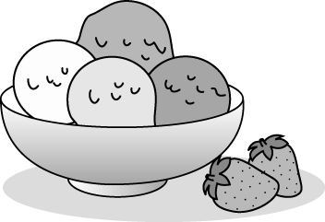
（ ）(47) Which is NOT in the ice cream sandwich?
(Ａ) Juice . (Ｂ) Strawberries. (Ｃ) Cookies. (Ｄ) Brownies.
（ ）(48) Amanda will（將）invite（邀請）five people to her house. She wants to make ice cream sandwiches for them and herself（她自己）. How much ice cream does she need?
(Ａ) Five cups. (Ｂ) Six cups. (Ｃ) Twelve cups. (Ｄ) Ten cups.

Look at the pictures and answer the questions.
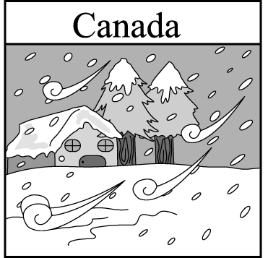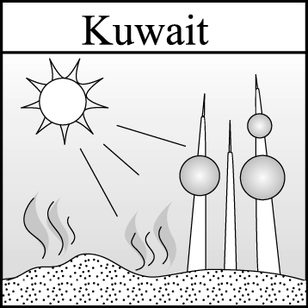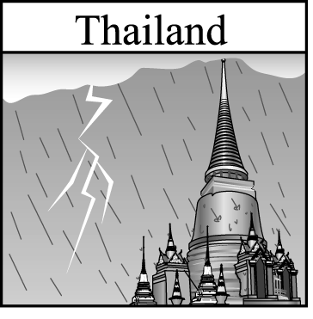
（ ）(49) How is the weather in Thailand?
(Ａ) It is snowy. (Ｂ) It is windy. (Ｃ) It is wet. (Ｄ) It is cold.
（ ）(50) What is the weather like in Kuwait?
(Ａ) It is dry and snowy. (Ｂ) It is rainy and hot. (Ｃ) It is rainy and dry. (Ｄ) It is hot and dry.

103學年度 第2學期 1年級第3次段考 英語/答案卷

1.(Ａ)2.(Ａ)3.(Ｂ)4.(Ａ)5.(Ｃ)
6 (Ａ)7 (Ａ)8 (Ｂ)9 (Ｃ)10 (Ｃ)
11(Ａ)12 (Ｃ)13 (Ａ)14 (Ｃ)15 (Ｃ)

16(B) 17(B) 18(A) 19(D) 20(C)
21(A) 22(C) 23(B) 24(B) 25(D)
26(B) 27(A) 28(D) 29(D) 30(D)
31(C) 32(A) 33(B) 34(C) 35(D)
36(C) 37()A 38(B) 39(D) 40(B)
41(D) 42(C) 43(A) 44(C) 45(A)
46(C) 47(A) 48(C) 49(C) 50(D)

